Year 4 Maths Home Learning – Week beginning 18th May 2020
Monday: Types of triangles and quadrilaterals
You could watch the teaching video at https://www.youtube.com/watch?v=xBebTV679Ug to recap the different types of triangles and quadrilaterals. Alternatively, use the BBC Bitesize videos https://www.bbc.co.uk/bitesize/topics/zvmxsbk/articles/zggsfrd (types of triangle) and https://www.bbc.co.uk/bitesize/topics/zvmxsbk/articles/z98n4qt (polygons).
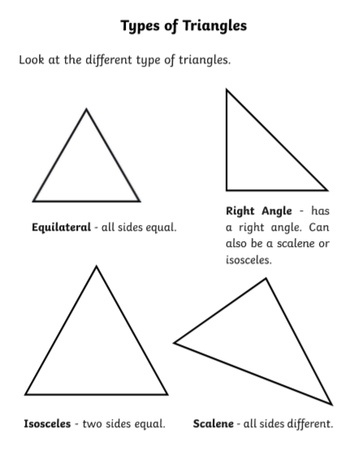
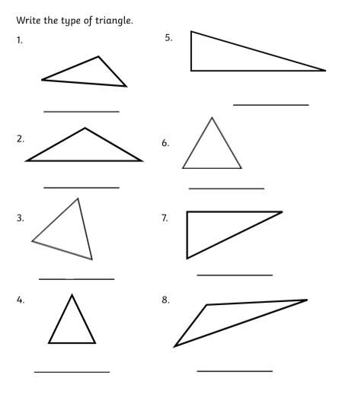

A quadrilateral is a four-sided shape.
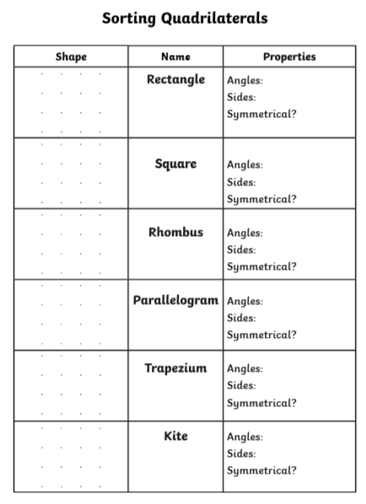
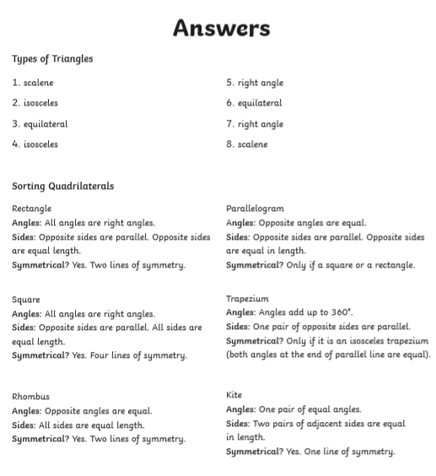

Tuesday: Angles
Can you remember your previous work on angles? Look carefully at the angles below…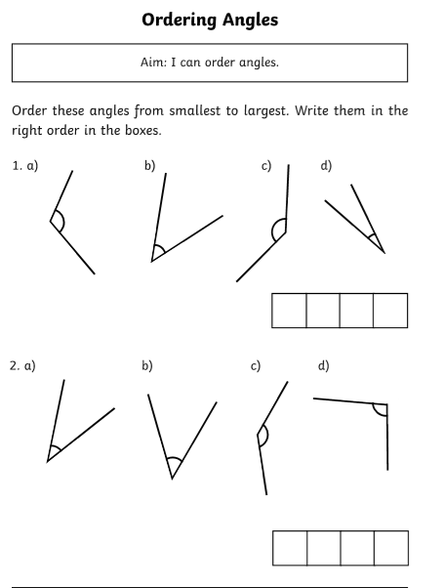
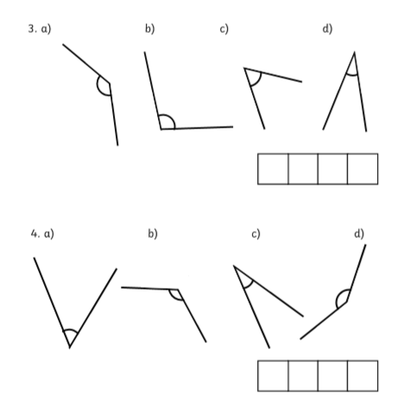
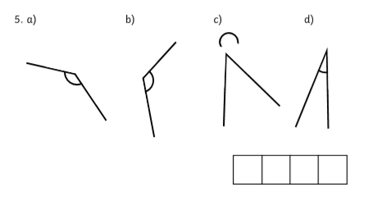
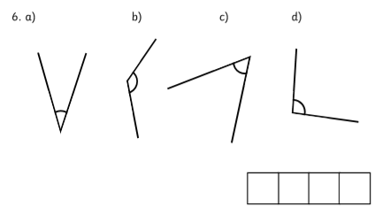
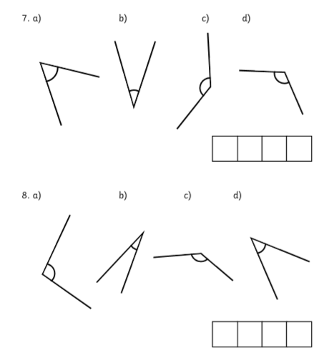
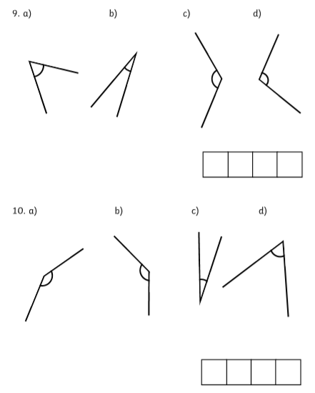
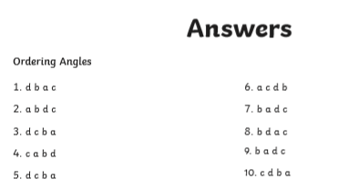

Wednesday: Revise different types of angles.
The BBC Bitesize video at https://www.bbc.co.uk/bitesize/topics/zb6tyrd/articles/zp327hv will help you to learn/ revise the different types of angles.
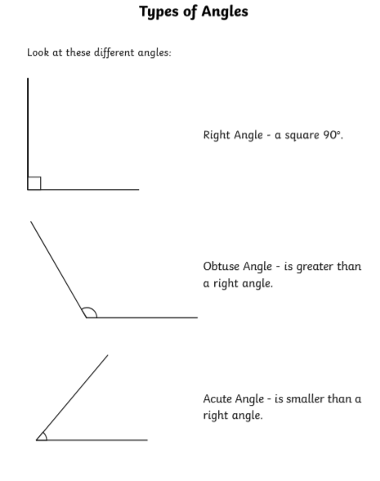
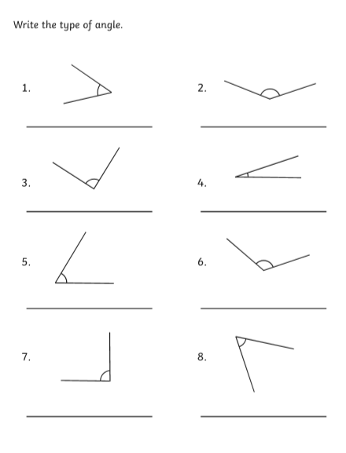

Thursday: Symmetry
Remember - a line of symmetry divides a shape exactly in half, so that what is on one side of the line is an exact mirror image of what is on the other side. Some shapes have no lines of symmetry, some have one and some have more.

The BBC Bitesize lesson at https://www.bbc.co.uk/bitesize/topics/zrhp34j/articles/z8t72p3 will help you to understand this more visually.

There is another useful video here: https://www.bbc.co.uk/teach/class-clips-video/maths-ks2-finding-lines-of-symmetry/zktfgwx

This video https://www.youtube.com/watch?v=RnmKc9QQCH8 demonstrates how to reflect a shape across a mirror line, point by point.

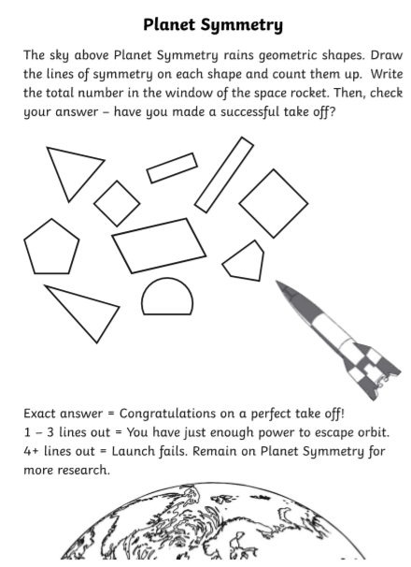

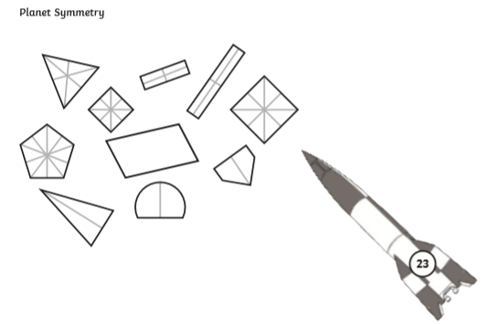
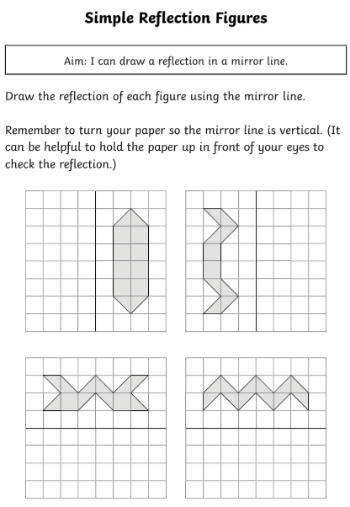

These are a bit more challenging. Remember to count the squares from the mirror line from each point/ vertex of the shape and then count the same on the other side of the mirror line. Once you have drawn all the points, use a ruler to join them up!
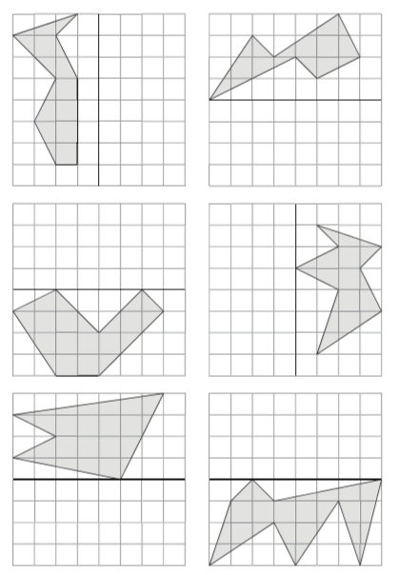

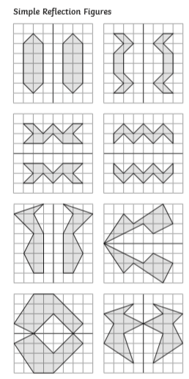
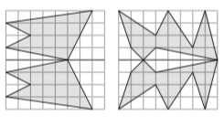

Friday: Symmetry, part 2
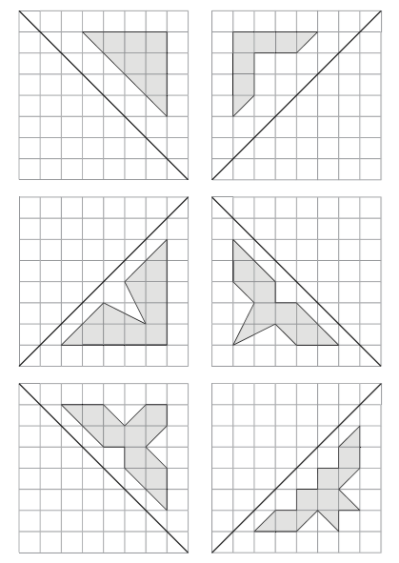
These lines of symmetry are diagonal. Imagine a perpendicular line through each corner or vertex across the mirror line and count the squares on each side, so that you place the vertices correctly, then join the points you have made, using a ruler. On this video https://www.youtube.com/watch?v=GZNR0Z0OXQE you will find a demonstration of how to do this.
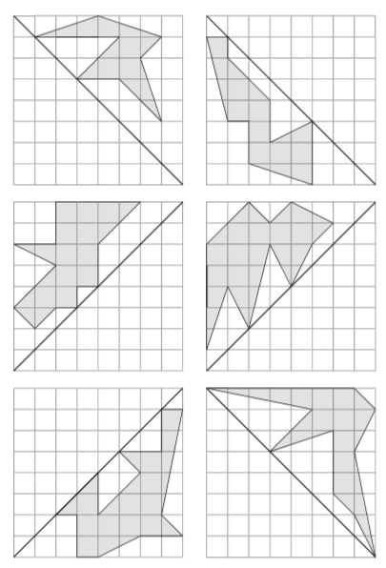

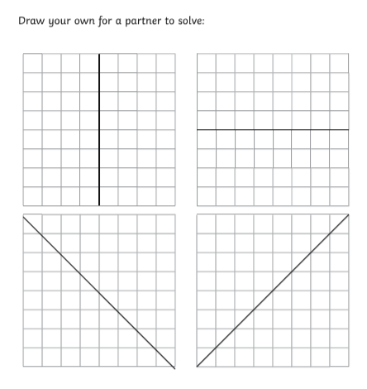
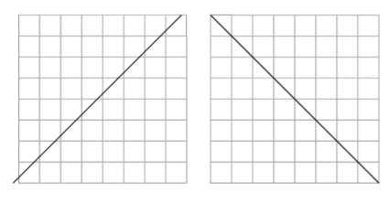
Why not send these to one of your Year 4 classmates for them to solve?

