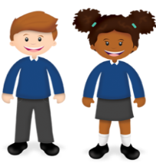
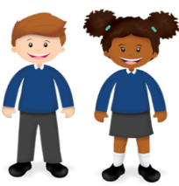
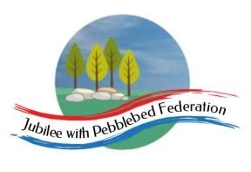
Class 2  Wk beg: 11th Jan ‘20 | Daily Dashboard  (10-15mins) | Spelling (30 mins) | Reading (30 mins) | Writing (1 hour) | Maths (45 mins) | Afternoon Project  When finished each day
Monday  Collective Worship  Today, you will find a Collective Worship video on the Google Classroom, introducing our new theme: Trust. | There is a presentation on the Google Classroom to guide you through today’s Daily Dashboard. | https://www.edshed.com/en-gb/login  Practise the spellings set for you in ‘Assignments’. Then practise the statutory words for your age group.  Year 3, please complete today’s Phonics revision lesson on Bug Club Phonics and then spend any remaining time on Spelling Shed.  Today’s lesson is  Unit 13 /zh/ as 's' Revision 's' | https://www.activelearnprimary.co.uk/login?c=0 | This week’s Literacy lessons will be posted on Google Classrooms by 8.30am each morning.  In today’s lesson, we will be reading our new Literacy text and thinking about how the author presents different characters an makes them interesting to read about.  If you are unable to access the lesson, you could have a look at another book you are reading. Choose a favourite story character and collect words and phrases the author uses that tell you what that character is like. Then choose 3 or 4 words or phrases to summarise your opinion of the character. | 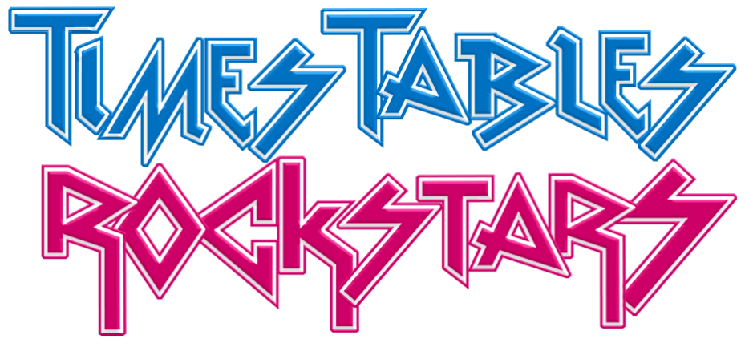  Warm up with  Year 3  https://classroom.thenational.academy/lessons/to-describe-unit-and-non-unit-fractions-75jkac  Year 4  https://classroom.thenational.academy/lessons/embed-previous-fraction-work-using-a-linear-model-cgt30e  Year 5  https://classroom.thenational.academy/lessons/ordering-fractions-c4vp6r  Year 6  https://classroom.thenational.academy/lessons/compare-fractions-greater-than-one-c8vkgr  I will be assigning some extension tasks, for Year 6 in particular, on the Google Classroom | PE  https://www.youtube.com/channel/UCLNV8D56t6RV0wbsPnbnYeA  RE  See Google Classrooms.  In RE this week, we will continue to explore the story of Moses.  Look at the video at https://www.youtube.com/watch?v=cL7B_W8Pld4  to recap the story and learn a bit more. You my need to complete the sequence/ caption tsk from the last lesson or you could practise retelling the story in your own word using the pictures from that lesson.  What do you think are the main themes in the story of Moses’ life – eg. freedom, God, suffering, leadership, vulnerability, obedience, good vs.evil? Can you give reasons for your choice?  In the story God rescues his people by delivering them from Egypt and then makes a covenant with them. He does not demand that they obey his commands first and only rescue them if they manage it. What difference does this make?  What does the story of the Exodus say about how following God brings freedom and justice?  Story  Watch the next installment of our class novel, ‘How to Train Your Dragon’, which you will find on the Google Classroom.
Tuesday | There is a presentation on the Google Classroom to guide you through today’s Daily Dashboard. | https://www.edshed.com/en-gb/login  Practise the spellings set for you in ‘Assignments’. Then practise the statutory words for your age group.  Year 3, please complete today’s Phonics revision lesson on Bug Club Phonics and then spend any remaining time on Spelling Shed.  Today’s lesson is  Unit 13 /wh/ as 'w' lesson | https://www.activelearnprimary.co.uk/login?c=0 | This week’s Literacy lessons will be posted on Google Classrooms by 8.30am each morning.  In today’s lesson we will be thinking a little more about how an author reveals a character to the reader. We will observe particular techniques the author uses and practise using similar sentence structures or techniques in writing about our own characters. If you are unable to access the lesson, look at a favourite book and choose a few sentences you think are particularly effective in helping the reader understand the main character. Can you use similar sentences or patterns to write about a character you have invented? | Warm up with  Year 3  https://classroom.thenational.academy/lessons/to-identify-and-describe-non-unit-fractions-6cr32t  Year 4  https://classroom.thenational.academy/lessons/assign-unit-fraction-names-and-notation-to-3d-representations-64vker  Year 5  https://classroom.thenational.academy/lessons/fractions-and-decimals-70tp4c  Year 6  https://classroom.thenational.academy/lessons/decimal-and-fraction-equivalence-cngk8r | History  Start by using the following BBC Bitesize lesson to extend your knowledge.  BBC Bitesize: When did the Anglo-Saxons come to Britain?  https://www.bbc.co.uk/bitesize/topics/zxsbcdm/articles/z23br82  Then, look on Google classrooms to find a lesson about the Anglo-Saxon monk, St. Bede and learn why he was significant.
Wednesday  Collective Worship  https://www.churchofengland.org/our-faith/faith-home/faith-home-videos/collective-worship-primary-schools-belonging-s2e1 | There is a presentation on the Google Classroom to guide you through today’s Daily Dashboard. | https://www.edshed.com/en-gb/login  Practise the spellings set for you in ‘Assignments’. Then practise the statutory words for your age group.  Year 3, please complete today’s Phonics revision lesson on Bug Club Phonics and then spend any remaining time on Spelling Shed.  Today’s lesson is  Unit 13 /ph/ as 'f' lesson | https://www.activelearnprimary.co.uk/login?c=0 | This week’s Literacy lessons will be posted on Google Classrooms by 8.30am each morning.  In today’s lesson, we will examine how the way that different characters speak tells us more about their character.  If you are unable to access the lesson, choose a character or two from books you have read or enjoyed and write some sentences about them using the following sentence frame:  The character reveled they were when they said… . | Warm up with  Year 3  https://classroom.thenational.academy/lessons/finding-non-unit-fractions-of-quantities-c5jp4d  Year 4  https://classroom.thenational.academy/lessons/assign-unit-fraction-names-and-notation-to-equal-parts-of-quantities-64ukec  Year 5  https://classroom.thenational.academy/lessons/thousandths-6wup6t  Year 6  https://classroom.thenational.academy/lessons/decimal-equivalents-of-fractions-cnh32r | Art  In today’s lesson, we will find out more about Anglo-Saxon Art.  Twinkle Go lesson: https://www.twinkl.co.uk/go  RM3578  Music  Our focus in Music this term is dynamics which means how loud or quiet a piece of music is. Learn more at https://www.bbc.co.uk/bitesize/topics/zcbkcj6/articles/z3rcgdm  You may also like to learn a song about the Anglo-Saxons at  https://www.bbc.co.uk/teach/school-radio/music-ks2-anglo-saxons-arrival-we-are-anglo-saxons/zj6jjhv
Thursday | There is a presentation on the Google Classroom to guide you through today’s Daily Dashboard. | https://www.edshed.com/en-gb/login  Practise the spellings set for you in ‘Assignments’. Then practise the statutory words for your age group.  Year 3, please complete today’s Phonics revision lesson on Bug Club Phonics and then spend any remaining time on Spelling Shed.  Today’s lesson is  Unit 13 Language Irregular lesson | https://www.activelearnprimary.co.uk/login?c=0 | This week’s Literacy lessons will be posted on Google Classrooms by 8.30am each morning.  In today’s lesson, we will explore how the main character feels at different points in the story and think about how the author communicates to the reader what the character is feeling, through what is explicitly stated and through what the character does and says. Often, we (the readers) are able to infer what the character is feeling from their speech and actions.  If you are unable to access the lesson, you could write about a character from one of your own books, using the following sentence frame:  I knew the character felt … when they … . | Warm up with  Year 3  https://classroom.thenational.academy/lessons/consolidating-finding-non-unit-fractions-of-quantities-6rwk8t  Year 4  https://classroom.thenational.academy/lessons/recognise-and-reason-about-unit-fractions-in-a-variety-of-contexts-74w66t  Year 5  https://classroom.thenational.academy/lessons/comparing-fractions-and-decimals-c5jp8r  Year 6  https://classroom.thenational.academy/lessons/add-fractions-cnk3ar | Science  This lesson will be on Google Classrooms.  In this lesson, we will be exploring Classification, particularly classification of vertebrates.  Twinkl Go lesson: Classifying Vertebrates  https://www.twinkl.co.uk/go  RM2398  The following Bitesize lessons might be useful for additional clarification:  What is classification?  https://www.bbc.co.uk/bitesize/topics/zn22pv4/articles/z3nbcwx  Classification Keys  https://www.bbc.co.uk/bitesize/topics/zxjj6sg/articles/z9cbcwx  What is a Vertebrate?  https://www.bbc.co.uk/bitesize/topics/zn22pv4/articles/zp6g7p3
Friday  Collective Worship  https://www.churchofengland.org/our-faith/faith-home/faith-home-videos/collective-worship-primary-schools-loved-s2e2 | There is a presentation on the Google Classroom to guide you through today’s Daily Dashboard. | https://www.edshed.com/en-gb/login  Practise the spellings set for you in ‘Assignments’. Then practise the statutory words for your age group.  Year 3, please complete today’s Phonics revision lesson on Bug Club Phonics and then spend any remaining time on Spelling Shed.  Today’s lesson is  Unit 13 Assessment lesson | https://www.activelearnprimary.co.uk/login?c=0 | This week’s Literacy lessons will be posted on Google Classrooms by 8.30am each morning.  In today’s lesson, we will be exploring some of the grammar from this literacy sequence.  Years 3 and 4 will be looking at the use of adverbs and adverbial phrases https://www.bbc.co.uk/bitesize/articles/zv73bdm  Years 5 and 6 will be learning about modal verbs.  https://www.bbc.co.uk/bitesize/topics/zwwp8mn/articles/zps4pbk  We will look at how some of the characters (such as Gobber) in ‘How to Train Your Dragon’ use modal verbs in their speech and how this might affect the reader’s impression of their character. Gobber makes a lot of use of the modal verb ‘will’ to give instructions. How would these speeches be different if he used ‘could’, ‘should’ or ‘might’ instead? | Warm up with  Year 3  https://classroom.thenational.academy/lessons/comparing-fractions-with-the-same-denominator-c4vkar  Year 4  https://classroom.thenational.academy/lessons/understand-that-equal-parts-can-look-different-area-cmu38t  Year 5  https://classroom.thenational.academy/lessons/improper-fractions-part-1-c4tkac  Year 6  https://classroom.thenational.academy/lessons/subtract-fractions-6hh66r | French  This lesson will be on Google Classrooms.  This week, we will continue to practise and learn new vocabulary relating to animals. Begin by using the flashcards you made last week to revise the animals you have already learned. Then try to learn the names of a few more animals.  https://www.youtube.com/watch?v=y0JBUEiLYXI  (video containing pictures and vocab of a range of animals). You could add to the flashcards you made last week. You will then find additional follow up work and a quiz in Google Classrooms.  PSHE  Money Matters lesson 2:  Twinkl Go https://www.twinkl.co.uk/go  RM5638

