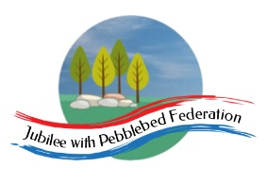

Class 2, Branscombe C of E Primary School

Dear Parents and Members of Class 2,

I hope you enjoyed last week’s safari to Africa. This week, in celebration of World Oceans day on Monday, we are going to be taking a break from visiting different countries and instead, visiting the two thirds of the Earth that is covered by its oceans. We will discover more about the different oceans of the world and the biodiversity contained within them.

We are making a special scrap book in school to record some of the things you have been getting up to at home for the school archives so we would love to receive any photos or pieces of work that you would like to send in.

Don’t forget the #DevonVirtualGames are continuing. You can still enter the previous two challenges (Walk, Jog, Run and Sportshall Pentathlon) and today a new dance challenge is launched. Do let us know if you are taking part in these as there are prizes for Devon schools with the highest proportion (yes, proportion, not numbers) of students taking part.

For more PE ideas, especially for a Monday afternoon when we would be working with Premier League, why not check out https://plprimarystars.com/home-learning

Also, don’t forget to use some of the resources on the website to continue to consider how you can take care of your own mental health and support those around you.

Happy learning! I’m looking forward to being with you again soon,

Miss Moss

The most important thing you can do to support your child’s learning whilst schools are closed is to ensure that they read every day and they continue to practise their number bonds and times tables.

Don’t forget to keep using the accounts you have through our school to practise basic skills, such as reading, reading comprehension (Bug Club), Times tables (Times Table Rock Stars) and Spelling (Spelling Shed). I have set work on TTRS each week and I shall be checking these sites regularly to keep an eye on what you’re doing. Feel free to challenge me (Dot McRock) to a Rockslam competition!

Week beginning Monday 8th June

Monday  8th June | Core activities |  |  | Suggestions for additional activities.
9.00 – 9.30 | Daily Dashboard:  Quelle est la date aujourd’hui?  C’est lundi huit juin 2020.  Can you write the number date in Roman numerals?  Today is World Oceans Day (worldoceansday.org) so this week we will be exploring the water on our planet.  A local event for World Occeans Day would have been the Downderry and Seaton Ocean Day 2020.  Instead, Mr B Productions have created 'The Ocean Show' featuring videos from the National Marine Aquarium, Cornish Seal Sanctuary, The Marine Biological Association, Cornwall Wildlife Trust, Ocean Infinity, Cornish Galleries Artists, UK Pro Surf Tour, Fins and Strings, Plymouth Coastal Observatory and more.  The show is now on You tube – why not watch snippets each day, especially if it’s wet outside! https://www.youtube.com/watch?v=RqHyllXJ1sc |  |  | You could ‘visit’ Royal Museums Greenwich (London) online today and attend a range of live events planned to celebrate World Oceans Day, from discussions to interviews to activities and crafts. Events kick off at 10am – I want to make an ocean in a bottle! https://www.rmg.co.uk/see-do/exhibitions-events/world-oceans-day-2020  “For 2020, World Oceans Day is growing the global movement to call on world leaders to protect 30% of the world's ocean by 2030 - a campaign called 30x30. By safeguarding a least 30% of our ocean through a network of highly protected areas we can help ensure a healthy home for both marine and human life.”  On 8th June 1786, the first commercial ice cream was sold in New York City.  Historical fact: In 1789, James Madison introduced a proposed Bill of Rights in the US House of Representatives. This was the term used for the first ten amendments to the Constitution, including the first amendment often invoked in debates about free speech. We’ll learn more about this on our visit to North America next week.
9.30-10.00 | Grammar – see Grammar and Spelling Resources |  |  | Use your spelling shed login to practise by playing spelling games.
10.00- 10.30 | A new challenge in the #DevonVirtualGames launches today. This week’s challenge is a dance challenge. Have a look and join in at https://www.activedevon.org/wp-content/uploads/2020/06/Dance.pdf  Or why not celebrate the release of two classic films today in 1984, Gremlins and Ghostbusters, by dancing around your front room to:  https://www.youtube.com/watch?v=m9We2XsVZfc
10.30-11.30 | Maths – follow the links to find online lessons for each year group:  Year 3: https://www.thenational.academy/year-3/maths/to-describe-2-d-shapes-based-on-their-properties-year-3-wk6-1  Year 4: https://www.thenational.academy/year-4/maths/measures-choosing-appropriate-measures-year-4-wk3-1  Year 5: https://www.thenational.academy/year-5/maths/to-convert-between-seconds-minutes-and-hours-year-5-wk3-1  Year 6: https://www.thenational.academy/year-6/maths/coordinates-and-shapes-to-recognise-3-d-shapes-year-6-wk5-1 |  |  |  | Alternatively, you could try out the new BBC Bitesize daily lessons. Remember to keep practising key facts such as times tables – a few minutes daily practice on Times Table Rock Stars can make a big difference to your confidence in Maths.
11.30-12.00 | Have a break and play a game or do another activity that you enjoy. | Care for Others: On this day in 1824, the washing machine was patented by Noah Cushing of Quebec, while in 1869, a gentleman named Ives W. McGaffey of Chicago, patented the 1st vacuum cleaner, calling it a “sweeping machine”. Who washes the clothes and sweeps the floor in your house? Although they’re probably grateful for the machines in 2020 that help us keep our surroundings clean, could you show your gratitude to them in some way? Perhaps with a card, a cup of tea or an offer of assistance?
12.00- 1.00pm | Lunch break. Eat a healthy lunch and, if you are able, try to get outside for some fresh air!
1.00pm – 1.30pm | Reading – Read a chapter or two more in your latest Bug Club book. Don’t forget to click on the bugs to answer the comprehension questions. |  | Today is Best Friends Day! Read more about this US celebration, recognised since 1935, here: https://www.daysoftheyear.com/days/best-friends-day/  Have you met a character in a book that you’d like to be friends with? Does any character remind you of a friend you have IRL (in real life)?
1.30pm – 3.00pm | Theme – Geography – Oceans of the world  Let’s start with a quiz…Go to https://online.seterra.com/en/vgp/3072 and see how many of the seas and oceans on the map you can name. Then, visit BBC Bitesize Geography. Watch the two videos and answer the questions in the quiz.  https://www.bbc.co.uk/bitesize/topics/z849q6f/articles/zmqwscw  Next explore this website for fabulous facts about our oceans –you could record the numerical ones. There are some astoundingly big numbers. Which would you include on a poster? How would you draw it? How else could you communicate your findings to other people?  https://www.natgeokids.com/uk/discover/geography/general-geography/ocean-facts/  If you prefer something printable, there is Powerpoint presentation with all the information necessary about the ocean in Additional Resources Ocean.  Can you fill out the map below, identifying oceans and continents? There are more amazing facts to be found on that sheet. Answers at the end of this document.  For me, an astounding fact is how deep our oceans can be. Find out more in the comic below. |  |  |  | Have a look at the Geography quiz on oceans https://world-geography-games.com/oceans/index.html to see if you remember from the BBC Bitesize video!  If you haven’t already, take a look at some of The Ocean Show at https://www.youtube.com/watch?v=RqHyllXJ1sc  What would you like to learn more about? Animals? Life at the bottom of the ocean? Pollution?

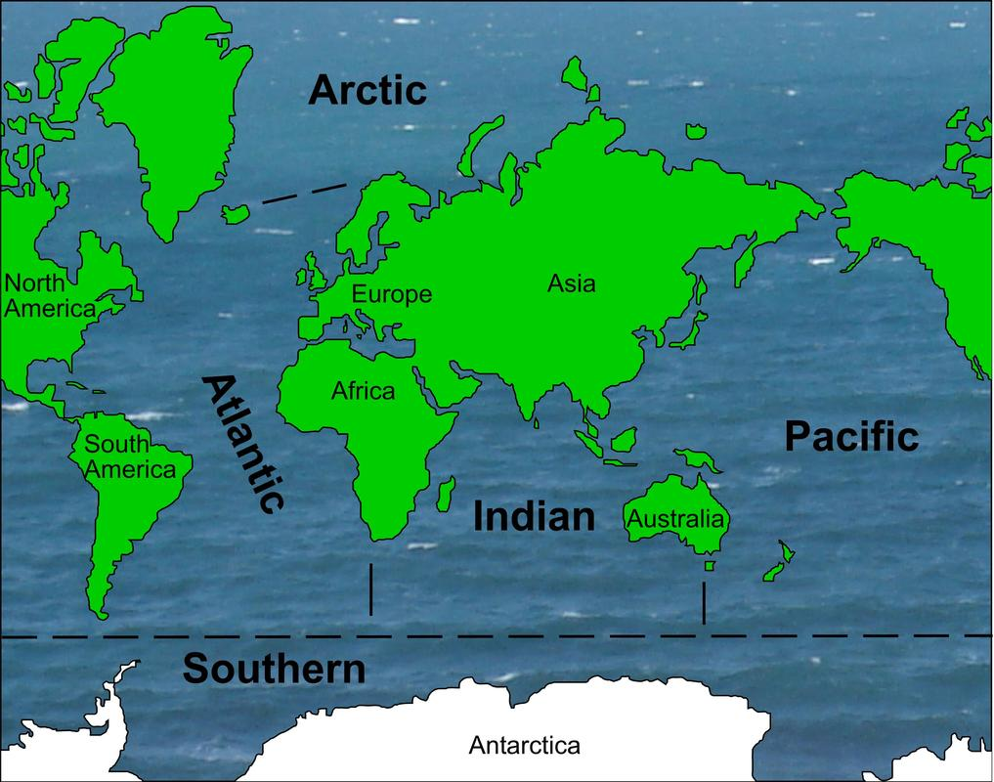

The ocean is a continuous body of salty water that covers two-thirds of the Earth’s surface. Humans have divided it into five main oceans and many smaller seas.

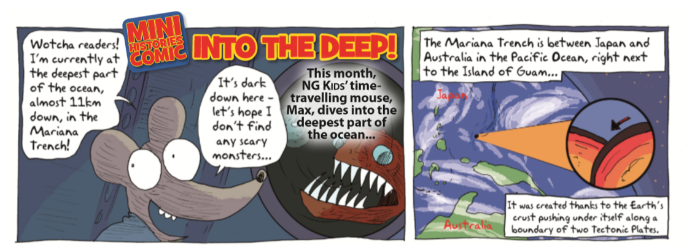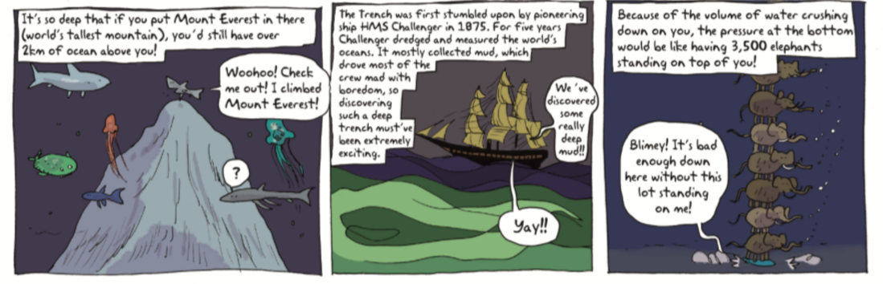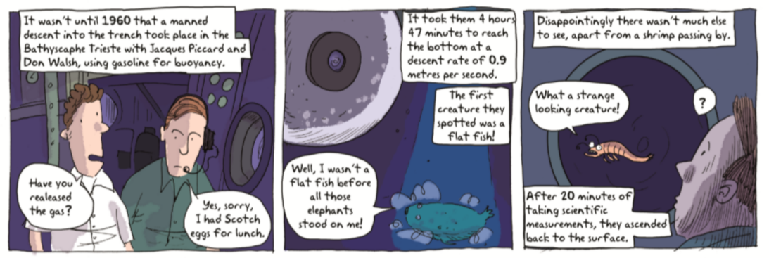
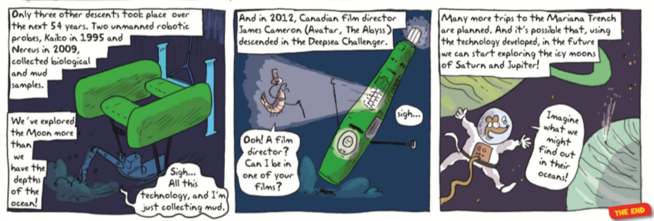

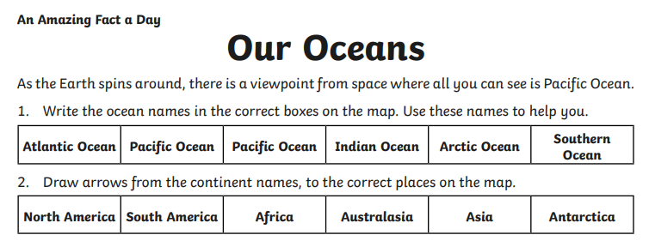
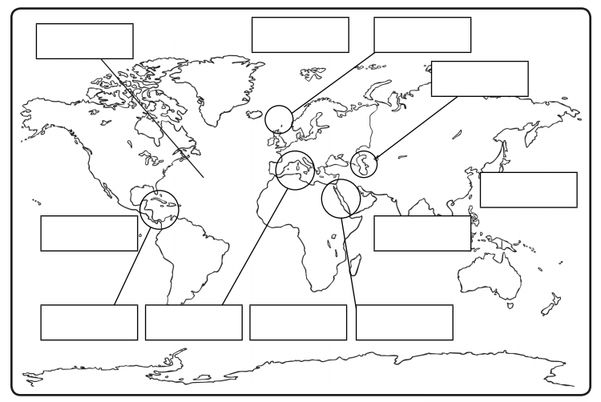
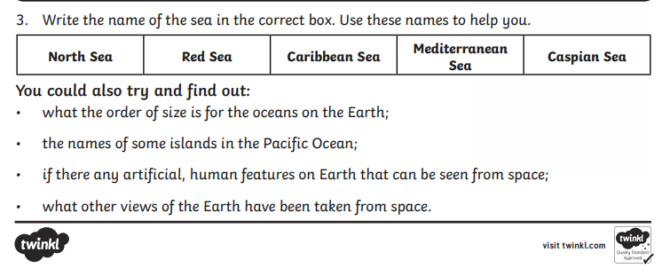
Simplified version
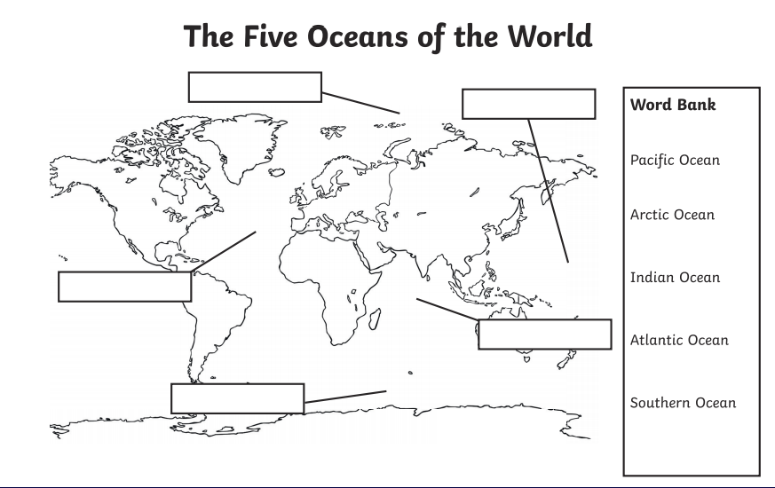

Tuesday 9th June | Core activities |  |  |  | Suggestions for additional activities.
9.00 – 9.30 | Daily Dashboard:  Quelle est la date aujourd’hui?  C'est le mardi neuf juin 2020  Can you write the number date in Roman numerals?  What is happening in the world? Have a look at https://www.bbc.co.uk/newsround or https://www.dogonews.com/ to see what is going on in the world. Choose a news article or two to read. |  |  |  | Today, 9th June, marks the birthday of Johnny Depp, 57, better known as Captain Jack Sparrow. Have you watched any of the Pirates of the Caribbean franchise? Which other pirates can you name from films or books?  It’s also Donald Duck Day! Donald made his first screen debut on June 9, 1934, in The Wise Little Hen. Watch some below: https://www.dailymotion.com/video/xt60fc
9.30-10.00 | Spelling – see Grammar and Spelling Resources |  |  |  | Use your spelling shed login to practise by playing spelling games.
10.00- 10.30 | Time for some physical activity. What about setting up a variety of circuit-training activities? You could include: star jumps, burpies, calf raises, skipping, bicep curls (use water bottles for weights), shuttle runs, bear crawls, high knee running… what other exercises can you think of? How many repetitions can you manage? Is that data better than when you first tried these exercises?  Alternatively, you could continue to train to improve your scores in the ‘Sportshall Pentathlon’ challenge or continue to develop your dance routine in the Dance challenge:  https://www.activedevon.org/find-the-devonvirtualgames-overview-and-terms-conditions-here/
10.30-11.30 | Maths – follow the links to find online lessons for each year group:  Year 3: https://www.thenational.academy/year-3/maths/to-draw-2-d-shapes-based-on-their-properties-year-3-wk6-2  Year 4: https://www.thenational.academy/year-4/maths/measures-converting-between-mm-and-cm-year-4-wk3-2  Year 5: https://www.thenational.academy/year-5/maths/to-solve-problems-involving-converting-between-hours-and-minutes-year-5-wk3-2  Year 6: https://www.thenational.academy/year-6/maths/coordinates-and-shapes-to-recognise-nets-of-3-d-shapes-year-6-wk5-2 |  |  |  |  | Alternatively, you could try out the new BBC Bitesize daily lessons.
11.30-12.00 | Have a break and play a game or do another activity that you enjoy. |  | Stay connected – who could you make a phone call or send an email to to to keep in touch?
12.00- 1.00pm | Lunch break. Eat a healthy lunch and, if you are able, try to get outside for some fresh air!
1.00pm – 2.00pm | Reading/ Literacy time  Read the Ocean text below then answer the questions. |  |  | On this day in 1958, London Gatwick Airport opened, 10 years after Heathrow, found south of London in West Sussex.  Read 13 facts in this article:  https://www.mylondon.news/news/south-london-news/13-astonishing-facts-gatwick-airport-17758584  Which is your favourite?  Find out more on kiddle:  https://kids.kiddle.co/Gatwick_Airport
2.00pm – 3.00pm | Theme – Art  Click on the following link to find a variety of ocean art and craft ideas, such as painting, printing and creating art from plastic bags:  https://www.rmg.co.uk/see-do/exhibitions-events/world-oceans-day-2020/antarctica-crafts  Do you remember when we were in Russia learning about biomes? I found this lovely Build-a-biome game: why not have a go?  https://switchzoo.com/games/buildabiome.htm | Royal Museum’s Greenwich have created a number of videos about science in your kitchen – this is an ocean science video that investigates how the currents in the world’s oceans are changed by salinity and temperature.  https://www.youtube.com/watch?v=oxAwn8nunGo&list=PLT6EQulbgyGdiQfwChdDCFKlijRbOEoK6&index=3  You’ve probably got a pretty good handle on naming and placing the five oceans since yesterday. Why not have a go at learning some of the seas around the planet? These are areas of ocean that are usually near land.  Start with the interactive map of seas around Europe – I’ve included a copy below to learn their names first.  https://www.toporopa.eu/en/seas_of_europe.html  For a world-wide version, go to:  https://world-geography-games.com/world_seas.html  Start with the map option, beginning to link seas to their nearby countries and islands.

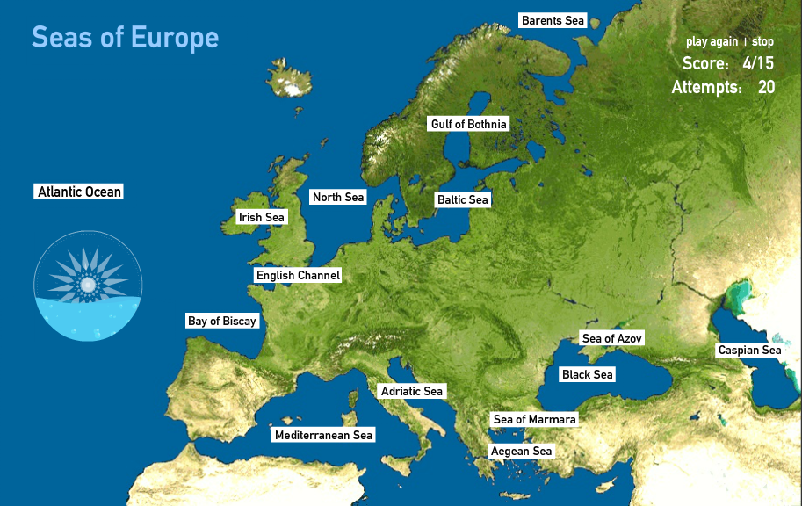

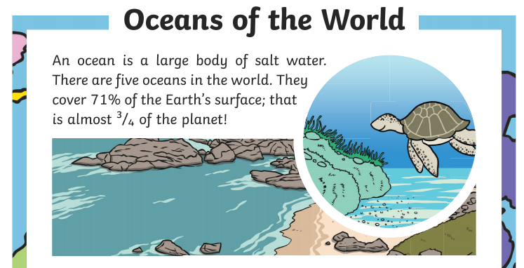
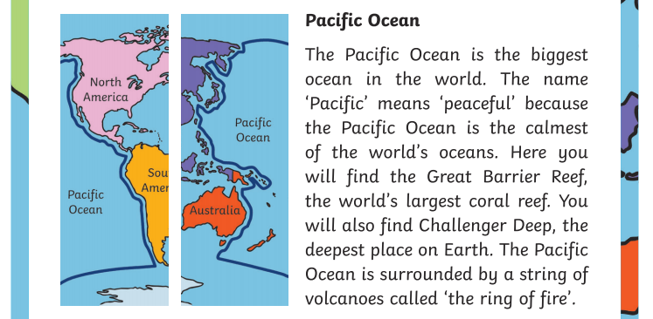
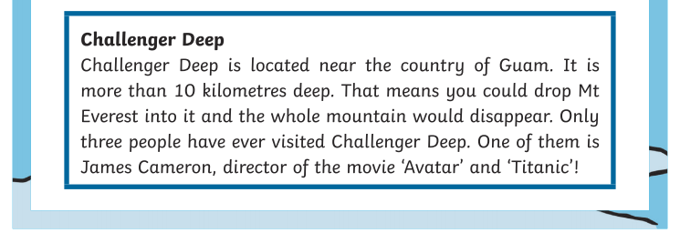
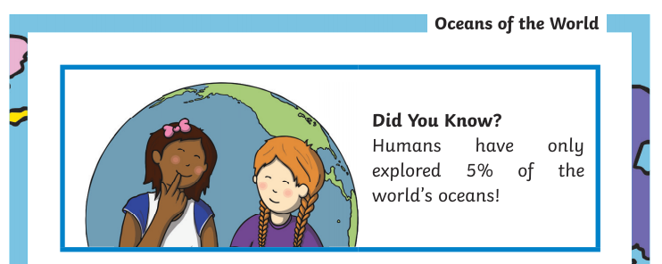
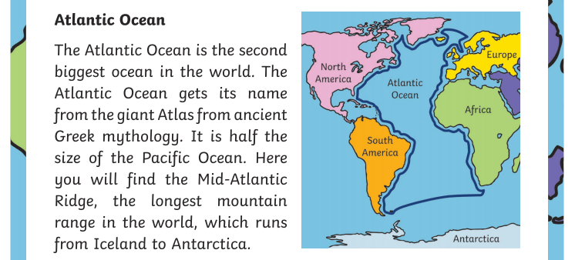
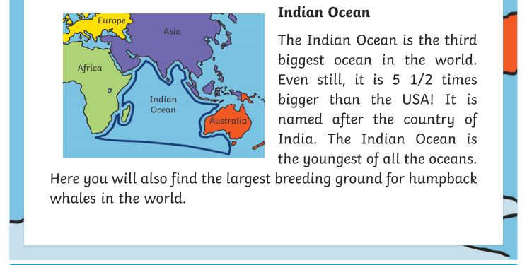
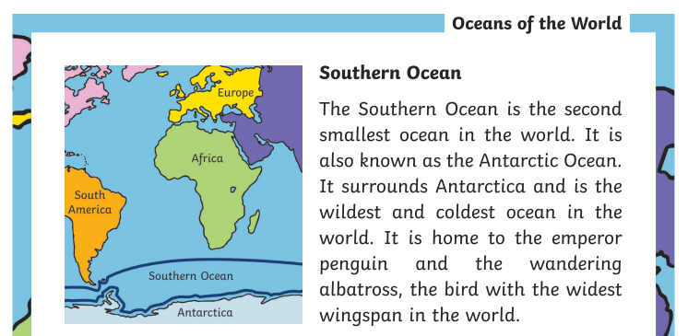
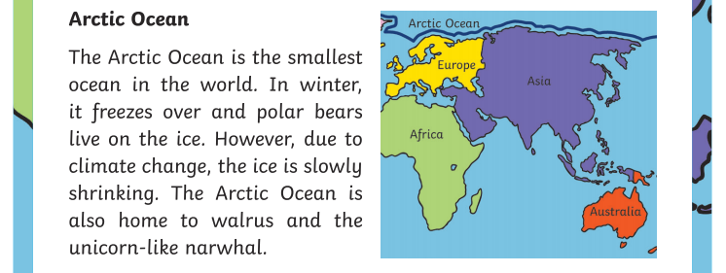
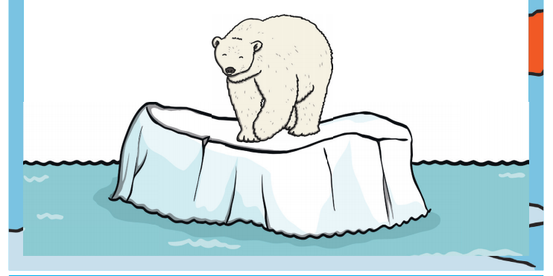
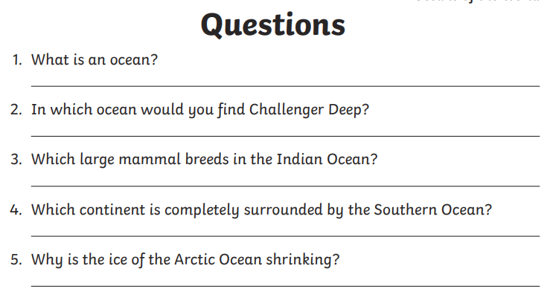

Wednesday 10th June | Core activities |  | Suggestions for additional activities.
9.00 – 9.30 | Daily Dashboard:  Quelle est la date aujourd’hui?  C’est mercredi dix juin, 2020.  Can you write the number date in Roman numerals?  What is happening in the world? Have a look at https://www.bbc.co.uk/newsround or https://www.dogonews.com/ to see what is going on in the world. Choose a news article or two to read.  On 10th June 1922, Judy Garland, an actress famous for her role in The Wizard of Oz in 1939, was born.  https://www.youtube.com/watch?v=oW2QZ7KuaxA  Find out more about her at http://www.judygarlandmuseum.com/judys-life |  | Find out about other geographical world data at: https://world-geography games.com/world.html  Click on rivers, lakes or straits for maps showing and naming them around the world.  On this day in 2000, The Millennium Bridge, spanning the river Thames in London, opened (and closed) for the first time. It was discovered that the vibration of visitors steps caused the bridge to wobble alarmingly! You can still visit it today.  The first zoo opened in Paris, in 1793. Zoos nowadays are geared around conservation of animals- why not take a virtual tour to find out more?  https://www.paigntonzoo.org.uk/conservation  Wild Planet Trust, based in Devon since 1957, owns 3 zoos, 2 local Nature Reserves and a National Nature Reserve. Find out about their conservation efforts here:  https://www.wildplanettrust.org.uk/
9.30-10.00 | Grammar – see Grammar and Spelling Resources |  |  | Use your spelling shed login to practise by playing spelling games.
10.00- 10.30 | Time for some physical exercise – continue to practise your dance or improve your scores in the Pentathlon events.
10.30-11.30 | Maths – follow the links to find online lessons for each year group:  Year 3: https://www.thenational.academy/year-3/maths/to-describe-the-properties-of-3d-shapes-year-3-wk6-3  Year 4: https://www.thenational.academy/year-4/maths/measures-converting-between-cm-and-m-year-4-wk3-3  Year 5: https://www.thenational.academy/year-5/maths/to-convert-between-units-of-length-year-5-wk3-3  Year 6: https://www.thenational.academy/year-6/maths/coordinates-and-shapes-to-solve-problems-involving-3-d-shapes-year-6-wk5-3 |  |  |  |  |  | Alternatively, you could try out the new BBC Bitesize daily lessons.
11.30-12.00 | Have a break and play a game or do another activity that you enjoy. | Eat well – how could you show your appreciation to the people who prepare your daily meals? Why not make a card to say thank you?
12.00- 1.00pm | Lunch break. Eat a healthy lunch and, if you are able, try to get outside for some fresh air!
1.00pm – 1.30pm | Reading time – Read the text below about the living creatures found in the different layers in the ocean then answer the comprehension questions.  A trickier version is found in Additional Resources. |  |  |  | Alternatively, read a news article or two about oceans from science news for students:  https://www.sciencenewsforstudents.org/topic/oceans
1.30pm – 3.00pm | Theme – Science/ STEM learning  Continuing our science learning about food chains and food webs, this afternoon we are going to look closer at what lives under the sea.  Why do oceans matter? Watch this video to find out why:  https://video.nationalgeographic.com/video/00000144-0a26-d3cb-a96c-7b2f454b0000  What could you do to make a difference? What have you learnt that you didn’t know before?  Look at the food chain below – it shows the creatures in layers. To remind you about food chains and food webs, read this page about marine producers and consumers.  https://study.com/academy/lesson/marine-food-chain-lesson-for-kids.html  Choose one of the creatures mentioned in the reading comprehension or revisit the second video from BBC Bitesize on Monday for inspiration on a sea creature. You could then research further and produce a fact-file. Is your chosen creature found in all oceans or just certain ones? Can you create a fact file for each of the creatures found in a marine food chain or web? |  |  |  |  | As always, BBC Bitesize has some relevant videos to prompt and inform you!  What do you find in a rockpool?  https://www.bbc.co.uk/bitesize/clips/zdys34j  What is a food chain? (includes an underwater one)  https://www.bbc.co.uk/bitesize/clips/zws87hv  And here is a video for upper KS2 that talks about food webs:  https://www.bbc.co.uk/teach/class-clips-video/science-ks2--ks3-food-chains-and-food-webs-in-animals/zn7g92p  Investigate the oceans role in the Carbon Cycle by exporing the web page here:  https://www.sciencelearn.org.nz/image_maps/3-carbon-cycle  Click on each part of the image for videos and information about each part. Where is carbon stored on our planet?  You could watch this clip from BBC Earth, showing the ocean food chain:  https://www.youtube.com/watch?v=-LQCqTVjQAU

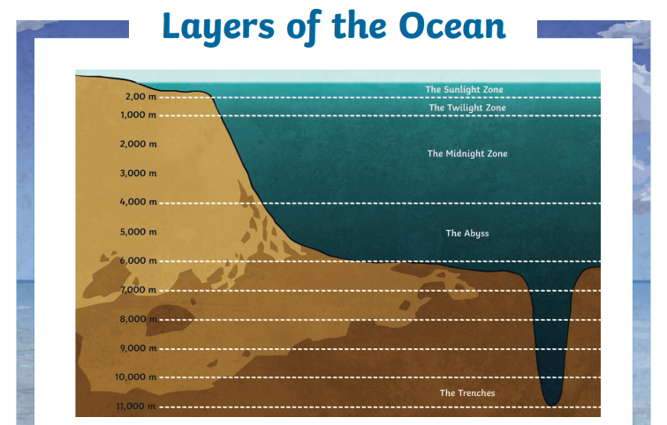
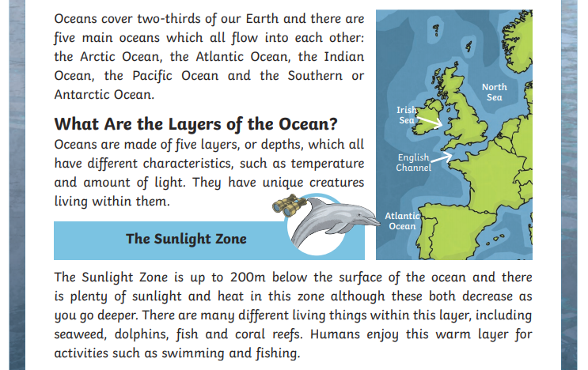
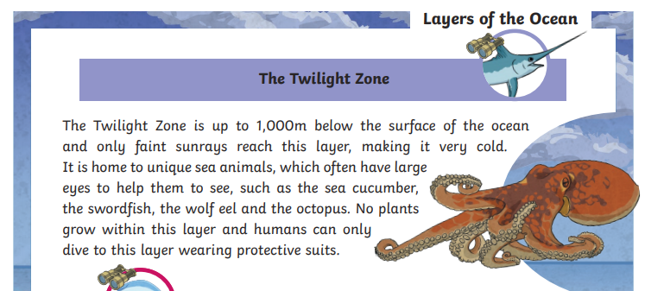
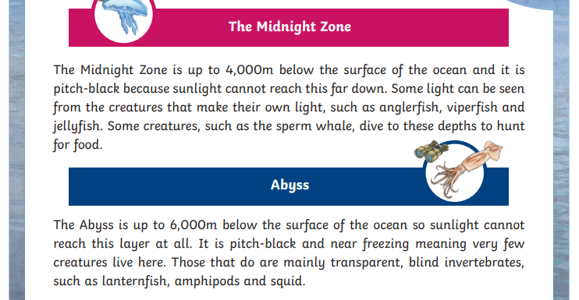
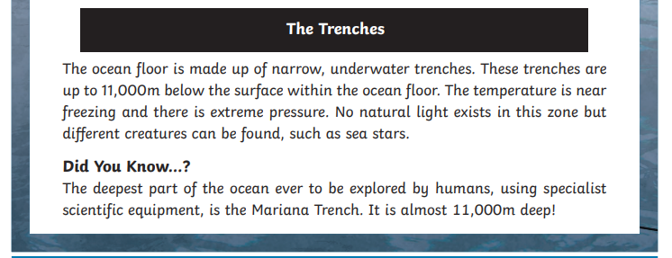
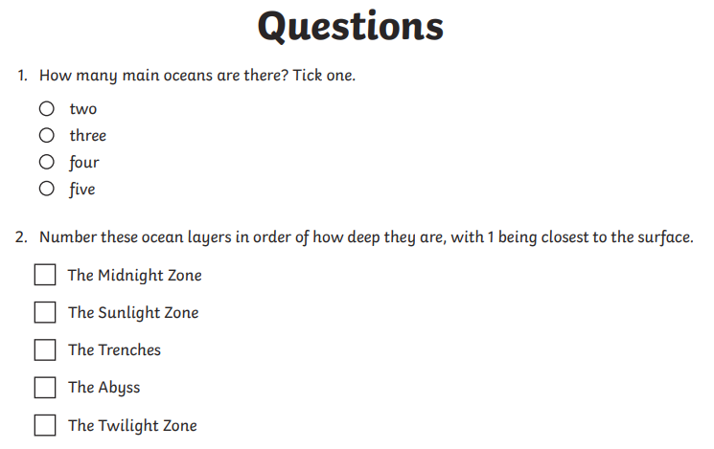
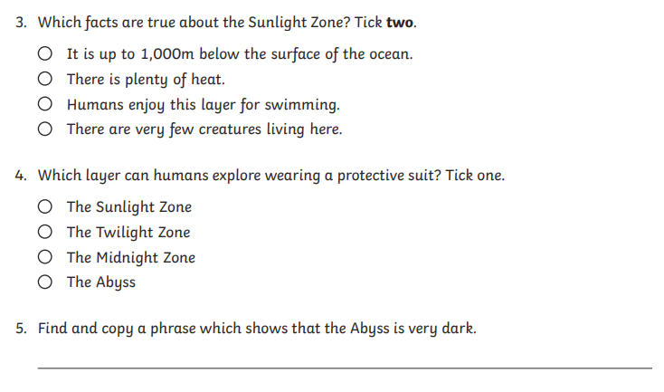
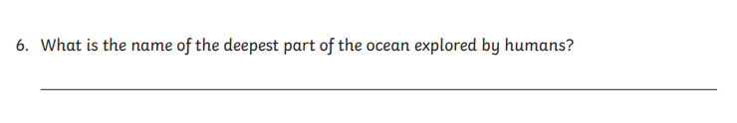
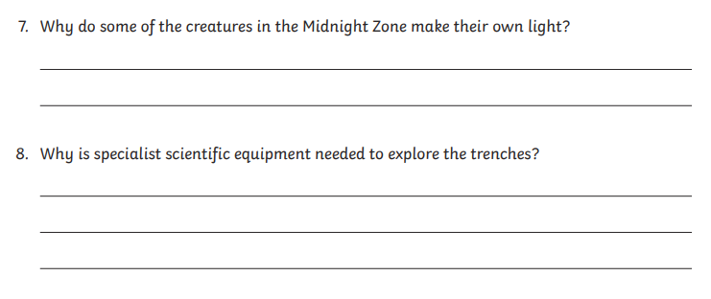

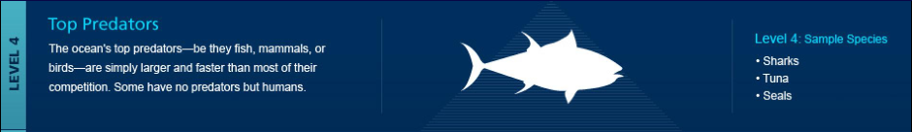
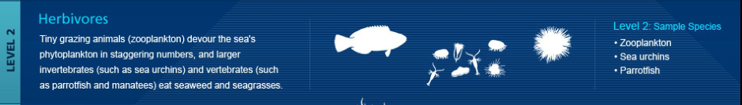
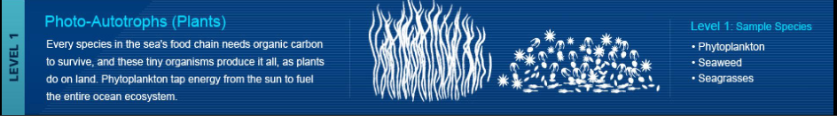

Thursday 11th June | Core activities |  |  |  | Suggestions for additional activities.
9.00 – 9.30 | Daily Dashboard:  Quelle est la date aujourd’hui?  C’est jeudi onze juin, 2020.  Can you write the number date in Roman numerals?  What is happening in the world? Have a look at https://www.bbc.co.uk/newsround or https://www.dogonews.com/ to see what is going on in the world. Choose a news article or two to read.  Why not research and write a short report about one or more of the oceans you’ve learnt about. |  |  | On this day in 1964, Queen Elizabeth ordered the Beatles to attend her birthday party- and they did! Who is your favourite musician/band? Which 3 would you recommend she invites to her next birthday party?  1770 - Captain James Cook discovered the Great Barrier Reef off of Australia when he ran aground.  In 1985, Russian space probe, Vega 1, landed on Venus today. Read more in this letter to the space probes, written last year.  https://www.nationalgeographic.com/science/2019/06/dear-vega-forgotten-soviet-mission-that-flew-around-venus/
9.30-10.00 | Grammar – see Grammar and Spelling Resources |  | Use your spelling shed login to practise by playing spelling games.
10.00- 10.30 | Time for some physical activity. Why not play a lively piece of music and make up a dance routine with your family? Ask an adult at home what songs they remember from their childhood and look them up – maybe they remember the routine that they did then and could teach you.
10.30-11.30 | Maths – follow the links to find online lessons for each year group:  Year 3: https://www.thenational.academy/year-3/maths/to-identify-and-describe-symmetry-in-2d-shapes-year-3-wk6-4  Year 4: https://www.thenational.academy/year-4/maths/measures-capacity-and-mass-year-4-wk3-4  Year 5: https://www.thenational.academy/year-5/maths/to-apply-length-conversions-to-problems-year-5-wk3-4  Year 6: https://www.thenational.academy/year-6/maths/coordinates-and-shapes-to-illustrate-and-name-parts-of-a-circle-year-6-wk5-4 |  |  |  |  |  | Alternatively, you could try out the new BBC Bitesize daily lessons.  Why not stretch your brain with one of these shape Maths investigations: https://nrich.maths.org/9021
11.30-12.00 | Have a break and play a game or do another activity that you enjoy. | Care for others – what little job around the house could you do today to show care for someone in your family?
12.00- 1.00pm | Lunch break. Eat a healthy lunch and, if you are able, try to get outside for some fresh air!
1.00pm – 1.30pm | Read about the water cycle at this link, including the role of the oceans. The interactive map is very detailed – can you simplify it by pulling out the key parts? Scroll down and watch the videos. Can you have a go at one of the simple challenges?  https://www.sciencelearn.org.nz/resources/713-h-o-on-the-go-the-water-cycle-introduction
1.30pm – 3.00pm | Theme – environment  This afternoon we are going to look at human effects on the oceans. Then you can choose which area you want to investigate further. Watch this live link lesson from BBC first.  https://www.bbc.co.uk/teach/live-lessons/blue-planet-live-lesson/zn7tkmn  For today’s task, could you write a letter to your MP, informing them of your concerns and requesting change the UK could make? Letters can change the world.  Or maybe you could write a persuasive article, explaining the problem and offering solutions your reader could do to help.  To find out more about plastic pollution – click on the link to find resources and activities about plastic pollution from Global Oceans: focus on children’s activity leaflet but everything is useful on this page. https://www.globalocean.org.uk/resources  Below are some statements about trash islands (formed by gyres/currents in the ocean) that are found across the world. (kidsagainstplastics). Check out this video from The Ocean Cleanup on how it happens:  https://www.youtube.com/watch?v=0EyaTqezSzs  To find out more about global-warming’s effect on the oceans – read the information, provided below the plan, on the effect of global warming on the oceans. Online it is from a website called a student’s guide to global climate change found at  https://archive.epa.gov/climatechange/kids/impacts/signs/oceans.html |  |  |  |  | Find out more: visit this blog and watch the video about marine reserves: a method of conserving declining fish stock.  https://blog.nationalgeographic.org/2012/09/25/you-can-have-your-fish-and-eat-them-too/  For a comprehensive look at what is happening in the ocean, read this:  https://climatekids.nasa.gov/ocean/  For creative ideas to reuse plastic bottle, check out the poster here:  https://www.teachwire.net/teaching-resources/10-creative-ways-to-reuse-plastic-bottles-global-ocean-activity-leaflet-for-ks1-2  Before you start today, parents might like to read these ideas for discussing big issues like pollution and climate change here:  https://www.bbc.co.uk/teach/live-lessons/climate-change-for-children/z77wvk7

Trash Islands
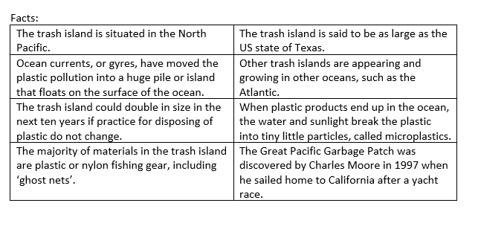

Copied from: https://archive.epa.gov/climatechange/kids/impacts/signs/oceans.html

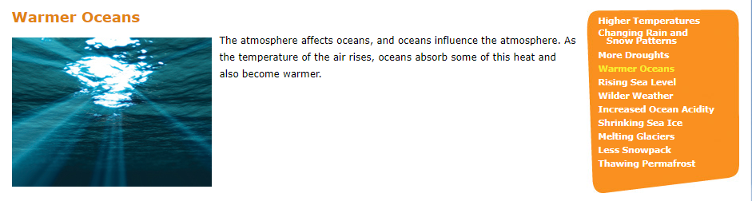
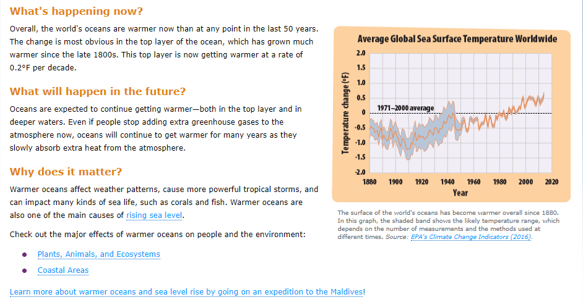

Friday 12th June | Core activities |  |  | Suggestions for additional activities.
9.00 – 9.30 | Daily Dashboard:  Quelle est la date aujourd’hui?  C’est vendredi douze juin, 2020.  Can you write the number date in Roman numerals?  What is happening in the world? Have a look at https://www.bbc.co.uk/newsround or https://www.dogonews.com/ to see what is going on in the world. Choose a news article or two to read.  Most countries honour the priest who married Roman soldiers to their sweetheart behind Emperor Claudius’ back (St. Valentine) on 14th February – the date of his death. However, in Brazil, Valentine’s Day (Dia dos Namorados) is celebrated today. Why not make a Brazilian-themed Valentine card for someone you are close to and surprise them with your global knowledge? |  |  | Today is Anne Frank’s birthday. To find out more about her story, click here:  https://www.natgeokids.com/uk/discover/history/general-history/anne-frank-facts/  Today, in 2013, the world’s oldest man in recorded history, Jiroemon Kimura, died at the age of one-hundred and sixteen years old. Kimura died of natural causes in Kyoto, Japan.  Can you find out who is the oldest man and oldest woman alive in 2020?
9.30-10.00 | Grammar – see Grammar and Spelling Resources | Use your spelling shed login to practise by playing spelling games.
10.00- 10.30 | Time for some physical activity. This week it is all about dance – here is a link to a routine to ‘Under the Sea’ from The Little Mermaid: https://www.youtube.com/watch?v=24JS0gjS5RM
10.30-11.30 | Maths – follow the links to find online lessons for each year group:  Year 3: https://www.thenational.academy/year-3/maths/to-revise-shapes-year-3-wk6-5  Year 4: https://www.thenational.academy/year-4/maths/measures-solving-measures-problems-year-4-wk3-5  Year 5: https://www.thenational.academy/year-5/maths/to-find-the-perimeter-and-convert-units-of-measurements-year-5-wk3-5  Year 6: https://www.thenational.academy/year-6/maths/coordinates-and-shapes-to-solve-practical-problems-involving-circles-year-6-wk5-5 |  |  |  | Alternatively, you could try out the new BBC Bitesize daily lessons.  Remember to keep practising key facts such as times tables – a few minutes daily practice on Times Table Rock Stars can make a big difference to your confidence in Maths.
11.30-11.45 | Have a break and play a game or do another activity that you enjoy. |  | Be proud of your very being! What have you done well this week? Why not award yourself a certificate!
11.45 – 12.00 | Why not join in with the act of Collective Worship that you will find on the school website.
12.00- 1.00pm | Lunch break. Eat a healthy lunch and, if you are able, try to get outside for some fresh air!
1.00pm – 1.30pm | Reading  How are you getting on with reading on Bug Club? Spend some time reading one of the books allocated to you and answer the comprehension questions by clicking on the bugs. |  |  | Alternatively, read a chapter or two of a novel. Pick out a few of your favourite sentences and consider what the author has done to make them have an impact on the reader. Share your thoughts with someone at home.
1.30pm – 3.00pm | Theme: STEM/Literacy  How could you present your learning from this week about oceans? Some ideas:  Diorama  Poster  Non-chronological report  You can decide which aspect to focus on and how you present your findings to a reader who is new to the subject. I look forward to seeing what you come up with – if you send it to admin via email, I can put it up on our home learning web page. |  |  | Alternatively, write a story that is based under the sea. Remember to be descriptive so you paint a picture with your words.  Remember the video we recommended at the beginning about Ocean Day 2020? Maybe you could present your knowledge as a news report and ask someone to video it for you. Don’t forget to rehearse with notes and think about whether a picture or diagram will help your audience understand your words.  Mr B Productions is found here:  https://www.youtube.com/watch?v=RqHyllXJ1sc
That’s all folks for our visit to the world’s oceans. Next week, the plan is to explore North America and learn about some of their history.

Hope you have had a great week and remember to stay safe!

