Spellings Year 2 weeks 1 + 2
Is it –le –el or –al ?
A helpful tip:
If the letter before the suffix is a tall or long letter (bdfghjklpty) then the ending is normally –le.
If it is a small letter (acemnorsuvwxz) then the ending is usually –el or –al
Circle the correct spelling of each word
tickal | tickle | tickel
nocturnal | nocturnle | nocturnel
hotal | hotle | hotel
barral | barrle | barrel
abal | able | abel
littal | little | littel
capital | capitle | capitel
channal | channle | channel
petal | petle | petel
squirral | squirrle | squirrel
bottal | bottle | bottel
tunnal | tunnle | tunnel
Can you think of 5 more words with each ending?

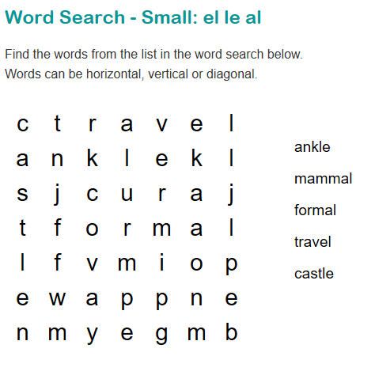

With your child, work through the words and discuss which ending is needed. If your child is unsure, this is a great time to practice dictionary skills. We would have been beginning to learn how to use dictionaries in school this term. Try to find the word in dictionary and find out what ending it needs.
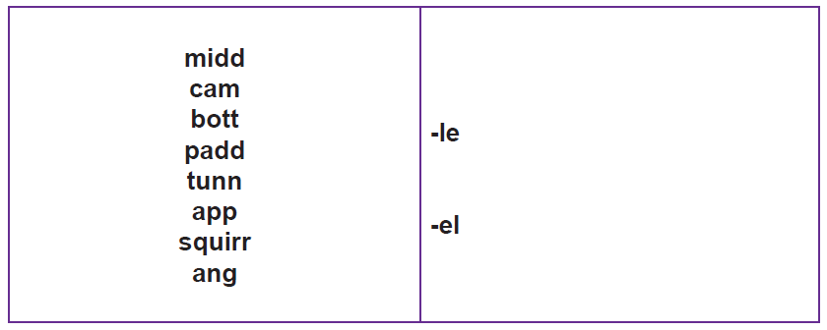

Week 2
The spelling rule about the sound spelt “or” after a “w” in words.
Look at these words:
word
work
worm
world
worth
worse
worst
Ask your child to sound them out. What do they notice?
Practise writing them together, and then explore some of these games to practise spelling.
https://spellingframe.co.uk/spelling-rule/98/21-The-sound-spelt-or-after-w

Challenge yourself to the test at the end

________________________

Remind your child of some of the words you learnt how to spell yesterday (word, work, worm, world, worth, worse, worst). Play some more of the games to help remind you if you need to
https://spellingframe.co.uk/spelling-rule/98/21-The-sound-spelt-or-after-w.
Dictate the following sentences (adult read, child writes from memory):
It will not be worth watching a worm as it works down into the soil. The world is full of worms that are on the path and grass.

____________________

Have a go at this quiz!
https://www.educationquizzes.com/ks1/english-spelling/year-2-the-sound-or-after-w/

