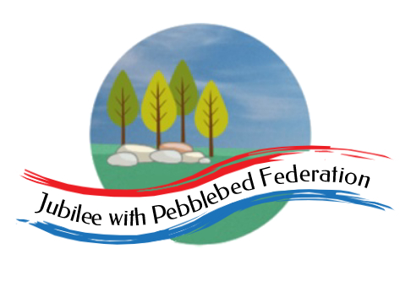
The Jubilee Hub of The Jubilee with Pebblebed Federation
Subject Intent Statement for History
Our Vision
‘Be who God meant you to be and you will set the world on fire.’
St Catherine of Siena
Intent
The teaching of history within the Jubilee Hub of the Jubilee with Pebblebed Federation aims to offer a high quality, immersive experience which helps pupils to gain an appreciation of the passage of time in relation to Britain’s past, and to that of the wider world. History is about real people who lived, and real events that have previously occurred. It is concerned with sequence, time and chronology and is the study of evidence from the past in order to give us a sense of identity.

Within the Jubilee Hub it is our intention to incorporate visits to key local historical sites, thereby offering children the opportunity to investigate the past first hand. They will consider historical events that happened locally related to events further afield. Investigations are supported by a variety of primary and secondary sources. The children will be encouraged to make links between different periods; teaching will equip children to ask questions, think critically, weigh evidence and develop perspective and judgement whilst exploring the diversity of human experience. History will allow children to gain a sense of their own identity by studying the lives of other people.
Implementation
History is taught through the Cornerstones’ Curriculum Maestro projects as this ensures the children cover all the objectives of the National Curriuclum. Projects include exciting, enquiry based learning which allow children to gain the skills necessary, whilst immersing themselves in the time period of study. This is demonstrated through vibrant displays and ‘DEN’ (Discuss, Explore, Negotiate) areas of the classroom. Children are also given the opportunity to go on trips to local areas and points of interest that relate to the area of history being studied. Each project begins with an exciting ‘hook’ activity which allows them to quickly engage with the topic.

In history lessons, the children are encouraged to think like a historian. Language plays a key role in the development of an understanding of chronology and begins in the early years where children are encouraged to discuss events that have happened in their lives. As children move through KS1 and into KS2, regular references are made to time lines and how topics fit together for children to develop a secure chronological understanding. Children will be taught skills that will enable them to interpret evidence from primary and secondary sources, whilst taking a hands on approach and exploring artefacts. The children are encouraged to reflect and compare their lives with those people of the time period studied and question how the events of the past impact their lives today. Projects end with an opportunity to showcase learning to parents and peers at the end of a topic through ‘real life’ situations. Children experience daily news immersion to enable them to understand historical moments happening now that will affect their lives.

Intended Impact
By the time children leave their school within the Jubilee Hub they will have:
- A secure knowledge and understanding of people, events and contexts from the historical areas which they have covered.
- The ability to think and explore history and communicate their findings to a range of audiences.
- The ability to think, reflect, debate and evaluate the past, forming and refining questions and lines of enquiry.
- A passion for history and an enthusiastic engagement in learning.
- A sense of curiosity about the past.
- A respect for historical evidence and the ability to make use of it to support their explanations and judgements.
- A desire to embrace activities, including opportunities to undertake high quality research across a range of history topics through investigating primary and secondary sources and encompassing visits within the local community.

