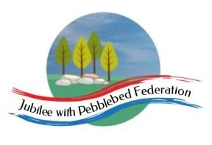

Class 1  Wk beg: 9th November 2020 | Lesson One | Lesson Two | Lesson Three | Lesson Four | Lesson Five
Monday | Phonics/  Spelling  https://www.activelearnprimary.co.uk/login?e=-610&c=0#bugclub_phonics  R: unit 5 session ‘s’ as ‘ss’  Y1: unit 20 ‘ur’ as ‘er’  Also play unit 19 assessment games.  Y2: as Y1, also play your set games on spelling shed:  https://www.edshed.com/en-gb/login | English  https://www.youtube.com/watch?v=3MTKWnxzqvM  Look at ‘Flotsam’ again together. Pause the video where the boy uses the microscope to look closely at the picture. There are photographs of the children who have found the camera in the past. What does this tell us? Look at the clothes the children are wearing. How long do they think the camera has been in the ocean? How can they tell it has been there a long time? What clues are there? Discuss what a microscope does. Then complete the reading comprehension sheets below. Your child can also highlight the answers in the text with a coloured pencil. | Maths  Reception  https://classroom.thenational.academy/lessons/count-four-objects-reliably-75jk4r  Year 1:  https://classroom.thenational.academy/lessons/combining-sets-count-all-cru68d  Year 2: https://classroom.thenational.academy/lessons/adding-two-2-digit-numbers-crvk6d | Computing  To work within the context of following picture instructions for building shapes.  To give instructions using pictures.  https://www.bbc.co.uk/bitesize/clips/z28qmp3  https://www.bbc.co.uk/bitesize/topics/z3tbwmn/articles/z3whpv4  Build a simple model using 5 blocks/lego pieces, taking a single photograph at each stage. Can you take a clear photograph for someone else to follow? Then pull apart all the bricks and give the tablet with the photos open, to someone in your family. Can they follow the pictorial instructions given to them to recreate the model? | PSHE/UW  https://classroom.thenational.academy/lessons/to-name-and-describe-different-feelings-6rt34d
Tuesday | Phonics/  Spelling  https://www.activelearnprimary.co.uk/login?e=-610&c=0#bugclub_phonics  R: unit 5 language session  Y1: unit 20 ‘ur’ as ‘ear’  Also play unit 19 assessment games.  Y2: as Y1, also spelling shed:  https://www.edshed.com/en-gb/login | English  R: Ask your child to draw a fish. Can they label it by writing initial sounds. E.g: F for fin, m for mouth, t for tail etc. If they want to have a go at writing the word too that would be great!  Y1/2:  https://www.bbc.co.uk/bitesize/topics/zrqqtfr/articles/zy2r6yc  Complete the adjective activities. | Maths  Reception:  https://classroom.thenational.academy/lessons/develop-an-understanding-about-the-number-four-cmu3cr  Year 1:  https://classroom.thenational.academy/lessons/combining-sets-count-on-74u32r  Year 2:  https://classroom.thenational.academy/lessons/subtracting-two-2-digit-numbers-6gup2t | Geography/UW  Reception:  https://classroom.thenational.academy/units/autumn-2278  Y1 and Y2 -  https://www.bbc.co.uk/bitesize/clips/z9xsb9q  Watch video clip on coastal erosion. Complete attached science experiment. | PSHE/UW  https://classroom.thenational.academy/lessons/to-act-out-different-feelings-c9gp4d
Wednesday | Phonics/  Spelling  https://www.activelearnprimary.co.uk/login?e=-610&c=0#bugclub_phonics  R: unit 1 assessment games  Y1: unit 20 language session  Also play unit 19 assessment games.  Y2: as Y1, also spelling shed:  https://www.edshed.com/en-gb/login | English  Recap what flotsam and jetsam mean.  R: Children to think of and find as many things around the house that start with each letter of ‘Flotsam’ Adult to scribe the words, can your child have a go at writing one or two words? Or making them with magnetic letters on the fridge?  Y1/2: Using the letters ‘FLOTSAM’ children to write a word bank with as many ocean linked words or phrases they can think of for each letter.  E,g: F: Fishy, flashing, floating for years, flapping fins. | Maths  Reception: https://www.topmarks.co.uk/learning-to-count/gingerbread-man-game  Year 1:  https://classroom.thenational.academy/lessons/linking-addition-equations-to-problem-solving-contexts-6rv66t  Year 2:  https://classroom.thenational.academy/lessons/adding-and-subtracting-two-2-digit-numbers-ctk3gr | ART  https://www.tate.org.uk/kids/make/paint-draw/make-wave-painting  https://www.tate.org.uk/kids/games-quizzes/tate-paint | PSHE/Remembrance Day  https://www.bbc.co.uk/newsround/15492752  Can you make or colour a poppy to wear or display in your window?
Thursday | Phonics/  Spelling  https://www.activelearnprimary.co.uk/login?e=-610&c=0#bugclub_phonics  R: unit 2 assessment games  Y1: unit 21 ‘ow’ as ‘ou’  Also play unit 20 assessment games.  Y2: as Y1, also spelling shed:  https://www.edshed.com/en-gb/login | English  R: Fine motor skills. Use scissors to cut out all the sea creatures below. Can your child name them all?  Y1/2: https://www.youtube.com/watch?v=3MTKWnxzqvM  Using your word bank you created yesterday, have a go at expanding these into phrases which help to describe the storyline in the text. Y1, E.g: Flapping fins, Lovely treasures... Y2, E.g: Floating in the ocean for decades.  Look closely at the photos to reveal their deep, dark secrets… | Maths  Reception  https://www.topmarks.co.uk/learning-to-count/teddy-numbers  Year 1:  https://classroom.thenational.academy/lessons/understanding-commutativity-c5gk8c  Year 2:  https://classroom.thenational.academy/lessons/exploring-strategies-to-add-three-1-digit-numbers-61j32c | PSHE  https://classroom.thenational.academy/lessons/we-are-all-responsible-64vk0r?step=1&activity=video | Art  Use the internet to research artists who have created wave themed paintings:  Artists that have painted sea themes include Abraham Willaerts (Stormy Sea, 1629), Hokusai (Great Wave of Kanagawa, 1829–32), William Turner (Snow Storm, 1842), Gustave Courbet (The Wave, 1869), Claude Monet (Stormy Sea in Étretat, 1883).  Compare these and discuss similarities, differences, common themes, colours and textures.
Friday | Phonics/Spelling  https://www.activelearnprimary.co.uk/login?e=-610&c=0#bugclub_phonics  R: unit 3 assessment games  Y1: unit 21 ‘oi’ as ‘oy’  Also play unit 20 assessment games.  Y2: as Y1, also spelling shed:  https://www.edshed.com/en-gb/login | English  R: https://www.activelearnprimary.co.uk/login?e=-610&c=0#bugclub_phonics  Login to bugclub and complete the phonics assessments set for you. Practise letter formation with different items in your house. Put some flour on a plate and trace letters on it. Or try shaving foam instead!  Y1/2: Write up your ‘Flotsam’ acrostic poem today. Write Flotsam down the left hand side of your page. Use your favourite phrases you generated yesterday to make a fantastic poem.  Y1: e.g: F is for flashing fish.  L is for lively hermit crabs…  Y2: Floating flotsam in the ocean for years and years… | Maths  Reception  https://www.topmarks.co.uk/learning-to-count/underwater-counting  Year 1  https://classroom.thenational.academy/lessons/subtracting-by-partitioning-crr3jr  Year 2  Addition problem solving task  https://nrich.maths.org/7819 | Science  http://devonbatproject.org/a-brilliant-bat-friendly-gardening-event/  Look at the ideas for how to make your garden more bat friendly.  Draw a plan of your garden and label where you could plant some bulbs for spring or plant seeds in spring. Research which flowers would be the best to attract the greater horseshoe bat’s favourite food – cockchafers. | PE  https://family.gonoodle.com/  Try some of these fun gonoodle activities.

Year 2
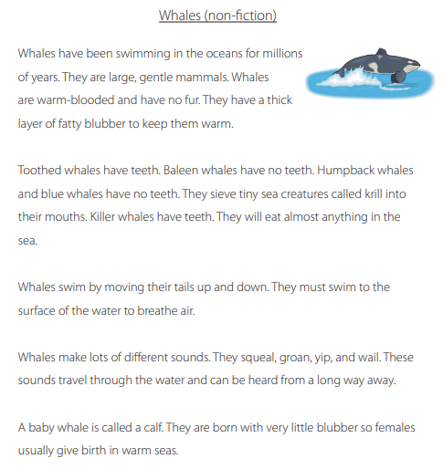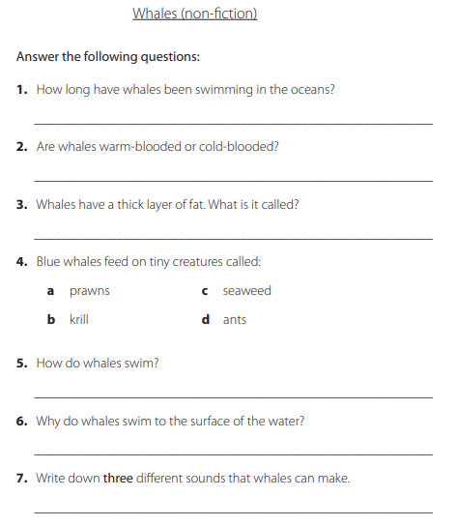

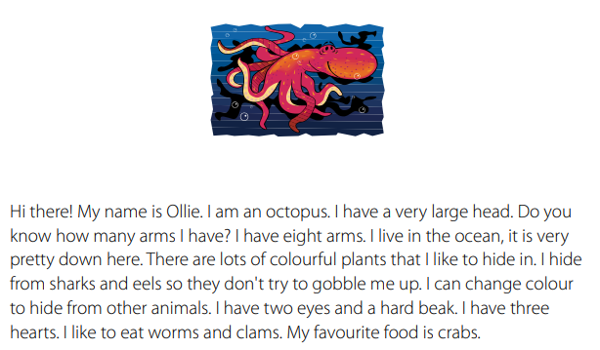
Year 1
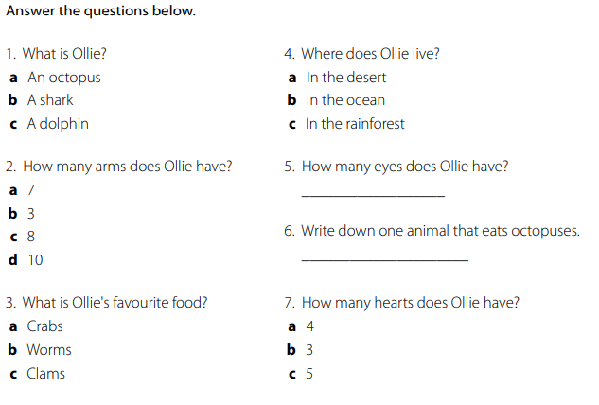

Reception cutting skills
