Class 2, Branscombe C of E Primary School

Dear Parents and Members of Class 2,
Welcome back to the start of the Summer Term! I hope you all had a refreshing and enjoyable Easter holidays. So far, your Easter presents are still sitting uneaten on my kitchen table – let’s hope they survive!
I wonder how you are getting on with your homeschooling? Have any of you been completing the Time capsule or Mental Health activities? Or have you found other ways to be creative in your learning? Don’t forget you can email via the school admin address if you would like to share what you have been up to or seek any help or advice. I would be happy to hear from you.

So, as we look towards the start of a very unusual term, I am preparing some more ideas of things that you can do as part of your homeschooling adventures. However, these are intended to be a resource for parents to draw upon, rather than a pressure for you to keep up. One of the main advantages of home-schooling is the freedom to learn at your own pace and explore the things that interest and excite you in more depth. I hope that all of you will enjoy the freedom to develop your own learning in new and exciting ways. Below are some ideas to help and support. I have included them in a suggested timetable structure for those who would find it helpful.

This is a very strange time in our world, when people are not easily able to travel around. However, with the benefit of the Internet, we can still investigate and find out about places around the world. Over the next few weeks, those of us still in school are going to be ‘travelling’ on a virtual tour around the world, visiting various countries where festivals would normally be happening at this time. We will be starting by traveling to Thailand for their New Year festival, Songkran. The activities below invite you to join us on our travels and find out more about different places and traditions.
Happy learning!
Miss Moss

The most important thing you can do to support your child’s learning whilst schools are closed is to ensure that they read every day and they continue to practise their number bonds and times tables.

Don’d forget to keep using the accounts you have through our school to practise basic skills, such as reading, reading comprehension (Bug Club), Times tables (Times Table Rock Stars) and Spelling (Spelling Shed). I have set work on TTRS each week and I shall be checking these sites regularly to keep an eye on what you’re doing. Feel free to challenge me (Dot McRock) to a Rockslam competition!

Week beginning Tuesday 14th April

Tuesday | Core activities | Suggestions for additional activities.
9.00 – 9.30 | Daily Dashboard:  Quel est la date aujourd’hui?  C’est mardi le quatorze avril, 2020.  Can you write the number date in Roman numerals?  What is happening in the world? Have a look at https://www.bbc.co.uk/newsround or https://www.dogonews.com/ to see what is going on in the world. Choose a news article or two to read.  April 13th-15th is the time of the Songkran Water Festival (Thai New Year) in Thailand. Can you find Thailand on a world map?  What can you find out about this festival? | In the USA, today is National Dolphin Day! See https://nationaldaycalendar.com/national-dolphin-day-april-14/  Can you find a tutorial to help you draw a dolphin? Find out a few facts about dolphins and make a poster to highlight different ways to help dolphins (see https://www.dolphinproject.com/blog/10-ways-to-help-protect-the-oceans/)
9.30-10.00 | Spelling - see Spelling Resources
10.00- 10.30 | Time for some physical activity. How about a workout with Joe Wicks, the Body Coach? Or, if you can, get out in the sunshine and make up your own workout!
10.30-11.30 | Maths – Use the following website to watch tutorial videos, print off activities and then use the marking guidance to see how you got on. https://whiterosemaths.com/homelearning/  Today, we are going to start our virtual round-the-world journey by heading to Thailand for the Songkran Water Festival.  If a single flight cost £429, how much would it cost for your whole family to travel to Thailand? You could research the cost of different options to fly to Thailand and the difference between these totals? Which is the cheapest option?  A flight to Thailand from London takes approximately 15 hours. Thailand is 6 hours ahead of the UK. If a flight leaves London at 11.00am on 14th April, when will it arrive in Thailand? (London time and local time?) | How about a warm-up using Times Table Rock Stars or else play a Maths game to help practise core number facts?
11.30-12.00 | Have a break and play a game or do another activity that you enjoy. | How are you taking care of your mental health? Have a go at one of the Mental Health activities suggested on the Branscombe C of E Primary School website – see the Coronavirus page in the Parent section.
12.00- 1.00pm | Lunch break. Eat a healthy lunch and try to get outside for some fresh air!
1.00pm – 1.30pm | Reading time – enjoy half an hour of reading your latest book on Bug Club. Don’t forget to click on the bugs and answer the comprehension questions! | Alternatively, read a chapter or two of a novel.
1.30pm – 3.00pm | Theme  Research the Thai festival of Songkran  https://rove.me/to/thailand/songkran  Write down some questions about Thailand – what else would you like to know?  Use the Thailand activity sheet below to find out more about the country of Thailand.  The Festival of Songkran consists of four days. The first day is called Wan Sungkharn Long. On this day, houses are cleaned and swept.  What could you clean in your home today? | If it is a sunny day, try one of these ideas…  If you have a garden, why not celebrate Songkran with a water fight? Or use water to clean something outside – like the car or some windows!  Or try painting some pictures on a pavement or outside wall in the sun using just a paintbrush and some water! You could paint a dolphin, since in the USA it is National Dolphin Day!  What about getting a tub of water and experimenting with various objects to see what floats and what sinks? Here is a link to a BBC Bitesize lesson about ‘Buoyancy’: https://www.bbc.co.uk/bitesize/topics/zc89k7h
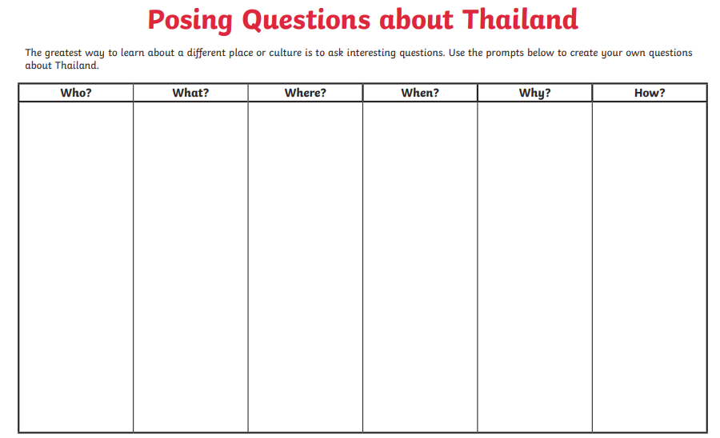
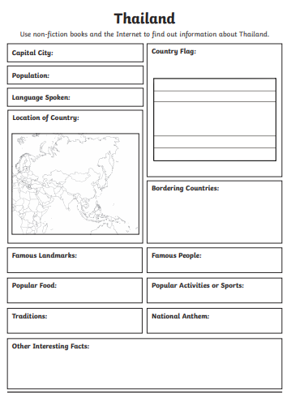

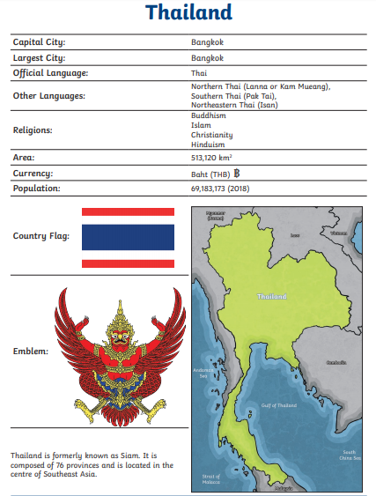

Wednesday | Core activities |  |  | Suggestions for additional activities.
9.00 – 9.30 | Daily Dashboard:  Quel est la date aujourd’hui?  C’est mercredi le quinze avril, 2020.  Can you write the number date in Roman numerals?  What is happening in the world? Have a look at https://www.bbc.co.uk/newsround or https://www.dogonews.com/ to see what is going on in the world. Choose a news article or two to read. |  |  | What time is it now? What time would it be in Thailand? Remember, their time is six hours ahead of UK time.
9.30-10.00 | Spelling – Have another look at the words you practised yesterday. Can you remember how to spell these words? Can you use the words in meaningful sentences? Can you find and spell other words with the same pattern?
10.00- 10.30 | Time for some physical activity. How about a workout with Joe Wicks, the Body Coach? Or, if you can, get out in the sunshine and make up your own workout!
10.30-11.30 | Maths – Use the following website to watch tutorial videos, print off activities and then use the marking guidance to see how you got on. https://whiterosemaths.com/homelearning/  Investigate capacity using different containers of water. Race around your house and find ten different things that could be used to hold water. Then use a measuring jug or other kitchen measures to investigate the capacity of each one. Order the containers according to how much water they will hold. What fraction of the capacity of the largest container is the capacity of the smallest one? Can you invent some Maths problems of your own using the different containers? |  |  | How about a warm-up using Times Table Rock Stars or else play a Maths game to help practise core number facts?  Elephants are the national animal of Thailand- they represent strength, loyalty and longevity. Many Thais believe, for example, that walking under one will bring luck. See https://www.chesterzoo.org/app/uploads/sites/5/2016/06/Elephant-Maths-KS2-Learning-resource.pdf for some Elephant Maths problems! Can you invent some of your own?
11.30-12.00 | Have a break and play a game or do another activity that you enjoy. | Stay connected – how about making a phone/Zoom/Skype call to one of your classmates and see how they are getting on with their homeschooling? You could talk to them about any difficulties you have encountered in your work or share what you have most enjoyed or had success with.
12.00- 1.00pm | Lunch break. Eat a healthy lunch and try to get outside for some fresh air!
1.00pm – 1.30pm | Reading time – Read the Indian story of the Blind Men and the Elephant (see below) and have a go at the activity. Can you write some comprehension questions of your own about this story, that will involve using your skills of clarifying, retrieval or inference? |  |  |  | Alternatively, read a chapter or two of a novel.
1.30pm – 3.00pm | Theme  The second day of the Songkran festival is called Wan Nao. On this day, food is prepared to be offered to monks the next day. Have a look online for some pictures of Buddhist monasteries. What do you notice about their design?  You could have a go at building a model of a Buddhist monastery in sand, Lego or out of junk. You could draw/ paint a picture of your favourite monastery – or even design your own! Don’t forget to send me a picture! |  | You could research Thai food and find out about how it is made. Fruit skewers are sometimes sold at street markets (see https://www.youtube.com/watch?v=TaRD-fi7o1Y for a video that shows fruit being prepared at a Thai street market). Why not prepare some delicious fruity snacks for your family? What fruits might be found in Thailand that are not commonly seen in British supermarkets?

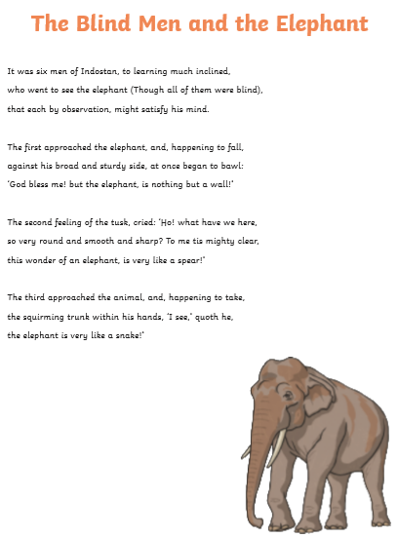

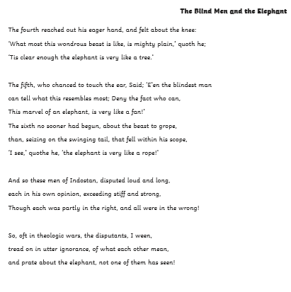
Comprehension Questions:

- Clarifying
Can you find an alternative word or phrase with similar meaning that might be used in place of each of the following words or phrases from the text…?
‘bawl’ ‘quoth he’ ‘disputants’

‘prate about’

- Retrieval
What were the six objects or items to which the different men compared the parts of the elephant?

- Inference
What made the fourth man think, when he felt the elephant’s knee, that he was feeling a tree?

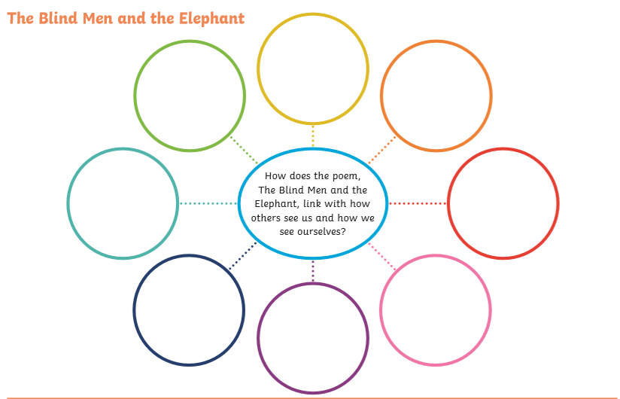

Thursday | Core activities | Suggestions for additional activities.
9.00 – 9.30 | Daily Dashboard:  Quel est la date aujourd’hui?  C’est jeudi le seize avril, 2020.  Can you write the number date in Roman numerals?  What is happening in the world? Have a look at https://www.bbc.co.uk/newsround or https://www.dogonews.com/ to see what is going on in the world. Choose a news article or two to read. | The British Voice Association has declared 16th April to be World Voice Day - see https://www.britishvoiceassociation.org.uk/world-voice-day.htm  We all have a voice and a right to speak. What message would you most want people to hear at the current time? You could take up the British Voice Association’s challenge to write a short narrative to inspire others. Or you could make a poster to share a message that is important to you.
9.30-10.00 | Spelling – Practise spelling the following words from the statutory lists:  Y3/4 – notice, mention, suppose, learn, believe  Y5/6 – accommodate, exaggerate, recognise, harass, interfere  What sort of words are these? Can you add suffixes or prefixes to alter the meanings of these words? Can you use them in sentences appropriately?
10.00- 10.30 | Time for some physical activity. How about a workout with Joe Wicks, the Body Coach? Or, if you can, get out in the sunshine and make up your own workout!
10.30-11.30 | Maths – Use the following website to watch tutorial videos, print off activities and then use the marking guidance to see how you got on. https://whiterosemaths.com/homelearning/  If you had a friend in Thailand, what would be a good time to plan a Skype or Zoom call to chat to them (remember that they are 6 hours ahead). What about if you wanted to include another friend who lives in Toronto, Canada? What time would you plan the call? (British time, Thai time and Canadian time). | How about a warm-up using Times Table Rock Stars or else play a Maths game to help practise core number facts?  Investigate Thai currency (money). At the time of writing this, one British pound is worth 40.75 Thai baht.  How much money in Thai baht would you get if you exchanged £10, £20, £100, £50?
11.30-12.00 | Have a break and play a game or do another activity that you enjoy. | Drink lots – when did you last have a glass of water? Go and get one now.  Help others – For £60, you can twin your tap, providing hygiene promotion and support in vulnerable countries. (https://www.toilettwinning.org/tap-twinning/)  Can you think of a way that you might help to raise money for a cause like this?
12.00- 1.00pm | Lunch break. Eat a healthy lunch and try to get outside for some fresh air!
1.00pm – 1.30pm | Reading time – Read a chapter or two of your latest book on Bug Club. Don’t forget to click on the bugs and answer the comprehension questions! | Alternatively, read a chapter or two of a novel. Can you summarise a chapter in less than 20 words?
1.30pm – 3.00pm | Theme  The third day of the Songkran festival is New Year's Day, or Wan Payawan. This day is celebrated by visiting the temple, presenting food and clothing to the monks, bathing the Buddha image with jasmine-scented water, and taking part in one of the many rituals believed to bring good luck.  Watch https://www.bbc.co.uk/bitesize/topics/zh4mrj6/articles/zdbvjhv to find out a little more about Buddhism. Read the information and complete the quiz.  Complete the reading comprehension about Buddhism – see below. |  | Research traditional Thai clothing. Draw a picture of some Thai people visiting a temple.  Make a beautiful piece of jewellery – why not send it to a friend you are missing?  Watch a video of Thai traitional musci https://www.youtube.com/watch?v=SXXK4P2Ogs0 and investigate traditional Thai instruments: https://www.soas.ac.uk/music/schools/lessons-for-schools-5-thailand.html

Years 3 and 4
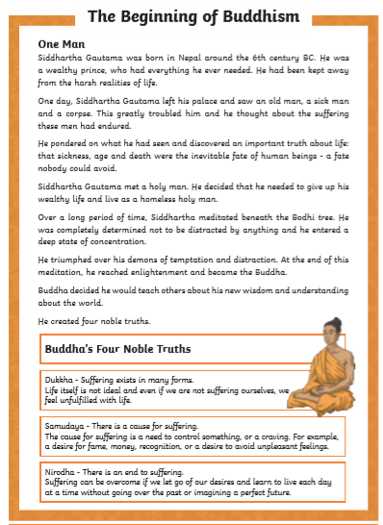

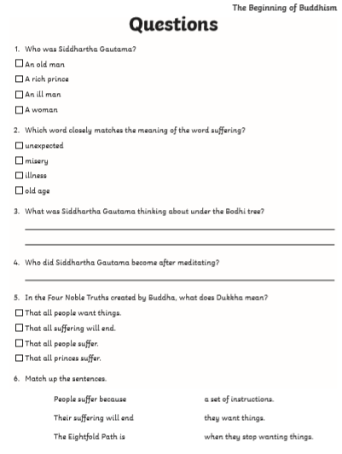

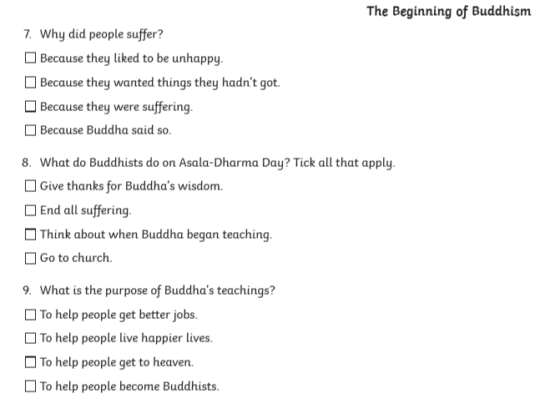

Year 5 and 6
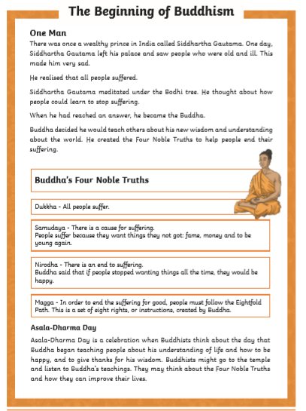
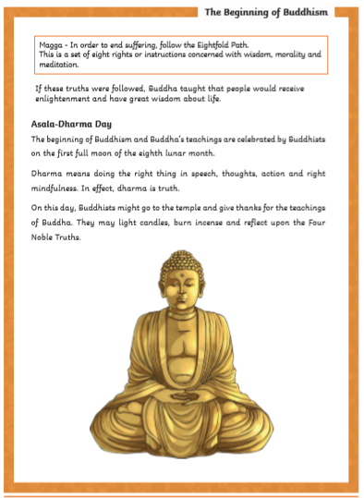

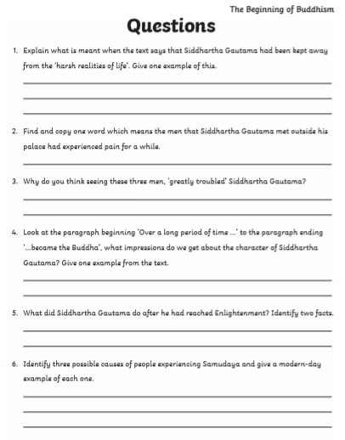

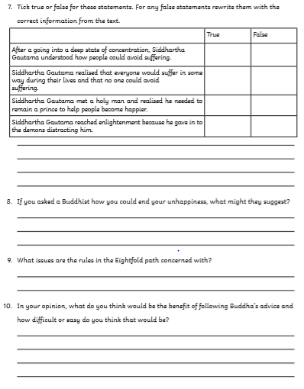

Friday | Core activities |  | Suggestions for additional activities.
9.00 – 9.30 | Daily Dashboard:  Quel est la date aujourd’hui?  C’est vendredi le dix-sept avril, 2020.  Can you write the number date in Roman numerals?  What is happening in the world? Have a look at https://www.bbc.co.uk/newsround or https://www.dogonews.com/ to see what is going on in the world. Choose a news article or two to read. |  | Today is Syria’s national day – Evacuation Day, which commemorates the day the last French soldier left Syria in 1946 and Syria declared its independence. Of course, Syria has had lots of trouble in recent times. Why not take time today to say a prayer for all those in Syria who have been affected by war and ask God to protect them from further difficulties from the spread of Coronavirus.
9.30-10.00 | Spelling – see Spelling Resources
10.00- 10.30 | Time for some physical activity. How about a workout with Joe Wicks, the Body Coach? Or, if you can, get out in the sunshine and make up your own workout!
10.30-11.30 | Maths – Use the following website to watch tutorial videos, print off activities and then use the marking guidance to see how you got on. https://whiterosemaths.com/homelearning/  Why not visit https://nrich.maths.org/9803 and have a go at one of the Maths investigations there. Be warned – these will really make you think! |  | How about a warm-up using Times Table Rock Stars or else play a Maths game to help practise core number facts?
11.30- 11.45 | Have a break and play a game or do another activity that you enjoy. | Eat well – why not prepare a healthy snack for your family? You could have a go at making your own muesli bars or make some fruit skewers.
11.45 – 12.00 | Devotions – why not join in the Federation prayer time and say some prayers for people around the world suffering from Coronavirus? You can download a script for this from the school website.
12.00- 1.00pm | Lunch break. Eat a healthy lunch and try to get outside for some fresh air!
1.00pm – 1.30pm | Reading time – Read a chapter or two of your latest book on Bug Club. Don’t forget to click on the bugs and answer the comprehension questions! |  | Alternatively, read a chapter or two of a novel. Pick out a few of your favourite sentences and consider what the author has done to make them have an impact on the reader.
1.30pm – 3.00pm | Theme  The fourth and final day of the Songkran festival is called Wan Parg-bpee. On this day, respect is paid to ancestors and elders. Water is gently poured over the hands or shoulders of an elder while they recite blessings and good wishes for the new year.  Consider how you might encourage or show care and respect for an elderly person in your family or community. Could you write a letter, put together a care package or draw a picture? |  | Have you found answers to all the questions you wrote on Tuesday?  Make a leaflet or Powerpoint presentation to explain what you have learned about Thailand and the Songkran Festival.  Imagine you are a visitor to Thailand during the Songkran Festival, Write a diary account, describing what you see, hear, smell, taste and feel.

That’s it for our visit to Thailand – next week we are off to Japan for a cherry blossom festival!
However, in ‘Additional learning about Thailand’, you will find a few more pages of activities linked to Thailand. Happy Learning!

