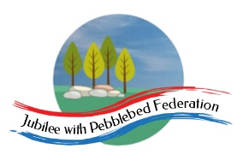

Class 2, Branscombe C of E Primary School

Dear Parents and Members of Class 2,

This week in our virtual travels around the world, we are heading to Mexico, home of festivals, music and colour. Known as Cinco de Mayo in Spanish, we will be investigating this celebration and the music and art of Mexico. I hope you will enjoy learning a little about Mexican culture and life, while also comparing their celebrations to our own May day celebrations.

I just wanted to remind all of you that the activities I have suggested are intended to be a bank of resources for you to select the most appropriate ones for your context. You may have other suggestions also. There is no way I would expect anyone to complete all the activities. I hope to provide a reasonable mixture of activities that can be accessed online and those that involve more traditional or practical learning media. All of you will have different access to computers, tablets, printers and other resources. Do get in touch with me via the school admin email address if you need further support to access the activities and resources suggested.

Happy learning!

Miss Moss

The most important thing you can do to support your child’s learning whilst schools are closed is to ensure that they read every day and they continue to practise their number bonds and times tables.

Don’t forget to keep using the accounts you have through our school to practise basic skills, such as reading, reading comprehension (Bug Club), Times tables (Times Table Rock Stars) and Spelling (Spelling Shed).

I have set work on TTRS each week and I shall be checking these sites regularly to keep an eye on what you’re doing. Please visit studio and soundcheck to update me on your tables speed and accuracy. Feel free to challenge me (Dot McRock) or Mrs Marsh (Irox Peel) to a Rockslam competition!

Week beginning Monday 4th April

Monday | Core activities |  | Suggestions for additional activities.
9.00 – 9.30 | Happy Star Wars Day -May the fourth be with you!  Daily Dashboard:  Quelle est la date aujourd’hui?  C’est lundi le quatre mai 2020.  Can you write the number date in Roman numerals?  The main language spoken in Mexico is Spanish. Here is a video created by Mexican children, speaking spanish, presenting and explaining activities in and out of school. Are there any words you recognise from English or other languages you know? These words are called cognates.  https://vimeo.com/274649569  Today is Greenery Day in Japan, which celebrates nature, including planting of a tree and seeds by the Emperor and Empress. Look out for changes in your environment while in your garden or out for a walk today. |  | Why has the May Day Bank Holiday been moved to Friday this year? Find out more at https://www.goodtoknow.co.uk/family/when-is-may-day-bank-holiday-539687  Learn more about Mayday celebrations, traditional events and its history. I’m sad we didn’t get to dance around the maypole this year…  https://www.countryfile.com/go-outdoors/days-out/when-is-may-day-whats-the-history-and-traditional-events-to-celebrate/  What is happening in the world? Have a look at https://www.bbc.co.uk/newsround or https://www.dogonews.com/ to see what is going on in the world. Choose a news article or two to read.
9.30-10.00 | Spelling - see Spelling Resources (Week 4) |  | Have you been using Spelling Shed? How about revising some of the spelling patterns you practised earlier in the year?
10.00-10.10 | Last Thursday, the Archbishop of Canterbury, Justin Welby, led a school assembly online. If, like those of us at school, you missed this on Friday, you can catch up with it here: https://www.youtube.com/watch?v=HkBOjxPCgOY Join us in watching it today!
10.10- 10.30 | Time for some physical activity. What about trying one or two of the short workout videos on https://imoves.com/the-imovement which explain the benefits of different movements for your health. While on the site, you might want to check out some of the ideas for taking care of your mental health, as well as your physical health.
10.30-11.30 | Maths – Use the following website to watch tutorial videos, print off activities and then use the marking guidance to see how you got on. https://whiterosemaths.com/homelearning/  Today, we are flying from Amsterdam in the Netherlands to Mexico City, a flight that takes 11 hours and 40 minutes. How many minutes is that in total? If episodes of my favourite comedy show are 25 minutes long, how many episodes would it be possible to watch during the flight?  Mexico’s time is 7 hours behind the Netherlands’ time, which, as we saw last week, is 1 hour ahead of the UK. What is the current time in the Netherlands and Mexico? If you catch a flight from Amsterdam that leaves when it is 11.00 am in the UK, what will the local time be when you leave Amsterdam and what will be the time in the country of origin (where you left from ) and at the destination, when you arrive in Mexico City? |  |  | This site is a teacher’s favourite: explore the world clock, time zones or sun and moon for hours of fun!  https://www.timeanddate.com/holidays/uk/early-may-bank-holiday  Why not try a BBC Supermovers Maths video to help warm up your Maths brain while getting in a bit of movement?  https://www.bbc.co.uk/teach/supermovers/ks2-maths-collection/z7frpg8
11.30-12.00 | Have a break and play a game or do another activity that you enjoy. | It’s also National Rememberance Day in the Netherlands today, when they remember and commemorate the soldiers and civilians who died in WW2 and other conflicts. They will hold a 2-minute silence at 8pm tonight. Does this remind you of anything from our country?  Where is your favourite spot at home to be quiet and think?
12.00- 1.00pm | Lunch break. Eat a healthy lunch and try to get outside for some fresh air!
1.00pm – 1.30pm | Embark on a Mexican adventure by heading to https://www.natgeokids.com/uk/discover/geography/countries/country-fact-file-mexico/ to read about Mexico. Can you summarise this by writing down 5 key facts you find out? Don’t forget to pick out key vocabulary you do not know and look up any unfamiliar words. |  | You can use this website to find out more about any country around the world you are interested in.
1.30pm – 3.00pm | Theme  Check out the introduction to Mexico slides in additional information week 4. This will give you a starting point in your research.  You could record the things you find on this fact sheet about Mexico below.  Watch this 3 minute clip from Welcome to Mexico at  https://www.bbc.co.uk/programmes/p0114db0  This page links you to 3 other clips from the episode – explore what catches your eye.  Will you focus more on the physical geography of Mexico? It is 8 times the size of the UK and includes 4 time zones, meaning there is quite a range to choose from!  See these clips from Mexico – Changing Environments for more information. https://www.bbc.co.uk/programmes/p01157t2  Or perhaps you are more interested in the human geography of lifestyle, settlements, tourism and industry, leading you to the History and customs of these people.  Find out more through these clips from Changing Settlements - https://www.bbc.co.uk/programmes/p0113tw4  You could present your learning as a poster or an information text, online or on paper-it’s up to you. |  | If you are researching online, start with https://www.oddizzi.com/teachers/explore-the-world/country-close-up/case-study-mexico/  The first page shows key facts, then you can navigate to other pages such as Landscape, Climate or Living in Mexico. After your first visit, you’ll be prompted to sign up, so move on.  Another simple, well-laid-out website is https://www.kids-world-travel-guide.com/mexico-facts.html  If you prefer your research in lists of facts, try out https://www.ducksters.com/geography/country/mexico.php  Watch this Youtube video to hear a song about the states found in Mexico and their capital cities. After many times reading Puebla and Guanajuato in novels, I now know how to pronounce them! Think about Spanish phonemes - such as, /ju/ makes a /q/ sound  https://www.youtube.com/watch?v=bTD-_JgvTNQ  Or explore Educational Videos for Students https://www.youtube.com/watch?v=SsP2QbDPbxY

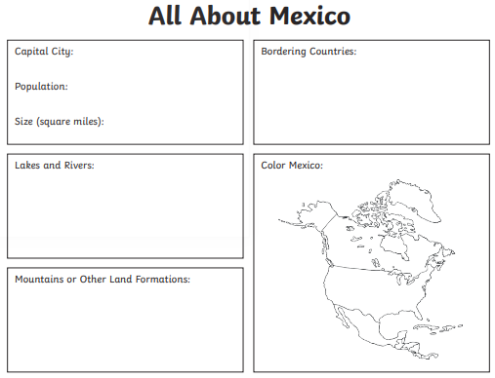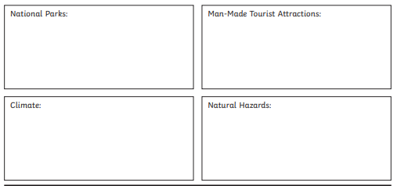

Tuesday 5th May | Core activities |  |  |  | Suggestions for additional activities.
9.00 – 9.30 | Daily Dashboard:  Quelle est la date aujourd’hui?  C’est mardi le cinq mai 2020.  Can you write the number date in Roman numerals?  What is happening in the world? Have a look at https://www.bbc.co.uk/newsround or https://www.dogonews.com/ to see what is going on in the world. Choose a news article or two to read.  Watch one or both of the following videos about Cinco de Mayo, our focus for today.  https://www.youtube.com/watch?v=KAOG795Yrm8  and/or  https://www.youtube.com/watch?v=A8Jj_KhAiGU  (This one is aimed at children, so may be easier to understand.) |  | What time is it now? What time would it be in Mexico?  It’s National Cartoonists Day in the USA – who is your favourite cartoonist? Or cartoon strip character? Is it Snoopy or Garfield or, my favourite, Calvin and Hobbes?  Why not read a cartoon book today or draw your own comic strip?  Have a look at Nathan Pyle’s Strange Planet –my favourite is the 4th strip down – Star Damage.  https://twitter.com/nathanwpyle/status/1098710518058176512?lang=en  Open the Y3/4 home learning pack on this page to practise using a comic strip to tell a story.  https://grammarsaurus.co.uk/portal/free-materials/
9.30-10.00 | Spelling – Practise spelling the following words from the statutory lists:  Y3/4 – bicycle, century, experiment, question, island, medicine  Y5/6 – bargain, secretary, government, competition, dictionary, shoulder  What sort of words are these? (Hint: can you use a determiner such as ‘a’, ‘an’, ‘the’ or ‘some’ with these words?) Can you add suffixes or prefixes to alter the meanings of these words? Can you use them in sentences appropriately?
10.00- 10.30 | Time for some physical activity. Why not check out some of the silly songs and moves on https://family.gonoodle.com/?
10.30-11.30 | Maths – Use the following website to watch tutorial videos, print off activities and then use the marking guidance to see how you got on. https://whiterosemaths.com/homelearning/ |  |  |  | In Additional Information Week 4, you will find a Maths challenge to plan a ‘Cinco do Mayo’ party!
11.30-12.00 | Have a break and play a game or do another activity that you enjoy. | In 1937 on this day, Delia Derbyshire, who wrote the theme music for Doctor Who, was born. Listen here https://www.youtube.com/watch?v=CM8uBGANASc
12.00- 1.00pm | Lunch break. Eat a healthy lunch and try to get outside for some fresh air!
1.00pm – 1.30pm | Reading time – Read the comprehension text below about Cinco de Mayo then answer the comprehension questions.  There is also a simplified version found in Additional Information Week 4. |  |  |  | Alternatively, there are some fact file sheets and a word search in Additional Information Week 4. Read some facts about this festival and invent your own comprehension questions!
1.30pm – 3.00pm | Theme – History/ PE/Geography  As it is the 5th of May today, we are focusing on popular festival celebrations including Cinco de Mayo.  Fiestas usually include music, dancing, dressing up and, of course, food. Look at the picture and question cards below and answer the questions.  Get into the mood for a festival by listening to some mariachi music here and watch the dancers.  https://www.youtube.com/watch?v=W3-jtiaYQc0  Look closely at the dancers. Do their movements remind you of other dances we’ve seen? Why not try some of the moves, then put them together in a sequence?  More music clips here  https://www.tunepocket.com/royalty-free-music/banda-mariachi-underscore/  https://www.jamendo.com/album/113466/mariachi?language=en  What instruments can you hear? What is the tempo (speed) of this music?  You don’t need to visit Mexico to sample their cuisine. There are lots of Mexican food staples now available here.  Can you name any mexican foodstuffs?  Research well-known mexican food using google and careful search terms. What do they export to other countries? What recipes might we have eaten in this country?  (I’ve included a recipe below for you to try!)  There is a sheet below that you could use to record your learning from today. |  |  | Find craft ideas for Cinco de Mayo here:  https://www.firstpalette.com/craft-theme/cinco-de-mayo.html  Learn more about mariachi music here  https://www.tripsavvy.com/mexican-mariachi-music-1588856  Why not plan a menu to include some favourites such as tortilla, guacomole and hot chocolate?  Talking of chocolate, say thank you to the Aztecs. The Aztecs were the ancient Mexican civilisation in charge before Spain invaded and took over the area. What can you find out about the Aztecs and their use of chocolate?

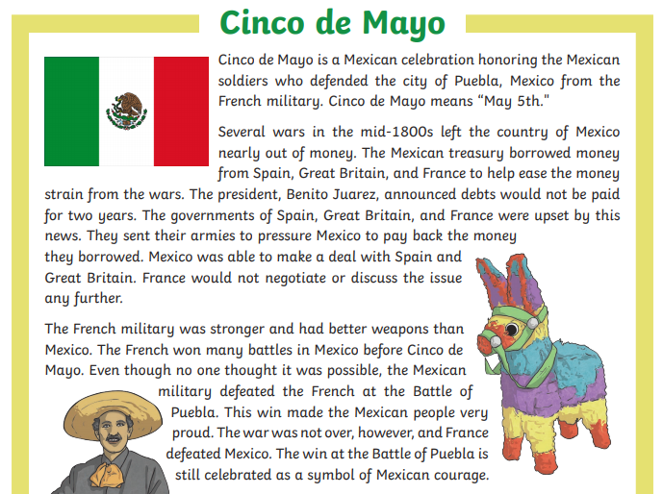
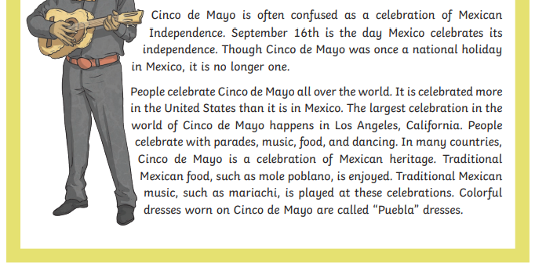
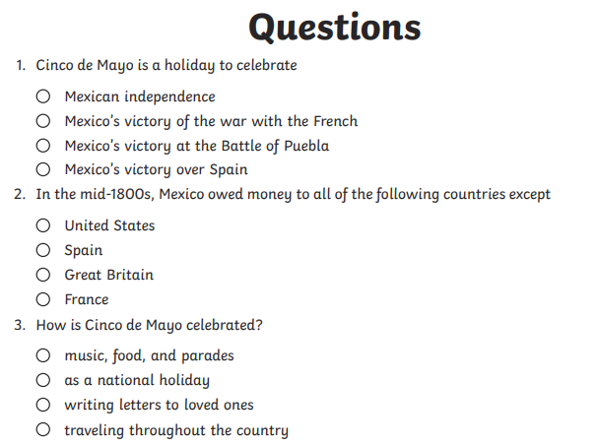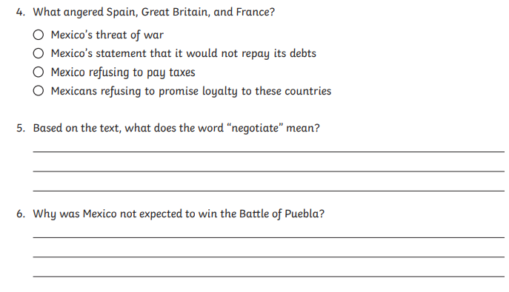

(Answers found at the end)

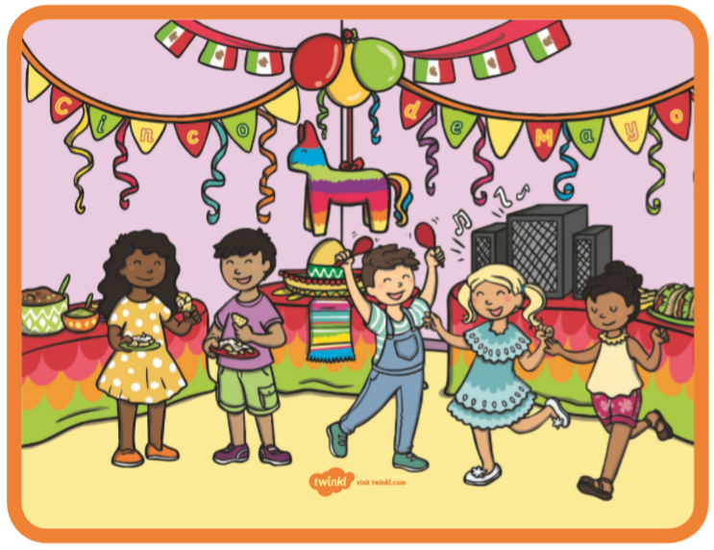
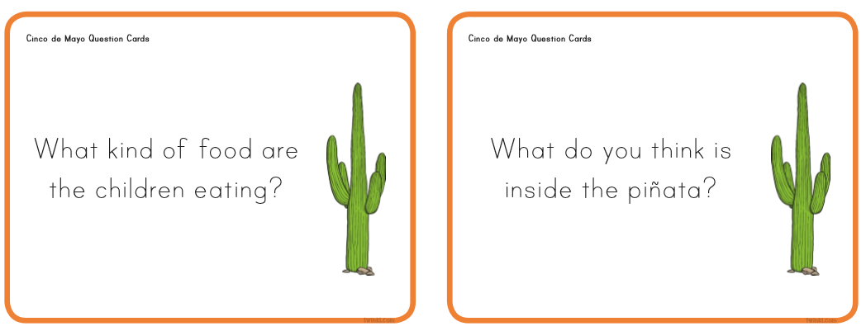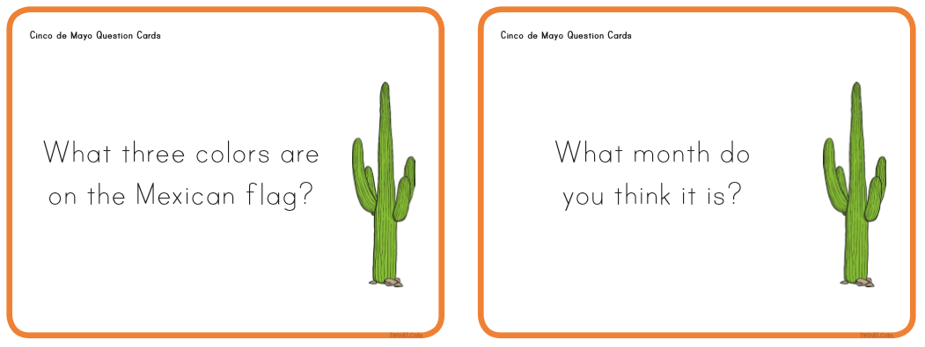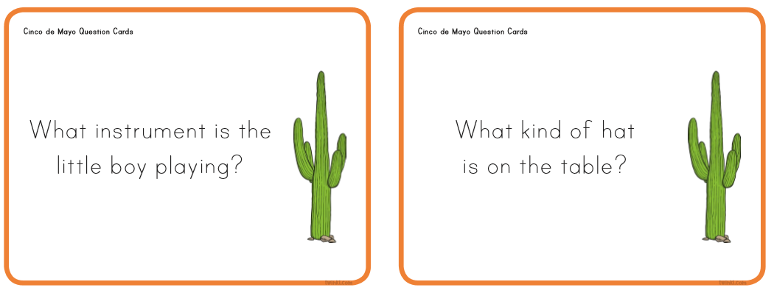
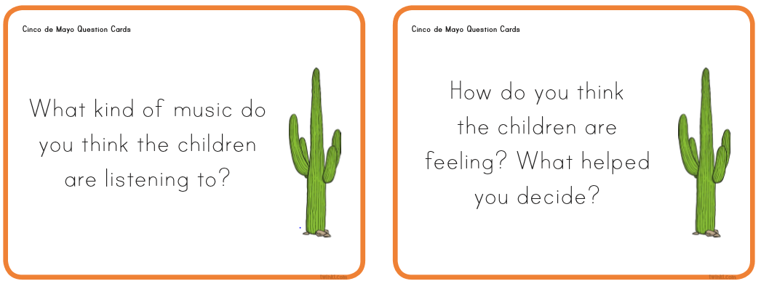

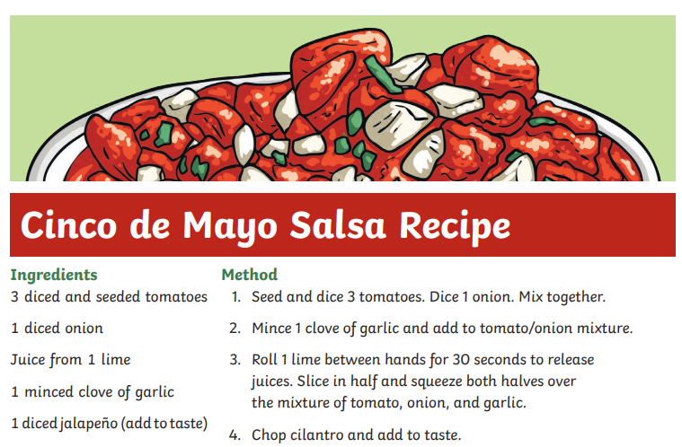
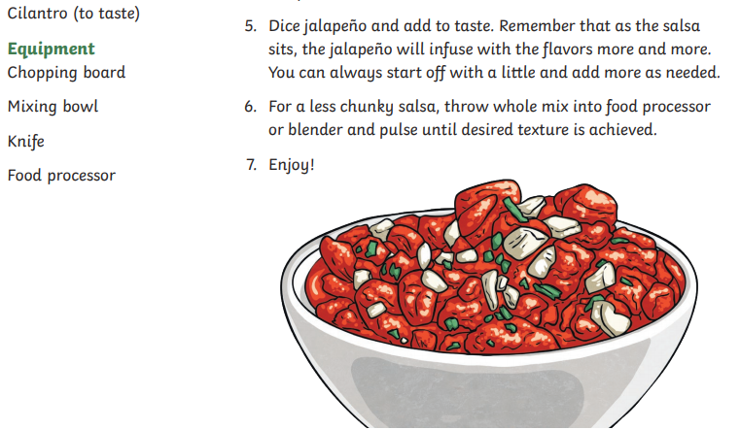
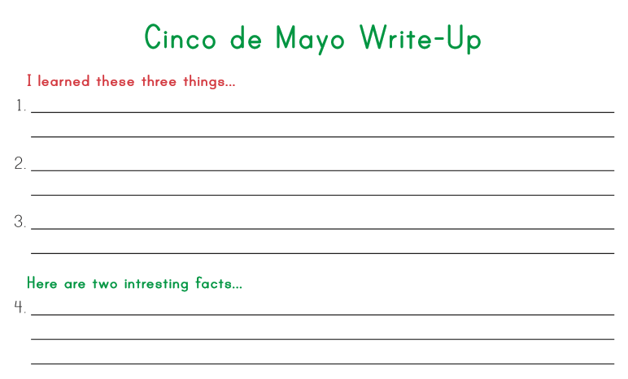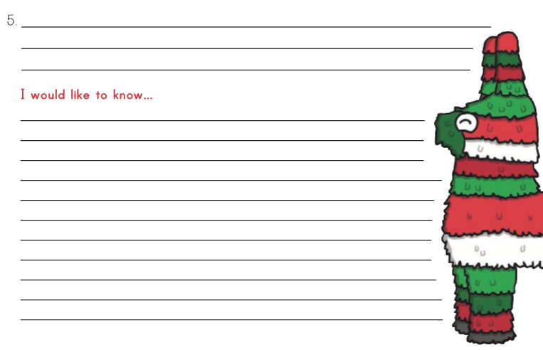

Wednesday  6th May | Core activities |  | Suggestions for additional activities.
9.00 – 9.30 | Daily Dashboard:  Quelle est la date aujourd’hui?  C’est mercredi le six mai, 2020.  Can you write the number date in Roman numerals?  What is happening in the world? Have a look at https://www.bbc.co.uk/newsround or https://www.dogonews.com/ to see what is going on in the world. Choose a news article or two to read. |  | Today is St George’s Day in Bulgaria. Can you find any other European countries who share St George as their patron saint?  On this day in 1953, former Prime Minister Tony Blair was born. Can you find out when he was Prime Minister? Who was prime minister before him? Since him? Who is prime minister today?  American songwriter Kal Mann was also born on this day in . Listen to one of his most famous creations here:  https://www.youtube.com/watch?v=OVsa4xdLkU4
9.30-10.00 | Spelling – see Spelling Resources
10.00- 10.30 | Time for some physical activity. What about looking at some of the fun Youtube dances of Australians Koo Koo Kanga Roo? https://www.youtube.com/watch?v=Imhi98dHa5w
10.30-11.30 | Maths – Use the following website to watch tutorial videos, print off activities and then use the marking guidance to see how you got on. https://whiterosemaths.com/homelearning/ |  | How about a warm-up using Times Table Rock Stars or else play a Maths game to help practise core number facts?  Investigate Mexican currency (money). At the time of writing this, one British pound is worth 30.83 Mexican Peso  How much money in Mexican Peso would you get if you exchanged £10, £20, £100, £50?
11.30-12.00 | Have a break and play a game or do another activity that you enjoy. |  | Today is National Laughter Day! Ask everyone you live with what is their favourite joke. Do you like story jokes, puns or knock-knock jokes?
12.00- 1.00pm | Lunch break. Eat a healthy lunch and try to get outside for some fresh air!
1.00pm – 1.30pm | Reading time – Read a chapter or two of your latest book on Bug Club. Don’t forget to click on the bugs and answer the comprehension questions! |  | Or read about Mexico City – you will find some pages to read in ‘Additional Information Mexico’. Can you invent some comprehension questions for others to check understanding of the text?
1.30pm – 3.00pm | Theme  On the websites below, you will find several different ways to explore Mexican Art and Craft. Choose the one that most appeals – or the one you have materials for!  Lots of easy crafts using bits and pieces found around the house:  https://kidactivities.net/mexican-theme/  This respected publisher offers lots of links to Mexican crafts including Ojo de Dios (Eye of God)  https://www.dltk-kids.com/world/mexico/index.htm  Scroll down for lots of ideas plus links at the bottom – check it out:  https://www.seasidemexico.com/mexican-crafts-for-kids/ |  | As well as art and craft ideas, this website also contains games, recipes and songs.  https://www.childfun.com/themes/world/mexico/  Or investigate traditional Mexican instruments such as the Mexican Guitar or Accordion here:https://loudbeats.org/instruments/mexican-musical-instruments/ or here https://ourpastimes.com/spanish-music-traditional-instruments-12497706.html  Which instruments did you recognise?  Listen to some magnificent Mexican music here (with dancing):  https://www.youtube.com/watch?v=-5q8T5b5GYQ&feature=youtu.be&t=36  And here  https://vimeo.com/46936958  Can you find any similarities between this festival and our own traditional May Day celebrations?
Thursday 7th May | Core activities |  | Suggestions for additional activities.
9.00 – 9.30 | Daily Dashboard:  Quelle est la date aujourd’hui?  C’est jeudi le sept mai, 2020.  Can you write the number date in Roman numerals?  What is happening in the world? Have a look at https://www.bbc.co.uk/newsround or https://www.dogonews.com/ to see what is going on in the world. Choose a news article or two to read. | In Kazakhstan, today is Defender’s Day, when they honour those who served in the Kazakh armed forces, both past and present.  Can you find Kazakhstan on the map? (Hint: it’s now part of Europe)  On this day in 1840,Peter Tchaikovsky – composer – was born. Listen to one of his most famous compositions here (including cannons!):  https://www.youtube.com/watch?v=gUmu-dmF4us  And from one of his ballets:  https://www.youtube.com/watch?v=Ow4t3C_gCCY  Which instruments can you hear? Look it up if you can’t remember names!
9.30-10.00 | Spelling – see Spelling Resources
10.00- 10.30 | Time for some physical activity. Have a look at https://www.lesmills.com/borntomove/ Did you know you can get a free trial subscription and join in with a host of exercise classes?
10.30-11.30 | Maths – Use the following website to watch tutorial videos, print off activities and then use the marking guidance to see how you got on. https://whiterosemaths.com/homelearning/  Why not visit https://nrich.maths.org/9803 and have a go at one of the Maths investigations there. Be warned – these will really make you think! |  | How about a warm-up using Times Table Rock Stars or else play a Maths game to help practise core number facts?
11.30-12.00 | Have a break and play a game or do another activity that you enjoy. |  | Drink lots! Don’t forget to stay well hydrated. Do something you enjoy or to help others. Why not prepare a chant for your family to shout out at the clap for carers at 8pm this evening or make a poster to encourage NHS/ postal/ refuse collection/ delivery workers…
12.00-1.00pm | Lunch break. Eat a healthy lunch and try to get outside for some fresh air!
1.00pm – 1.30pm | Reading time – read about famous Mexican Artist Frida Kahlo here:  https://www.tripsavvy.com/museo-frida-kahlo-1589077 |  | Alternatively, read a chapter or two of a novel. Pick out a few of your favourite sentences and consider what the author has done to make them have an impact on the reader.
1.30pm – 3.00pm | Literacy/Art  Frida Kahlo and her husband Diego Rivera are very famous Mexican painters. They both painted people: Frida focusing on self-portraits due to her paralysis and Diego on huge murals that included people and landscapes.  Learn about Frida Kahlo here  https://kids.kiddle.co/Frida_Kahlo  and Diego Rivera https://kids.kiddle.co/Diego_Rivera  Here is a simple blog with a biography of her https://www.lottie.com/blogs/strong-women/frida-kahlo-biography-for-kids  Watch the video through this blog, for a variety of Frida’s self portraits https://kidworldcitizen.org/kids-learn-frida-kahlo-mexican-artist-extraordinaire/  Draw your own self-portrait today, either in the style of Frida or the style of Diego. Look here for more ideas linked to Frida:  https://www.redtedart.com/frida-kahlo-projects-for-kids/  Another collection: https://artsycraftsymom.com/frida-kahlo-art-projects-for-kids/ |  |  | A short video about Frida with key information https://www.youtube.com/watch?v=wfbLR15Bh74  A video from Khan Academy  https://www.khanacademy.org/humanities/art-1010/latin-america-modernism/surrealism-latin-america/v/frida-kahlo-frieda-and-diego-rivera-1931  A video with a brief biography and artwork (Diego Rivera)  https://www.youtube.com/watch?v=47aaDNjlDuc  Ideas for art using his painting ‘Mother’s helper’  https://www.deepspacesparkle.com/diego-riveras-mothers-helper-art-lesson/  Why not choose an aspect of Mexican culture that you are curious about and do some research to find out more? You could present the information in a short report.

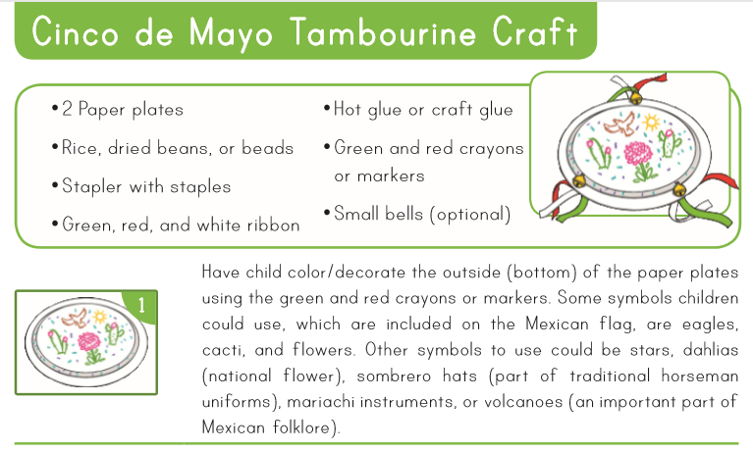
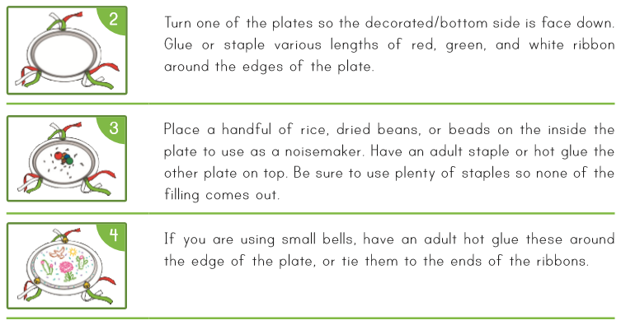

Friday 8th May 2020 – Early Bank Holiday –

British Naturalist and TV presenter Sir David Attenborough was born in London in 1926

Read about him here: https://www.bbc.co.uk/teach/nine-astonishing-ways-david-attenborough-shaped-your-world/z4k2kmn
Watch top 5 moments on the youtube channel BBC Earth below:
https://www.youtube.com/watch?v=-tvA3Ezqjl8

On this day in history in 1919, a letter was published in the London Evening News, by Edward George Honey. In this letter, he proposed a period of silence in remembrance of those who died in the Great War. This resulted in our tradition of Remembrance Sunday, every 11th of November from then on.

That’s it for our visit to Mexico – next week we returning to Europe to visit Austria, home of great composers.

However, in ‘Additional learning about Mexico’, you will find a few more pages of activities linked to the geographical skill of comparing aerial photographs and maps, as well as slides with information about Mexico in general and Cinco de Mayo. Happy Learning!

