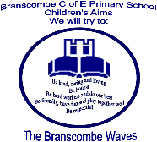

BRANSCOMBE C OF E PRIMARY SCHOOL
WITH LITTLE EXPLORERS’ PRE-SCHOOL
NEWSLETTER
4- 21/22
Friday 3rd December 2021

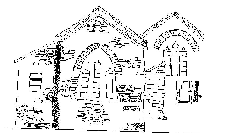

Dear Parents,

In Class One, the children have been enjoying our History topic ‘The Great Fire of London’. They have been making a timeline about the Great Fire of London and understanding how historical sources such as diaries and paintings can be used as evidence to find out about the past. The children should be able to tell everyone at home how we know what happened in the Great Fire, despite there being no internet, cameras or T.V. back in 1666. They have been looking at old maps to identify the area the fire started in Pudding lane and to see where it spread to. The children were excellent at locating St Paul's Cathedral and the River Thames. They also used drama to show what made the fire spread so quickly and which techniques were used to control the fire. The reception children developed their learning further within their play, by creating their own version of Pudding Lane using Duplo and various props. As you can see from the photo below, all the children have enjoyed acting out the story within continuous provision and have been very creative with their version of events. It has been wonderful to listen to their history knowledge of Samuel Pepys and also see them cooperate and share so well together.

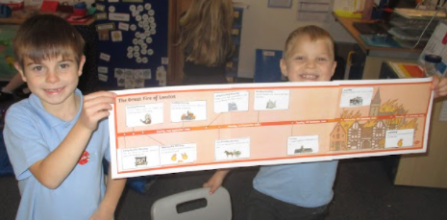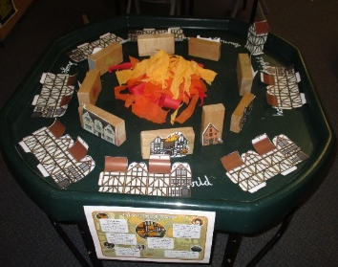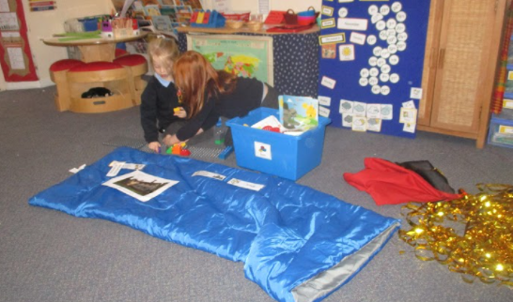

In D.T. Class 1 have been finding out about Christopher Wren and looking at London buildings that use triangles (trusses). They thoroughly enjoyed investigating how triangles strengthen structures using lolly sticks and various other construction equipment. By the end of the term children will have designed, made and evaluated a strong, sturdy model of a London building using recycled materials.

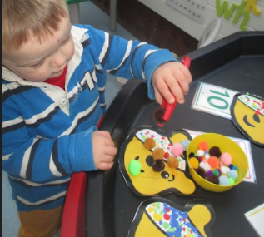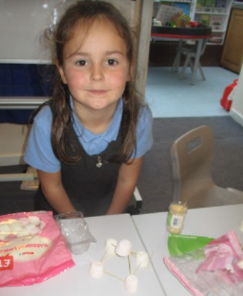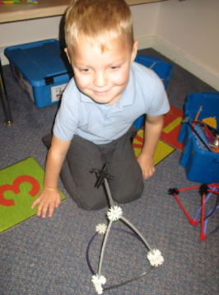

In science, Class 1 have been learning about different world habitats including microhabitats and how animals and plants have adapted to live there and depend on each other. They enjoyed the ‘welly walk’ in the woodland area and mapped out areas where animals and plants could be found.

We have also been busy sharing our wonderful art skills with the local community. Did anyone see our beautiful poppy printing displayed in the Seaton Tesco? If you head into Exeter Cathedral you will also see our school sculpture displayed as part of the ‘Star of Wonder’ exhibition. The children have each made a beautiful star out of clay and salt dough and decorated it to go on a tree. This ties in brilliantly with our school vision - ‘Be who God meant you to be and you will set the world on fire’, as every star was individual which reflects how everyone is unique.

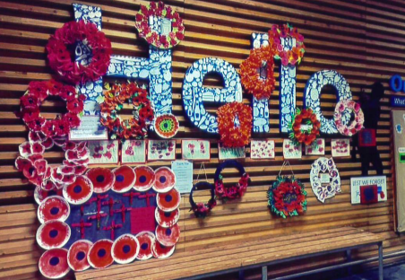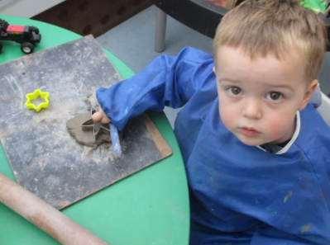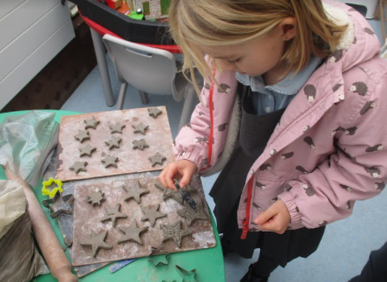

In Music, the Class 1 children have been using the song ‘London’s Burning’ to experiment with pitch and have been playing tuned and un-tuned instruments, following symbols.

In English, the Class 1 children have been focusing on writing in full sentences with a capital letter, end punctuation and clear finger spaces. We are so pleased with how hard they are trying to form letters correctly, starting and ending in the correct place. They are currently working towards writing a simple story with a moral at the end of it, based on ‘The Town Mouse and the Country Mouse’.

In Maths, Class 1 have finished their addition and subtraction unit, Year 1 are now looking at partitioning 2-digit numbers into tens and ones and Year 2 are starting their unit on multiplication. They will be looking at different ways of learning their 2, 5 and 10 times tables which can be practiced at home through various apps and games. Times Tables Rock Stars would be a great game to use to practise these times tables.

Our Early Years’ children have settled well into the school routines, showing greater independence and team work. They are learning to help themselves to resources and tidy up afterwards. They love looking at the class timeline showing key moments of their learning for each month. This will be a wonderful record of their progress throughout the school year.

Class 2 meanwhile, have been writing a non-fiction book about different aspects of their learning about space and in the next couple of weeks, they will also be researching and writing the biography of a famous astronaut or astronomer. Their 'book launch' event will give their parents the opportunity to read their writing and will also give the children a reason to edit, improve, publish and present their writing.

The Class 2 children have also been working on pictures inspired by the work of two artists: John Conrad Berkey and Peter Thorpe. They experimented with ink marbling to create a colourful background and they have begun to design, draw, paint and use collage to create an imaginary space craft to form the foreground of the picture.

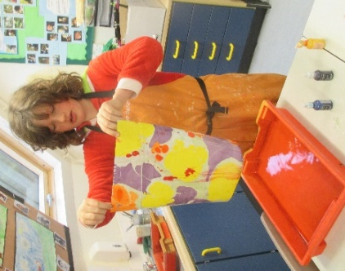
In Science work over the last few weeks, the Class 2 children have been learning more about contact forces, including friction, air resistance, water resistance and up-thrust and non-contact forces, such as gravitational or magnetic force. The children have carried out some experiments, such as recreating Galileo's famous experiment in which he dropped two balls of similar size but different weights from the top of the leaning tower of Pisa to see which would land first. Like Galileo, the children discovered that the balls landed at the same time, despite their different masses. They watched footage of a similar experiment on the Moon, in which an astronaut dropped a hammer and a feather and they both fell at the same time. The Class 2 children discussed the reasons why a feather might take longer than the hammer to fall on Earth, where air resistance might slow it down. They have also been learning about balanced and unbalanced forces.

Some of the children in Class 2 were keen to organise some charity fund-raising for Children in Need, so they got together and decided to hold a 'comfy clothes day' and playtime cake sale, which raised approximately £60 for the charity. Many thanks to all who supported their efforts.

This term, Class 2 have been enjoying their swimming lessons on Wednesday afternoons. Last week, the Year 5 and Year 6 pupils also had the opportunity to compete in Athletics against 5 other schools from the Honiton Learning Community. Most of the schools attending sent teams of 6 girls and 6 boys, which meant that the Branscombe children, with only 3 girls and 3 boys, had to work doubly hard. On the positive side, it also meant that they all had the opportunity to participate in every event - sometimes twice! The Year 5 children have also had the opportunity to attend a special transition Art workshop at Sidmouth College, where they enjoyed seeing the artwork of the older children and experiencing working in a secondary school art studio. The children completed some wonderful printing work as part of the workshop, which will be excellent preparation for their printing focus in next term's Art project here in school.

In their P.S.H.E. work this term on the theme of 'Keeping Safe', Class 2 have considered fire safety at home, in school or out and about (such as at Bonfire night) and they have considered the importance of a fire safety plan. Along with their reflections on this term's Collective Worship theme of Friendship, the children also celebrated Anti-Bullying Week, which included Odd Socks Day. Odd Socks Day is an annual opportunity to celebrate the fact that each of us is unique and special and we all deserve to be treated with respect. This year, the theme of Anti-Bullying Week was 'One Kind Word'. Class 2 have been creating a chain of kindness by writing down kind things about their classmates and using these to create a paperchain to decorate the classroom. In the same week, the Ethos team met online with teams from the four other schools in the Jubilee with Pebblebed Federation and discussed the related themes of Friendship, Reconciliation and Forgiveness. The children now have a host of new ideas about how they would like to develop the classroom prayer areas and playground areas to support each other in maintaining strong friendships and restoring any friendships that have been damaged by unkind words, actions or misunderstandings. The children in Years 5 and 6 have also been attending a series of workshops, led by a visitor from the mental health charity Heads Up, to train them to be Mental Health Ambassadors in the school. They will then work alongside the Ethos Team to promote mental health and wellbeing in our school. And to finish the term by linking their P.S.H.E. work on friendship and keeping safe, the children of Class 2 have been considering the benefits and challenges of developing friendships online, as well as in real life. They have begun to consider some of the ways they need to protect themselves and also how they might need to be especially aware of being kind to others when communicating online.

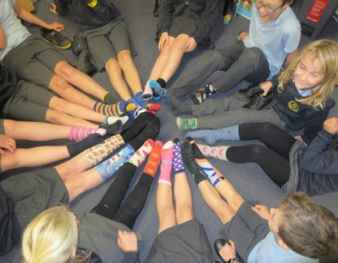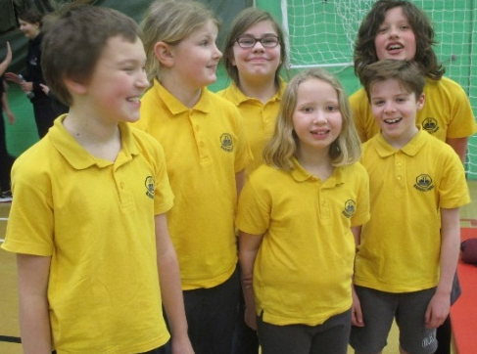
On Thursday 16th December, at 2.45pm, we would like to invite parents and friends of the school to a special sharing assembly in the playground. At this event, children will have the opportunity to show their parents some of the work they have been doing this term.

Thank you for all your continued support.
God bless and have a lovely weekend.
Best wishes from Katie Gray and the staff at Branscombe CE School
Question of the Month
Class One: What does Christmas mean to you?

Class Two: What do you think would be the most important qualities, skills or knowledge needed for a person to become an astronaut?

Key Dates - Autumn Term 2021
8th December– Swimming lesson for Key Stage 2.
Tuesday 14th December- Christingle service 6pm at St Winifred's Church Branscombe.
Thursday 16th December, 2.45pm - Class 2 'book launch event and sharing 'assembly' in the playground.
Thursday 16th December - Christmas Dinner. Please order by lunchtime on Friday 3rd December.
Last day of term: Friday 17th December 2021.
Christmas holiday Monday 20th December 2021 to Monday 3rd January 2022.
Wednesday 5th January 2021- Guitar lessons restart.
Branscombe Waves
Class One:
Cara: for great effort with handwriting
Sophia: for focus in Maths.
Jake: for improved concentration and focus.

Class Two:
Sam: for an improved attitude to learning and excellent progress in reading, writing and Maths.
Rupert: for responsible, respectful behaviour and excellent reading for Remembrance.
Annabelle: for supporting another pupil in Science, while also working hard to complete her own work.
Zoe: for working hard in every lesson and being a good friend.
Dominic: for working well to complete independent writing and an improved attitude to learning.
Barney: for great effort in learning to swim.
Sam: for a fantastic attitude to learning, consistent effort and catching up quickly after a few days away.
Isla: for a great improvement in handwriting and presentation of written work and fluent, expressive reading.
William: for being consistently friendly, positive and helpful to everyone and always ready to learn.
Guitar Lessons
Please note our Guitar lessons will change, from Wednesday to Tuesday until after Christmas.
Thank you.

Drop off and Pick up
Please can all Parents and Carers remember to keep 2 metres apart at drop off and collection time.
This is important for all our safety to reduce the spread of Covid-19. Adults and teenagers should wear masks outside the school gate. Thank you for your help with this.

Free School Meals
If your circumstances have changed as a result of the Covid-19 crisis your child may have become eligible for free school meals. This will also bring extra funding to the school, which will be used to help your child. For an instant decision or to learn more please go online at https://www.devon.gov.uk/educationandfamilies/school-information/school-meals.

Wellbeing
There has been much press in recent months about children’s mental health. As part of our drive to support this we are going to include something each month in the newsletter about Health and Wellbeing. We hope you find this section useful. If you have any topics you would like us to find some helpful tips about, please let us know.

Looking after a child or young person's mental health
There are times when we all feel the strain. As parents and carers, there are ways we can support children and young people to give them the best chance to stay mentally healthy. Visit the NHS website to see ways of supporting your child. https://www.nhs.uk/every-mind-matters/supporting-others/childrens-mental-health/

Collective Worship Activity
This term we will be focussing in school on the value of Friendship. We hope your family will find these ideas helpful as you explore the value and have fun together. If the children bring back something that you have done at home linked to the Collective Worship activity, or can talk about a discussion they’ve had at home linked to it, then Mrs Gray will award them with a new special sticker.

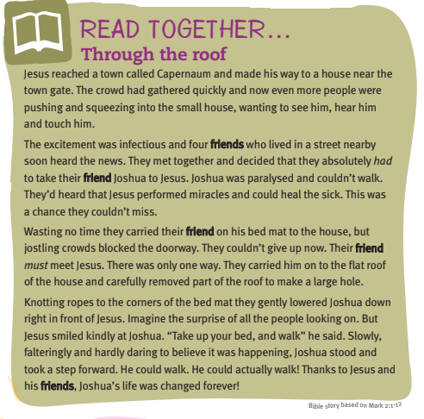
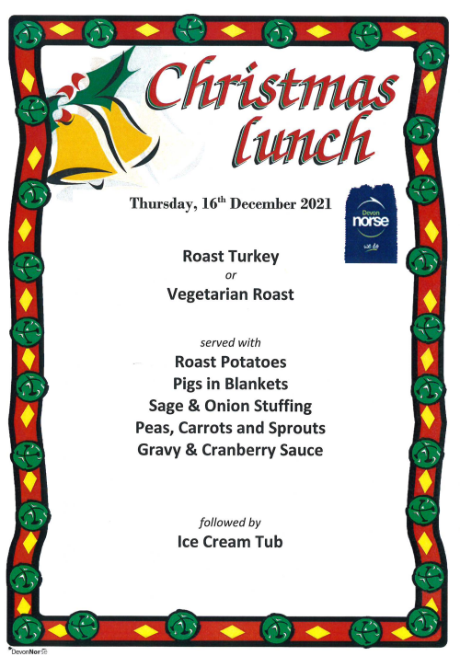

Christmas Lunch
Please order by lunchtime on Friday 3rd December. This is the ONLY menu available on this day. Thank you.

