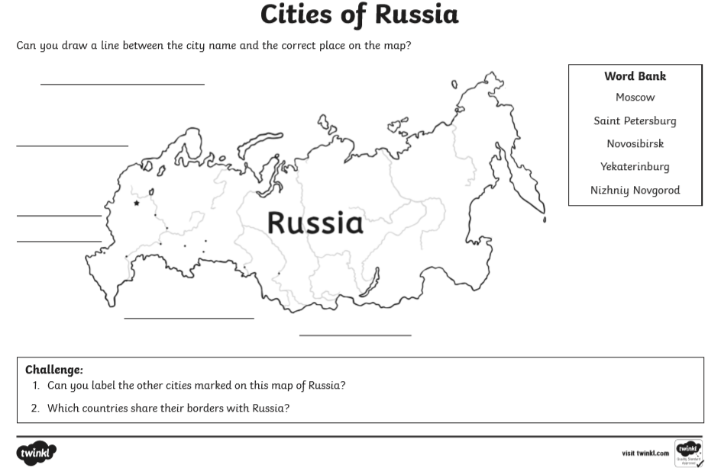

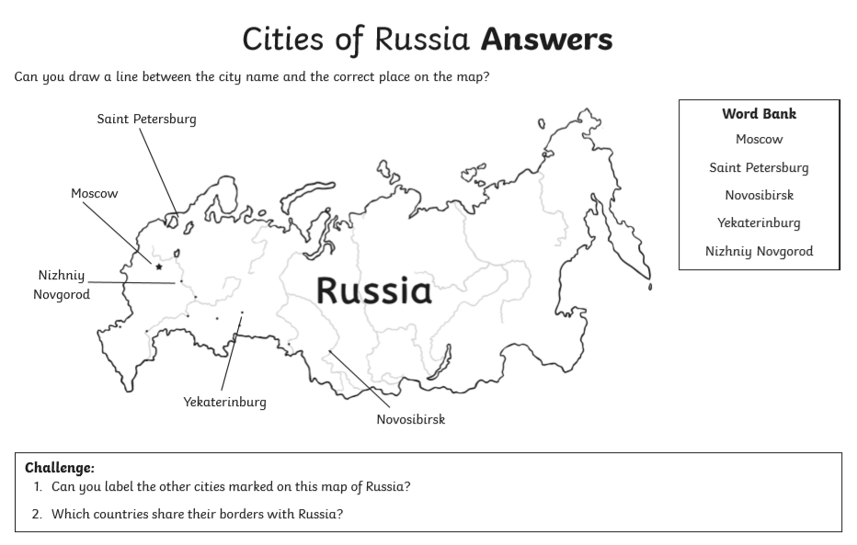

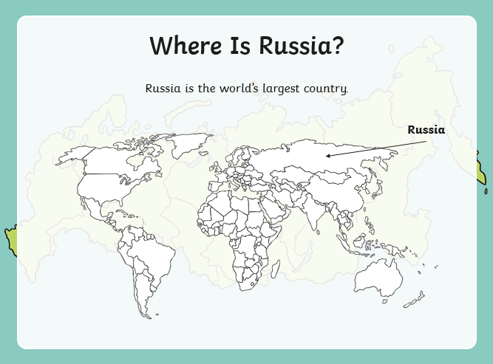
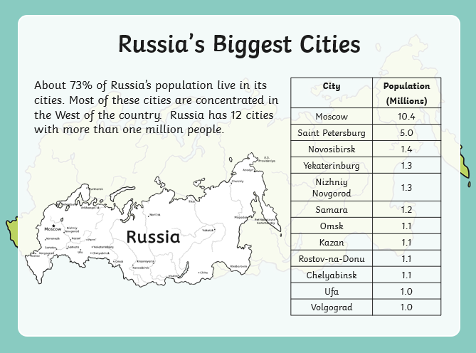
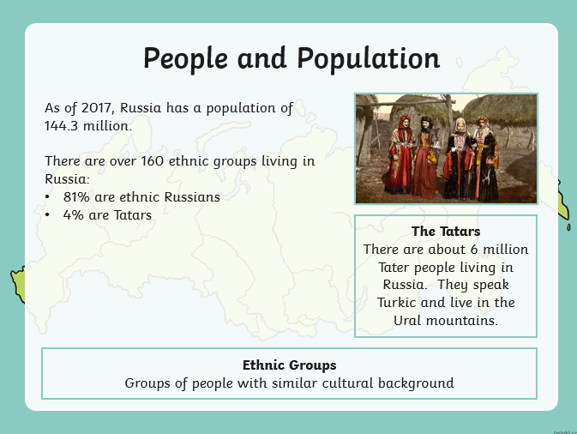
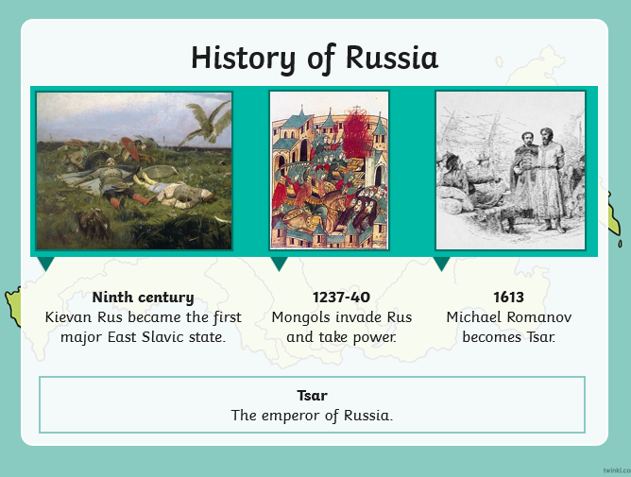
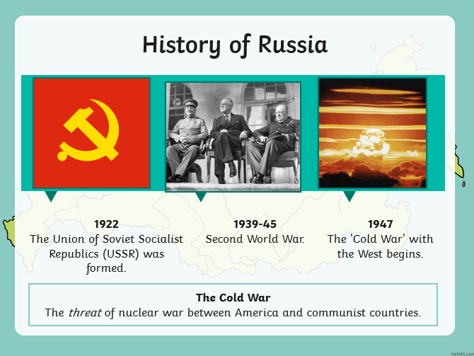
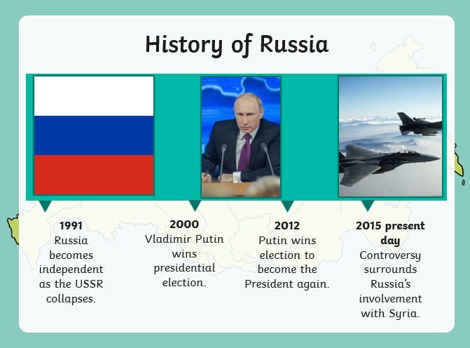
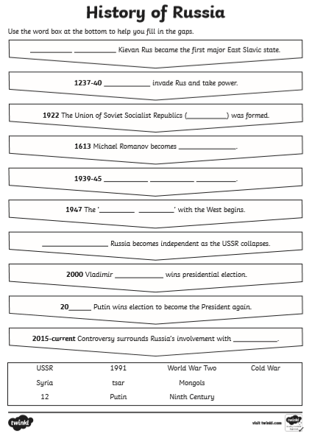

Read the statements below about Russia. Cut them up and sort them into ‘paragraphs’ linking together facts on the same subject. Choose a ‘topic sentence’ to begin each paragraph and then put the report in order.
The population is most dense in the European part of the country, with milder climate, centering around Moscow and Saint Petersburg. 74% of the population is urban, making Russia a highly urbanized country. | Many young people return to their rural homes after acquiring the type of education or technical training that is available only in cities | Russia has about 62,000 libraries. Most towns and large villages have a public library. | About one-fourth of the Russian population lives in rural areas.
The most remote areas of Russia, some homes lack gas, plumbing, running water, and electricity. | About three-fourths of Russia's people live in urban areas. Approximately 35 cities in Russia have populations over 500,000. Two of Russia's cities--Moscow and St. Petersburg--each have more than 4 million inhabitants. | The routine of life in many rural villages has scarcely changed over many generations; the central concerns continue to be the weather and the condition of crops and livestock. | The people of Russia are avid nature lovers, and they enjoy spending time in the countryside. Many Russians have country cottages called dachas. There, they garden, hike, bicycle, swim, fish, gather mushrooms, and take part in other outdoor activities.
Rural dwellers tend to spend more time in their homes than residents of urban areas. Rural homes generally are larger than those in the city and have private garden plots. | In addition, the quality of education, health care, and cultural life is lower than in the cities. | Russian cities have many athletic clubs, stadiums, recreational centres, and other sporting facilities. | When Russia was part of the Soviet Union, most rural people worked on huge farms run by the government. After the Soviet Union collapsed, Russia began to break up these farms. New laws allow people to withdraw from the government farms and set up private farms.
Russian cities are crowded. Beginning in the 1930's, large numbers of people migrated from the countryside to urban areas. During World War II (1939-1945), bombs destroyed many houses and other buildings. These circumstances combined to create a housing shortage in Russian cities that continues to this day. | Millions of city dwellers live in small apartments in high-rise buildings. The scarcity of housing forces some families to share kitchen and toilet facilities. Single-family houses are common in small towns and on the outskirts of large cities. Some of these houses still lack indoor plumbing and other modern conveniences. | However, rural life is undergoing change. Rural stores, for example, have a wider selection of goods available than they once offered. | The tastes of country people are simpler and less Western-oriented than those of their urban counterparts, and they have less money to spend on leisure

Geographical Research challenge… Can you find the answers to the following questions about Russia?
What is the Capital of Russia?  Answer:_________________________________ | Russia shares its border with 9 countries – name three of them!  Answer:_________________________________  Answer:_________________________________  Answer:_________________________________
Name two cities with a population between 1 000 000 and – 5 000 000 inhabitants.  Answer:_________________________________  Answer:_________________________________ | Name the major river than runs through Volgograd City?  Answer:_________________________________
What is the name of the body of water between Kazakhstan and Iran?  Answer:_________________________________ | Ukraine borders the country of Russia! What is the capital of Ukraine?  Answer:_________________________________
Name the plateau in central Russia?  Answer:_________________________________ | What is the furthest east city?  Answer:_________________________________
Name the mountain range in European Russia?  Answer:_________________________________ | Identify the major lakes north of St.Petersburg?  Answer:_________________________________  Answer:_________________________________
Identify the Ocean north of Russia?  Answer:_________________________________ | Russia borders many seas. Identify the sea between Poland and Finland?  Answer:_________________________________

