Weeks beginning Monday 15th June and Monday 22nd June – Home Learning for Class 1

Dear Parents and Children of Class 1,

Welcome to Summer Term B - Weeks 3 and 4, of your Home Learning! Off we go with another tranche of learning: Here is another fortnight worth of work and a bank of resources for you to access.

Our primary focus over the next fortnight continues to be to develop the children’s reading skills so please do keep up with reading Bug Club, however you will also notice that we have included an emphasis on mental health and mindfulness, to support the children with coping with the changes in the world around them. From Monday 22nd June we have also adapted a weeks worth of our phonics planning to support the children in using their reading/phonics skills in creative writing episodes.

Remember that you musn’t panic if you don’t manage to do everything, just have a go. As always, we hope that you are managing to do some learning at home and that you are finding all of the work helpful and enjoyable but the most important thing you can do at this unusual time is to read every day and continue to practise your phonics and key mathematics skills such as number bonds to 10, 20 and 100 and 2, 3, 5 and 10 times tables.

Do you remember the challenge that we set you to take a photo of you reading a book in an unusual or bizarre place light of our current focus on reading? We promised to send you our photos in our next letter to you so here you are! Maisie made Miss Harvey-Jones read to her in the shower - luckily without the water turned on! Her favourite books at the moment are the Little Miss and Mr Men books.

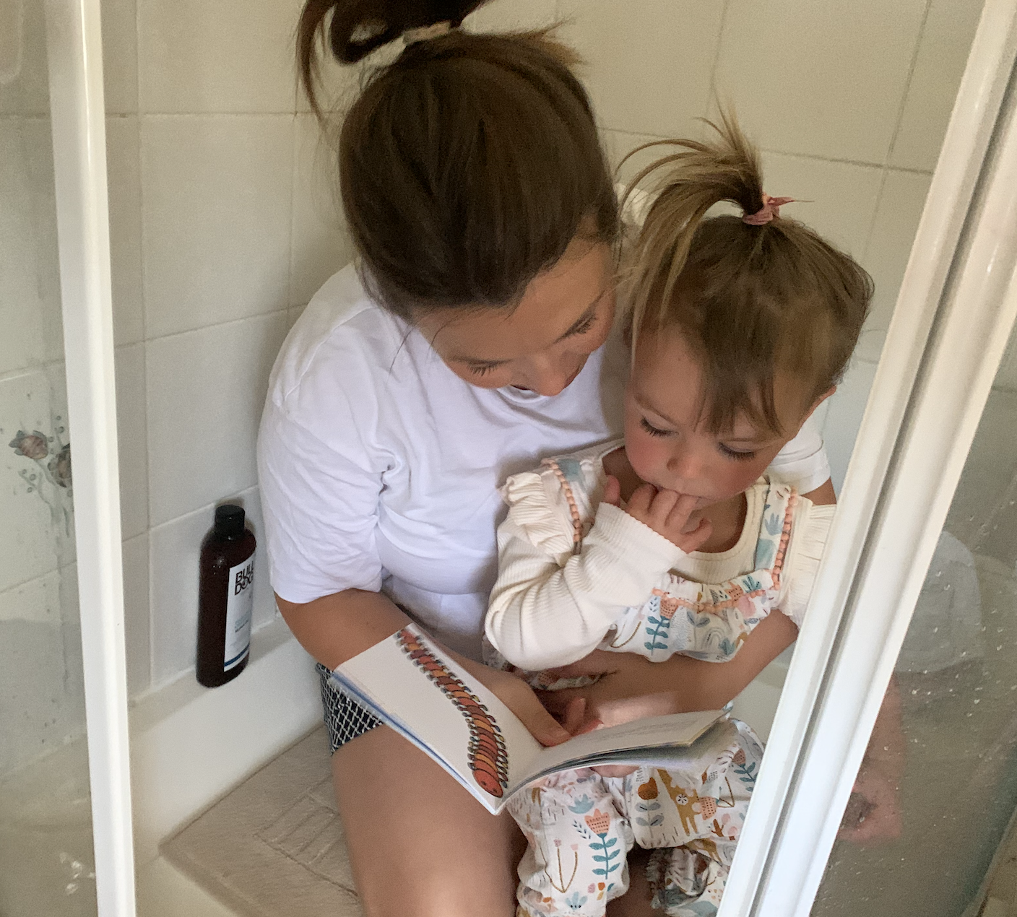

We thought you might also like to see the pebble that Maisie found on her walks this week. Did you manage to decorate a pebble with an uplifting message? Did you leave it somewhere for other people to find? Don’t forget to send us a photo of it in it’s place!

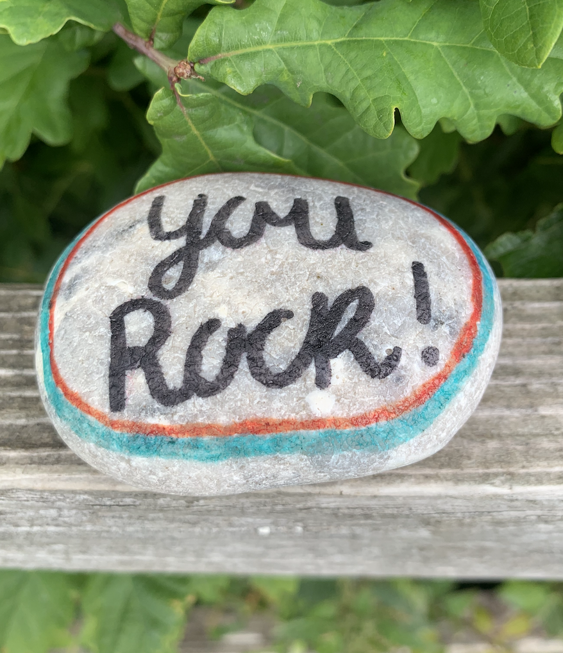

Missing you all… As always, keep reading a book that you enjoy and stay safe and well with your family,

Miss Harvey-Jones and Mrs Bartlett

EVERY DAY
- 20 minutes phonics: Pre-school, Reception, Y1 and Y2. Reception, Y1 and Y2 pupils please see the table below for details/activities. Remember, you could also use Phonics Play to practise reading sounds and words and also practise sounding and blending skills with the games provided on here. It is FREE at this time: https://new.phonicsplay.co.uk/. It is also app/tablet friendly. Pre-school children would benefit from spending some time to practise writing their name – ideally forename and surname (remembering the capital letters), so that they know how to spell it using correctly formed letters. They could also practise letter formation of the other letters of the alphabet. (See below for guidance).
- 20 minutes ‘Bug Club’ Reading (with comprehension ‘bug’ questions): Reception, Y1 and Y2. Bug Club books continue to be updated to suit your level.
- Choose 5 spellings from your Home Learning Books, Common Exception Words list or High Frequency Words list to learn: Reception, Y1 and Y2. (See below for these word lists).
- 15 minutes ‘Spelling Shed’, ‘SPAG.com’ OR ‘Bug Club Grammar’ games (KS1 only). As before, please do contact us if you would prefer to access paper-based work to limit screen time we can email additional SPAG documents for you to print off.
- 15 minutes ‘Times Table Rockstars’ (KS1 only) OR to limit screen time you may wish to spend this time learning 2, 3, 5 and 10 times tables to be able to recall them at speed. Reception pupils would benefit from spending a little time counting in twos e.g. count some teddies or dolls in twos.
- 20 - 30 minutes Maths: Pre-school, Reception, Y1 and Y2. See table below for a 5 minute warm ups with your parents/game, then complete any tasks set if in Reception or KS1. KS1 pupils can also continue to work in their ‘Power Maths’ Practice Books should you wish. Pre-school children may enjoy watching the videos too or could access some of the websites attached on website to play some number and shape games.
- PE/Active Time: Pre-school, Reception, Y1 and Y2. Joe Wicks (The Body Coach) has daily workout videos on YouTube (go online with your grown ups) but you do not need to feel restricted to this – get some fresh air when walking the dog, using skills developed in out of school clubs such as football/ballet or exercising in the garden instead, if you can safely do so.
- We would like children to continue their Summer Term diary: Pre-school, Reception, Y1 and Y2. Write one or two sentences a day (labels/captions scribed or written with support if necessary for pre-school children) and draw a picture. The sentence might be about something they have done, something they have seen or even what the weather is like. Some examples might be: ‘It is sunny.’ ‘It is a flower.’ ‘I went to the park’. Sentences do not need to be spelt correctly but the children should use their phonic skills to attempt to write words. KS1 children could also use the Time Capsule sheets attached on a separate link to help with ideas.
- Please keep reading/sharing a book you enjoy with your family: Pre-school, Reception, Y1 and Y2. Try to keep a log together (one or two sentences) of what you have read that day. If you are reading a fiction book, what happened or what characters did you meet? If you are reading a non-fiction book perhaps you write down something that you have found out that you didn’t know before.

Monday | Phonics  Preschool – see notes above.  Reception – Phase 4 revision: Practise GPCs and Phase 4 Tricky Words – You can continue to play ‘Flashcards’ using the previously attached resources and ‘Quickwrite Graphemes’ (say the sound on the flashcard ask your child to write it without them seeing it), or alternatively if any of the activities that have been set in weeks 1 and 2 were particularly successful in helping your child to learn their tricky words you could incorporate these for a change. Complete pages 1-3 of the Phase 4 ‘caption cards read and draw’ activity sheets (separate).  Year 1 – Phase 6 revision: We are learning to read verbs that have -ing added onto them. Go through all of the GPCs phase 2 – 5 with your child at a rapid pace (you can use the resources from last week or you can play ‘Flashcards’, selecting to use these sounds on Phonics Play if you subscribe for free. Practise writing GPCs by playing Quickwrite Graphemes (say the sound on the flashcard ask your child to write it without them seeing it). Look at the suffix -ing. Show that it can be easily read using existing phonic knowledge. Model blending to read various words that end in -ing – eating, whirling, cartwheeling. Play Countdown (how many of these plural words can you read in one minute/how many times: playing, straying, bounding, hounding, reading, treating, enjoying, destroying, twirling, yawning, drawing, whispering, chewing, launching, taunting. You can also play ‘Crater Creature Countdown’, selecting to use these words on Phonics Play if you subscribe for free. Hold up each of these sentences on paper. Ask your child to read the sentence you. Encourage them to discuss and figure out any words that they find difficult: I don't like people whispering when I am reading. The puppy was enjoying destroying the shoes. A great booming noise came thundering across the mountains. There are lots of dangers that unicorns can face. Now cover up the sentences so that your child can’t see them and slowly dictate each one to your child, asking them to write the sentences in their books, applying their learning from today.  Year 2 revision – /l/ or /əl/ sounds spelt ‘il’ at the end of words: Remind your child of the /l/ and /əl/ sounds at the end of words and the graphemes they have learnt so far to represent them. Show them the chart with the words they collected before (Summer Term A). Which is the most common spelling of this sound?  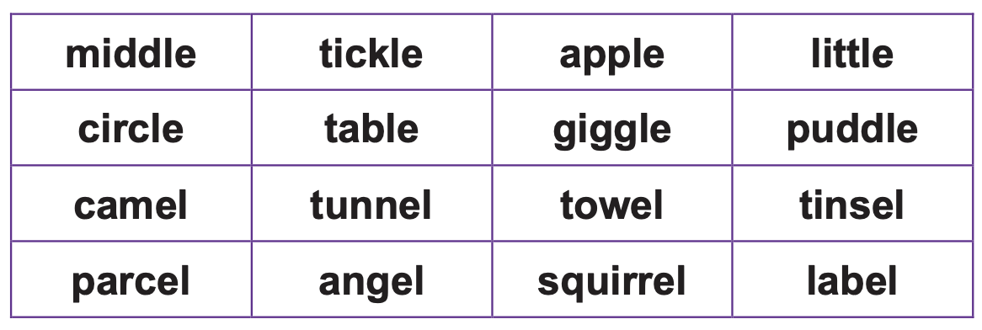  Show them the following words: pencil, fossil, nostril, stencil. How is the phoneme spelt in these words? Tell them that this is a very unusual spelling. Add them to the chart of the different spellings in a new column. Practise handwriting them.  Maths  EYFS Maths Starter – Practise your number bonds to 10. You should be getting really quick at reciting these now… can you begin to learn your number bonds to 20?  EYFS - Access the White Rose Maths website for home learning (link below).  https://whiterosemaths.com/homelearning/early-years/  Complete Summer Term Week 6 (w/c 1st June) - Day 1: The Snail and the Whale (watch the video before following the links to complete suggested activities).  KS1 Maths Starter  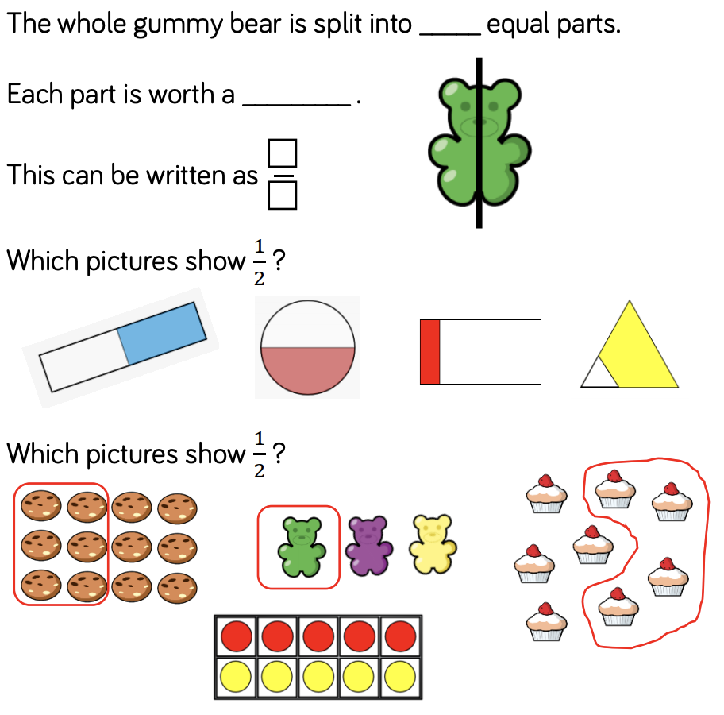  Y1 Access the White Rose Maths website for home learning (link below).  https://whiterosemaths.com/homelearning/year-1/  Complete Summer Term – Week 8 (w/c 15th June) Lesson 1 (watch the video before following the links to complete suggested activities).  Y2 Access the White Rose Maths website for home learning (link below).  https://whiterosemaths.com/homelearning/year-2/  Complete Summer Term – Week 8 (w/c 15th June) – Lesson 1 (watch the video before following the links to complete suggested activities).  KS1 - If you do have access to a printer and want to print the linked sheets that go with each lesson, you can do. If you do this, you do not have to do the Power Maths pages as well.  If you do not have access to a printer, watch the White Rose video each day and then complete work in your Power Maths books.  Daily Project – PSHE/Mental Health – EYFS/KS1  Today we will be thinking about how some of our friends have now returned to school/or might be returning to school in the next few weeks and how we might be feeling about this.  TASK 1: Talk about how rainbows have been a symbol during the pandemic/think back to those you may have seen/made - explain that there are no rainbows without rain and that lots of people have been displaying them in the windows of their homes etc. Explain what this means. Your child may have already made a rainbow for your windows at home but here are some more ideas for making rainbows in different ways if you wish: Printing using utensils, sponges and objects/Cutting strips of paper (red longest, violet shortest) staple each end and glue cotton  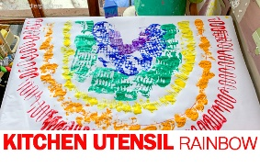  Now research a different inspirational quote to display. Design/make your own symbol for this.  TASK 2: Do you have any playdough or clay? If so, can you use it to make three dimensional masks of the different emotions from the fans (https://www.twinkl.co.uk/resource/t-t-190-ourselves-emotion-fans) ). Talk about how we might be feeling lots of different emotions at the moment and that all of them are okay. Talk about how it okay not to feel okay but it is important to talk to someone if you are feeling unhappy or unsafe. If you don’t have any playdough/clay, you could use cardboard/junk to make them or draw your own pictures.  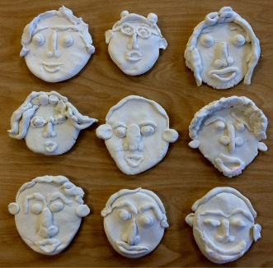  You might also like to listen to this story: Pass it On Sophie Henn - https://www.youtube.com/watch?v=lzupwdcLjkw
Tuesday | Phonics  Preschool – see notes above.  Reception – Phase 4 revision: Practise GPCs and Phase 4 Tricky Words – You can continue to play ‘Flashcards’ using the previously attached resources and ‘Quickwrite Graphemes’ (say the sound on the flashcard ask your child to write it without them seeing it), or alternatively if any of the activities that have been set in weeks 1 and 2 were particularly successful in helping your child to learn their tricky words you could incorporate these for a change. Complete pages 4 – 6 of the Phase 4 ‘caption cards read and draw’ activity sheets (separate).  Year 1 – Phase 6 revision: We are learning to write verbs that have the -ing suffix added on (and revise spelling strategies using the best guesses).  Ask children to quickly write down all the graphemes they know for /oi/. Which is the best guess in the middle of the word? Which at the end? Which are very rare? Repeat for /ow/. Refer to best guess posters:  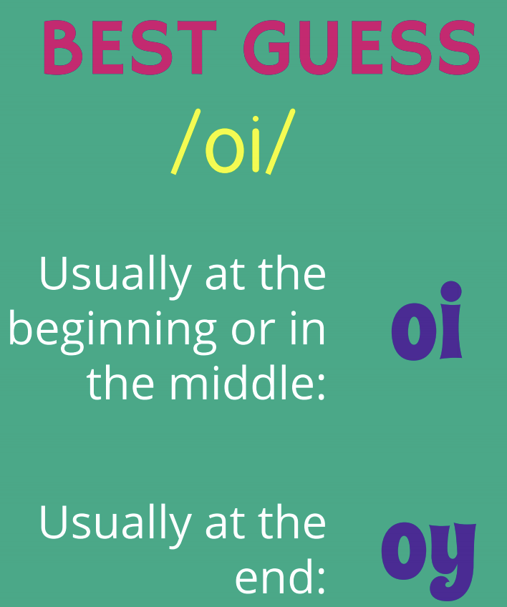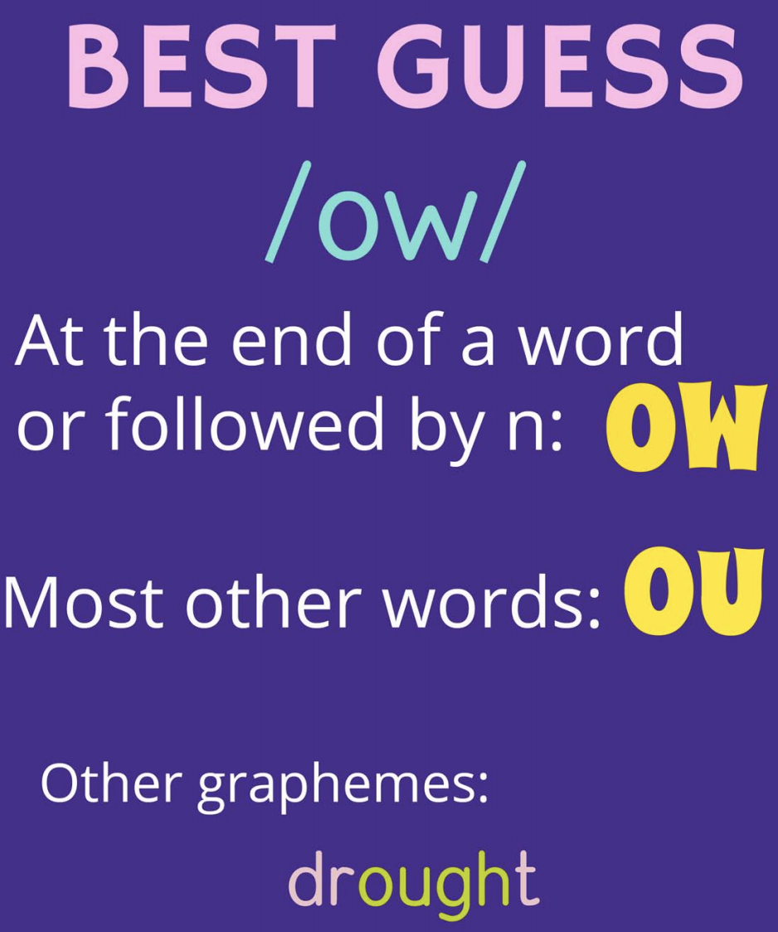  Model segmenting to spell the word enjoying. Model thinking about how to spell the /oi/ sound. E.g. “I'll split the word into syllables.” Draw sound buttons for each syllable and write in the easy phonemes. “The /oi/ sound is at the end of the syllable joy so the best guess spelling is oy.” Write all the letters in. Repeat (segment, sound buttons, put in the easy bits, talk about the thought processes for the tricky bits, make a best guess for the tricky bits) for boiling and destroying. Practise writing: toiling, curling, twirling, burning, squirting, joining, pointing, annoying. Now dictate the following sentences as your child writes them: That annoying elephant was squirting me. I was enjoying that book. I can't help blurting things out. Reveal correctly written sentences and encourage your child to check their own spellings.  Year 2 revision – /l/ or /əl/ sounds spelt ‘il’ at the end of words: Ask pupils to find as many /l/ or /əl/ words spelt in the four different ways as they can in the wordsearch. They should write each word down as they circle it. Tell them that there are 16 words to find. (Answers: muddle, fossil, metal, parcel, animal, pencil, hospital, apple, angel, label, purple, circle, puddle, petal, bubble, table).  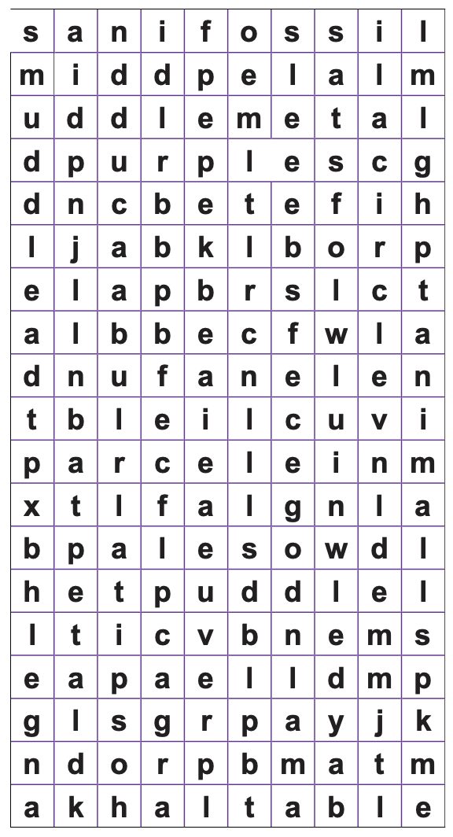  Maths  EYFS Maths Starter:  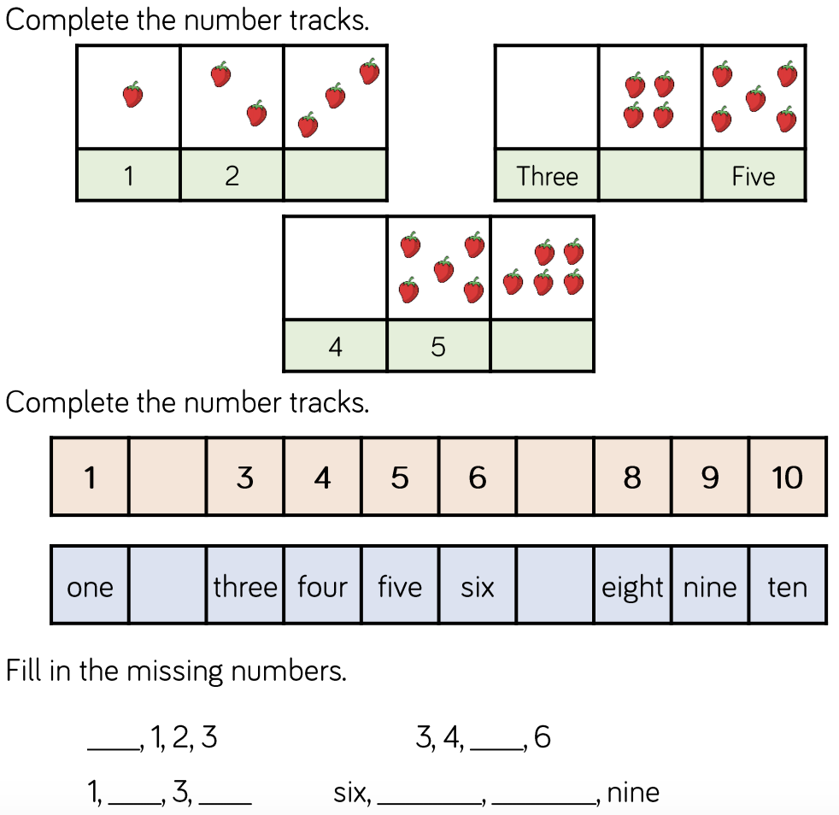  EYFS - Access the White Rose Maths website for home learning (link below).  https://whiterosemaths.com/homelearning/early-years/  Complete Summer Term Week 6 (w/c 1st June) - Day 2: The Snail and the Whale (watch the video before following the links to complete suggested activities).  KS1 Maths Starter:  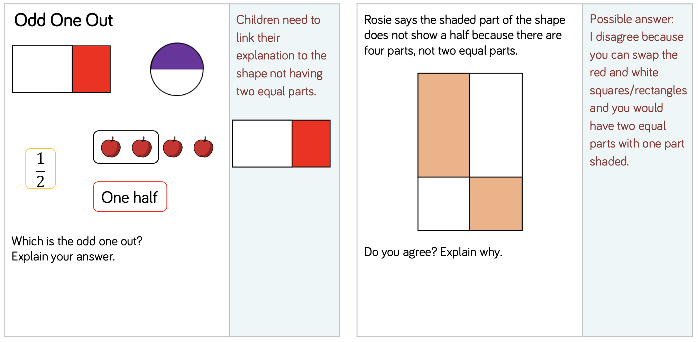  Y1 Access the White Rose Maths website for home learning (link below).  https://whiterosemaths.com/homelearning/year-1/  Complete Summer Term – Week 8 (w/c 15th June) Lesson 2 (watch the video before following the links to complete suggested activities).  Y2 Access the White Rose Maths website for home learning (link below).  https://whiterosemaths.com/homelearning/year-2/  Complete Summer Term – Week 8 (w/c 15th June) Lesson 2 (watch the video before following the links to complete suggested activities).  KS1 - If you do have access to a printer and want to print the White Rose sheets that go with each lesson, you can do. If you do this, you do not have to do the Power Maths pages as well.  If you do not have access to a printer, watch the White Rose video each day and then complete the Power Maths books.  Daily Project – TOPIC and PSHE/Mental Health  Task 1 – Topic - EYFS and KS1: Make a page for a book that describes three of your favourite toys. Compose two or three descriptive sentences to go with a picture of each. Remember to use your best describing words (we have attached some in an additional document on the website to get you started). Don’t forget to check your work for incorrect spellings and choose alternative or better words to use as you proof read and improve your writing.  Task 2 – PSHE/Mental Health – EYFS and KS1: Talk about the things that you are grateful for. Make a gratitude tree: Find a branch, paint it, wrap it with wool etc. to decorate it. Now stick symbols, write words on tags and draw pictures to hang on the tree.  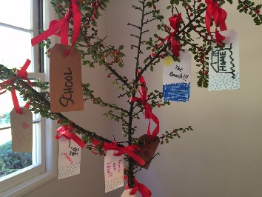  You might also like to listen to this story: https://www.youtube.com/watch?v=J82L14IMU2k

Wednesday | Phonics  Preschool – see notes above.  Reception – Phase 4 revision: Practise GPCs and Phase 4 Tricky Words – You can continue to play ‘Flashcards’ using the previously attached resources and ‘Quickwrite Graphemes’ (say the sound on the flashcard ask your child to write it without them seeing it), or alternatively if any of the activities that have been set in weeks 1 and 2 were particularly successful in helping your child to learn their tricky words you could incorporate these for a change. Begin ‘Phase 4 Activity Booklet Week 3’ (separate).  Year 1 – Phase 6 revision: We are learning to read the days of the week: Monday, Tuesday, Wednesday, Thursday, Friday, Saturday, Sunday. Play a rhyming game. E.g. Say something along the lines of, “I need a rhyme in extra quick time and the word I want a rhyme for is...” Child calls out rhyming words. Keep a tally chart of how many they get before they get stuck, give a word that doesn't actually rhyme, or repeats one that has already been suggested. Repeat for other words. Try: bat, poor, week, school or any other word. You can also play ‘Cake Bake’, on Phonics Play if you subscribe for free. Look at each day of the week. Ask them to think about where soundbuttons would go. Does the word have any tricky bits? Ask a child to soundtalk and blend to read a word and then repeat. Repeat with all days and then practise reading flashcards of the days of the week, aiming to get faster and faster. Show sentences involving days of the week, one at a time. Child reads independently in their head, when confident, read the question out loud. Show with thumbs up or thumbs down whether the answer to the question is true or false. Monday is the first day of the school week. Saturday and Sunday make up the weekend. Wednesday has more letters than any of the other days.  Year 2 revision - /l/ or /əl/ sounds spelt ‘il’ at the end of words: Play a memory game with the /l/ or /əl/ words. RULES: Display a range of words from the previous session with the different endings. Ask your child to look at them carefully and chant some of the trickier ones. Tell them to close their eyes and try to remember them. Remove or cover one of the words and ask pupils to write the missing word down. Reveal the word and check spellings. Repeat with other words.  Maths  EYFS Maths Starter:  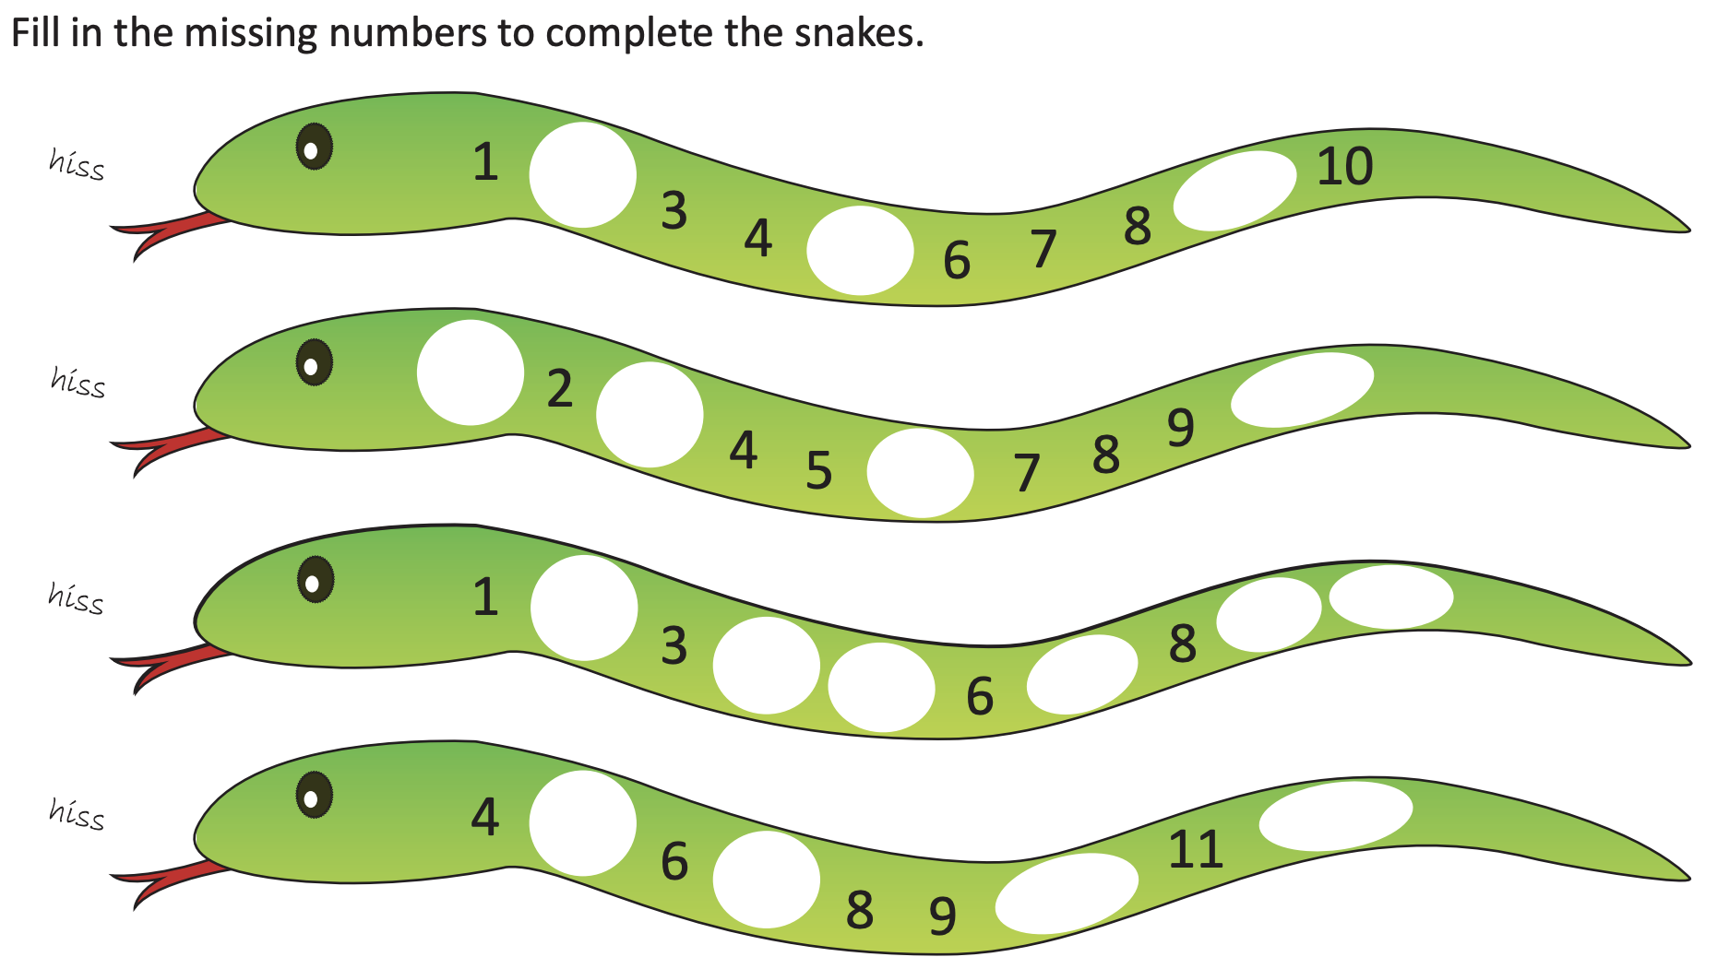  EYFS - Access the White Rose Maths website for home learning (link below).  https://whiterosemaths.com/homelearning/early-years/  Complete Summer Term Week 6 (w/c 1st June) - Day 3: The Snail and the Whale (watch the video before following the links to complete suggested activities).  KS1 Maths Starter:  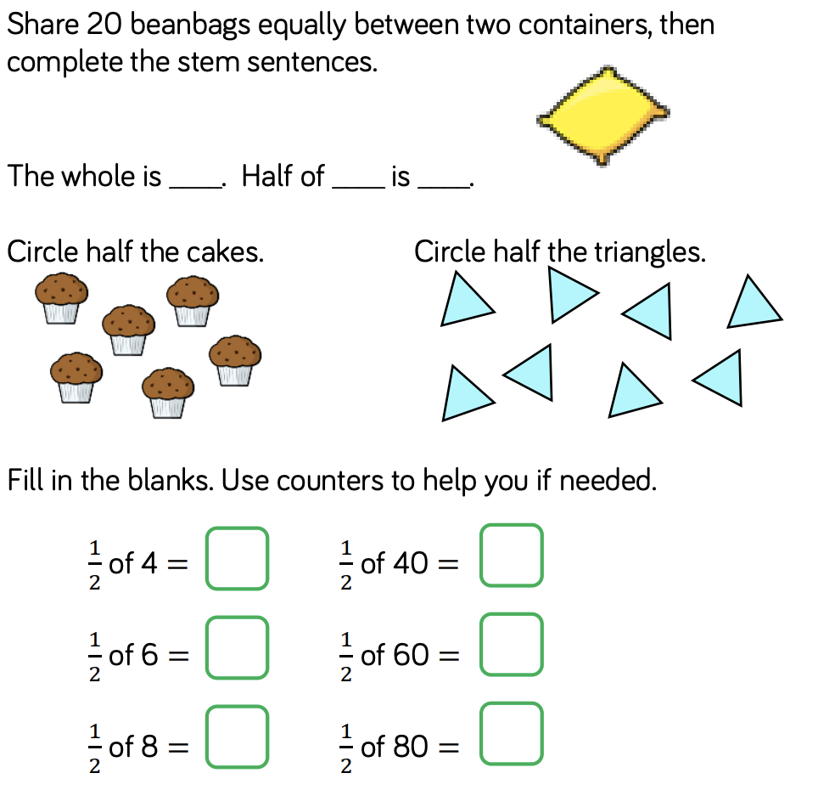  Y1 Access the White Rose Maths website for home learning (link below).  https://whiterosemaths.com/homelearning/year-1/  Complete Summer Term – Week 8 (w/c 15th June) Lesson 3 (watch the video before following the links to complete suggested activities).  Y2 Access the White Rose Maths website for home learning (link below).  https://whiterosemaths.com/homelearning/year-2/  Complete Summer Term – Week 8 (w/c 15th June) Lesson 3 (watch the video before following the links to complete suggested activities).  KS1 - If you do have access to a printer and want to print the White Rose sheets that go with each lesson, you can do. If you do this, you do not have to do the Power Maths pages as well.  If you do not have access to a printer, watch the White Rose video each day and then complete the Power Maths books.  Daily Project – PE/Mental Health/PSHE  TASK 1 - EYFS and KS1: As many of you will have been using the computer over the last few weeks, we are including a unit on Computer Safety for this week and next. Follow this link: https://us8.campaign-archive.com/?u=57437507f4a3aad76843b6d9e&id=bc8f45e3ce&e=b9859c0018; it will take you to a You Tube video featuring DeeDee (DeeDee is our PSHE friend). She will talk to you about being safe on the computer. There is also a PowerPoint for you to then follow and the required resources are on the same page to download and complete as indicated in the PowerPoint. Please complete this ‘unit of work’ over the next 2 weeks.  TASK 2 – EYFS and KS1: Continue with the next page of your ‘Family positivity and gratitude pack’ (see resources attached on the website from week 1).
Thursday | Phonics  Preschool – see notes above.  Reception – Phase 4 revision: Practise GPCs and Phase 4 Tricky Words – You can continue to play ‘Flashcards’ using the previously attached resources and ‘Quickwrite Graphemes’ (say the sound on the flashcard ask your child to write it without them seeing it), or alternatively if any of the activities that have been set in weeks 1 and 2 were particularly successful in helping your child to learn their tricky words you could incorporate these for a change. Complete ‘Phase 4 Activity Booklet Week 3’ (separate).  Year 1 – Phase 6 revision: We are learning to read verbs that have had -er added onto them. Revise blending to read phase 5 words and making alternative pronunciation choices.  If you have access to Phonics Play (subscribe for free) play Cheeky Chimps or Sneaky Squirrels (for the ch grapheme). Show your child the following verbs and ask them to soundtalk then blend to read the verb, then act it out – sing, jump, scratch, listen, nibble, scream, trudge. Briefly explain that the words are easy to act out because they are action words (verbs). If you feel they are ready, look at verbs like think, guess, decide and worry – talk about the fact that these are actions that we take inside our heads so they are harder to act out. Touch also on verbs like am, can, will, was, is and explain that these are also verbs (because they describe a state of being) but they are very hard to act out on their own. Show that we can add an -er ending to turn the verb into a name for a person or thing (noun) that does that action. Ask the children to do each action again. Say “You jump so you are a... (jumper). You teach so you are a ... (teacher).” etc. Show the word with the -er ending each time. Remind them that they have easily been able to read the grapheme -er at the end of the word since Phase 3. Now dictate the following sentences as your child writes them: A teacher also has to be a learner. The farmer was a very hard worker. She was a bit of a dreamer but a brilliant painter. Reveal correctly written sentences and encourage your child to check their own spellings.  Year 2 revision - Strategies for learning words: common exception words: Ask your child to tell you all the different ways that they now know to learn their spellings. Display some of the common exception words that pupils are finding difficult in daily spelling work. Which strategy do they think would help them to learn each word? Child to record the words in and start using the strategies to learn the words – for example:  - Look, say, cover, write, check  - Tracing over and Rainbow writing  - Highlighting the tricky bit  - Making up a mnemonic  - Saying the word in a funny way  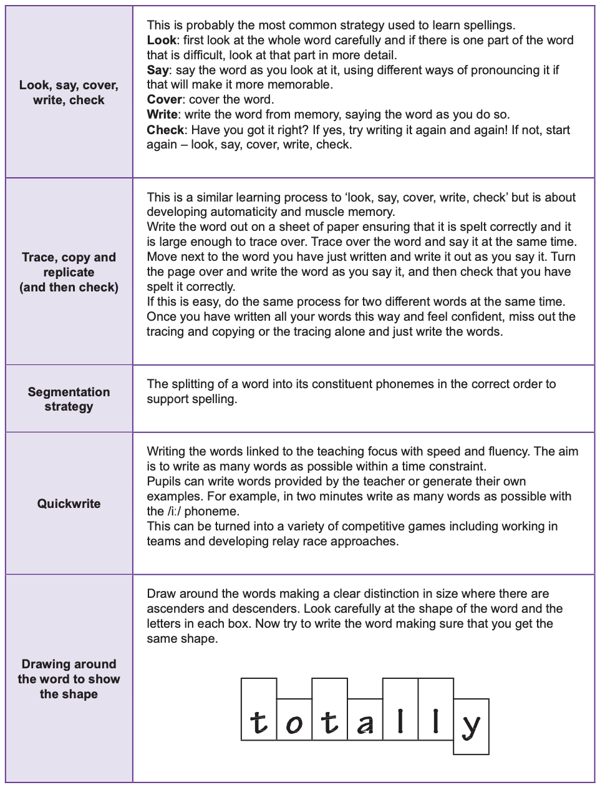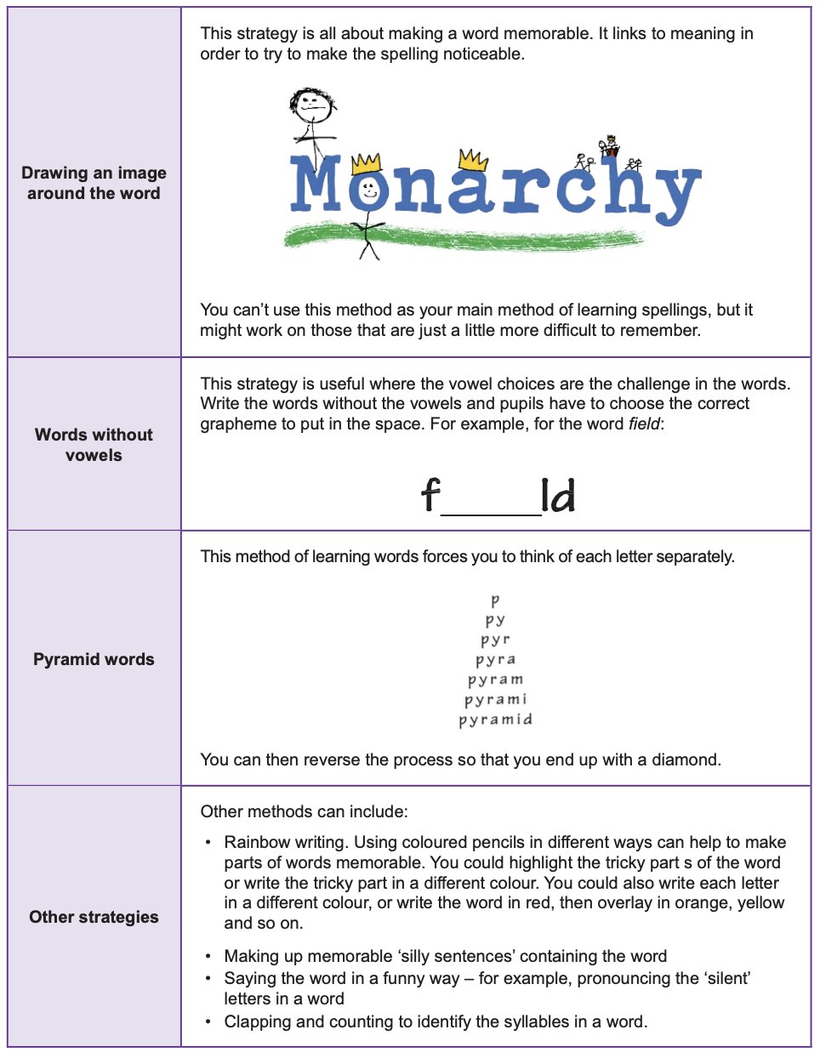  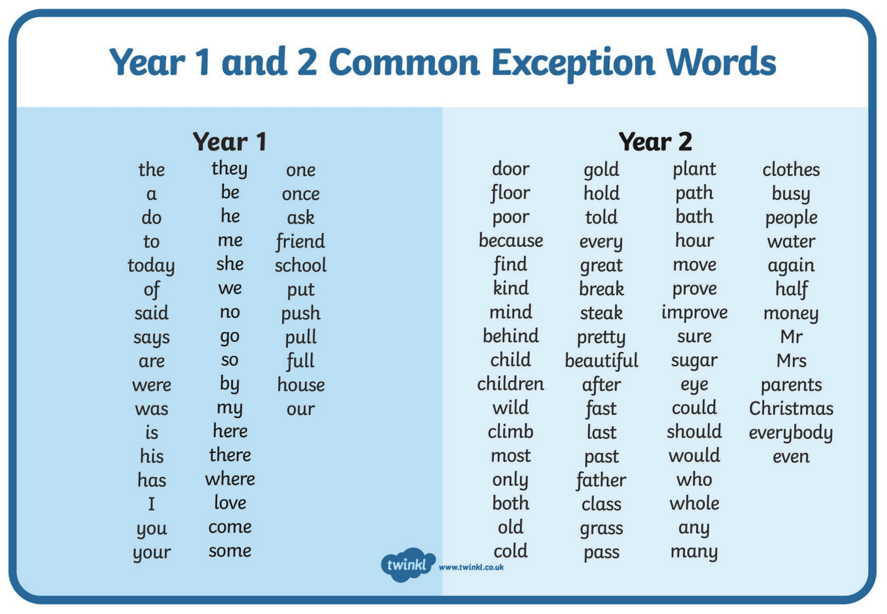  Maths  EYFS Maths Starter:  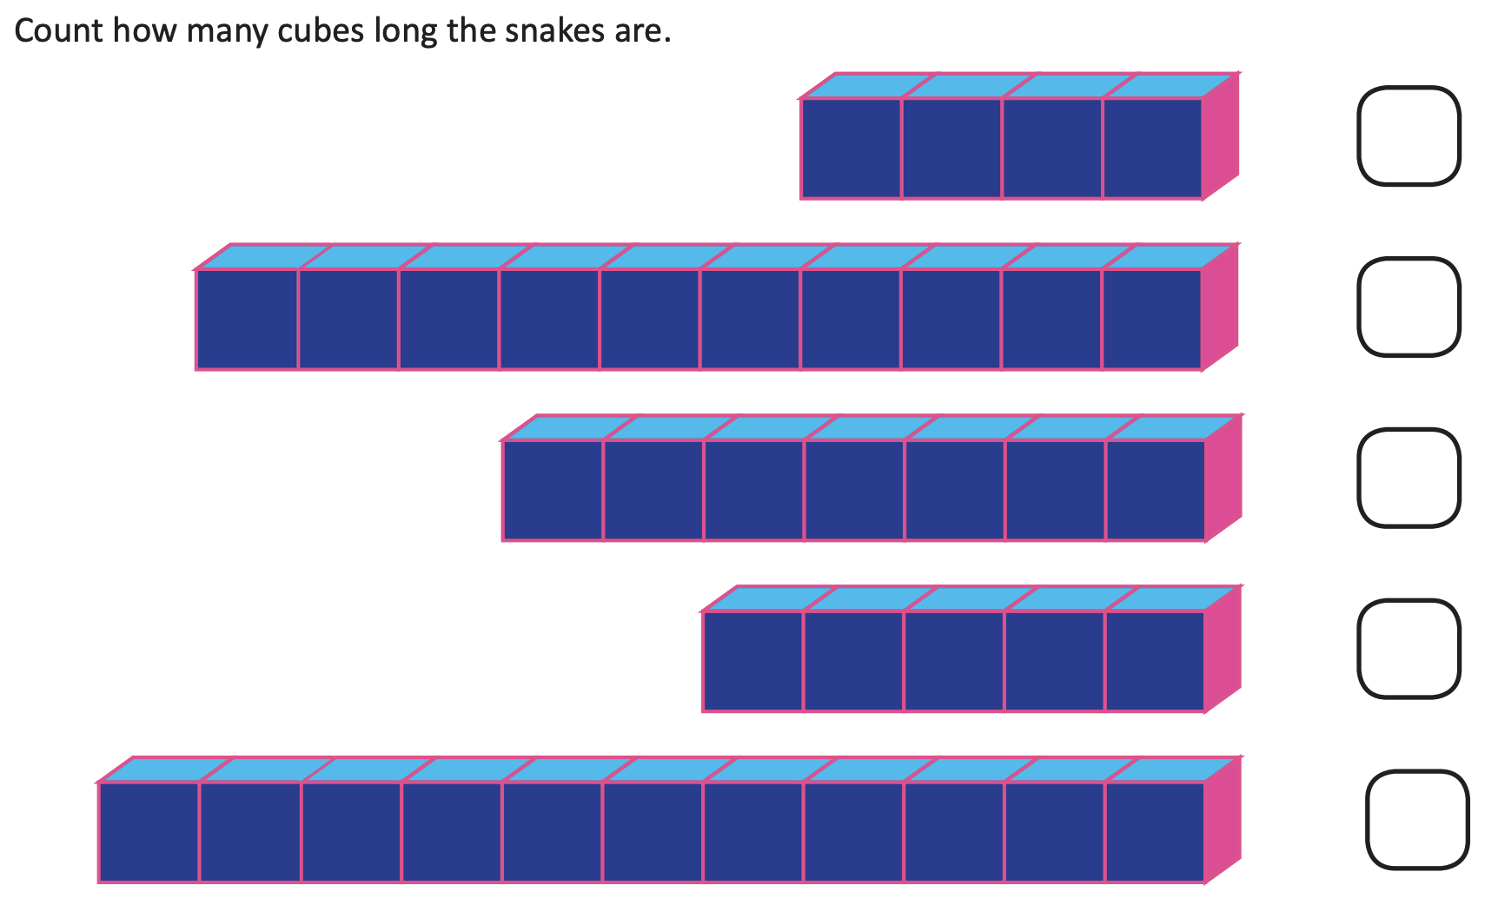  EYFS - Access the White Rose Maths website for home learning (link below).  https://whiterosemaths.com/homelearning/early-years/  Complete Summer Term Week 6 (w/c 1st June) - Day 4: The Snail and the Whale (watch the video before following the links to complete suggested activities).  KS1 Maths Starter:  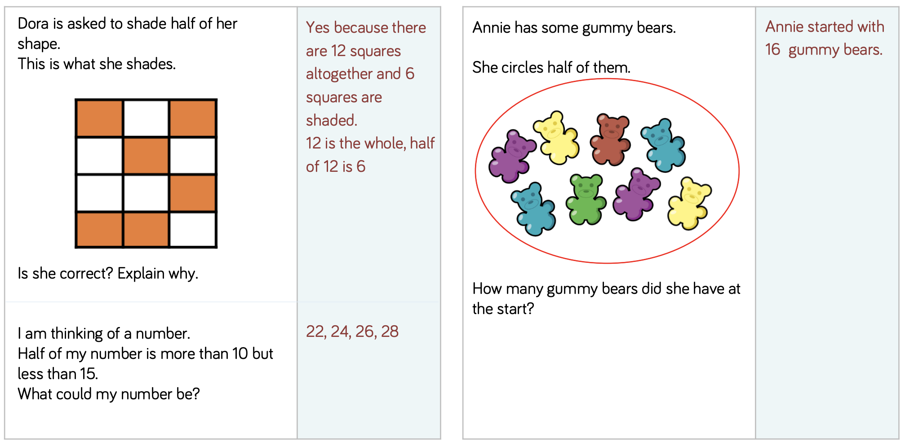  Y1 Access the White Rose Maths website for home learning (link below).  https://whiterosemaths.com/homelearning/year-1/  Complete Summer Term – Week 8 (w/c 15th June) Lesson 4 (watch the video before following the links to complete suggested activities).  Y2 Access the White Rose Maths website for home learning (link below).  https://whiterosemaths.com/homelearning/year-2/  Complete Summer Term – Week 8 (w/c 15th June) Lesson 4 (watch the video before following the links to complete suggested activities).  KS1 - If you do have access to a printer and want to print the White Rose sheets that go with each lesson, you can do. If you do this, you do not have to do the Power Maths pages as well.  If you do not have access to a printer, watch the White Rose video each day and then complete the Power Maths books.  Daily Project – PE/ PSHE/Mental Health/Art  Task 1 – EYFS and KS1: Share the idea that we are all unique and all have our own individual profile of strengths. Enable your child to think of one special thing about someone else. Have a go at signing and signing Katy Perry, ‘Roar’. A song about feeling empowered and choosing to recognise our strength https://www.youtube.com/watch?v=wCfjV_G_x5s. Encourage your child to take photographs of others, if possible. Print and photocopy in black and white - then add labels onto this surface using felt tipped pens or pencils to record some of their ideas.  Task 2 – EYFS and KS1: Make a face mobile to represent an expression or emotion.  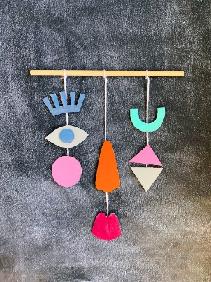
Friday | Phonics  Preschool – see notes above.  Reception – Phase 4 revision: AS LAST WEEK Watch some of these videos to revise your phonemes https://www.bbc.co.uk/bitesize/topics/zvq9bdm. Have a look at the games on this website: http://www.letters-and-sounds.com/phase-4-games.html and have a go at some of them to practise your phonics.  Year 1 – Phase 6 revision: We are learning to spell verbs that have had -er added on to turn them into a noun. Ask your child to quickly write down all the graphemes they know for /or/. Which is the best guess in the middle of the word? Which at the end? Which are very rare? Repeat for /ai/. Refer to best guess posters:  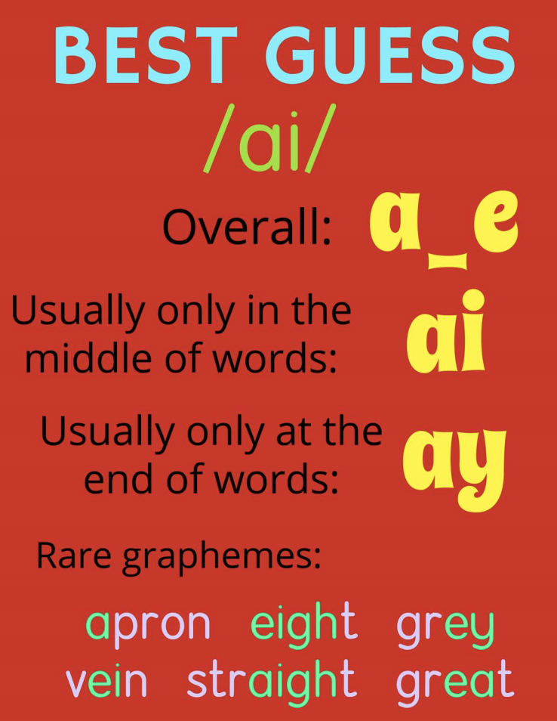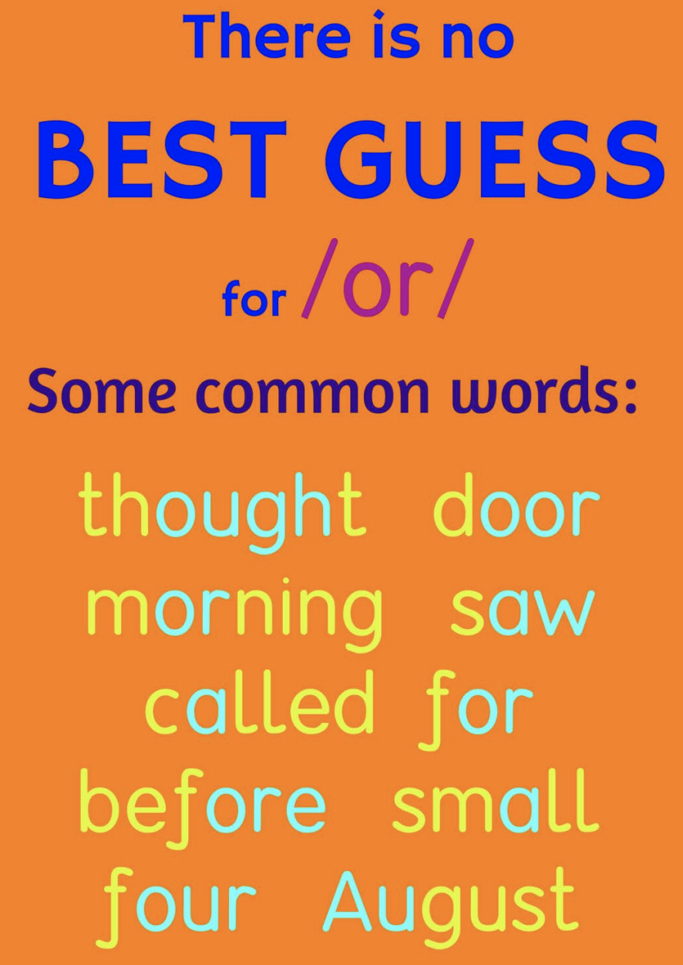  Model segmenting to spell the word player. Model thinking about how to spell the /ai/ sound. E.g. “I'll start with the first syllable /p/ /l/ /ay/.” Draw sound buttons and write in the easy phonemes “The /ai/ sound is a tricky one but as it is at the end of the root word, the best guess spelling is ay. The last syllable is /er/ (draw one more sound button) and at the end of a word. We know that this sound at the end of a word is often spelt er.” Write all the letters in. Repeat (segment, sound buttons, put in the easy bits, talk about the thought processes for the tricky bits, make a best guess for the tricky bits) for walker and charmer. Try writing: waiter, painter, burner, speaker, heater, hunter. Now dictate the following sentences as your child writes them: The walker would not slow down. The trainer was ready for the big race. This dragon was a bit of a charmer. Reveal correctly written sentences and encourage your child to check their own spellings.  Year 2 – revision: Use the strategies discussed in the previous session to practise spelling Common Exception Words..  Maths  EYFS Maths Starter:  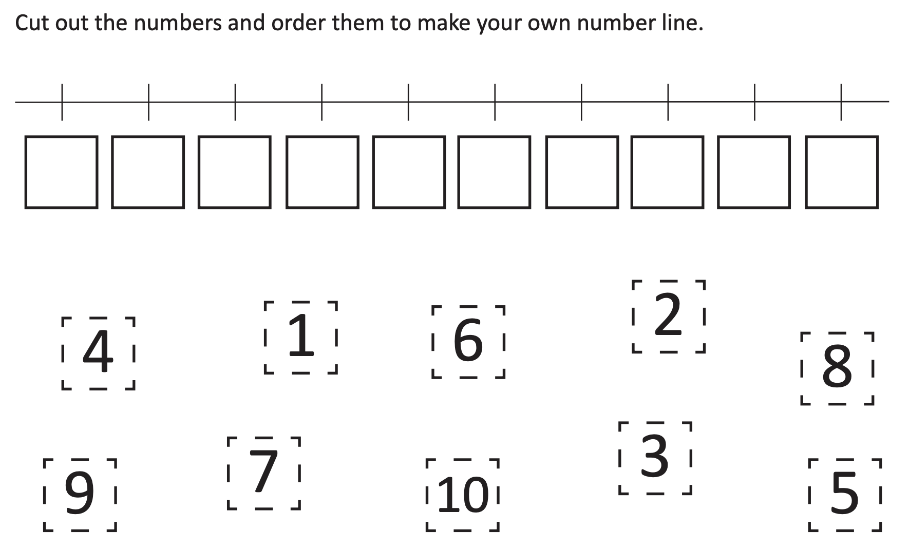  EYFS - Access the White Rose Maths website for home learning (link below).  https://whiterosemaths.com/homelearning/early-years/  Complete Summer Term Week 6 (w/c 1st June) - Day 5: The Snail and the Whale (watch the video before following the links to complete suggested activities).  KS1 Maths Starter:  Why not have some fun with fractions today? Visit https://www.twinkl.co.uk/resources/numeracy-maths/fractions/activities-and-games-fractions-maths-key-stage-1 to print, make and play a fractions board game or use one of their interactive resources! Have fun!  Y1 Access the White Rose Maths website for home learning (link below).  https://whiterosemaths.com/homelearning/year-1/  Complete Summer Term – Week 8 (w/c 15th June) Lesson 5 (watch the video before following the links to complete suggested activities).  Y2 Access the White Rose Maths website for home learning (link below).  https://whiterosemaths.com/homelearning/year-2/  Complete Summer Term – Week 8 (w/c 15th June) Lesson 5 (watch the video before following the links to complete suggested activities).  KS1 If you do have access to a printer and want to print the White Rose sheets that go with each lesson, you can do. If you do this, you do not have to do the Power Maths pages as well.  If you do not have access to a printer, watch the White Rose video each day and then complete the Power Maths books.  Daily Project – SPELLING  KS1 – See attached sheets on website for revision and practise. (Please note that there is a sheet for this week and also one ready for next week).  Daily Project - Extra-Curricular Time (PE/ PSHE/Mental Health/Mindfulness/Art)  Task 1 – EYFS and KS1: Research Andy Warhol - have a go at creating pop art for an everyday object (maybe hand sanitiser instead of soup)!  Task 2 – EYFS and KS1: Guided Mindfulness Listening Activity: https://www.youtube.com/watch?v=uUIGKhG_Vq8  Task 3 – EYFS and KS1: Continue learning the signing and signing to Katy Perry’s, ‘Roar’ (yesterday) - a song about feeling empowered and choosing to recognise our strengths https://www.youtube.com/watch?v=wCfjV_G_x5s. Now make Super Hero Lolly Sticks - Make a super hero lolly stick of yourself or someone you admire. You could use twigs if you don’t have a lolly stick – get creative!  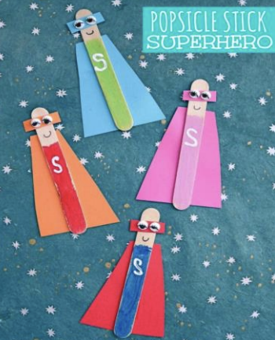

Reception spellings
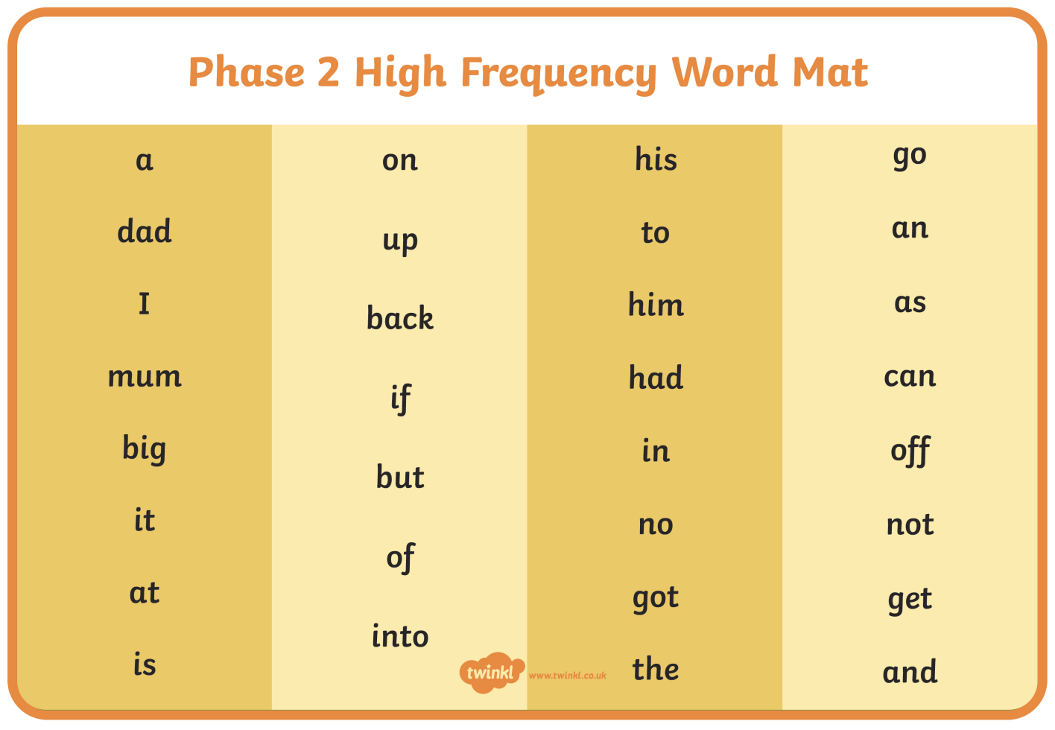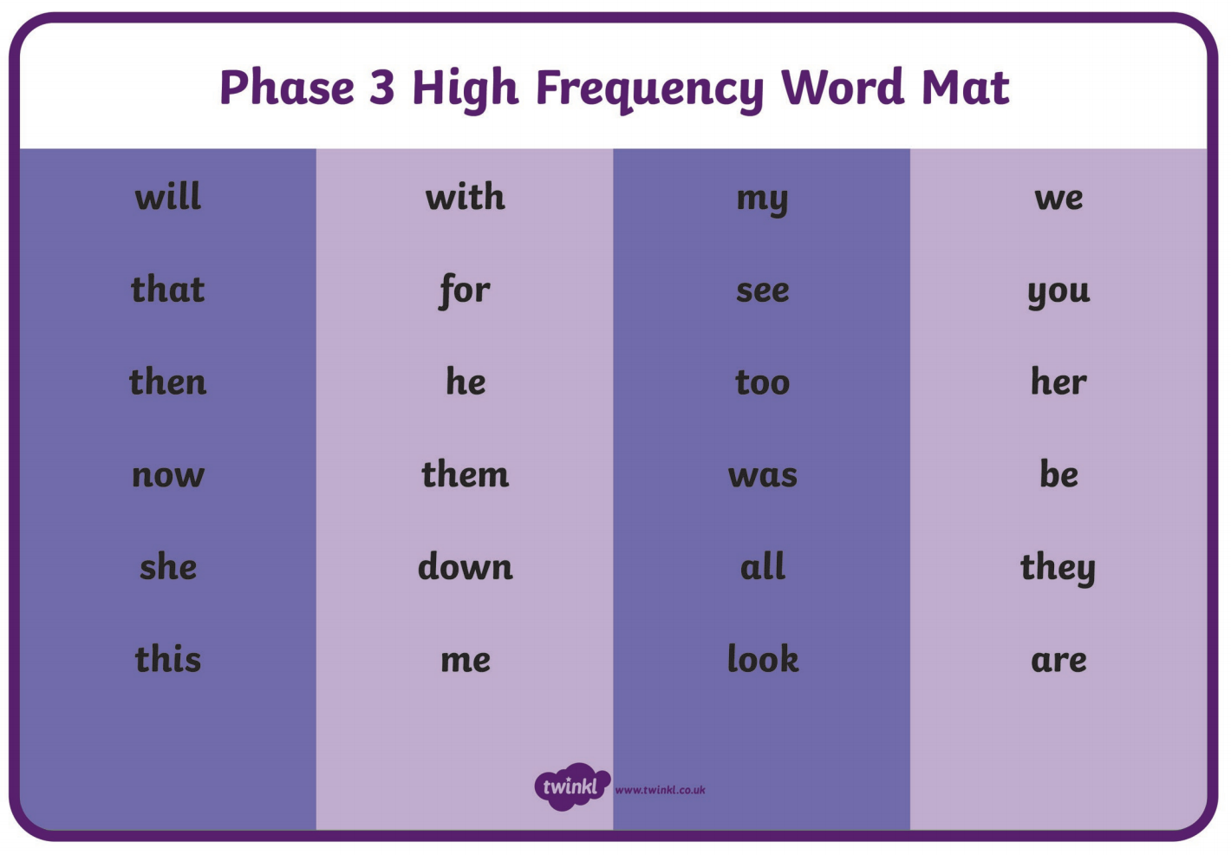

KS1 – Spellings
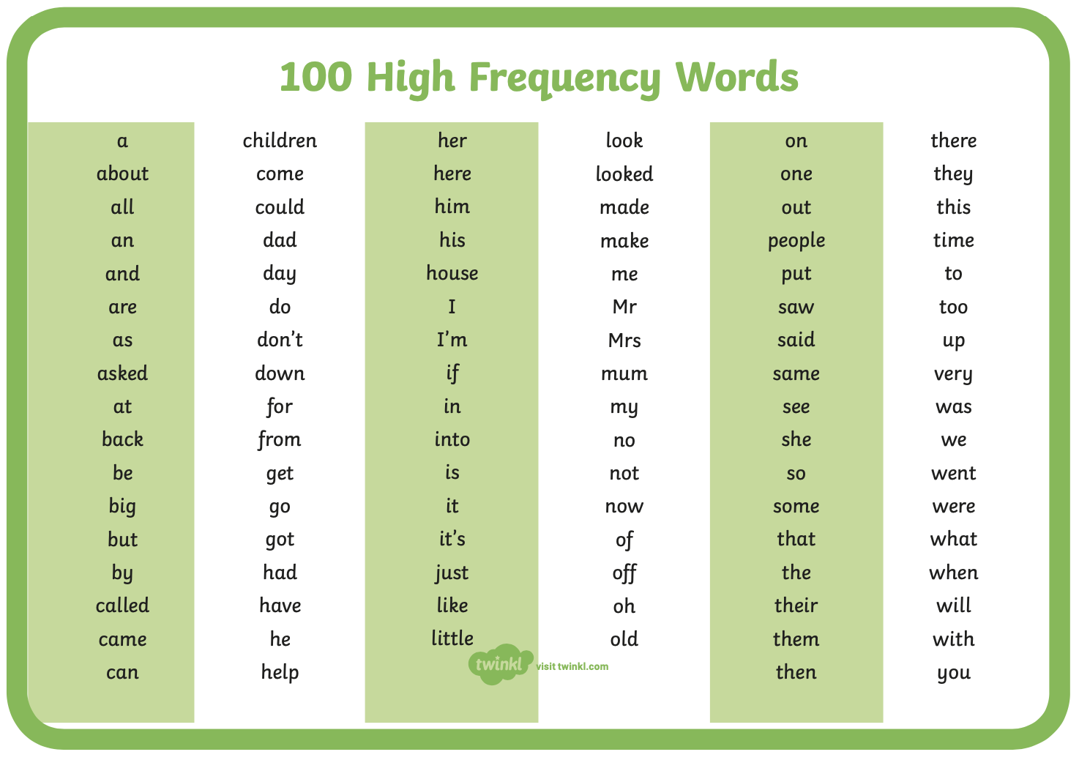

Pre-school Letter Formation Guidance
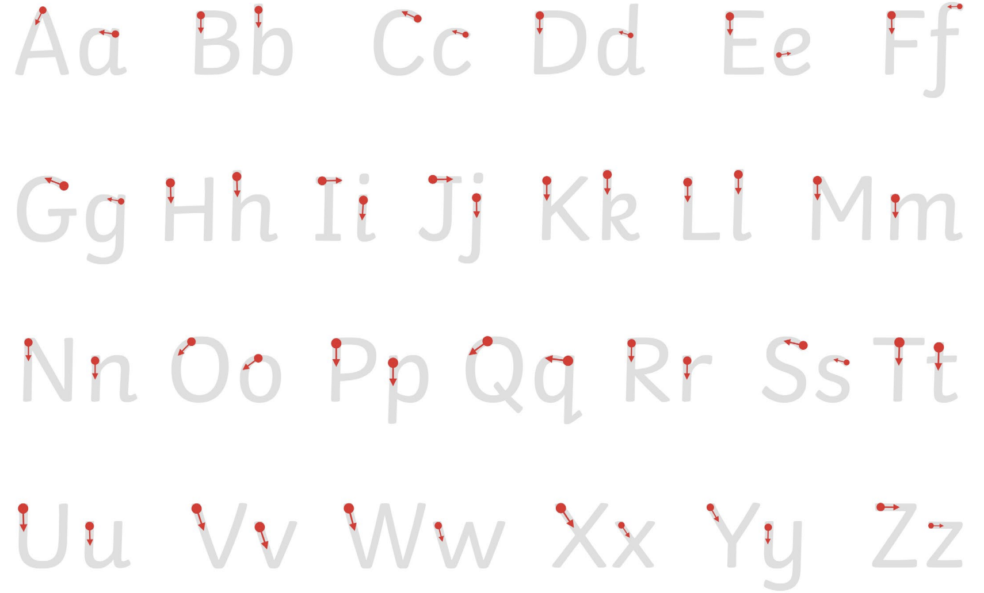
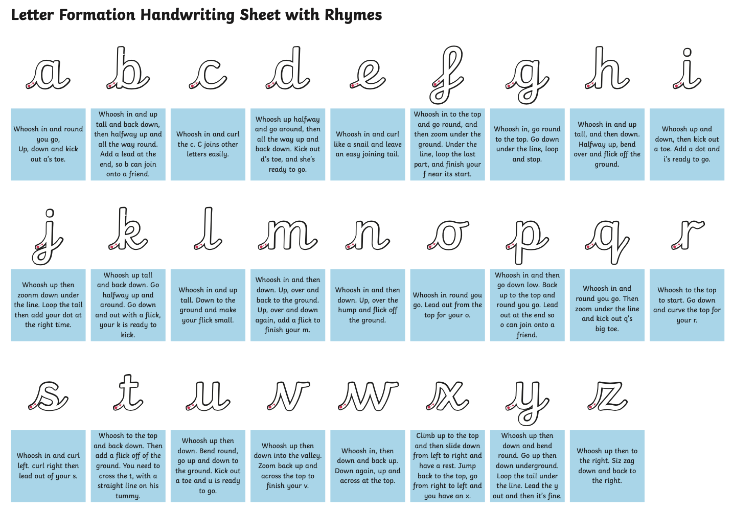

Monday | Phonics  Preschool – see notes above.  Phonics for this week R- Y2: Talk for Creative Writing  Instead of specific phonics revision planning this week, we have set a creative writing unit for you to complete during this time (you will see that there are also occasions that you can use your Daily Project time to complete a little more of it). You should also aim to continue to revise your GPCs and Tricky Words using some of the activities that we have suggested in previous planning/Phonics Play and using other online interactive materials signposted previously (look back in particular to those sessions/graphemes that you found more challenging). Our aim now is to encourage you to make use of your phonic skills as you write a bit more (we need to build up writing stamina), as well as to give you an opportunity to be creative. You will need some help from a grown up, but we would like you to try to work as if we were doing a guided reading session in school.  EY: ‘Mouse’s Adventures’  There are 8 little sections in this lovely unit of work. Work through this little booklet; please try to complete one-two sections each day.  Year 1: ‘Sayeeda - The Pirate Princess’  There are many activities (not all writing) for you to work through. Please try one-two activities each day. You can use the sheets in the pack to record on or you can record in your books.  Year 2: ‘Rainbows, Rainbows Everywhere’  This comprises several activities of which you should do one-two per day where possible. Please do not rush through - remember to use everything that we have taught you this year to help you.  Maths  EYFS Maths Starter  Match fingers to numerals Games (to 10): Say that we will play a game where you show a number card and they have to show that number of fingers. Ask your child to put their hands behind their back. Show a card. On a count of three, they bring out their hands to show! Repeat.  Now do this:  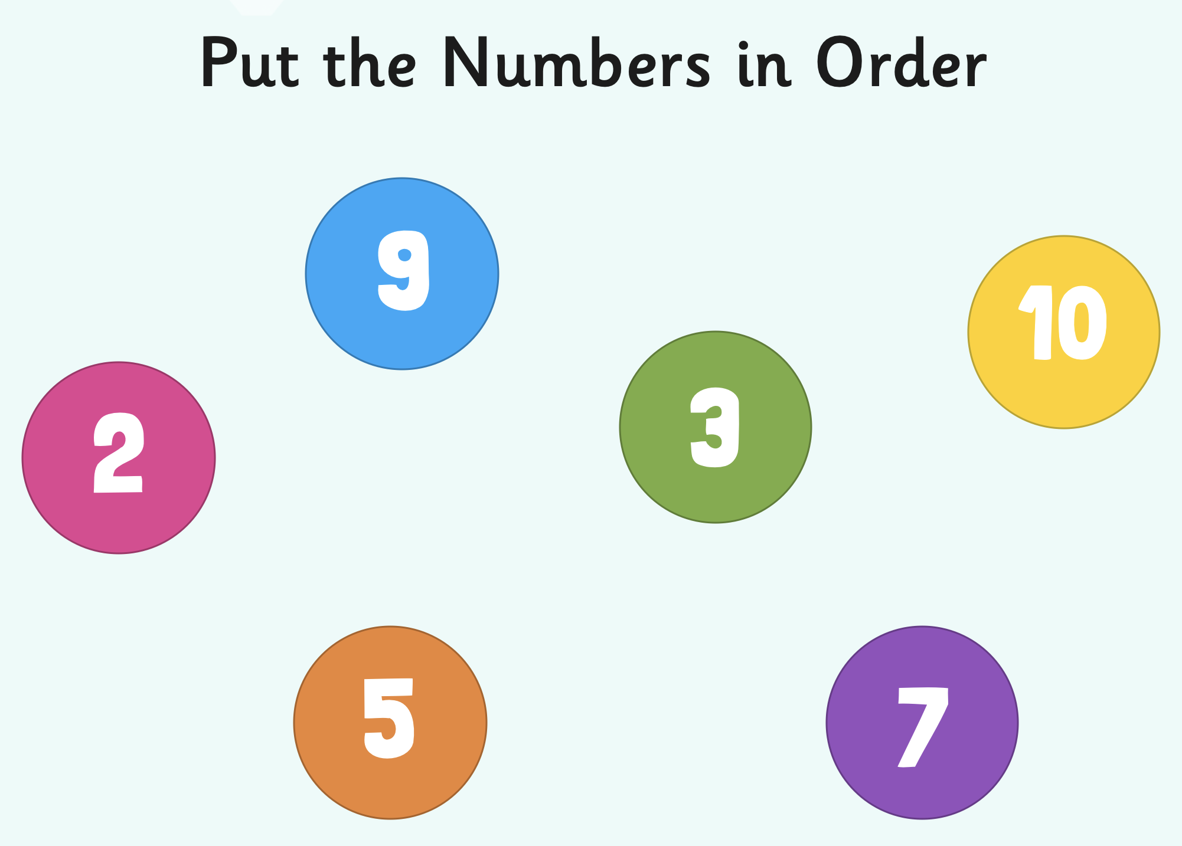  EYFS - Access the White Rose Maths website for home learning (link below).  https://whiterosemaths.com/homelearning/early-years/  Complete Summer Term Week 7 (w/c 8th June) - Day 1: The Princess and the Wizard (watch the video before following the links to complete suggested activities).  KS1 Maths Starter  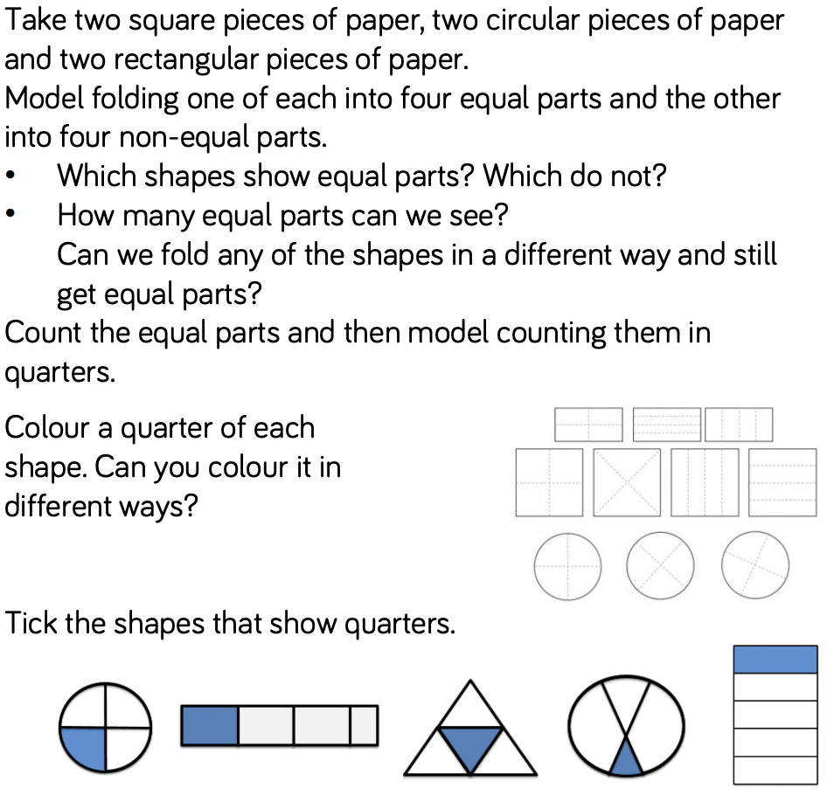  Y1 Access the White Rose Maths website for home learning (link below).  https://whiterosemaths.com/homelearning/year-1/  Complete Summer Term – Week 9 (w/c 22nd June) Lesson 1 (watch the video before following the links to complete suggested activities).  Y2 Access the White Rose Maths website for home learning (link below).  https://whiterosemaths.com/homelearning/year-2/  Complete Summer Term – Week 9 (w/c 22nd June) Lesson 1 (watch the video before following the links to complete suggested activities).  KS1 - If you do have access to a printer and want to print the White Rose sheets that go with each lesson, you can do. If you do this, you do not have to do the Power Maths pages as well.  If you do not have access to a printer, watch the White Rose video each day and then complete the Power Maths books.  Daily Project – PE/Mental Health/PSHE/RE  TASK 1 - EYFS and KS1: Complete the unit on Computer Safety (see last week). Follow link: https://us8.campaign-archive.com/?u=57437507f4a3aad76843b6d9e&id=bc8f45e3ce&e=b9859c0018.  TASK 2 – EYFS and KS1: Continue with the next page of your ‘Family positivity and gratitude pack’ (see resources attached on the website from week 1).  TASK 3 – EYFS and KS1: RE work attached on website ‘Special Places’.
Tuesday | Phonics  Preschool – see notes above.  Phonics for this week R- Y2: Talk for Creative Writing – See Monday planning.  Maths  EYFS Maths Starter:  Count and read numbers to 20: Throw a beanbag/ball to your child, saying ‘one’. They throw it back saying ‘two’. You throw it back to them, saying ‘three’. They throw it back saying ‘four’. Continue to 20 then start over.  EYFS - Access the White Rose Maths website for home learning (link below).  https://whiterosemaths.com/homelearning/early-years/  Complete Summer Term Week 7 (w/c 8th June) - Day 2: The Princess and the Wizard (watch the video before following the links to complete suggested activities).  KS1 Maths Starter:  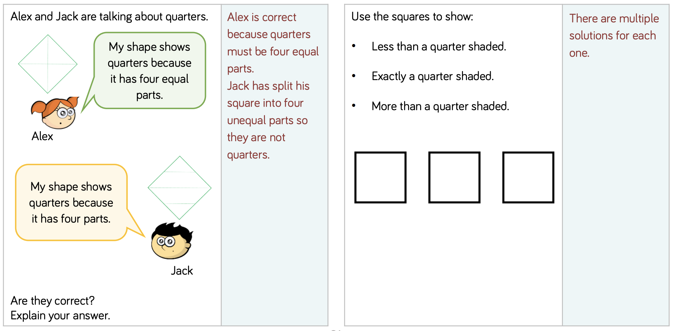  Y1 Access the White Rose Maths website for home learning (link below).  https://whiterosemaths.com/homelearning/year-1/  Complete Summer Term – Week 9 (w/c 22nd June) Lesson 2 (watch the video before following the links to complete suggested activities).  Y2 Access the White Rose Maths website for home learning (link below).  https://whiterosemaths.com/homelearning/year-2/  Complete Summer Term – Week 9 (w/c 22nd June) Lesson 2 (watch the video before following the links to complete suggested activities).  KS1 - If you do have access to a printer and want to print the White Rose sheets that go with each lesson, you can do. If you do this, you do not have to do the Power Maths pages as well.  If you do not have access to a printer, watch the White Rose video each day and then complete the Power Maths books.  Daily Project - EYFS and KS1  Use this time to do some more work on your Talk for Creative Writing.

Wednesday | Phonics  Preschool – see notes above.  Phonics for this week R- Y2: Talk for Creative Writing – See Monday planning.  Maths  EYFS Maths Starter:  Making Money - Count out ten 1p coins. Take a 5p coin. Use some of your 1p coins to make the same amount as your 5p. Take a 2p coin. Use some of your 1p coins to make the same amount as your 2p. Take a 10p coin. Use your 1p coins to make the same amount as your 10p coin. Make 5p using 2p and 1p coins. Make it again in a different way.  EYFS - Access the White Rose Maths website for home learning (link below).  https://whiterosemaths.com/homelearning/early-years/  Complete Summer Term Week 7 (w/c 8th June) - Day 3: The Princess and the Wizard (watch the video before following the links to complete suggested activities).  KS1 Maths Starter:  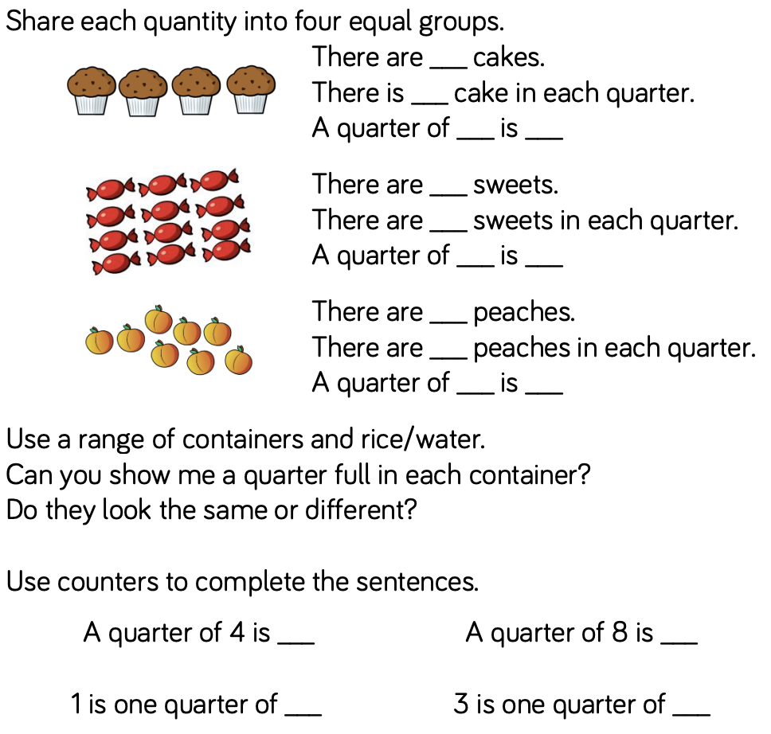  Y1 Access the White Rose Maths website for home learning (link below).  https://whiterosemaths.com/homelearning/year-1/  Complete Summer Term – Week 9 (w/c 22nd June) Lesson 3 (watch the video before following the links to complete suggested activities).  Y2 Access the White Rose Maths website for home learning (link below).  https://whiterosemaths.com/homelearning/year-2/  Complete Summer Term – Week 9 (w/c 22nd June) Lesson 3 (watch the video before following the links to complete suggested activities).  KS1 - If you do have access to a printer and want to print the White Rose sheets that go with each lesson, you can do. If you do this, you do not have to do the Power Maths pages as well.  If you do not have access to a printer, watch the White Rose video each day and then complete the Power Maths books.  Daily Project - EYFS and KS1  Use this time to do some more work on your Talk for Creative Writing.
Thursday | Phonics  Preschool – see notes above.  Phonics for this week R- Y2: Talk for Creative Writing – See Monday planning.  Maths  EYFS Maths Starter:  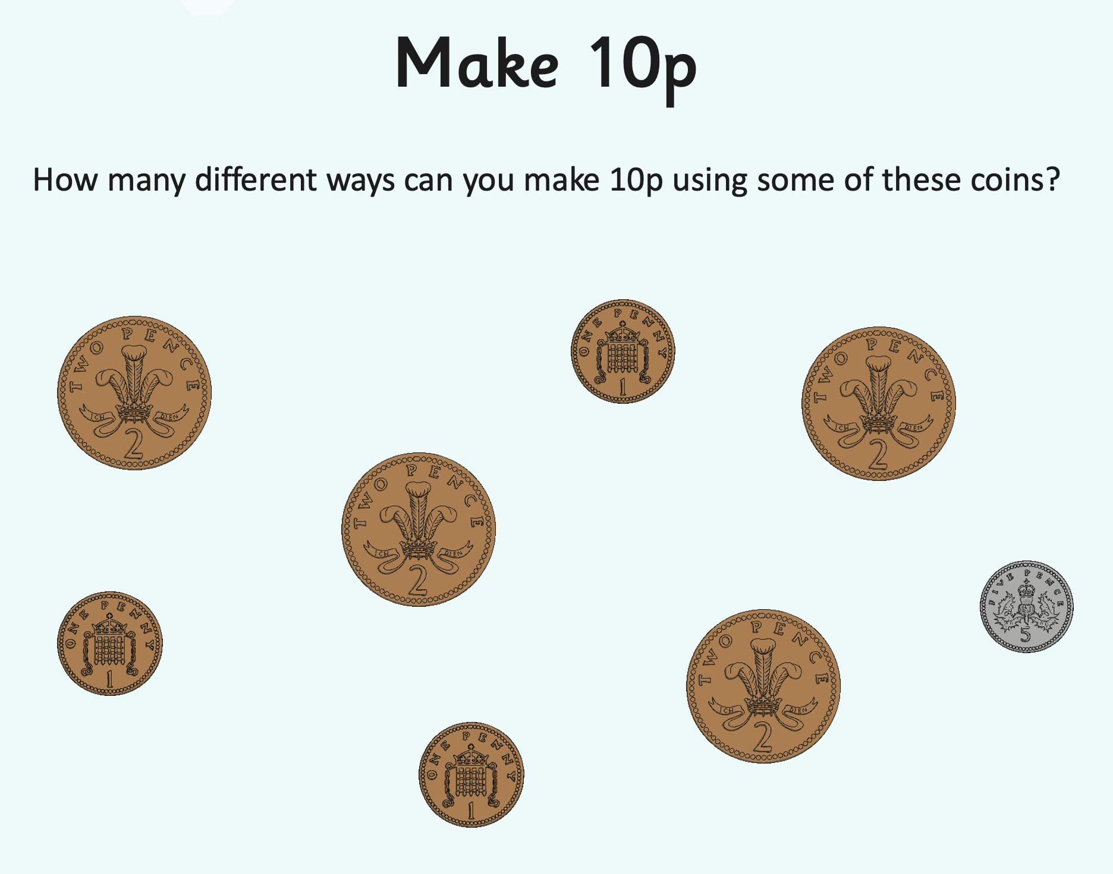  EYFS - Access the White Rose Maths website for home learning (link below).  https://whiterosemaths.com/homelearning/early-years/  Complete Summer Term Week 7 (w/c 8th June) - Day 4: The Princess and the Wizard (watch the video before following the links to complete suggested activities).  KS1 Maths Starter:  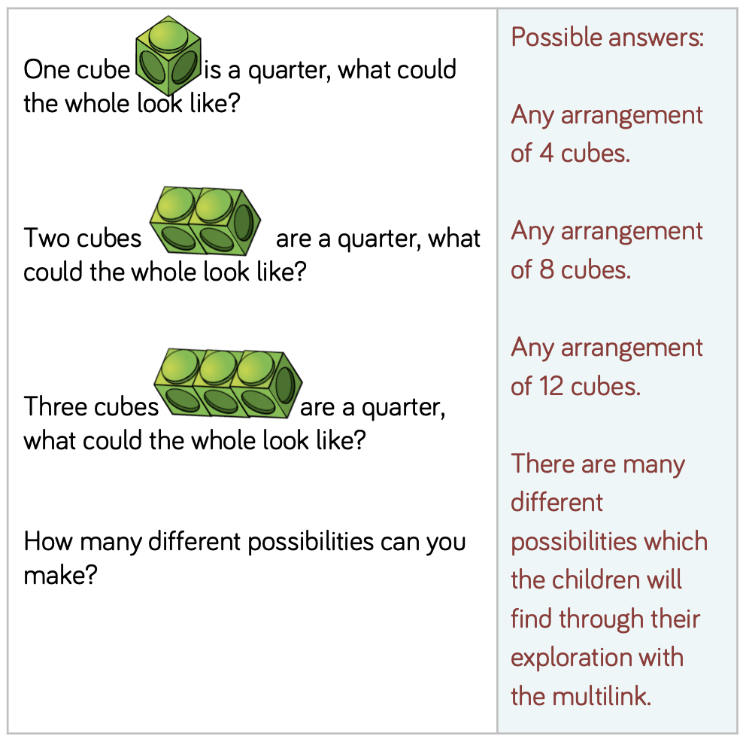  Y1 Access the White Rose Maths website for home learning (link below).  https://whiterosemaths.com/homelearning/year-1/  Complete Summer Term – Week 9 (w/c 22nd June) Lesson 4 (watch the video before following the links to complete suggested activities).  Y2 Access the White Rose Maths website for home learning (link below).  https://whiterosemaths.com/homelearning/year-2/  Complete Summer Term – Week 9 (w/c 22nd June) Lesson 4 (watch the video before following the links to complete suggested activities).  KS1 - If you do have access to a printer and want to print the White Rose sheets that go with each lesson, you can do. If you do this, you do not have to do the Power Maths pages as well.  If you do not have access to a printer, watch the White Rose video each day and then complete the Power Maths books.  Daily Project – TOPIC - EYFS and KS1  Look at the pictures of everyday items from the past. Compose questions about the artefacts to find out more about them, including asking questions about how people might have used them in the past. Use the question words who, what, when, where and why to generate your questions and begin to think about and discuss how people's lives are the same or different now compared to the past. (See attached document on website).  Daily Project – SPELLING  KS1 – See attached sheets on website for revision and practise.
Friday | Phonics  Preschool – see notes above.  Phonics for this week R- Y2: Talk for Creative Writing – See Monday planning.  Maths  EYFS Maths Starter:  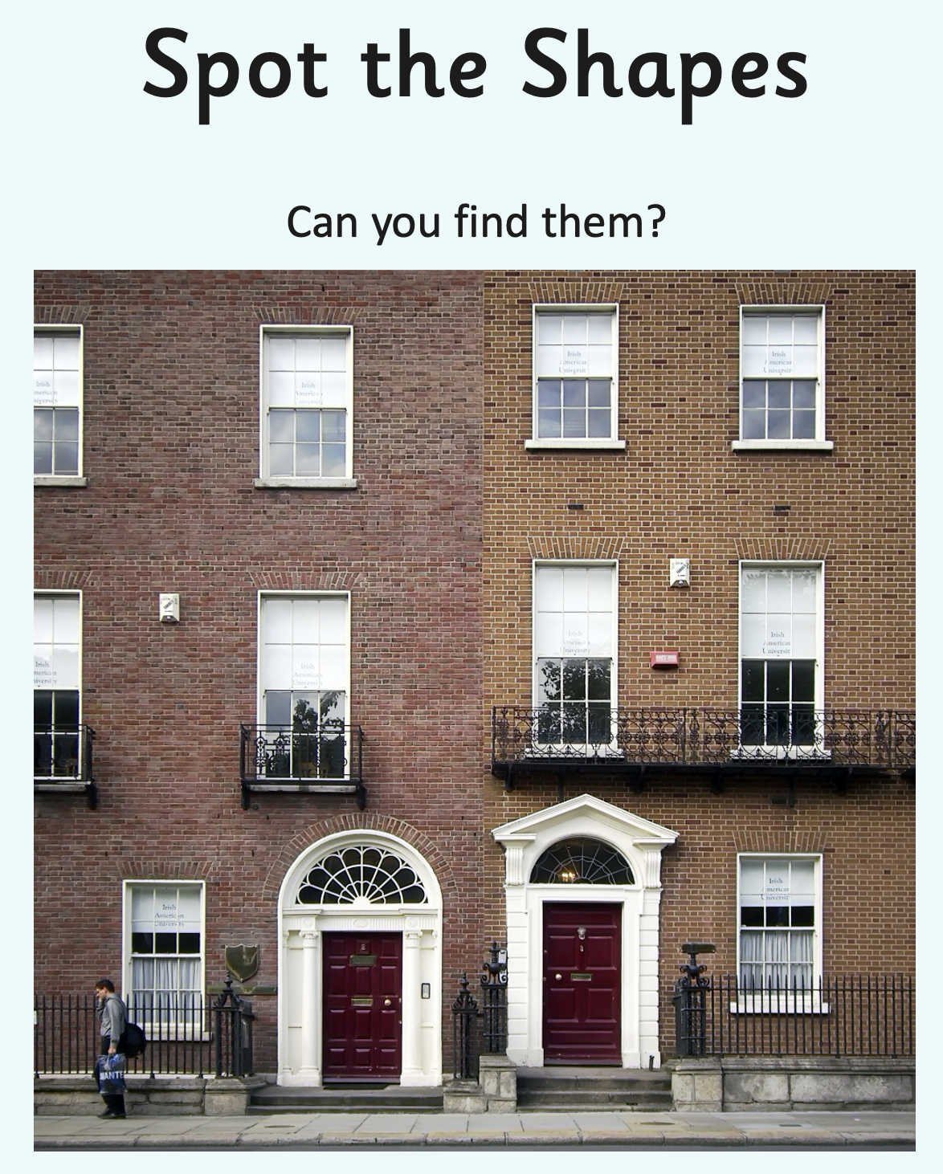  EYFS - Access the White Rose Maths website for home learning (link below).  https://whiterosemaths.com/homelearning/early-years/  Complete Summer Term Week 7 (w/c 8th June) - Day 5: The Princess and the Wizard (watch the video before following the links to complete suggested activities).  KS1 Maths Starter:  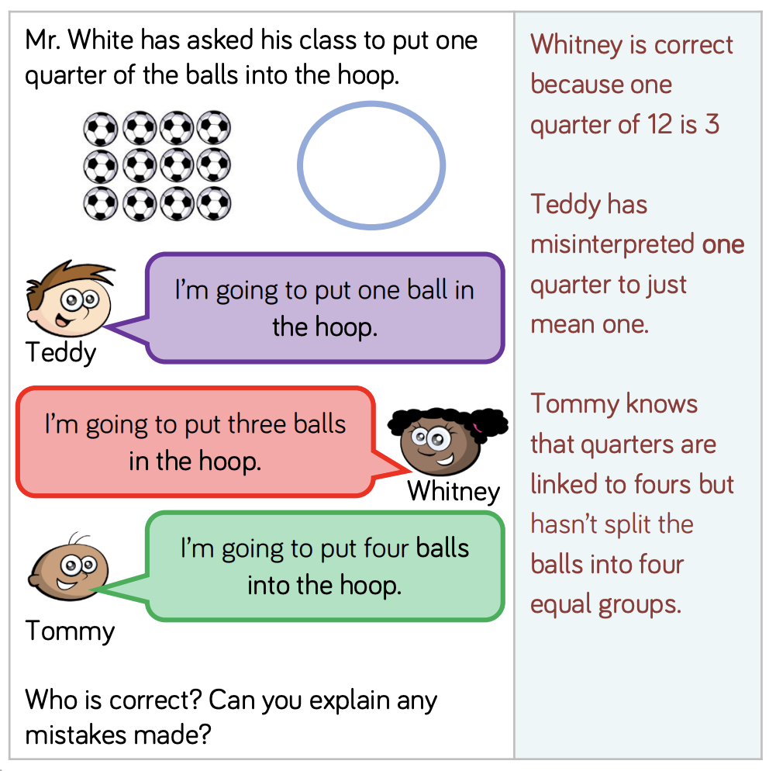  Y1 Access the White Rose Maths website for home learning (link below).  https://whiterosemaths.com/homelearning/year-1/  Complete Summer Term – Week 9 (w/c 22nd June) Lesson 5 (watch the video before following the links to complete suggested activities).  Y2 Access the White Rose Maths website for home learning (link below).  https://whiterosemaths.com/homelearning/year-2/  Complete Summer Term – Week 9 (w/c 22nd June) Lesson 5 (watch the video before following the links to complete suggested activities).  KS1 If you do have access to a printer and want to print the White Rose sheets that go with each lesson, you can do. If you do this, you do not have to do the Power Maths pages as well.  If you do not have access to a printer, watch the White Rose video each day and then complete the Power Maths books.  Daily Project - Extra-Curricular Time (PE/ PSHE/Mental Health/Mindfulness/Art)  Task 1 – EYFS and KS1: Emotions activity - Painting Stones. Paint a stone to express an emotion or feeling. Your child might choose to decorate their stone using paint, collage or pens. They might choose to use a face to show the feeling or a texture, colour or image.  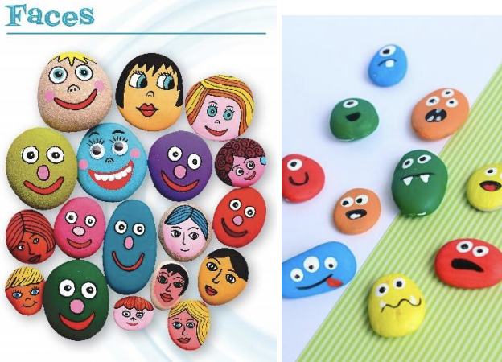  Task 2 – EYFS and KS1 - Guided Mindfulness Listening Activity: https://www.youtube.com/watch?v=uUIGKhG_Vq8 or https://www.savethechildren.org.uk/what-wedo/coronavirus/resources/learning-at-home/relaxationexercises-to-do-at-home-with-your-kids  TASK 3 – EYFS and KS1: RE work attached on website ‘Special Places’.

