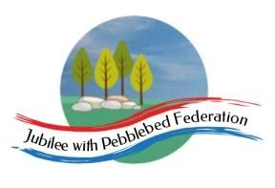
Class 2  Wk beg: 5th Jan ‘20 | Spelling (30 mins) | Reading (30 mins) | Writing (1 hour) | Maths (45 mins) | Afternoon Project  When finished each day
Tuesday  Collective Worship:  You may like to start the day with a ‘virtual assembly’ at Faith At Home - Collective Worship for Primary Schools - Episode 7: Kindness - YouTube | Email school if your child has forgotten their log in!  https://www.edshed.com/en-gb/login  Practise the spellings set for you in ‘Assignments’. Then practise the statutory words for your age group. | https://www.activelearnprimary.co.uk/login?c=0  Remember, your password now contains your initials as well as the numbers of your TTRS password. | This week we will be completing the work we began last term on writing play scripts, while also beginning to read our new core text, ‘How to Train Your Dragon’ by Cressida Cowell.  Use the following BBC Bitesize video to remind yourself of what we discovered last term about how to set out a play script.  https://www.bbc.co.uk/bitesize/topics/zsn4h39/articles/zx8kng8  Follow the links below to find a play script and narrative version of the same play script.  Playscript: I Spy (Louise Crichton) DOC  I Spy - Narrative Version (Zoe Birch) DOC  Make a chart to compare the two texts, listing the similarities and differences between them. | 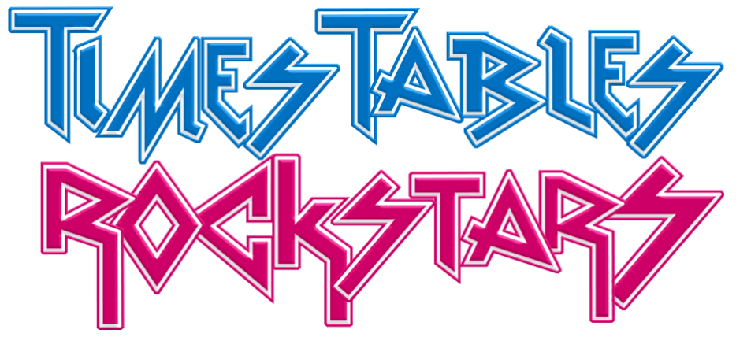  Warm up with  Contact school if you need a reminder of your login details!  Year 3  https://classroom.thenational.academy/lessons/to-recognise-parts-that-are-equal-and-parts-that-are-unequal-70rpcd  Year 4  https://classroom.thenational.academy/lessons/divide-and-describe-the-same-whole-when-divided-into-differing-numbers-of-equal-parts-c9k36e  Year 5  https://classroom.thenational.academy/lessons/what-is-a-fraction-70rkjc  Year 6  https://classroom.thenational.academy/lessons/to-identify-describe-and-represent-fractions-ccw3ee | PE  https://www.youtube.com/channel/UCLNV8D56t6RV0wbsPnbnYeA  History  Today’s lesson will introduce the Anglo-Saxons and Vikings and help you to develop an understanding of the chronology of the period in which they lived in Britain.  To get started, use the BBC Bitesize lesson ‘Who were the Anglo-Saxons’ at  https://www.bbc.co.uk/bitesize/topics/zxsbcdm/articles/zq2m6sg  Then, find further information and activities at https://www.twinkl.co.uk/go  using the password:  RM5486
Wednesday  Collective Worship  Today is the start of advent.  You may like to start the day with a ‘virtual assembly’ at  Faith At Home - Collective Worship for Primary Schools - Episode 8: Generosity - YouTube | Email school if your child has forgotten their log in!  https://www.edshed.com/en-gb/login  Practise the spellings set for you in ‘Assignments’. Then practise the statutory words for your age group. | https://www.activelearnprimary.co.uk/login?c=0  Remember, your password now contains your initials as well as the numbers of your TTRS password. | Yesterday, we compared a narrative and play script version of the same short story. Today, have a go at writing a play script version of a story. You could use a well-known story such as a fairy tale, or a favourite picture book. You do not need to complete the whole story – you may wish to choose a section of the story.  Remember to start the scene by listing who is in that scene and writing stage directions to explain where the scene is set.  Then, write the characters’ names in the margin, followed by a colon and what they say. You should use brackets for stage directions to tell the actors how to speak or what to do. Remember to punctuate your sentences carefully, using ? for questions and ! for exclamations. | Warm up with  Contact school if you need a reminder of your login details!  Year 3  https://classroom.thenational.academy/lessons/to-recognise-parts-that-are-equal-and-parts-that-are-unequal-70rpcd  Year 4  https://classroom.thenational.academy/lessons/understand-fraction-notation-to-represent-a-relationship-between-part-and-whole-74wkcr  Year 5  https://classroom.thenational.academy/lessons/representing-fractions-cthked  Year 6  https://classroom.thenational.academy/lessons/understanding-equivalence-75hkge | Geography  In our Daily dashboard sessions and Geography lessons this term, we are going to practise locating places using the 8 points of the compass and identifying the location of key features of the United Kingdom, including famous rivers and mountains.  You could make a start on this work by using some of the worksheets at https://www.3dgeography.co.uk/uk-worksheets  You could also use the quiz site https://lizardpoint.com/geography/england-rivers-lvl1-quiz.php  to practise locating the main rivers in England.  RE  This term, our new key question in RE is ‘How can following God bring freedom and justice?’ We will begin by investigating the story of Moses. Use the following links to begin to learn the main events of Moses’ life. You could try drawing some of the key events of Moses’ life and labeling each picture with a caption.
Thursday  Collective Worship  Here is another link to a ‘Faith at Home’ video you could use for your own assembly at home:  Faith At Home - Collective Worship for Primary Schools - Episode 9: Vulnerability - YouTube | Email school if your child has forgotten their log in!  https://www.edshed.com/en-gb/login  Practise the spellings set for you in ‘Assignments’. Then practise the statutory words for your age group. | https://www.activelearnprimary.co.uk/login?c=0  Remember, your password now contains your initials as well as the numbers of your TTRS password. | Yesterday, you practised turning a story into a play script. Over today and tomorrow, you are going to turn a play script into narrative, using speech punctuation accurately.  First, use the BBC Bitesize lesson to revise how to set out and punctuate direct speech: https://www.bbc.co.uk/bitesize/topics/zr6bxyc/articles/zhqh92p  Then, look at this play script and try turning it into a narrative story. Remember to set out and punctuate the dialogue as it would be in a normal story. You will also need to take care to write the story in the past tense. You may find it helpful to look back at Tuesday’s work to help you remember the main differences between a narrative and play script version of a story.  You should complete this task in tomorrow’s lesson. | Warm up with  Contact school if you need a reminder of your login details!  Year 3  https://classroom.thenational.academy/lessons/to-recognise-identify-and-describe-unit-fractions-ccwpce  Year 4  https://classroom.thenational.academy/lessons/begin-to-use-and-understand-the-terms-numerator-and-denominator-cmw3ee  Year 5  https://classroom.thenational.academy/lessons/equivalent-fractions-cgt66c  Year 6  https://classroom.thenational.academy/lessons/finding-equivalent-fractions-ctgp4r | Science  In Science this week, we begin a new sequence of work on living things.  First, look at the following clip to revise the differences between living and non-living things: https://www.bbc.co.uk/bitesize/clips/ztbw2p3  Then, find today’s Science lesson,  Grouping Living Things at  https://www.twinkl.co.uk/go  Use the password below to locate the appropriate lesson and download the resources:  RM8930
Friday  Collective Worship  Here is another link to a ‘Faith at Home’ video you could use for your own assembly at home:  Faith At Home - Collective Worship for Primary Schools - Week 10: Compassion - YouTube | Email school if your child has forgotten their log in!  https://www.edshed.com/en-gb/login  Practise the spellings set for you in ‘Assignments’. Then practise the statutory words for your age group. | https://www.activelearnprimary.co.uk/login?c=0  Remember, your password now contains your initials as well as the numbers of your TTRS password. | Today, you should complete the writing you began in yesterday’s lesson.  Think carefully about where you might need to add further description of the characters or setting. Try to remember all the lessons we learned last term about effective description of a setting! | Warm up with  Contact school if you need a reminder of your login details!  Year 3  https://classroom.thenational.academy/lessons/to-find-unit-fractions-of-a-given-quantity-61k34t  Year 4  https://classroom.thenational.academy/lessons/name-unit-fractions-and-match-them-with-the-fraction-notation-and-a-representation-chgk8c  Year 5  https://classroom.thenational.academy/lessons/tenths-and-hundredths-6nj68c  Year 6  https://classroom.thenational.academy/lessons/compare-fractions-less-than-one-c4ukcc | French  In our French lessons this term, we will be asking and answering the question, ‘As-tu un animal?’ (Do you have an animal)  Use the following video to help you learn a few animal names in French. Why not make some flashcards by drawing the animals and writing their names. Or you could make some ‘Memory Pairs’ cards by drawing each animals and putting the names on a separate card. Then, play memory games to help you learn the new vocabulary.  Don’t forget to learn the gender of the nouns (un/ une) along with the words.  PSHE  This term, we will learn more about money, where it comes from and how to manage it responsibly.  Find the lesson at https://www.twinkl.co.uk/go  Use the password below to locate the appropriate lesson and download the resources:  RM2078

