Week beginning Monday 27th April 2020 – Home Learning for Class 1

Dear Parents and Children of Class 1,

Welcome to Week 3 of your Home Learning! We hope that you are all happy and well. As before, this very long piece of writing sets out your learning over the next week. We have continued to include them in a suggested daily activities list and accompanying daily timetable structure for those who would find it helpful, which includes the maths online videos as well as phonics lessons and your daily/weekly projects to complete. We hope that you are finding this accessible and clear.

We’d like to take this opportunity to share with you some new resources that may be of interest:
- The DFE have created a suite of resources to support parents called Oak Tree Academy, linked with the BBC. You can access this here: https://www.thenational.academy/?fbclid=IwAR1SltQXGn_uBUrQIWo6Y4APOFImRBk25_hFXjpoUxHnxrKj5ccKBfelV_U From Monday 20th April, BBC Bitesize will also publish daily online lessons to help pupils expand their learning and to aid parents to engage children of all ages with learning at home at https://www.bbc.co.uk/bitesize.
- This is a fabulous document from SKIP for Early Years Educators (a page worth looking at): https://www.skipforeyeducators.co.uk/booklet/covid19_familybooklet.pdf?fbclid=IwAR0-N_fPDO6GyFOf7yGOGMd3vubUOYOjNJkWUxZZcb90ygcpnZl1Wpn50g4. It is a comprehensive and informative guide for parents about how to support their EYFS child at home, with lovely, relaxed, play-based ideas as well as advice for managing anxiety etc. during the COVID-19 situation.
- Advice for parents and carers of primary aged children:
https://www.gov.uk/guidance/help-primary-school-children-continue-their-education-during-coronavirus-covid-19?fbclid=IwAR15ye7p37STocS20o9YYCeUn6pnt5r0mq5BIDCQXn62zHnEDNmJ17epfLY
- Advice for parents and carers of children who have not yet started school: https://www.gov.uk/guidance/help-children-aged-2-to-4-to-learn-at-home-during-coronavirus-covid-19?fbclid=IwAR25t2GmJYmGXNBeWxOEUl06RSEul2Yxd0kp4o1aujX77RQ4kYXb6s-aJFY
- Linked to the above and particularly useful for children 0 – 5 years: https://hungrylittleminds.campaign.gov.uk/

We wanted to take this opportunity to remind all of you that the activities we have suggested are intended to be a bank of resources for you to select from. We do not expect anyone to complete all the activities. We hope that we have provided you with a mixture of activities that can be accessed online and those that involve more traditional or practical learning media, as well as appealing to a range of different interests and skills. We understand of you will have different access to computers, tablets, printers and other resources. Remember that there are printed packs left to pick up outside of school fortnightly, should you need them – please contact the school as per the guidelines on the website: If packs of work are needed (rather than you using the resources on the website) then these will be available for collection from the playground. Please just take a pack - you don't need to come to the school door - to reduce the number of people coming into contact with the pupils and staff. Please call school first and let us know you are coming so that we can print more packs if needed. The most important thing you can do to support your child’s learning whilst schools are closed is to ensure that they read every day and that they continue to practise their phonics and key mathematics skills such as number bonds to 10, 20 and 100 and 2, 3, 5 and 10 times tables.

As always, if you have any questions at all or you would like to email a picture of some lovely work you have been doing, please use the following email address - admin@branscombe.devon.sch.uk. Thank you to those of you who have already sent photographs of your learning - it really does make us smile to see what you have been getting up to at home.

Have a good week and as always stay safe,
Miss Harvey-Jones and Mrs Bartlett

EVERY DAY
- 20 minutes phonics (Bug Club) (Reception and Y1). See table below for details of which lesson/resources to access. Y2 see below for separate phonics activities. A note to all: You could also use Phonics Play to practise reading sounds and words and also practise sounding and blending skills. They can also read sentences. It is FREE at this time: https://new.phonicsplay.co.uk/. App/tablet friendly.
- 20 minutes ‘Bug Club’ Reading (with comprehension ‘bug’ questions). Bug Club books continue to be updated to suit your level.
- 15 minutes ‘Spelling Shed’, ‘SPAG.com’ OR ‘Bug Club Grammar’ games (KS1 only). Please do contact us if you have any issues with passwords. If you would prefer to access paper-based work to limit screen time we can email SPAG documents for you to print off.
- 15 minutes ‘Times Table Rockstars’ (KS1 only) OR to limit screen time you may wish to spend this time learning 2, 3, 5 and 10 times tables to be able to recall them at speed.
- Choose 5 spellings from your Home Learning Books to learn.
- 20 - 30 minutes Maths: KS1 – see below for a 5 minute warm ups with your parents/game, then complete any tasks set. On days when work is not set you can work in your ‘Power Maths’ Practice Books (you should complete pages in your Autumn Term books including place value and number, addition and subtraction, 2D and 3D shapes (Y1), money (Y2), multiplication and division (Y2) to finish these books).
Reception/Pre-School – see activities detailed below.
- PE/Active Time - Joe Wicks (The Body Coach) has daily workout videos on YouTube (go online with your grown ups) but you do not need to feel restricted to this – get some fresh air when walking the dog, using skills developed in out of school clubs such as football/ballet or exercising in the garden instead, if you can safely do so.
- We would like children to continue their Summer Term diary and write one or two sentences a day (with support if necessary for younger pupils) and draw a picture. The sentence might be about something they have done, something they have seen or even what the weather is like. Some examples might be: ‘It is sunny.’ ‘It is a flower.’ ‘I went to the park’. Sentences do not need to be spelt correctly but the children should use their phonic skills to attempt to write words. KS1 children could also use the Time Capsule sheets attached on a separate link to help with ideas.
- Please keep reading/sharing a book you enjoy with your family. Try to keep a log together (one or two sentences) of what you have read that day. If you are reading a fiction book, what happened or what characters did you meet? If you are reading a non-fiction book perhaps you write down something that you have found out that you didn’t know before.

Monday | Phonics - ALL  Year 1 - Target phoneme /ch/ written as 'tch'  Year 2 – Give your child a pair of cards (I fly, he…). Your child should pick up the card and read it before writing the missing word e.g. I fly, he flies. Now do this for as many cards as they can e.g. I cry, he cries. Check spellings and discuss any errors.  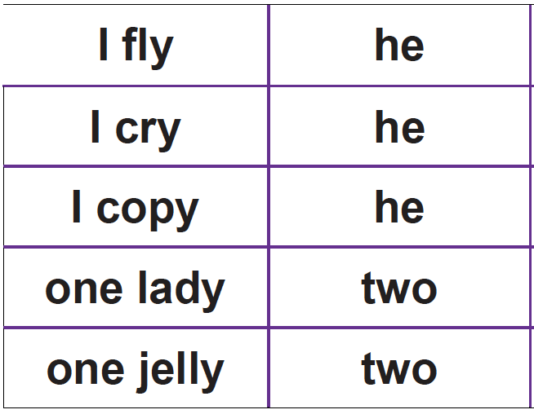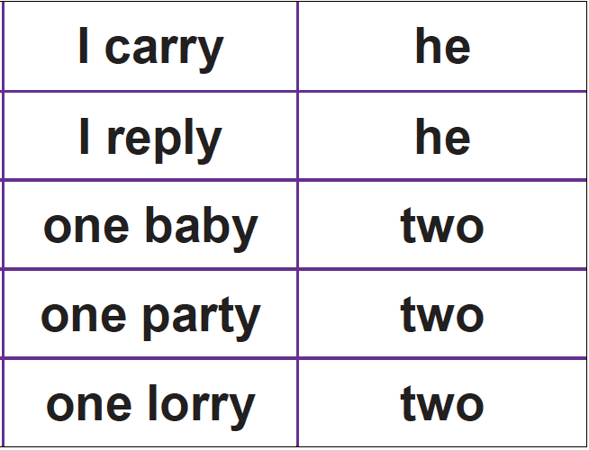  EYFS - Practise GPCs - Play Flashcards using the attached resources or Quickwrite Graphemes (say the sound on the flashcard ask your child to write it without them seeing it).  Teach reading CVCC words by writing ten on a whiteboard. Soundtalk (t-e-n) and blend. Add the letter t to make tent. Soundtalk again. Ask your child to join in. Repeat with bend, damp.  Play Buried Treasure (real words go in a treasure chest, nonsense words in a bin) with words: tent, damp, lump, bend, mend, fump, hent, yend.  Read the sentences, encourage your child to blend graphemes if they get stuck: Help! I got a bump on the leg. A tent will get damp in the rain. Milk is good for teeth and gums.  Maths  EYFS Maths Starter – Write out the numbers 0 – 20 on some paper. Cut them up and ask a grown-up to mix the numbers up. Don’t peek! Now see how quickly you can put them into the correct order. Can someone time you? See if you can get faster when you try again.  EYFS - Access the White Rose Maths website for home learning (link below).  https://whiterosemaths.com/homelearning/early-years/  Complete Week 2 - Lesson 1 – What the ladybird heard (watch the video before completing the activity).  KS1 Maths Starter – Number Bond Pairs: Write out the digits 0 – 20 on separate pieces of paper (or print and use the attached). Shuffle them and place them face down. On your go, turn over two cards. If the numbers make a number bond to 10 or 20, keep them, if not, turn them back over. The player with the most pairs at the end is the winner.  Y1 Access the White Rose Maths website for home learning (link below).  https://whiterosemaths.com/homelearning/year-1/  Complete Summer Term – Week 2 - Lesson 1 – Find a half (watch the video before completing the activity).  Y2 Access the White Rose Maths website for home learning (link below).  https://whiterosemaths.com/homelearning/year-2/  Complete Summer Term – Week 2 – Lesson 1 – Compare Lengths (watch the video before completing the activity).  KS1 - If you do have access to a printer and want to print the White Rose sheets that go with each lesson, you can do. If you do this, you do not have to do the Power Maths pages as well.  If you do not have access to a printer, watch the White Rose video each day and then complete the Power Maths books.  Daily Project  ALL - Thursday 23rd April was the beginning of the Islamic festival of Ramadam. Can you find out about how Muslims celebrate Ramadam and draw and write some ideas?  If you have access to the internet, this clip may help you: https://www.bbc.co.uk/bitesize/topics/zpdtsbk/articles/zjc2bdm
Tuesday | Phonics - ALL  Year 1 - Target phoneme /sh/ alternatives  Year 2 - The Possessive Apostrophe - Ask your child to give you something belonging to them, for example, a pencil, a coat, a book. Ask them whose pencil/coat/book you have. Write up the words on the board, for example, John’s, Beth’s. Show them the apostrophe before the ‘s’ for belonging. Practise saying the word apostrophe and show them how and where it is written in the words displayed. Show pictures of people holding things belonging to them. Ask your child to generate a caption for a picture, for example The girl’s cat. Ask them to choose another picture, decide on a caption together and write it.  EYFS - Practise GPCs - Play Flashcards using the attached resources or Quickwrite Graphemes (say the sound on the flashcard ask your child to write it without them seeing it).  Teach reading tricky words said and so  Play Buried Treasure (real words go in a treasure chest, nonsense words in a bin) with words: tent, damp, lump, bend, mend, fump, hent, yend.  Read the sentences, encourage your child to blend graphemes if they get stuck: Mum said, “It is best not to jump on the bed.” A lost chimp felt so sad he wept. This belt is so tight, it hurts my waist.  Maths  EYFS Maths Starter – Write out the numbers 0 – 20 on some paper. Cut them up and ask a grown-up to mix the numbers up. Don’t peek! Now see how quickly you can put them into the correct order. Can someone time you? See if you can get faster when you try again.  EYFS - Access the White Rose Maths website for home learning (link below).  https://whiterosemaths.com/homelearning/early-years/  Complete Week 2 - Lesson 2 – What the ladybird heard (watch the video before completing the activity).  KS1 Maths Starter – As yesterday. This time, think about the following questions: What can you use to prove to your partner that it is a number bond to 10 or 20? Try using the language of addition and subtraction. Is it best to turn over both cards together or one at a time? Why?  Y1 Access the White Rose Maths website for home learning (link below).  https://whiterosemaths.com/homelearning/year-1/  Complete Summer Term – Week 2 - Lesson 2 – Find a quarter (1) (watch the video before completing the activity).  Y2 Access the White Rose Maths website for home learning (link below).  https://whiterosemaths.com/homelearning/year-2/  Complete Summer Term – Week 2 – Lesson 2 – Order Lengths (watch the video before completing the activity).  KS1 - If you do have access to a printer and want to print the White Rose sheets that go with each lesson, you can do. If you do this, you do not have to do the Power Maths pages as well.  If you do not have access to a printer, watch the White Rose video each day and then complete the Power Maths books.  Daily Project  Task 1 RE – See separate documentation.  Why do Jewish people have Shabbat each week?  - Explain to it is a holy day each week where many Jewish people rest and really think about God. It is called ‘Shabbat’. To find out why they celebrate Shabbat each week we need to look at a story from the Jewish Torah. The Creation Story. Your child may remember this is also an important story to Christians.  - After reading the story ask you child to recall what God did on the seventh day of the creation story (rested and made it holy). Explain this is why Jewish people have a holy day where they also rest each week.  - Ask children if they remember how Jewish people celebrate Shabbat (we looked at this in the Autumn term). Look at the Shabbat information and ask your child to draw pictures and write sentences about what Jewish people do during Shabbat.  Task 2 PSHE – See separate documentation Hazard Watch.  Task 3 PE/Mental Health/PSHE - This week, let’s look at how we keep our bodies and minds healthy by eating well and drinking plenty of water. Can you keep a diary of what you eat and drink this week, as well as your sleep.
Wednesday | Phonics – ALL  Year 1 - Target phoneme /e/ written as 'ea'  Year 2 – The Possessive Apostrophe - Remind your child about the possessive apostrophe and how to write it correctly (Tuesday session). Use either the pictures provided yesterday or your own photographs of your child with their toys. Give them a selection of pictures, model how to write a caption using the possessive apostrophe and ask them to write a short caption for another picture of their choice.  EYFS – Practise GPCs - Play Flashcards using the attached resources or Quickwrite Graphemes (say the sound on the flashcard ask your child to write it without them seeing it).  Use a large four letter phoneme frame (a grid like below:)  Parent says the word stop. Soundtalk it slowly: s-t-o-p. Make the word in the phoneme frame with magnetic letters/write out individual letters on 4 pieces of paper and lay out in the frame (e.g. example below). Repeat with sent.  s t o p  Play Phoneme Frame: Give you're the phoneme frame. Read out a word and ask them to create it in the phoneme frame with magnetic letters or grapheme cards or write them in. Words: dump, bump, jump, went, tent, damp, bend, mend.  Read the sentences, encourage your child to blend graphemes if they get stuck: I can boast that I had toast for my lunch. I think that pink socks might be the best. If you feel down in the dumps then jump and sing. Encourage them to soundtalk words. Pick one sentence to dictate and ask your child to write it. Show them the sentence and ask them to check each letter. Encourage them to correct any mistakes.  Maths  EYFS Maths Starter – Ask an adult to hide the numbers to 20 around your house. See if you can find all 20 and place them in order.  EYFS - Access the White Rose Maths website for home learning (link below).  https://whiterosemaths.com/homelearning/early-years/  Complete Week 2 - Lesson 3 – What the ladybird heard (watch the video before completing the activity).  KS1 Maths Starter – Can you make up a number bonds game of your own? You could include bonds to 10, 20 or 100.  Y1 Access the White Rose Maths website for home learning (link below).  https://whiterosemaths.com/homelearning/year-1/  Complete Summer Term – Week 2 - Lesson 3 – Find a quarter (2) (watch the video before completing the activity).  Y2 Access the White Rose Maths website for home learning (link below).  https://whiterosemaths.com/homelearning/year-2/  Complete Summer Term – Week 2 – Lesson 3 – Four operations with length (watch the video before completing the activity).  KS1 - If you do have access to a printer and want to print the White Rose sheets that go with each lesson, you can do. If you do this, you do not have to do the Power Maths pages as well.  If you do not have access to a printer, watch the White Rose video each day and then complete the Power Maths books.  Daily Project  EYFS – Literacy/Writing - Can you draw a picture of your favourite teddy or toy? Why do you like it so much? Have a go at writing 5 sentences about your teddy or toy.  KS1 – Science/Theme - Find an object that you had when you were a baby or a toddler. Draw a careful picture of this and write three sentences of why that was important for you as a baby (remember handwriting, finger spaces, spelling and letter formation!) Now, ask your grown up if they have anything that was important to them as a child. Can you look at it and compare it to your item? Draw a careful picture of their item and write three sentences about why it was important to them. You could also think about what it is made of (remember our work on materials in Science) and include this in your sentences.
Thursday | Phonics - ALL  Year 1 - Target phoneme /w/ /o/ written as 'wa'  Year 2 – Below you will find the important vocabulary for our current topic ‘Memory Box’ in the form of a ‘Word Mat’.  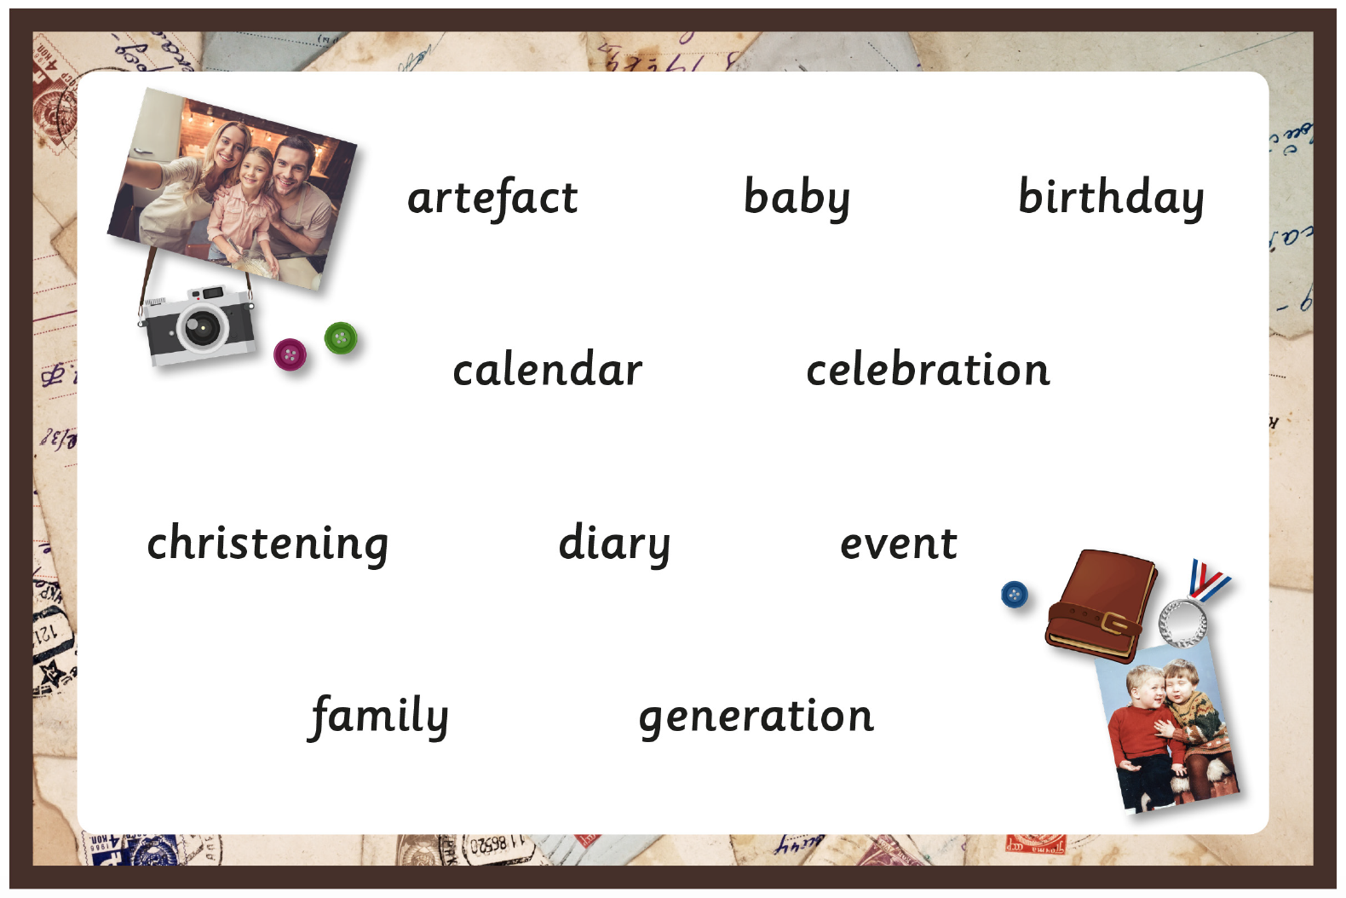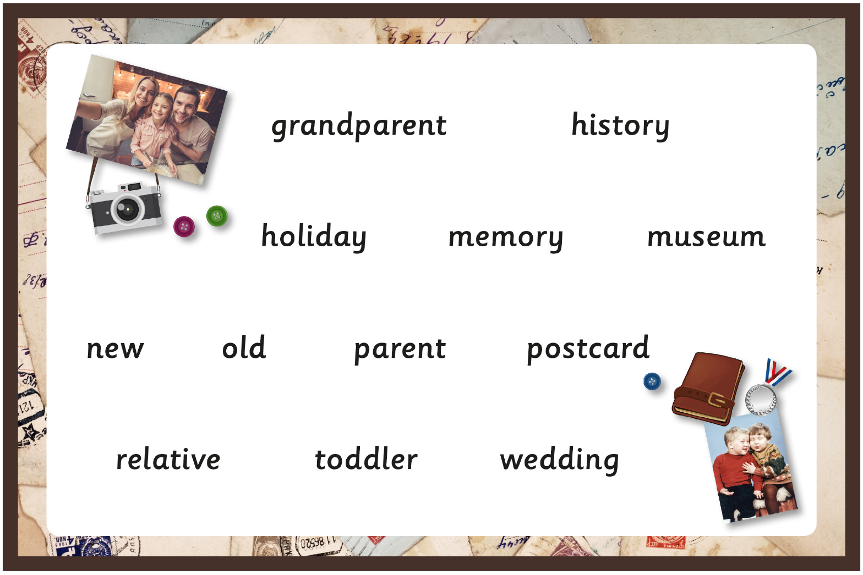  Can you find out the meanings of these words to create a glossary? Don’t forget that this will need to be in alphabetical order. Here are the first three to get you started…  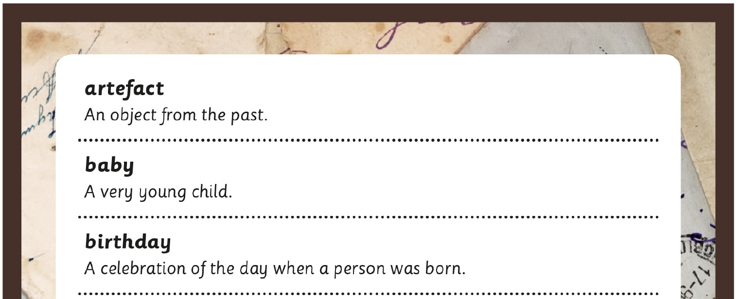  EYFS - Repeat lesson from Day 3, this time choose a different sentence to write.  Maths  EYFS Maths Starter – Draw circles on a piece of paper and put different colour paints/colouring pencils ready. Choose a number between 1 and 20. Dip your finger into the paint/use the crayons to add that many petals to one of the circles, making a flower. Count the petals to check how many you have and write that number in the middle of the circle. Choose another number and do the same until you fill up your page with colourful flowers, each with different amounts of petals.  EYFS - Access the White Rose Maths website for home learning (link below).  https://whiterosemaths.com/homelearning/early-years/  Complete Week 2 - Lesson 4 – What the ladybird heard (watch the video before completing the activity).  KS1 Maths Starter – As yesterday: Play your own number bonds game.  Y1 Access the White Rose Maths website for home learning (link below).  https://whiterosemaths.com/homelearning/year-1/  Complete Summer Term – Week 2 - Lesson 4 – Problem Solving (watch the video before completing the activity).  Y2 Access the White Rose Maths website for home learning (link below).  https://whiterosemaths.com/homelearning/year-2/  Complete Summer Term – Week 2 – Lesson 4 – Problem Solving (watch the video before completing the activity).  KS1 - If you do have access to a printer and want to print the White Rose sheets that go with each lesson, you can do. If you do this, you do not have to do the Power Maths pages as well.  If you do not have access to a printer, watch the White Rose video each day and then complete the Power Maths books.  Daily Project – ALL  EYFS – Theme/PD - Have a chat with your grown up about the people in your family. Can you draw me a picture of the people who are in your family? You could have a go at writing their names.  KS1 - History/Theme - Find out who is in your family. Can you make a family tree? Can you find some card (it could be an old cereal box or anything that you can find). Make some cut outs of people to look like your family members. Use fabric, sequins, wool or any other materials to create clothing and features for your ‘family members’. Can your family recognise themselves? Remember, we would love to see some photos of what you have made. Email them in at admin@branscombe.devon.sch.uk
Friday | Phonics - ALL  Year 1 – Target Phoneme /u/ written as 'o'  Year 2 – Ask your child to write some silly sentences where each sentence includes a topic word (word mat from yesterday), a common exception word (see bottom of document) and a high-frequency word (see bottom of document). Remind them to use the three word banks when they need to. Check their spellings and reinforce that these spellings are non-negotiable.  EYFS – Practise GPCs - Play Flashcards using the attached resources or Quickwrite Graphemes (say the sound on the flashcard ask your child to write it without them seeing it).  Write the word he. Check that your child can read it. Say a sentence using the word. Soundtalk the word, raising a finger for each phoneme: h-e. Ask your child to do the same. Discuss the letters required for each phoneme, using letter names. Ask your child to trace the shapes of the letters with their fingers. Hide the word and ask your child to write the word on their own. Repeat with she, we, me be.  Play Phoneme Frame: Give you're the phoneme frame. Read out a word and ask them to create it in the phoneme frame with magnetic letters or grapheme cards or write them in. Words: help, just, chimp, roast, pond, nest, milk.  Read the sentences, encourage your child to blend graphemes if they get stuck: The chimp sings a song as he jumps up and down. We put the tent next to the pond. He put the milk in the sink. Now ask your child to write one of the sentences. Encourage them to soundtalk words. Show them the sentence and ask them to check each letter. Encourage them to correct any mistakes.  Maths  EYFS Maths Starter – Write the numbers 0 – 20 on plastic building bricks. Make a tower of 21 bricks, seeing if you can put the numbers in the correct order. Start with 0 at the bottom and 20 at the top. Then try starting with 0 at the top and 20 at the bottom.  EYFS - Access the White Rose Maths website for home learning (link below).  https://whiterosemaths.com/homelearning/early-years/  Complete Week 2 - Lesson 5 – What the ladybird heard (watch the video before completing the activity).  KS1 Maths Starter – Have a go at this addition game:  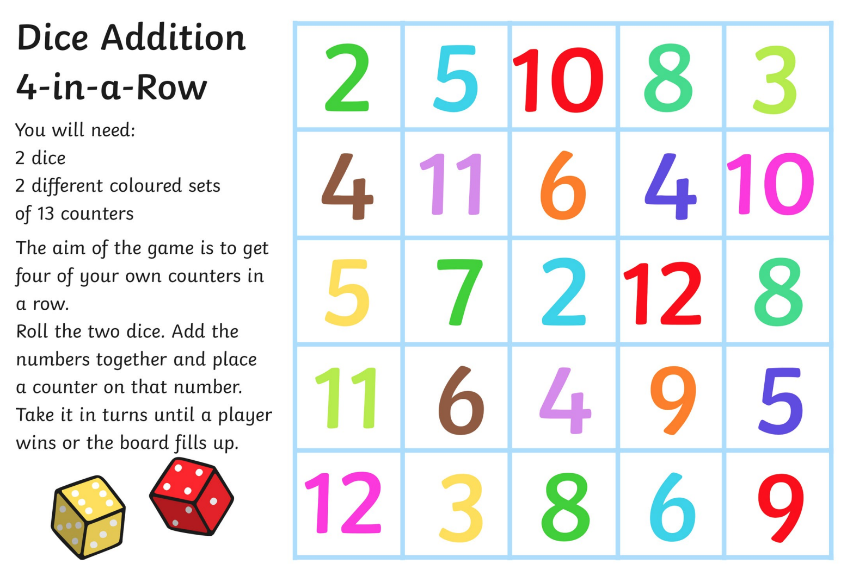  Y1 Access the White Rose Maths website for home learning (link below).  https://whiterosemaths.com/homelearning/year-1/  Complete Summer Term – Week 2 - Lesson 5 – Friday Maths Challenge (watch the video before completing the activity).  Y2 Access the White Rose Maths website for home learning (link below).  https://whiterosemaths.com/homelearning/year-2/  Complete Summer Term – Week 2 – Lesson 5 – Friday Maths Challenge (watch the video before completing the activity).  KS1 If you do have access to a printer and want to print the White Rose sheets that go with each lesson, you can do. If you do this, you do not have to do the Power Maths pages as well.  If you do not have access to a printer, watch the White Rose video each day and then complete the Power Maths books.  Daily Project  Theme - Look at the photographs taken at different times of day (final pages of this document). If you can, print them out and mix up the order. Talk about the pictures and decide at what times of the day they might have been taken. Place the images in time order and write a sentence about each one to describe what is happening.

