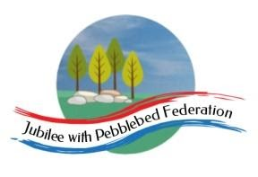
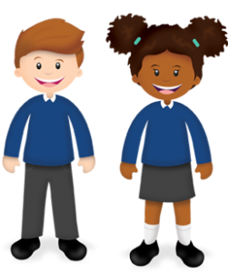
Learning
from Home

Class 1  Wk beg: 5th January 2021 | Lesson One | Lesson Two | Lesson Three | Lesson Four | Lesson Five
 | INSET DAY
Tuesday | Phonics/  Spelling  https://www.activelearnprimary.co.uk/login?e=-610&c=0#bugclub_phonics  R: unit 6: v  - Y1: Unit 24 language session  - Also play unit 23 assessment games.  Y2: as Y1, also spelling shed:  https://www.edshed.com/en-gb/login | English  BBC iPlayer - Andys Dinosaur Adventures - 19. T-Rex and Roar  Y1/2 - Watch this video clip. Ring or facetime a family member and tell them about one or more of the dinosaurs in the programme. Think about how you construct your sentences.  EYFS: Using play dinosaurs, paint a picture of your favourite dinosaur and have a go at writing its name. | Maths  R: Exploring the concept of zero (thenational.academy)  See below for printable number cards.  Y1: To identify numbers to 20 by counting ten and then counting on (thenational.academy)  Y2: To recognise the value of different coins (Part 1) (thenational.academy) | History/UW  Dinosaurs - Assemblies - Oak National Academy | PSHE/UW  https://classroom.thenational.academy/units/healthy-isnt-a-goal-its-a-lifestyle-4f16
Wednesday | Phonics/  Spelling  https://www.activelearnprimary.co.uk/login?e=-610&c=0#bugclub_phonics  R: unit 6: w  - Y1: Unit 25: Phoneme /j/ written as 'g(e)', 'g(i)', 'g(y)  - Also play unit 24 assessment games.  Y2: as Y1, also spelling shed:  https://www.edshed.com/en-gb/login | English  Use the scanned copy from the Dino Dinners Book and read through it with an adult at home. Try to learn the text off by heart and include actions to help you remember it.  Y1/2: Use the Story Map to help you learn the text.  R: Learn the green part of the story map. | Maths  R: Curious George . Hide and Seek | PBS KIDS  Use the pond picture below. Cut out the ducks and frogs. Ask your child to put different amounts of animals on the log or pond including zero. Write these numbers down as you go. E.g. Put three frogs on the log and zero in the pond. Let’s write 3 by the frogs and 0 by the pond.  Y1: To position numbers to 20 on a number line (thenational.academy)  Y2: To recognise the value of different coins (Part 2) (thenational.academy) | Computing  https://scratch.mit.edu/projects/19685257/  https://beebot.terrapinlogo.com/  Use your skills learnt from last term to complete the beebot games. | RE  Our new topic in RE this term is: What makes some places sacred to believers?  YR - Draw a picture of a place that is special to you. Talk about your pictures with an adult who can scribe your reasons for this being your special place.  Y1/2 complete the Elicitation sheet saved on google classroom. This is a test to see what the children already know and will help us to plan lessons to their needs. So please do not help your child with the answers. You can scribe their answers for them if necessary.  What is Christianity? - BBC Bitesize  Watch this video clip to learn about how Christians worship.
Thursday | Phonics/  Spelling  https://www.activelearnprimary.co.uk/login?e=-610&c=0#bugclub_phonics  R: unit 6 x  Y1: unit 25: Phoneme /j/ written as 'dge'  Also play unit 24 assessment games.  Y2: as Y1, also spelling shed:  https://www.edshed.com/en-gb/login | English  Design a dinosaur which contains the same characteristics as you do, eg what do they eat? What do they look like? Make it look and behave like you do, eg: a Mrs Finnasaurus. | Maths  R: BBC iPlayer - Numberblocks - Series 3: Zero  Y1: To count from 1 to 19 and match pictorial and abstract representations of these numbers (thenational.academy)  Y2: To recognise the value of different coins and notes (thenational.academy) | PSHE  Fire Safety  Write a list or draw pictures of people who help us.  Talk to your adult about when you should call 999 and when you should not.  Complete the activity sheet on google classroom. | DT  Create a prehistoric landscape. Use different natural materials, such as stones, sand, twigs, rocks and soil, and a range of small tools to shape, mould, carry and sift. Use small world dinosaurs if you have them or make some with playdough to create thematic play.
Friday | Phonics/Spelling  https://www.activelearnprimary.co.uk/login?e=-610&c=0#bugclub_phonics  R: unit 6 language session  Y1: unit 25 language session  Also play unit 24 assessment games.  Y2: as Y1, also spelling shed:  https://www.edshed.com/en-gb/login | English  Use information books or the internet to research dinosaurs.  Watch bbc video:  Dinosaurs  Year 1 – to design a short narrative about their dinosaur but ‘talk’ as if they are the dinosaur. E.g. I am a diplodocus and I have a really long neck...  Year 2 – to design their own page for the book Dino-Dinners using their own dinosaur from yesterday and some of the technical language from the research gathered.  EYFS  To talk about their dinosaur as if they are the dinosaur and practise being the dinosaur. | Maths  R: Combining two groups including zero (thenational.academy)  Y1: To identify one more and one less than a number within 20 (thenational.academy)  Y2: To compare different amounts of money (thenational.academy) | Science  R: Rumble in the Jungle | BookTrust  Can you identify all these animals?  Y1 and Y2: Login to google classroom and complete the Science Elicitation Task. This is a test to see what the children already know and will help us to plan lessons to their needs. So please do not help your child with the answers. You can scribe their answers for them if necessary. | PE  Add a move: agility, coordination, working together.  Work in a family group, stand in a circle. First person comes up with a dance move/action whilst others watch. Second person copies the first action then adds their own. Third person copies first and second actions then adds their own and so on!

Reception Tuesday Maths

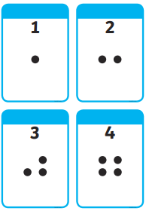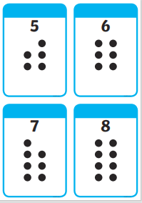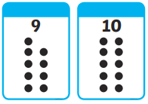

Reception Wednesday Maths
