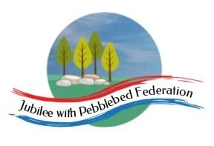
G;’

Class 1  Wk beg: 23rd November 2020 | Lesson One | Lesson Two | Lesson Three | Lesson Four | Lesson Five
Monday | Phonics/  Spelling  https://www.activelearnprimary.co.uk/login?e=-610&c=0#bugclub_phonics  R: unit 1 assessment games  Y1: unit 23 ‘c’ written as ‘c’  Also play unit 22 assessment games.  Y2: as Y1, also play your set games on spelling shed:  https://www.edshed.com/en-gb/login | English  https://youtu.be/46wCRq50Wwg  Go through your story map and retell the story of the Lighthouse keeper’s lunch. Use the pictures below.  Reception – sequence the pictures and write sounds / words they can sound out.  Year 1 – sequence the pictures and write the main events for each part of the story.  Year 2 – sequence pictures and write main events. Extend sentences with and/but/because. | Maths  YR  https://classroom.thenational.academy/lessons/count-six-objects-reliably-61k6cc  Year 1  https://classroom.thenational.academy/lessons/subtracting-by-partitioning-crr3jr  Year 2  https://classroom.thenational.academy/lessons/adding-two-2-digit-numbers-crvk6d | RE  Use music to consider how we live everyday.  https://www.bbc.co.uk/programmes/articles/3xwJ8Zpzz44vNJlZfqtxbbX/short-ride-in-a-fast-machine-by-john-adams  https://www.bbc.co.uk/music/works/4bf36cb5-817b-4ef4-b0e4-63e00fa27dc5 | PSHE/UW  https://classroom.thenational.academy/lessons/keep-calm-and-carry-on-6cu34c
Tuesday | Phonics/  Spelling  https://www.activelearnprimary.co.uk/login?e=-610&c=0#bugclub_phonics  R: unit 2 assessment games  Y1: unit 23 ‘k’ written as ‘k’  Also play unit 22 assessment games.  Y2: as Y1, also spelling shed:  https://www.edshed.com/en-gb/login | English  R: Use your toys (duplo/lego?) or make pictures to re-enact the events of the story using time connective vocabulary: first, next, then, after that...  Y1/2: Use your sentences from yesterday, ask the children to colour in each event using the following code:  Green: everything is happy for the Grinlings.  Yellow: things start to go wrong.  Red: things continue to go wrong.  Purple: things begin to go right.  Watch this video clip about time connectives. Can your child use them to retell the story?  https://www.bbc.co.uk/bitesize/topics/zpbbkqt/articles/zbv72sg | Maths  YR  https://classroom.thenational.academy/lessons/explore-conservation-of-number-within-6-ccw30c  Year 1  https://classroom.thenational.academy/lessons/counting-back-in-ones-to-subtract-6gu64r  Year 2  https://classroom.thenational.academy/lessons/subtracting-two-2-digit-numbers-6gup2t | History/UW  https://primaryfacts.com/3277/captain-james-cook-facts-and-information/  Give the children a length of paper so that they can create their own timeline of Captain James Cook.  Reception – Can you draw picture of Captain Cook? | PSHE/UW  https://classroom.thenational.academy/lessons/turn-things-around-60u3ar
Wednesday | Phonics/  Spelling  https://www.activelearnprimary.co.uk/login?e=-610&c=0#bugclub_phonics  R: unit 3 assessment games  Y1: unit 23 ‘c’ written as ‘ck’  Also play unit 22 assessment games.  Y2: as Y1, also spelling shed:  https://www.edshed.com/en-gb/login | English  R: Challenge!  Make a cottage on a cliff (use a chair) and make lighthouse out of junk modelling. Use string to send a basket or package down to the lighthouse.  Y1/2: https://www.bbc.co.uk/bitesize/articles/z6yxt39  Look at the diary example and check list. Can you write a diary entry for Monday as Mr Grinling? Think about what he would say about the seagulls stealing his lunch. How would he feel? | Maths  YR  https://classroom.thenational.academy/lessons/to-explore-one-more-within-six-74u34t  Year 1  https://classroom.thenational.academy/lessons/linking-subtraction-equations-to-problem-solving-contexts-cdjkgc  Year 2  https://classroom.thenational.academy/lessons/adding-and-subtracting-two-2-digit-numbers-ctk3gr | Computing  https://scratch.mit.edu/projects/19685257/  Choose a level and click the buttons. Then click GO. Try to make the shortest script - you will get three stars!  X clears the script.  Reload returns Bee-Bot into the original position.  You can re-enter any level and improve your score (unless you click the green flag). | PSHE/UW  https://classroom.thenational.academy/lessons/dont-worry-about-a-thing-68u32d?
Thursday | Phonics/  Spelling  https://www.activelearnprimary.co.uk/login?e=-610&c=0#bugclub_phonics  R: unit 4 assessment games  Y1: unit 23 ‘c’ written as ‘ch’  Also play unit 21 assessment games.  Y2: as Y1, also spelling shed:  https://www.edshed.com/en-gb/login | English  R: Challenge 2!  Think about different ways you can make your basket seagull proof.  Y1/2:  Continue your diary entries for Mr Grinling for the rest of the week. Use the success criteria to check your work. | Maths  YR  https://classroom.thenational.academy/lessons/explore-one-fewer-within-six-6wr66c  Year 1  https://classroom.thenational.academy/lessons/recognising-the-relationship-between-addition-and-subtraction-60tp4t  Year 2  https://classroom.thenational.academy/lessons/exploring-strategies-to-add-three-1-digit-numbers-61j32c | PSHE  https://classroom.thenational.academy/lessons/safety-first-ccu64t | Art  If you have paints at home explore making different shades and tones of colour. Create different colours to create waves.  Or use drops of food colouring in flour and water. Experiment with adding different amounts of colours.  You could experiment with squashing blackberries or spinach and see if you can make your own paint this way.
Friday | Phonics/Spelling  https://www.activelearnprimary.co.uk/login?e=-610&c=0#bugclub_phonics  R: unit 5 assessment activities  Y1: unit 23 language session  Also play unit 22 assessment games.  Y2: as Y1, also spelling shed:  https://www.edshed.com/en-gb/login | English  R: login to bugclub and read ‘Animal Homes’. Click on read to me. Click on the bugs to complete the comprehension activities.  Y1/2: Login to bugclub.  https://www.activelearnprimary.co.uk/login?e=-610&c=0#bugclub_phonics  Read ‘Oceans’  Discuss: Why do the oceans all have different creatures living in them? Pages 2–3: After these pages you may wish to turn back to the contents for children to choose sections to read as the book does not have to be read from beginning to end. Pages 6–7: Ask children where and why the crab digs a hole. Pages 8–9: Talk about which fish likes warm water. Pages 12–13: Ask children to find and point to the word that describes the polar bear’s fur. Can the children name the 5 oceans? | Maths  YR  https://classroom.thenational.academy/lessons/to-place-numbers-1-6-in-order-ctk66t  Year 1  https://classroom.thenational.academy/lessons/exploring-problems-involving-addition-and-subtraction-6dh68c  Year 2  Addition problem solving task  https://nrich.maths.org/7819 | Science  Food chains  https://www.bbc.co.uk/bitesize/articles/zhnny9q | PE  https://family.gonoodle.com/  Try some of these fun gonoodle activities.

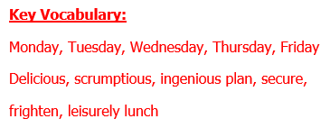
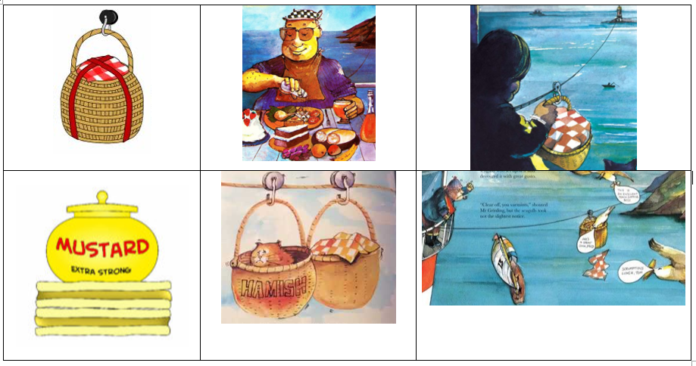
Success Criteria | Have I used this? | Does my teacher think I have used this?
Past tense
First person
Personal pronouns
Feelings
Time conjunctions
Expanded noun phrases (Y2)
Suffixes (ed, ing, ly)
Capital letters and full stops
A range of punctuation (Y2)
Finger spaces
Neat handwriting
Joined handwriting (Y2)

