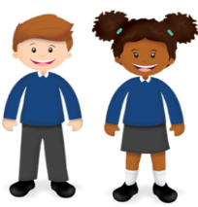
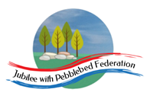
Learning
from Home

Class 2  Wk beg: 26th April ‘21 | Our Key Learning Behaviour this week is the Cat’s behaviour: questioning  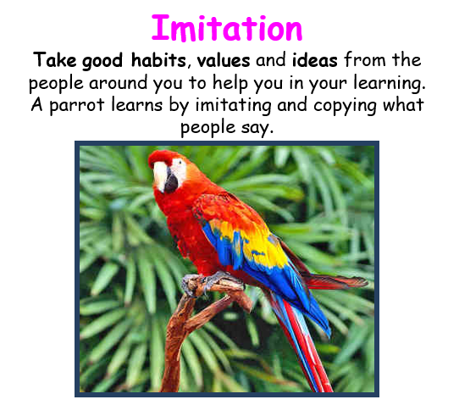  In Literacy, we will be exploring and collecting ideas from our new core texts, imitating the way the authors write and employing some of the words and phrases that they use to write our own sentences.  In Maths, we will learn about different ways of presenting data and we will imitate good habits to draw accurate charts and tables of our own.  In Geography, we will use imitation to draw our own labelled sketches of the course of a river, labelling the key features with appropriate vocabulary and we will use imitation to practise spelling these key words.  In French, we will imitate the structure of sentences, using these to create our own and attempting to imitate a French accent as we pronounce the words.  In Art, we will imitate the work of a famous artist.
 | Mental Health  (30 minutes) | Spelling (30 mins) | Reading (30 mins) | Writing (1 hour) | Maths (45 mins) | Afternoon Project  When finished each day
Monday  Collective Worship  In this week’s Collective Worship, we will continue to explore the theme of justice.  In particular this week, we will be thinking about ‘Standing up for others who have been treated unjustly’. We will read the book, The Yellow Star’ by Carmen Agra Deedy. You can find a read-through of this book on You-tube (eg. https://www.youtube.com/watch?v=32j-83k7Vrg)  How can we stand up for others who are treated unfairly? | Mental Health focus: Eat Well  We will be linking our Mental Health work this week to our PSHE topic on keeping healthy.  We will set up a food and exercise diary for the week so that we can reflect on how healthy our own eating and fitness habits are. We will also discuss some of the ways and reasons why people can develop an unhealthy relationship with food. | https://www.edshed.com/en-gb/login | https://www.activelearnprimary.co.uk/login?c=0  Please ensure you read regularly from Bug Club, answering the comprehension questions,  as well as from any other books you are reading.  Don’t’ forget to record your reading in your reading record book! | In today’s Literacy lesson, we will begin to explore our core text for this Literacy sequence: ‘One Well’ by Rochelle Strauss.  You can find a read-through of the first part of the book at https://www.youtube.com/watch?v=Jrp3XkndbuI  The book is described as ‘The Story of Water on Earth’.  Do you think the story reads like a story? How would you describe this type of writing? Which genre of writing do you think it fits best with? Why?  What do you think is the main intended purpose and audience of this text? Why?  What presentation and language features have been used and how do these suit the purpose and help the author to achieve their aims?  Listen to the book again. This time, pause at the end of each page and draw some sketches to help you remember some of the main points made in the text | Warm up with  This week, some year groups’ Maths lessons are from White Rose. These have accompanying worksheets that will be posted on the Google Classroom if required.  Year 3  https://whiterosemaths.com/homelearning/year-3/spring-week-5-statistics/  Make Tally Charts  Year 4  https://classroom.thenational.academy/lessons/reading-interpreting-and-comparing-pictograms-6tjkgd  Year 5 https://classroom.thenational.academy/lessons/interpreting-line-graphs-cmr3ec  Year 6 https://whiterosemaths.com/homelearning/year-6/summer-week-1-statistics/  Read and Interpret Line Graphs  (Follow-up worksheet on Google Classroom if required.) | PE  Have a look at one of the PE grids on the Google Classroom from a previous week or have another go at one of the lessons.  Art  In our artwork this term, we are going to be exploring the use of contrasting colours using a range of media.  Start by exploring what is meant by the term at https://www.bbc.co.uk/bitesize/guides/z3bqycw/revision/7  Then, using whatever materials you have at home, have a go at drawing a water-themed picture like the ones below, using complementary colours.  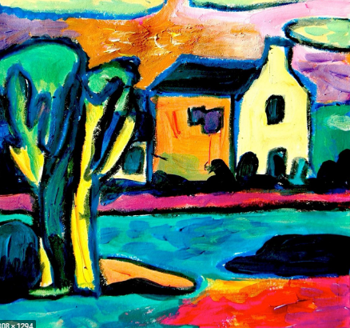  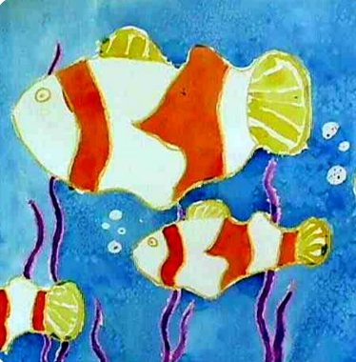  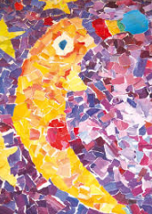
Tuesday | Mental Health focus:  Be Proud of Your Very Being/ Ask for Help  We will take the opportunity at school to reflect about what we learned last term, how we made progress towards our targets and to celebrate our successes. We will also consider our personal targets for the coming term’s learning and what help we might need to achieve those targets.  Have a think about the areas in which you feel confident and those areas where you might need a little more support or help…  Who could you ask for help? Let us know! | https://www.edshed.com/en-gb/login  Practise the spellings set for you in ‘Assignments’. Then practise the statutory words for your age group.  Your spelling Assignment change weekly on a Tuesday. I will be checking today and I will award 50 extra honey pots and 5TP to anyone who has achieved Royal Bee status in the past week’s assignments. | https://www.activelearnprimary.co.uk/login?c=0 | If required, this lesson will be posted on the Google Classroom.  In this lesson, we will continue to familiarise ourselves with the text, One Well.  We will re-read the text and make a note of the main points made on each page to summarise the text.  Have a go at writing your own text summary of this text. What are the main points the author makes in each section?  We will explore some of the sentence structures used in the text, particularly those used to show cause and effect.  Try writing some sentences about water yourself, using the conjunctions when, so, because, since, as to present the effects of human actions on the water cycle.  Look at the following sentences:  Without plants, the water cycle would be disrupted. Without water, plants could not survive.  Can you write some other sentences that begin,  Without water, … using facts from the book or from your own knowledge? | Warm up with  Year 3  https://whiterosemaths.com/homelearning/year-3/spring-week-5-statistics/  Draw Pictograms  Year 4  https://classroom.thenational.academy/lessons/construct-pictograms-64w3ce  Year 5  https://classroom.thenational.academy/lessons/reading-and-interpreting-line-graphs-cgtkad  Year 6 https://whiterosemaths.com/homelearning/year-6/summer-week-1-statistics/  Draw Line Graphs  (Follow-up worksheet on Google Classroom) | Geography  In today’s Geography lesson, we will develop the vocabulary we use to describe the features of a river.  First, use  https://www.bbc.co.uk/bitesize/topics/z849q6f/articles/z7w8pg8Oak  to explore some of the features of a river.  Then, follow up, using the lesson at the link below:  Access this lesson using pin code: RM5790  at Twinkl Go
Wednesday  Collective Worship  What groups of people are treated unfairly today? How can we stand up for those people? We will consider recent and current events as we explore this question further and consider what the Bible says about standing up for others:  Learn to do good; seek justice, correct oppression; bring justice to the fatherless, plead the widow’s cause. (Isaiah 1:17)  Proverbs 31: 8-9 — “Open your mouth for the mute, for the rights of all who are destitute. Open your mouth, judge righteously, defend the rights of the poor and needy.”  Micah 6:8 — “He has told you, O man, what is good; and what does the Lord require of you but to do justice, and to love kindness, and to walk humbly with your God?” | Mental Health focus:  10 a day:  Review the 10-a-day for Mental Health. Which do you need to focus on this week? Choose one or two that you sometimes find to be more of a challenge and consider how you can make an effort to build in some activities this week to help you achieve these. | https://www.edshed.com/en-gb/login  Practise the spellings set for you in ‘Assignments’. Then practise the statutory words for your age group. | https://www.activelearnprimary.co.uk/login?c=0 | If required, this lesson will be posted on the Google Classroom.  We will continue to explore cause and effect sentences in the text and we will explore the use of commas between clauses when a conjunction is fronted.  Look at the sentence:  Because water is not evenly distributed across the globe, nearly one-fifth of the world’s population does not have access to enough water.  Can you express the facts in this sentence in a different way? How many different ways can you find to say it? Which sentence structure do you like best and why?  Now look at this sentence:  While dams make more water available, they also change the flow of rivers and damage habitats.  The conjunctions while, yet, but and although can be used to contrast two very different effects of something. Can you complete the following sentences, using an appropriate clause:  Although North America has only one third of the population of Africa, ….  ………………………….. , yet this is not the only reason that humans are using more water than they did a hundred years ago.  While modern technology means we can clean dirty water at a sewage works, …  Plants can help to remove chemicals from water but … | Warm up with  Year 3  https://whiterosemaths.com/homelearning/year-3/spring-week-6-statistics/  Interpret Pictograms  Year 4 https://classroom.thenational.academy/lessons/read-interpret-and-compare-bar-charts-cth3gd  Year 5 https://classroom.thenational.academy/lessons/reading-scales-on-a-line-graph-6wuk0t  Year 6 https://whiterosemaths.com/homelearning/year-6/summer-week-1-statistics/  Use Line Graphs to Solve Problems  (Follow-up worksheet on Google Classroom) | Music  Today we will continue to explore the concept of melodic shape, identifying melodies which move by step and those that leap. Look on the Google Classroom for this lesson, where you will find extracts from Vltava, which is from a set of six symphonic poems by the Czech composer Smetana and describes the course of a river and also from ‘Dance of the Knights’ from Prokofiev’s ballet, “Romeo and Juliet”.  As you listen to the music, you should try to draw/ identify the shape of the melody. When does the music go up and down? When do you hear sudden leaps from high to low or low to high? When is the music ‘spiky’ and when is it more ‘smooth’? Can you invent hand signals to show the spiky parts and the smooth parts and match your hand signals to the music as you listen again?  RE  This half term in RE we will be considering the key question, ‘When Jesus left, what was the impact of Pentecost?’  Today we will re-read the story of Pentecost, which is related in the Bible in the book of Acts, chapter 2. We will look at and discuss a range of works of Art that represent the story and consider the importance of the story to Christians as we discuss the way that different artists have represented it. (See the pictures at the links below and make some notes about what you notice in each one.  Then, retell the story of Pentecost by writing two diary entries about the events: one from the point of view of one of the disciples and the other from the point of view of one of the onlookers. What might they say about what they saw, felt and experienced?
Thursday | Mental Health focus:  Do something you enjoy/ Care for others  Today, we will think about some of the hobbies and interests we have and how we can use these to care for others and the world around us. What can you do today to care for those around you or your local environment. Take time to plan something to do today that you will do to show love and care for others. You could…  Go on a litter-picking walk.  Plant some seedlingss to give a surprise gift to someone you know who enjoys gardneing later this term.  Make a card for someone who needs encouragement or support.  Make a phone call to someone who may be feeling isolated or lonely.  Offer to do a job in your house – tidy up or clean something! | https://www.edshed.com/en-gb/login  Practise the spellings set for you in ‘Assignments’. Then practise the statutory words for your age group. | https://www.activelearnprimary.co.uk/login?c=0 | If required, this lesson will be posted on the Google Classroom.  Over the next two lessons,  Year 3 and 4 will be challenged to summarise some of the main points of the text ‘One Well’ in their own words, using the images they drew earlier in the week.  Meanwhile, Year 5 and 6 will begin to explore the text ‘Are Humans Damaging the Atmosphere?’ by Catherine Chambers.  Before reading, look at the cover of the book and consider/ make notes about what you already know about this question:  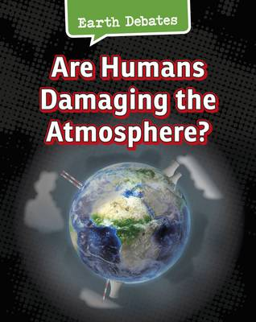  A read through of the book and key pages from it will be on the Google Classroom.  Challenge: Can you use the text to make a list of bullet points to inform Class 1 about the key ways in which farming is damaging the atmosphere?  If you are unable to access the Google Classroom, you could conduct some research about the question from other sources and present what you find out in a list of bullet points on  Does farming harm the atmosphere? | Warm up with  Year 3  https://whiterosemaths.com/homelearning/year-3/spring-week-6-statistics/  Draw Bar Charts  Year 4  https://classroom.thenational.academy/lessons/constructing-bar-charts-6th3er  Year 5  https://classroom.thenational.academy/lessons/tables-and-line-graphs-6xgk0t  Year 6 https://whiterosemaths.com/homelearning/year-6/summer-week-1-statistics/  Circles  (Follow-up worksheet on Google Classroom) | Science  This term we are starting new sequences of work. While Year 3 and 4 investigate rocks and soils, Year 5 and 6 will find out more about how plants and animals adapt to suit their environments and the traits that they inherit.  Today, Year 3 and 4 should use https://classroom.thenational.academy/lessons/how-is-igneous-rock-formed-70v66r  to learn more about rocks that are formed by volcanic activity.  Year 5 and 6 should use https://www.bbc.co.uk/bitesize/topics/zvhhvcw/articles/zxg7y4j  as an introduction to this lesson and then complete the lesson on ‘What is adaptation?’ at https://classroom.thenational.academy/lessons/what-is-an-adaptation-cmw6ct
Friday  Collective Worship  As we consider the theme of justice, we will explore the topic of racial injustice in today’s collective worship:  https://www.churchofengland.org/our-faith/faith-home/faith-home-videos/collective-worship-primary-schools-racial-injustice-s3e1 | Mental Health focus:  In our PSHE lesson today, we will be considering the theme that ‘life is all about balance’.  In what areas of your life do you sometimes find it hard to get the balance right? We will think about balancing our relationships, hobbies, work and play, sleeping and waking and spending time alone or with others. We will consider how our personality might affect our preferences.  What does the phrase ‘work-life balance’ mean? What would happen if the balance tips one way or the other? | https://www.edshed.com/en-gb/login  Practise the spellings set for you in ‘Assignments’. Then practise the statutory words for your age group. | https://www.activelearnprimary.co.uk/login?c=0 | If required, this lesson will be posted on the Google Classroom.  Year 3 and 4 should complete the writing they began yesterday, summarising the main points in the ‘One Well’ text in their own words.  Meanwhile, the Year 5 and 6 children will work individually or in pairs, each looking at a different section of the book and summarising the main points in bullet points before reporting back to the rest of the class.  On the Google Classroom, you will find a section of the text for you to summarise in a series of brief bullet points. Upload your work to share with the rest of the group.  Alternatively, you could complete some independent research about one of the following points, presenting your findings ina series of bullet points:  Does transport harm the atmosphere?  Do aerosols damage the atmosphere?  Do plastics damage the atmosphere?  How do buildings harm the atmosphere? | Warm up with  Year 3  https://whiterosemaths.com/homelearning/year-3/spring-week-6-statistics/  Bar Charts  Year 4  https://classroom.thenational.academy/lessons/consolidation-lesson-bar-chart-6nk6at  Year 5  https://classroom.thenational.academy/lessons/constructing-a-line-graph-6gv38r  Year 6 https://whiterosemaths.com/homelearning/year-6/summer-week-1-statistics/  Read and Interpret Pie Charts  (Follow-up worksheet on Google Classroom) | PSHE  In this week’s lesson, we will learn a little more about healthy eating. You can learn more by completing the following lesson:  https://classroom.thenational.academy/lessons/food-glorious-food-64vkec  French  In our French lessons this term, we will learn a range of words to talk about the sports and activities we enjoy, combining this with last term’s work on clothes and then learning more about describing the weather and describing the sports played in different types of weather. Later in the term, we will begin to extend our sentences using conjunctions...  In today’s lesson, we will use the verbs and vocabulary we began to learn in the last lesson to talk about the sports and activities we enjoy.  https://classroom.thenational.academy/lessons/saying-i-play-or-dont-play-and-i-do-or-dont-do-sports-6gtkac

