Week Beginning 27th April
Spelling Task Monday

Year 3: From Year 2: apostrophes for contractions
One use of an apostrophe is to show where letters are omitted (left out) when two words are contracted to form one. Eg. are not aren’t
Can you find all the contractions formed from the words in this chart? Have a go at using them in sentences…
I will | is not | has not
I am | he will | will not
do not | cannot | I had
I would | I have | are not
had not | have not | could not
you are | they are | you will
he will | you have

Year 4: Homophones

Look at homophones and investigate the meanings of the words. Use an online dictionary if you need to.
Then create sentences using the words correctly.

weather | whether | who’s | whose
medal | meddle | missed | mist
team | teem

Year 5: Words with the /i:/sound spelt ‘ei’ (usually after ‘c’ – for example, ceiling)
The grapheme ‘ei’ can represent lots of different phonemes.
You may remember that last term we discussed bow it can also be very hard to know whether to use ‘ei’ or ‘ie’. Sometimes people use the rule ‘i’ before ‘e’ except after ‘c’, but this isn’t sufficient. However, today, have a look at some of the words that do follow this rule:
ceiling receive deceive receipt conceit perceive conceive
Do you know what all these words mean?
Use the activities on https://www.spellzone.com/word_lists/list-34.htm to practise these words.

Year 6: Revision

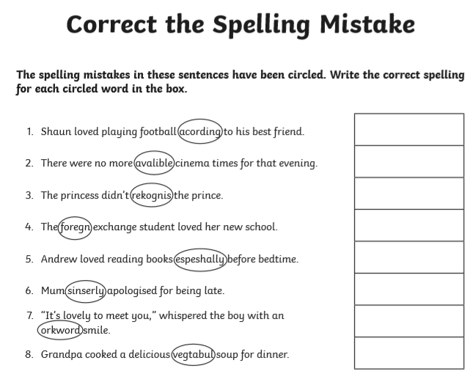
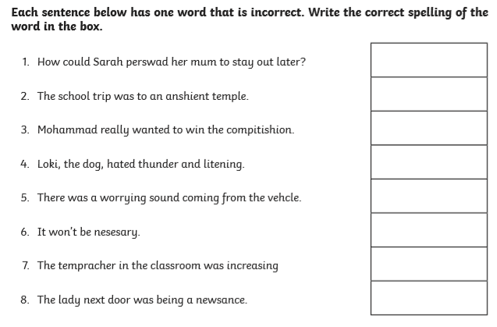

(See below for answers)

Spelling Task Wednesday

Year 3: Rare GPCs (/ɪ/ sound)
Match these words to the pictures below:
pretty mystery cygnet myth pyramids Egypt builder business
What letters are making the short /i/ sound in each of these words? Practise spelling the words. You could play a game – cut up the pictures and lay them out picture side down. Then turn them over one at a time and test yourself on the spelling.

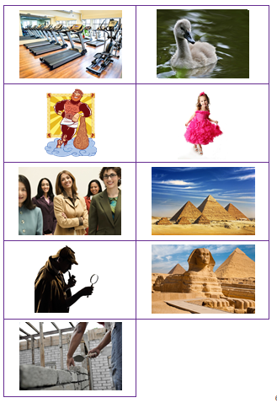
Year 4: Homophones
Revise the homophones practised yesterday. Can you select the appropriate spelling in each of the following sentences?
- The (weather/ whether) yesterday was wet and cloudy.
- Do you know (whose/who’s) the prime minister at the moment?
- I think that all the NHS staff deserve a (medal/ meddle) for their hard work.
- The children all (missed/ mist) their friends when they had to stay at home.
- Graham and his (team/ teem) won the online quiz.
- No-one really knows yet (weather/ whether) the children will be able to return to school this term.
- The cars moved more slowly than usual in the early morning (missed/ mist).
- She was warned not to (medal/ meddle) with her sister’s belongings.

Year 5: ie/ ei exception words
Some people use the rule ‘i before e, except after c’. However, many words break this rule. Here are some of them: ancient, efficient, science, conscience, protein, seize, weird, foreign, sovereign, height, either, neither, forfeit, counterfeit.
Can you use each of these words in a sentence? Use dictionaries to check what they mean if you are not sure. Have a go at some of the Spellzone activities to help you learn the spellings: https://www.spellzone.com/word_lists/list-37.htm

Year 6: Revision

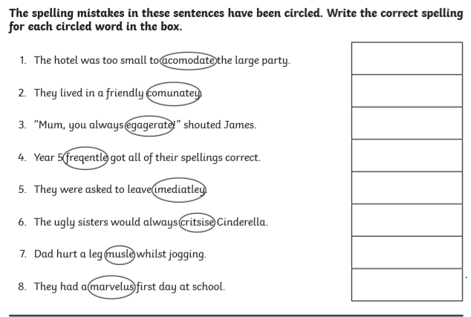
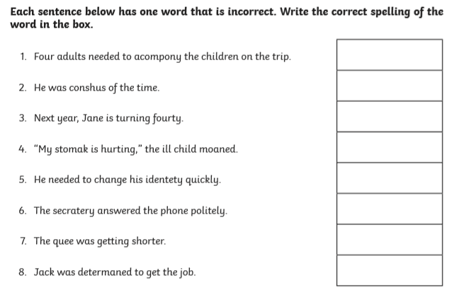

(See below for answers)
Spelling Task Thursday

Year 3: Rare GPCs (/ɪ/ sound)
Have a look at some other words in which the letter y makes a short /i/ sound:
https://www.spellzone.com/word_lists/list-175.htm On this site, you can play a range of games to help you practise spelling these words.

Year 4: Homophones
Review the homophones practised over the past couple of days. Then look at a range of other homophones, using the list and activities found at: https://www.spellzone.com/word_lists/list-8251.htm

Year 5: ie/ ei
Today, why not practise some of the words containing ie, such as: field, brief, thief, chief, grief, relief, mischief, niece, piece, siege, priest, fierce, achieve, believe, relieved, hygiene, retrieve, diesel
Which of these words do you need to investigate or practise further. You could use the activities and games on https://www.spellzone.com/word_lists/list-133.htm to help you practise these spellings.

Year 6: Revision:
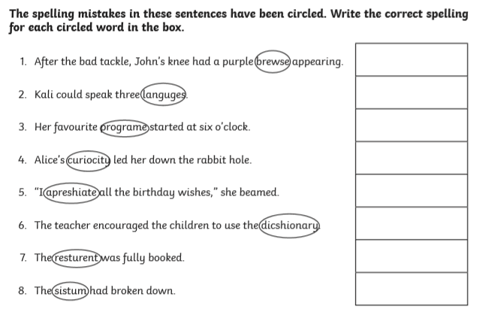
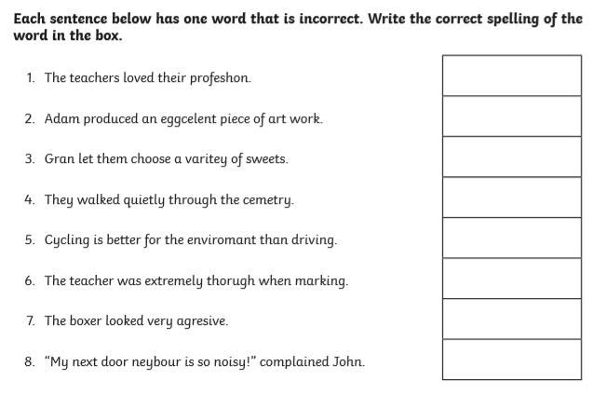

(See below for answers)

