RE
The month of Ramadan begins for Muslims this year on the evening of Thursday 23rd April and will end on Saturday 3rd May.
Watch these video clips from Newsround to find out more.
https://www.bbc.co.uk/newsround/23286976
You could make a Ramadan lantern or answer the questions on the worksheet below.
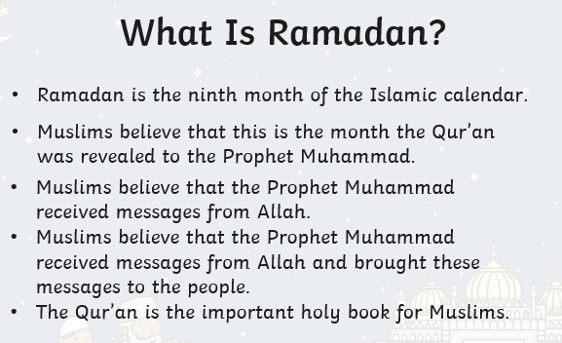
Here are a few main points.
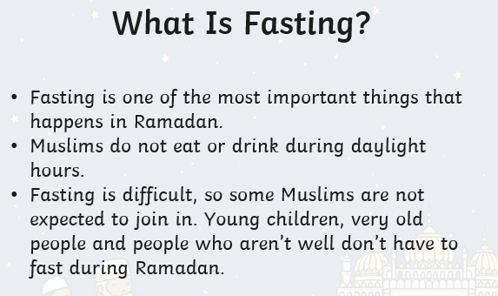

Instructions for a lantern

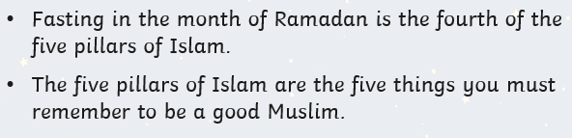

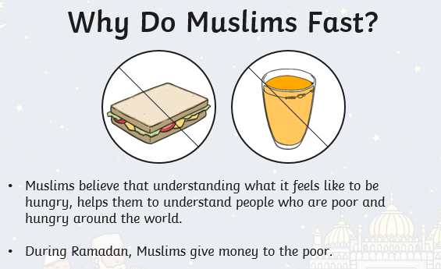

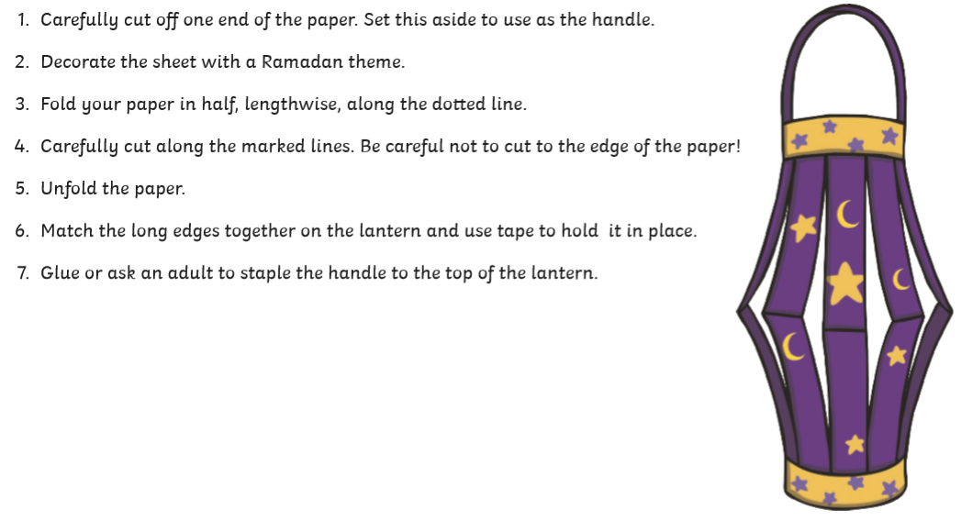

Lantern to decorate and cut out

