Weeks beginning Monday 11th May 2020 and Monday 18th May 2020 – Home Learning for Class 1

Dear Parents and Children of Class 1,
Welcome to Weeks 5 and 6 of your Home Learning! We hope that you are all happy and well. As promised last week, we are sending you big hugs! Did you manage to mail a hug?

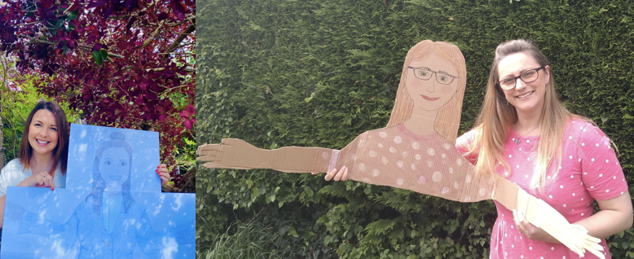

Here is your bank of resources for the final two weeks of the half term. Remember that the most important thing you can do at this unusual time is to read every day and continue to practise your phonics and key mathematics skills such as number bonds to 10, 20 and 100 and 2, 3, 5 and 10 times tables. Some new resources that we have found this week:
- You will find a Children’s Activity Pack created by CAP, designed to support children and families through Coronavirus. (Find attached as a separate document).
- This link takes you to a fabulous document from SKIP for Early Years Educators (a page worth looking at). It is a comprehensive and informative guide for parents about how to support their EYFS child at home, with lovely, relaxed, play-based ideas as well as advice for managing anxiety etc. during the COVID-19 situation: https://www.skipforeyeducators.co.uk/booklet/covid19_familybooklet.pdf?fbclid=IwAR0-N_fPDO6GyFOf7yGOGMd3vubUOYOjNJkWUxZZcb90ygcpnZl1Wpn50g4
As always, if you have any questions at all or you would like to email a picture of some of the lovely work that you have been doing, please use the following email address - admin@branscombe.devon.sch.uk. We wanted to say a bug thank you to all of you who have sent us photographs of you enjoying your learning at home. It has been wonderful to see what you have been up to. We are printing and sticking some of these photographs to make a scrapbook for us to look at when we finally return to school.
Well done Class 1, you have worked so hard this half term and you now deserve to have a break from your school work! We hope that you have a lovely half term break.

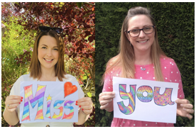

Please keep reading a book you enjoy and staying safe with your family,
Miss Harvey-Jones and Mrs Bartlett
EVERY DAY
- 20 minutes phonics (Bug Club) (Reception and Y1). See table below for details of which lesson/resources to access. Y2 see below for separate phonics activities. A note to all: You could also use Phonics Play to practise reading sounds and words and also practise sounding and blending skills. They can also read sentences. It is FREE at this time: https://new.phonicsplay.co.uk/. App/tablet friendly.
- 20 minutes ‘Bug Club’ Reading (with comprehension ‘bug’ questions). Bug Club books continue to be updated to suit your level.
- 15 minutes ‘Spelling Shed’, ‘SPAG.com’ OR ‘Bug Club Grammar’ games (KS1 only). Please do contact us if you have any issues with passwords. If you would prefer to access paper-based work to limit screen time we can email SPAG documents for you to print off.
- 15 minutes ‘Times Table Rockstars’ (KS1 only) OR to limit screen time you may wish to spend this time learning 2, 3, 5 and 10 times tables to be able to recall them at speed.
- Choose 5 spellings from your Home Learning Books to learn.
- 20 - 30 minutes Maths: KS1 – see below for a 5 minute warm ups with your parents/game, then complete any tasks set. On days when work is not set you can work in your ‘Power Maths’ Practice Books (you should complete pages in your Autumn Term books including place value and number, addition and subtraction, 2D and 3D shapes (Y1), money (Y2), multiplication and division (Y2) to finish these books).
Reception/Pre-School – see activities detailed below.
- PE/Active Time - Joe Wicks (The Body Coach) has daily workout videos on YouTube (go online with your grown ups) but you do not need to feel restricted to this – get some fresh air when walking the dog, using skills developed in out of school clubs such as football/ballet or exercising in the garden instead, if you can safely do so.
- We would like children to continue their Summer Term diary and write one or two sentences a day (with support if necessary for younger pupils) and draw a picture. The sentence might be about something they have done, something they have seen or even what the weather is like. Some examples might be: ‘It is sunny.’ ‘It is a flower.’ ‘I went to the park’. Sentences do not need to be spelt correctly but the children should use their phonic skills to attempt to write words. KS1 children could also use the Time Capsule sheets attached on a separate link to help with ideas.
- Please keep reading/sharing a book you enjoy with your family. Try to keep a log together (one or two sentences) of what you have read that day. If you are reading a fiction book, what happened or what characters did you meet? If you are reading a non-fiction book perhaps you write down something that you have found out that you didn’t know before.

Monday | Phonics – ALL with support from parents/carers  Year 1 – Phase 6 – Unit 28 - Language session – After: suffix endings '-ing' and '-ed'  Year 2 – Dictionary Skills: Revise the alphabet and remind your child how a dictionary works. Practise finding different letters and using the word at the top of each page (the head  word) to navigate. Pick a word. Show pupils how to use a dictionary to find the correct spelling. Teach looking at second and third letter when searching if appropriate to the word.  EYFS- We are learning to read some tricky words and practising words with adjacent consonants. Practise GPCs - Play Flashcards using the attached resources or Quickwrite Graphemes (say the sound on the flashcard ask your child to write it without them seeing it).  Teach reading tricky words were, there, little one. Play Buried Treasure (real words go in a treasure chest, nonsense words in a bin) with words: steep, tree, trail, train, smeep, gree, prail, frain. Read the sentences, encourage your child to blend graphemes if they get stuck: Were there some chimps at the zoo? Yuck! There was a paint brush in the coffee cup. One little brown toad got stuck down a drain.  Maths  EYFS Maths Starter – Access https://home.oxfordowl.co.uk/kids-activities/fun-maths-games-and-activities/ (Age 4-5 tab) to select a game of your choice.  EYFS - Access the White Rose Maths website for home learning (link below).  https://whiterosemaths.com/homelearning/early-years/  Complete Summer Term Week 2 - Day 1 – Night Pirates (watch the video before completing the activity).  KS1 Maths Starter – Access https://home.oxfordowl.co.uk/kids-activities/fun-maths-games-and-activities/ (Age 5-6 tab) to select a game of your choice.  Y1 Access the White Rose Maths website for home learning (link below).  https://whiterosemaths.com/homelearning/year-1/  Complete Summer Term – Week 4 - Lesson 1 (watch the video before completing the activity).  Y2 Access the White Rose Maths website for home learning (link below).  https://whiterosemaths.com/homelearning/year-2/  Complete Summer Term – Week 4 – Lesson 1 (watch the video before completing the activity).  KS1 - If you do have access to a printer and want to print the White Rose sheets that go with each lesson, you can do. If you do this, you do not have to do the Power Maths pages as well.  If you do not have access to a printer, watch the White Rose video each day and then complete the Power Maths books.  Daily Project  EYFS and KS1 Theme/Speaking and Memory Games!  Task 1: Play spot the difference, choosing someone to go outside of the room and change one thing about themselves (maybe pull one sock down or remove a headband). Spot and describe what the person has changed.  Task 2: Learn and recite some memory rhymes that help us remember things. Read and remember common memory rhymes about topics like the months of the year or the alphabet. Listen carefully and join in where possible. Then practise, reciting them aloud.  Challenge - Can you learn one per day this week?
Tuesday | Phonics – ALL with support from parents/carers  Year 1 – Phase 6 - Unit 29 Suffix ending: '-s' (as plural morpheme)  Year 2 – Dictionary Skills: Ask your child to identify two or three errors in a short piece of their own writing/a piece you have produced. Ask them to use a dictionary to look up the correct spelling and correct it.  EYFS - We are learning to read two syllable words with adjacent consonants - Practise GPCs - Play Flashcards using the attached resources or Quickwrite Graphemes (say the sound on the flashcard ask your child to write it without them seeing it). Write a two syllable word making a slash between the two syllables e.g. lunch/box. Sound talk the first syllable and blend it l-u-n-ch lunch. Sound talk the second syllable b-o-x box. Say both syllables lunchbox. Repeat and ask the children to join in. Repeat with the words: helpdesk, windmill, treetop, starlight, desktop, sandwich, sandpit. Read the sentences, encourage your child to blend graphemes if they get stuck: You put a shampoo sandwich in my lunchbox. Ring the helpdesk and tell them my cat is stuck. I stuck a little windmill in this sandpit.  Maths  EYFS Maths Starter: Practise your number bonds to 10.  EYFS - Access the White Rose Maths website for home learning (link below).  https://whiterosemaths.com/homelearning/early-years/  Complete Summer Term Week 2 - Day 2 – Night Pirates (watch the video before completing the activity).  KS1 Maths Starter:  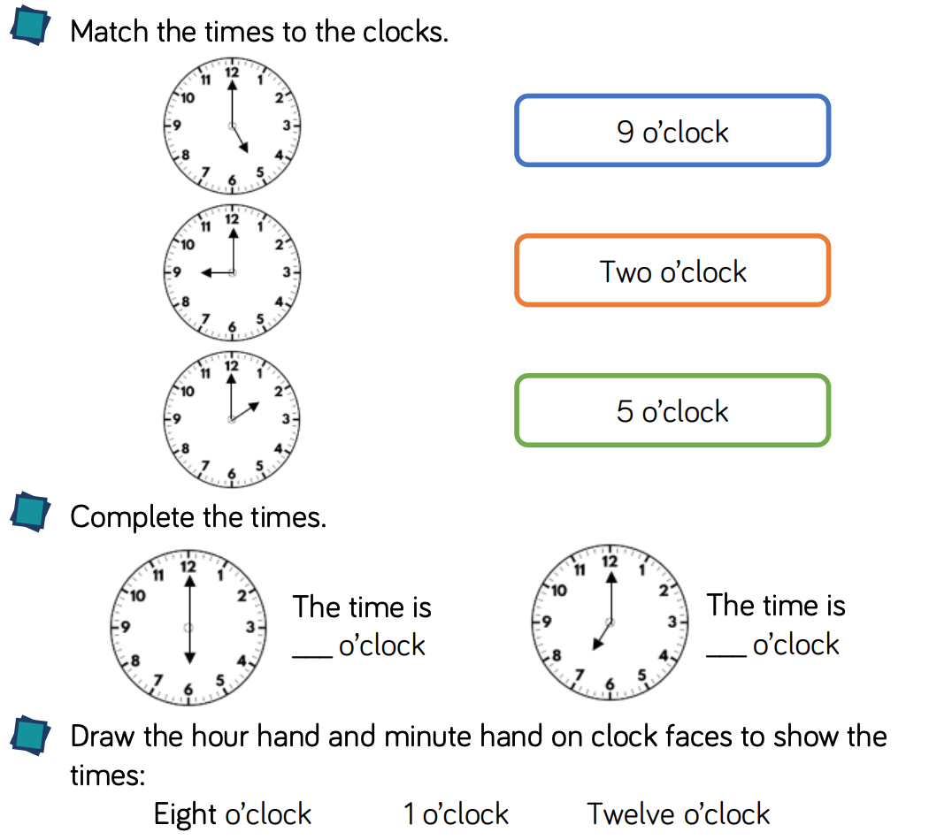  Y1 Access the White Rose Maths website for home learning (link below).  https://whiterosemaths.com/homelearning/year-1/  Complete Summer Term – Week 4 - Lesson 2 (watch the video before completing the activity).  Y2 Access the White Rose Maths website for home learning (link below).  https://whiterosemaths.com/homelearning/year-2/  Complete Summer Term – Week 4 – Lesson 2 (watch the video before completing the activity).  KS1 - If you do have access to a printer and want to print the White Rose sheets that go with each lesson, you can do. If you do this, you do not have to do the Power Maths pages as well.  If you do not have access to a printer, watch the White Rose video each day and then complete the Power Maths books.  Daily Project  Task 1: EYFS and KS1 - Last week we learnt about the month of Ramadan. This week we are going to look at the festival of Eid that Muslims celebrate at the end of Ramadan, Eid al-Fitr.  Watch this short video clip to find out more: https://www.bbc.co.uk/newsround/33575453  Then have a go at this quiz! https://www.bbc.co.uk/cbbc/quizzes/eid-al-fitr-quiz. You can also access the separate document attached for more information and a delicious recipe to try.  Task 2: EYFS and KS1 - Play ‘I went to market’, recalling items bought in alphabetical order and see how far you can get.  Task 3: KS1 ONLY - Remind your child of the word ‘mnemonic’. Apply their phonic knowledge to read some simple mnemonics and discover what words the mnemonics help them to spell. For example, what does the mnemonic ‘big elephants can always understand small elephants’ spell? Or 'warm hands and toes' and 'snakes and insects dance' (see attached document). Explain to them that a mnemonic is used to help us remember how to spell tricky words. Ask children to try and create mnemonics for words they find tricky to spell and other things that you find tricky to remember. Try to make them as funny as they can, as this makes them easier to learn. Write mnemonics on word cards with illustrations to help to remember them and display around your house.

Wednesday | Phonics – ALL with support from parents/carers  Year 1 - Phase 6 – Unit 29 - Suffix ending: '-es' after 'ss', 'x'  Year 2 – The/l/ or /əl/ sound spelt ‘-el’ at the end of words: Revisit the /l/ or /əl/ sounds spelt ‘-le’ at the end of words, for example: bottle, muddle, little. Explain that another spelling of this phoneme is ‘-el’. Give them a set of word cards and a chart headed ‘-le’ and ‘-el’. Ask them to read each word card and then put it into either the ‘-le’ or ‘-el’ column on the chart.  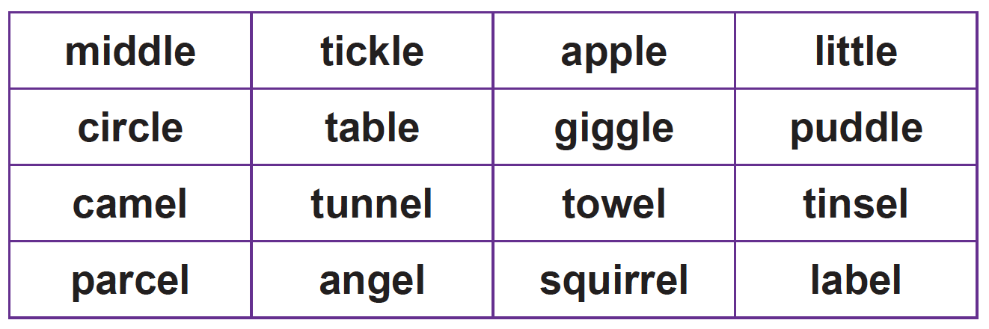  EYFS – We are learning to spell two syllable words with adjacent consonants - Practise GPCs - Play Flashcards using the attached resources or Quickwrite Graphemes (say the sound on the flashcard ask your child to write it without them seeing it). Say a word e.g. desktop, clap each syllable and ask them to do the same. Repeat with two or three more words. Clap the first word again and tell them that the first clap is on desk and the second is on top. Ask the children for the sounds in desk and write it down. Repeat with the second syllable. Read the complete word. Repeat with another word. Now read out two syllable words – ask your child to clap out the syllables and then segment them and write them when writing them. Use the words: lunchbox, helpdesk, windmill, treetop, starlight, desktop, sandwich, sandpit. Read the sentences, encourage your child to blend graphemes if they get stuck: Can lightning hit a windmill? The chimpanzee did a handstand. This frog is chomping on pondweed. Encourage them to soundtalk words. Pick one sentence to dictate and ask your child to write it. Show them the sentence and ask them to check each letter. Encourage them to correct any mistakes.  Maths  EYFS Maths Starter: Encourage your child to represent numbers to 20 in different ways e.g. drawing pictures, towers of a certain amount, collecting an amount of pebbles etc.  EYFS - Access the White Rose Maths website for home learning (link below).  https://whiterosemaths.com/homelearning/early-years/  Complete Summer Term Week 2 - Day 3 – Night Pirates (watch the video before completing the activity).  KS1 Maths Starter:  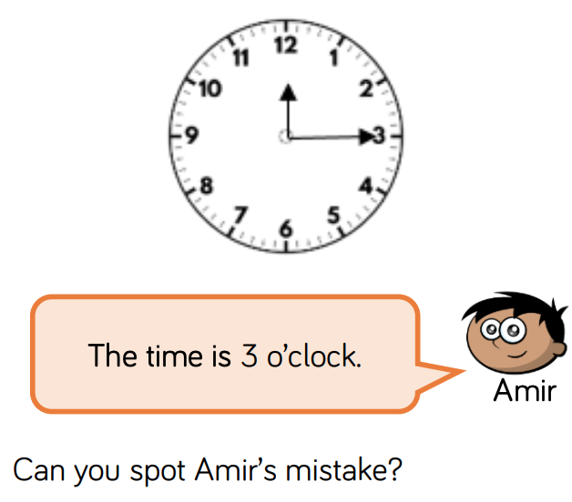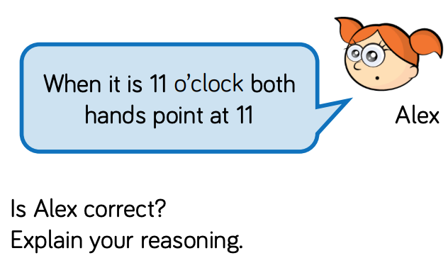  Y1 Access the White Rose Maths website for home learning (link below).  https://whiterosemaths.com/homelearning/year-1/  Complete Summer Term – Week 4 - Lesson 3 (watch the video before completing the activity).  Y2 Access the White Rose Maths website for home learning (link below).  https://whiterosemaths.com/homelearning/year-2/  Complete Summer Term – Week 4 – Lesson 3 (watch the video before completing the activity).  KS1 - If you do have access to a printer and want to print the White Rose sheets that go with each lesson, you can do. If you do this, you do not have to do the Power Maths pages as well.  If you do not have access to a printer, watch the White Rose video each day and then complete the Power Maths books.  Daily Project  EYFS and KS1  Task 1 - Dance: Do you know a dance routine you can teach to the rest of your family? Today I would like you to learn some simple dance steps and movements using the link below, and then you will need to make up your own fun, contemporary dance for others to remember and follow. You will need to perform and teach your dance to be able to perform as a family. How much of your dance can your family members remember?  Access this link for support:  https://www.bbc.co.uk/programmes/articles/2xgXhhwf2jBWsdtF3vDkx36/primary-dance  Task 2 – Music: Sing songs and rhymes, such as I Can Sing a Rainbow, The Alphabet Song and Dem Bones that help us to remember different things.  https://www.bbc.co.uk/teach/school-radio/nursery-rhymes-i-can-sing-a-rainbow/zn3tqp3  https://www.bbc.co.uk/cbeebies/watch/get-squiggling-letters-alphabet-song  https://www.dailymotion.com/video/x2drfyf
Thursday | Phonics – ALL with support from parents/carers  Year 1 - Phase 6 – Unit 29 - Suffix ending: '-es' after 'ch', 'sh', 'tch'  Year 2 – The/l/ or /əl/ sound spelt ‘-el’ at the end of words: Take your child outside (or use a room indoors if this is not safe). Label one side of the garden/room with ‘-el’ and the other with ‘-le’. Call out a word and ask your child to run to the correct side of the room/garden depending on the spelling of the ending.  Hold up the word card and ask pupils to chant it letter by letter.  EYFS - We are learning to spell HFW and practise writing words with adjacent consonants -  Practise GPCs - Play Flashcards using the attached resources or Quickwrite Graphemes (say the sound on the flashcard ask your child to write it without them seeing it). Write the word ‘they’ out. Check that all children can read it. Say a sentence using the word. Soundtalk the word, raising a finger for each phoneme. Ask your child to do the same. Discuss the letters required for each phoneme, using letter names. Explain that although the word has the /ai/ phoneme at the end, we need to train our brains to spell it with ey. Ask children to trace the shapes of the letters with their fingers. Rub the word off the whiteboard and ask all children to write the word on their whiteboards. Repeat with ‘all’ and ‘are’. Give them two minutes to see how many times they can write the word ‘they’. Ask them to count up the words. Repeat with the words all and are. Read the sentences, encourage your child to blend graphemes if they get stuck: They all had a sandwich and some crisps for a snack. The windmills are all near the farm. They are all jumping for joy. Encourage them to soundtalk words. Pick one sentence to dictate and ask your child to write it. Show them the sentence and ask them to check each letter. Encourage them to correct any mistakes.  Maths  EYFS Maths Starter: Access https://www.themathsfactor.com/games/ to select a game from the ‘Explorer Key’ section.  EYFS - Access the White Rose Maths website for home learning (link below).  https://whiterosemaths.com/homelearning/early-years/  Complete Summer Term Week 2 - Day 4 – Night Pirates (watch the video before completing the activity).  KS1 Maths Starter:  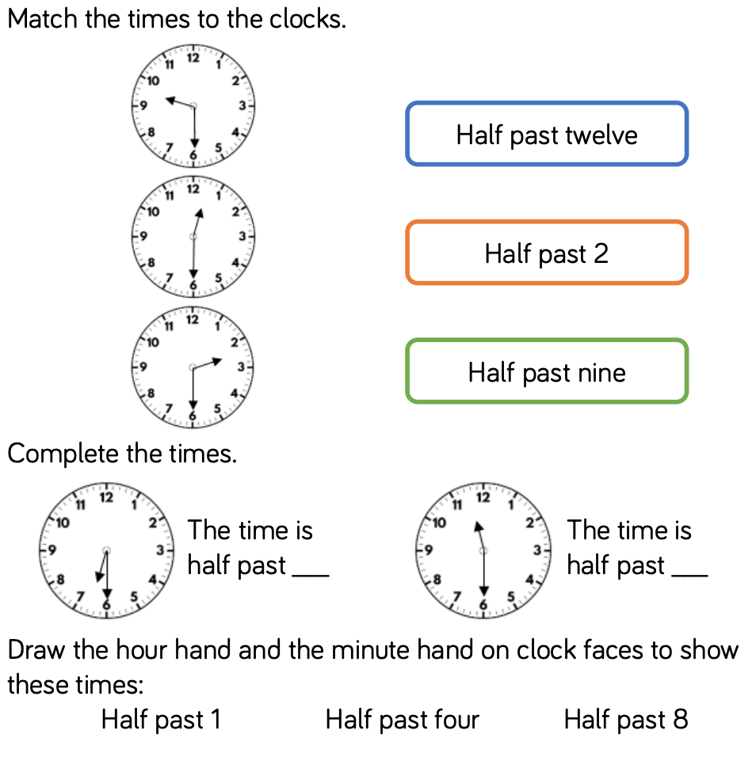  Y1 Access the White Rose Maths website for home learning (link below).  https://whiterosemaths.com/homelearning/year-1/  Complete Summer Term – Week 3 - Lesson 4 (watch the video before completing the activity).  Y2 Access the White Rose Maths website for home learning (link below).  https://whiterosemaths.com/homelearning/year-2/  Complete Summer Term – Week 3 – Lesson 4 (watch the video before completing the activity).  KS1 - If you do have access to a printer and want to print the White Rose sheets that go with each lesson, you can do. If you do this, you do not have to do the Power Maths pages as well.  If you do not have access to a printer, watch the White Rose video each day and then complete the Power Maths books.  Daily Project  EYFS and KS1 – Theme/PSHE:  Think about a special friend and say why you like them. Identify any shared hobbies, likes and interests and talk about shared experiences. Present these thoughts in any way that you wish to your family (for example poster/speech). Be prepared to answer questions about why you are friends with this person.  EYFS/KS1 Challenge  Did you manage to find time to have a go at this last week? If not, why not try it this evening? If you did manage to do this last week and enjoyed yourselves, choose a different film to show at your ‘home cinema’!  Can you organise a ‘home cinema’ night?  Some ideas:  - Make a poster for the sitting room door.  - Make some tickets.  - Take some money to spend and give change for snacks during the interval.  - Take it in turns to be usher to show family members to their seats using a torch.  Have fun!
Friday | Phonics – ALL with support from parents/carers  Year 1 – Phase 6 – Unit 29 - Language session – After: suffix endings '-s' and '-es'  Year 2 – The/l/ or /əl/ sound spelt ‘-el’ at the end of words: Show a list of words with the ‘-le’ or ‘-el’ missed off. Ask your child to write the words with the correct ending. Reinforce asking ‘Does it look right?’ or ‘Have I seen this word written like this in a book?’  Check spellings.  EYFS – Repeat lesson from Thursday. Pick another sentence to dictate and write.  Maths  EYFS Maths Starter –Access https://www.bbc.co.uk/cbeebies/topics/numeracy to select a game to play.  EYFS - Access the White Rose Maths website for home learning (link below).  https://whiterosemaths.com/homelearning/early-years/  Complete Summer Term Week 2 - Day 5 – Night Pirates (watch the video before completing the activity).  KS1 Maths Starter:  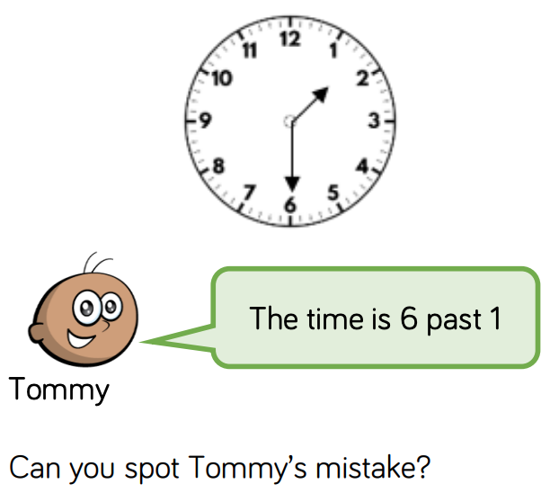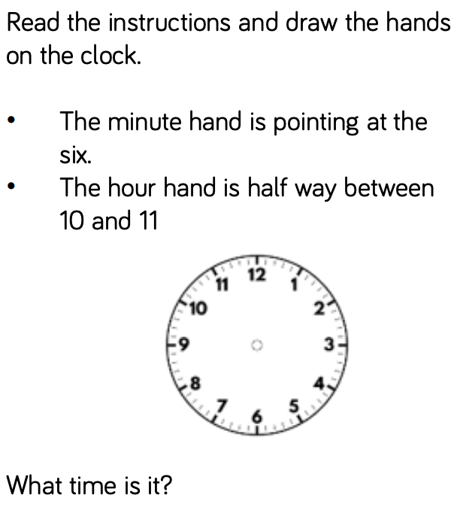  Y1 Access the White Rose Maths website for home learning (link below).  https://whiterosemaths.com/homelearning/year-1/  Complete Summer Term – Week 4 - Lesson 5 – Friday Maths Challenge (watch the video before completing the activity).  Y2 Access the White Rose Maths website for home learning (link below).  https://whiterosemaths.com/homelearning/year-2/  Complete Summer Term – Week 4 – Lesson 5 – Friday Maths Challenge (watch the video before completing the activity).  KS1 If you do have access to a printer and want to print the White Rose sheets that go with each lesson, you can do. If you do this, you do not have to do the Power Maths pages as well.  If you do not have access to a printer, watch the White Rose video each day and then complete the Power Maths books.  Daily Project  EYFS and KS1  Task 1 – RE: Today we will continue looking at Islam and find out about the Prophet Muhammed. Please click on the link to watch the videos and complete the tasks. https://www.natre.org.uk/uploads/Free%20Resources/Pupil%20resources%20amended/F1%205-7%20RE%20Today%20and%20NATRE%20home%20learning%20Islamic%20stories.pdf  Task 2 – Speaking and Listening: Play memory games such as Kim’s game. (Kim’s game is a classic game for developing memory skills. Provide a range of everyday items on a tray, now ask your child to close their eyes and then remove one item. After the item is removed, ask them to look carefully to spot what has been taken. Can they remember what was there and what has been removed?) Talk about how they try to remember all the things on the tray.

Monday | Phonics – ALL with support from parents/carers  Year 1 – Phase 5 - Unit 30 - Prefix 're-'  Year 2 – Adding endings ‘-ing’, ‘-ed’, ‘-er’, ‘-est’ to words ending in ‘y’: Use the following words: copy, worry, happy, cry, reply, funny. Choose one of the words from the list above and draw a chart with the headings ‘-ing’, ‘-ed’, ‘-er’, ‘-est’.  Show your child how the word is changed when adding the endings. What do they notice? (The ‘y’ changes to ‘i ‘apart from when ‘-ing’ is added, otherwise there would be ‘ii’). Ask them to try one of the other words. (Not all the words can have all the morphemes added to them.) Try as many words as there is time for. Say the words in a sentence to check that they are real words.  EYFS – We are learning to read some tricky words and practising words with adjacent consonants. Practise GPCs - particularly long vowel phonemes. Play Flashcards using the attached resources or Quickwrite Graphemes (say the sound on the flashcard ask your child to write it without them seeing it). Teach reading tricky words do, when, out, what.  Play Buried Treasure (real words go in a treasure chest, nonsense words in a bin) with words: think, thank, street, spring, plink, thand, spreet, sprick. Read the sentences, encourage your child to blend graphemes if they get stuck: Do clocks get cross? Can crabs clap hands? Are you fond of plums? Did a shark ever jump up a tree? Do trains run on tracks? Will a truck go up steep stairs? Can we see the stars on a clear night? When you get wet, will you shrink? Will trash jump from a dustbin?  Maths  EYFS Maths Starter – Odd and Even Q&A: Ask your child to collect and odd number of cubes (or use an alternative to suit). Ask them how they can check/prove that the amount is indeed an odd number. Now ask them to collect one more cube and add it to their set. Ask them how many they have now. Ask them if they still have an odd number of cubes or not. Ask them to continue adding one more cube and to discuss what they notice. Ask them what the largest odd umber they can build/gather is. Ask them how they can check if this is odd of not.  EYFS - Access the White Rose Maths website for home learning (link below).  https://whiterosemaths.com/homelearning/early-years/  Complete Summer Term Week 3 - Day 1 - (watch the video before completing the activity).  KS1 Maths Starter  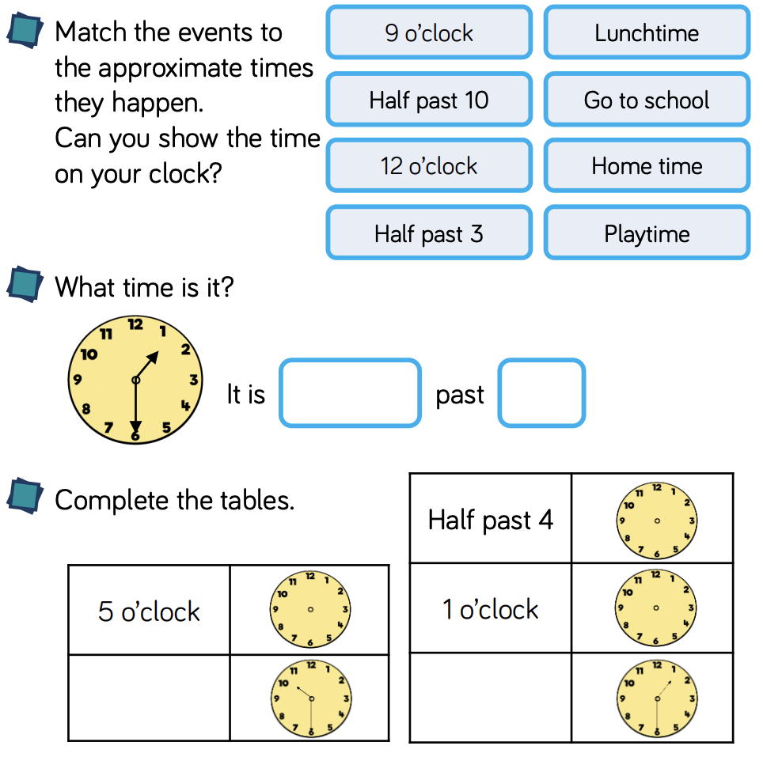  Y1 Access the White Rose Maths website for home learning (link below).  https://whiterosemaths.com/homelearning/year-1/  Complete Summer Term – Week 5 - Lesson 1 (watch the video before completing the activity).  Y2 Access the White Rose Maths website for home learning (link below).  https://whiterosemaths.com/homelearning/year-2/  Complete Summer Term – Week 5 – Lesson 1 (watch the video before completing the activity).  KS1 - If you do have access to a printer and want to print the White Rose sheets that go with each lesson, you can do. If you do this, you do not have to do the Power Maths pages as well.  If you do not have access to a printer, watch the White Rose video each day and then complete the Power Maths books.  Daily Project  EYFS and KS1 - Maths/Science: Today you will be using your senses!  Place a selection of fruit and vegetables on the table. Ask your child to explore the food. Encourage them to use all their senses to explore the foods by asking them to smell, feel and touch their fruit and veg and to talk about what they are experiencing. Ask questions specifically about each sense: Do you like any of these foods? Do you like green fruits? Can you think of something else that is crunchy? What does the skin feel like? What does it sound like when you tap it with your finger? Do you have one with a bumpy skin? Does its smell remind you of anything else?  Now can you turn the room into a fruit and vegetable market children? You will need to set your market stall out clearly. How will you sort your food? When you have identified a way of sorting your food, you need to write it on a large piece of paper, like a banner for your stall (Soft and hard foods! Get your shiny and bumpy food here! etc.). Set out the food on the stall with their banner displayed. Can you label your food with prices? Then declare the market open. Wander around and talk about the clearly laid out food and the different ways you have classified your food to attract customers. When a customer wants to buy with it accept some money and work out what change you need to give.
Tuesday | Phonics – ALL with support from parents/carers  Year 1 – Phase 6 - Unit 30 - Prefix 'un-'  Year 2 - Adding endings ‘-ing’, ‘-ed’, ‘-er’, ‘-est’ to words ending in ‘y’: Using the matrix below, ask your child to make as many words as possible. Check that they are spelling the words correctly and using the convention of ‘y to ‘i’ apart from when adding ‘-ing’.  EYFS - We are learning to spell HFW and practise writing words with adjacent consonants: Practise GPCs - Play Flashcards using the attached resources or Quickwrite Graphemes (say the sound on the flashcard ask your child to write it without them seeing it). Display a word card. Words: said, so, do, have, like, some, come, were, there, little, one, when, out, what. Point to each grapheme as the children soundtalk the graphemes (as far as is possible with tricky words) and read the word. Say a sentence using the word. Repeat with each word card. Start again with the first word card and repeat the process more quickly but without giving a sentence. Work through all cards. Go through cards a final time with children saying the word without sounding them out. Read the sentences, encourage your child to blend graphemes if they get stuck: When you drink milk, will you hear it crunch? Will an igloo melt in spring? Will a pink shrimp punch a green crab? Can string think? Do you think mud will scrunch? Do cars sleep? Will a plump toad burst? Do skunks stink? Do fish blink?  Maths  EYFS Maths Starter – Find a half: Provide 2 teddies and plates and a selection of items for halving. Ask your child to explore which quantities will halve exactly into 2 equal groups and which will have one left over. Ask them the following questions. If you have 6, can you give both teddies the same? What about if you start with 5? Is this an even of an odd number? How do you know? Ask your child to draw pictures to record their findings.  EYFS - Access the White Rose Maths website for home learning (link below).  https://whiterosemaths.com/homelearning/early-years/  Complete Summer Term Week 3 - Day 2 - (watch the video before completing the activity).  KS1 Maths Starter  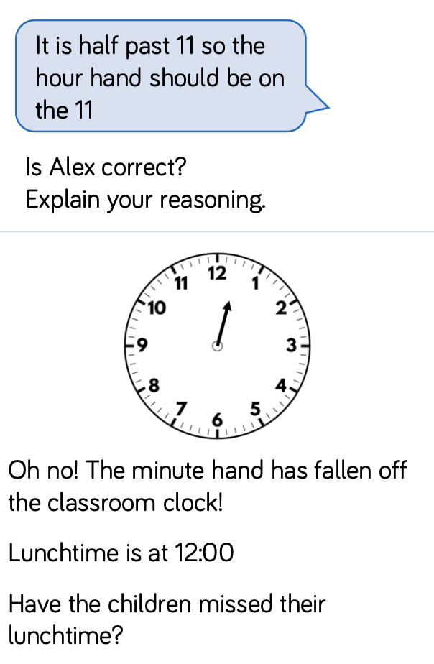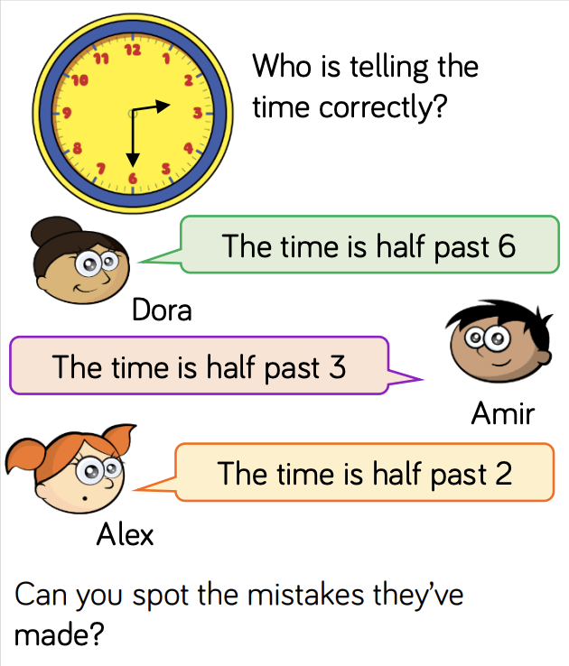  Y1 Access the White Rose Maths website for home learning (link below).  https://whiterosemaths.com/homelearning/year-1/  Complete Summer Term – Week 5 - Lesson 2 (watch the video before completing the activity).  Y2 Access the White Rose Maths website for home learning (link below).  https://whiterosemaths.com/homelearning/year-2/  Complete Summer Term – Week 5 – Lesson 2 (watch the video before completing the activity).  KS1 - If you do have access to a printer and want to print the White Rose sheets that go with each lesson, you can do. If you do this, you do not have to do the Power Maths pages as well.  If you do not have access to a printer, watch the White Rose video each day and then complete the Power Maths books.  Daily Project  Task 1 - EYFS and KS1 - Science: Today you have a simple Science investigation to attempt! You will complete two tests with one eye closed and then both eyes open to understand why humans and other animals have two eyes.  What to do: Work with a partner (parent or sibling) to complete these two simple tests.  - Stand a metre apart and hold a pencil out in front of you (both partners). Take it in turns to close one eye and try to touch the tip of your partner's pencil with the tip of your own. Repeat the action again to see what happens when they have both eyes open and when standing different distances apart. Write down a summary of your findings.  - Sit on a chair with one eye closed. Carefully watch your partner slowly move a coin in the air until you think it is directly above a cup on a table. When you think the coin is in the right place, shout 'Drop!' and watch to see if the coin lands in the cup. Take it in turns to repeat the test with both eyes open. Write down a summary of your findings.  Task 2 – KS1 ONLY - PSHE: Today we are going to continue and complete our ‘Hazard Watch’ topic. Think back to your learning in Week 4. Take a look around the room that you are working in. Can you see any hazards or spot any potential dangers? Record your answers on your ‘Safety Detectives’ worksheet (see separate attached documentation). Now share and discuss your ideas with your parent/s. Would you like to add or change anything? (Make changes in a different colour to highlight your learning). Now copy and finish these sentences:  - I should not play with …. because …  - I should not eat/drink with …. because …  - If I spot a potential danger or hazard I can…  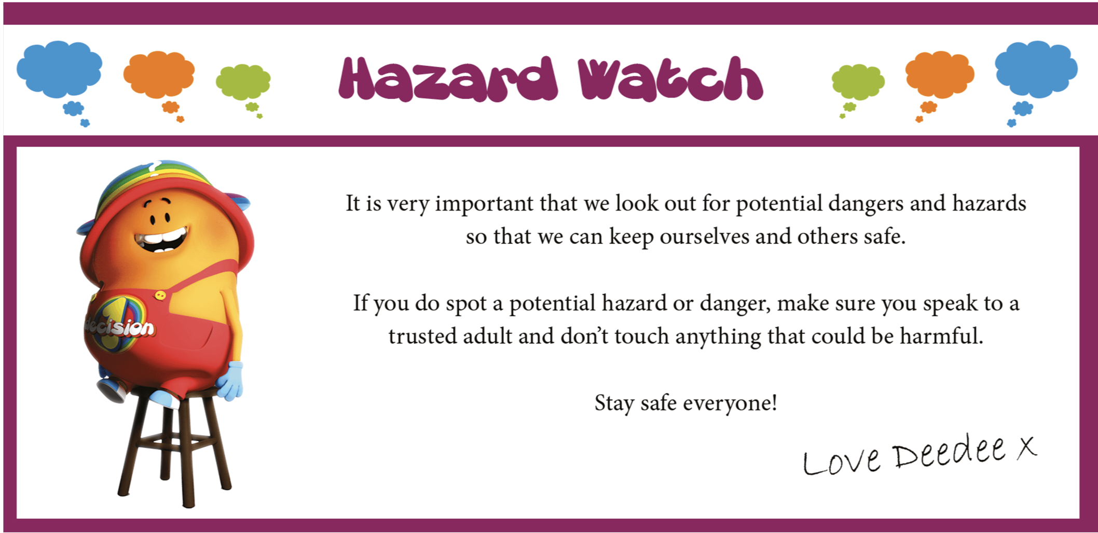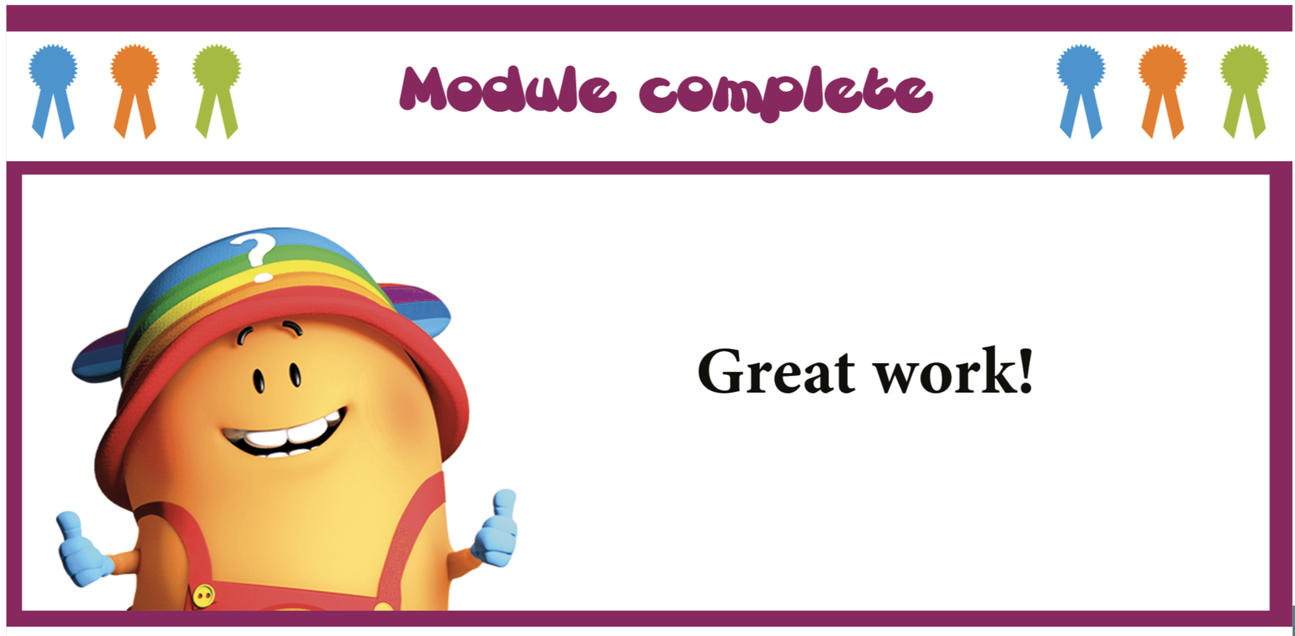
Wednesday | Phonics – ALL with support from parents/carers  Year 1 - Phase 6 – Unit 30 - Prefix, root, suffix  Year 2 – Suffixes ‘-ment’ and ‘-ness’: Share the two matrices with your child and together create words from them. What do they notice about adding ‘-ness’ to words that end in ‘y’?  Remind pupils about what happened when they added other suffixes to words ending in ‘y’, for example, copy, copier; happy, happily, happier, happiest. Share the words that pupils have made. Discuss what the words mean. The suffix ‘-ness’ changes an adjective to a noun and means ‘the state of being’, for example, the state of being happy or sad.  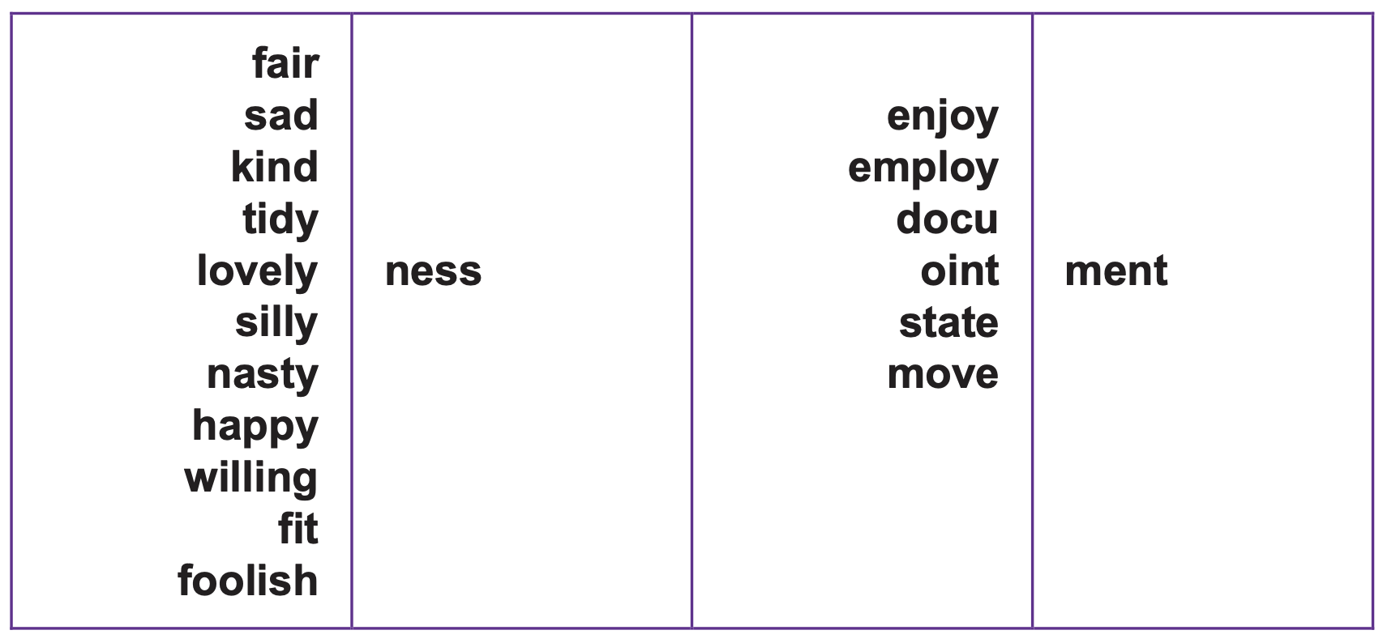  EYFS - We are learning to spell HFW and practise writing words with adjacent consonants: Practise GPCs - Play Flashcards using the attached resources or Quickwrite Graphemes (say the sound on the flashcard ask your child to write it without them seeing it).  Have four, five and six phoneme frames available (see separate attached documentation). Say a word e.g. think and model counting out phonemes on your fingers. Ask your child how to write each of the phonemes. Count them off against your fingers to check that you haven’t forgotten any. Write the word. Words: think, thank, street, spring, crept, slept, crunch, scrunch, trunk, drift. Play phoneme fingers: Adult reads word, child shows the number of phonemes by holding up that number of fingers and then tries writing the word. Read the sentences, encourage your child to blend graphemes if they get stuck: A shrimp slept in a shell. A crab crept into a crack. An octopus puts on lots of pink socks with brown spots.  Maths  EYFS Maths Starter – Making equal groups: Your starter today is a bit like yesterday. This time keep to 12 items to share each time but vary the number of teddies and plates. Ask your child to explore sharing the 12 items into equal groups so that each teddy gets the same. Ask them the following questions. If there are 2 teddies will they each get the same? How many are in each group? Are there any items left over? What about 3 teddies? 4? 5? 6?  EYFS - Access the White Rose Maths website for home learning (link below).  https://whiterosemaths.com/homelearning/early-years/  Complete Summer Term Week 3 - Day 3 - (watch the video before completing the activity).  KS1 Maths Starter  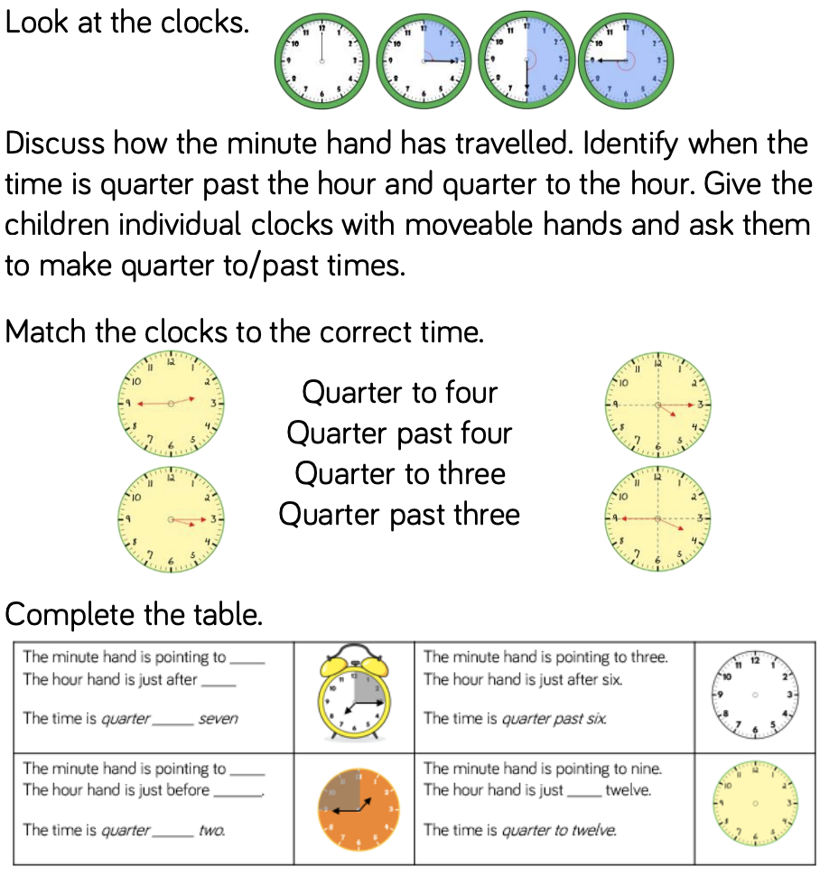  Y1 Access the White Rose Maths website for home learning (link below).  https://whiterosemaths.com/homelearning/year-1/  Complete Summer Term – Week 5 - Lesson 3 (watch the video before completing the activity).  Y2 Access the White Rose Maths website for home learning (link below).  https://whiterosemaths.com/homelearning/year-2/  Complete Summer Term – Week 5 – Lesson 3 (watch the video before completing the activity).  KS1 - If you do have access to a printer and want to print the White Rose sheets that go with each lesson, you can do. If you do this, you do not have to do the Power Maths pages as well.  If you do not have access to a printer, watch the White Rose video each day and then complete the Power Maths books.  Daily Project  Task 1 - EYFS and KS1 – Did you know that memories can be short-term or long-term and we can use different strategies to help us remember more things? Today, as part of a scientific investigation, I would like you to play games that test your memory and investigate a strategy that will help you to remember more information.  What to do:  - Observe 12 different words for one minute then see how many you can remember.  - Repeat the process with 12 different numbers and then again with 12 pictures of different objects.  - Were you able to recall words, numbers or pictures most often? Write down your findings.  - Finally, collect 12 new objects and make up some silly stories about them as a strategy to try to remember them. How successful was this strategy in helping you to recall more information?  Task 2 – EYFS and KS1 - PE/Mental Health/PSHE: It is important to ask for help when you need it. You can ask a trusted grown up. Can you think about who you know that you might ask for help and when you might need help? KS1 Children - Perhaps you could make a poster to help someone who didn’t know how or who to ask for help.
Thursday | Phonics – ALL with support from parents/carers  Year 1 - Phase 6 – Unit 30 - Language session – After: prefix 're-', 'un-', prefix, root, suffix  Year 2 – Revision: Practise spelling Common Exception words that you find tricky.  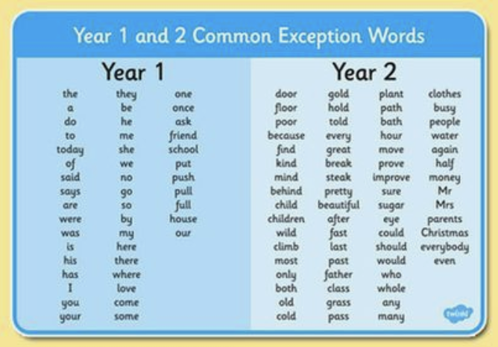  EYFS - We are learning to spell HFW and practise writing words with adjacent consonants: Practise GPCs - Play Flashcards using the attached resources or Quickwrite Graphemes (say the sound on the flashcard ask your child to write it without them seeing it). Write the word my for your child. Check that they can read it. Say a sentence using the word. Soundtalk the word, raising a finger for each phoneme. Ask children to do the same. Discuss the letters required for each phoneme, using letter names. Ask children to trace the shapes of the letters with their fingers. Rub the word off and ask your child to write the word on their own. Repeat with all, her. Read the sentences, encourage your child to blend graphemes if they get stuck: My damp tent smells as bad as a mad skunk. Do all brown toads grunt and groan? My chimp had a sandwich for her lunch. Encourage them to soundtalk words. Pick one sentence to dictate and ask your child to write it. Show them the sentence and ask them to check each letter. Encourage them to correct any mistakes.  Maths  EYFS Maths Starter – Please practise your number bonds to 10.  EYFS - Access the White Rose Maths website for home learning (link below).  https://whiterosemaths.com/homelearning/early-years/  Complete Summer Term Week 3 - Day 4 - (watch the video before completing the activity).  KS1 Maths Starter  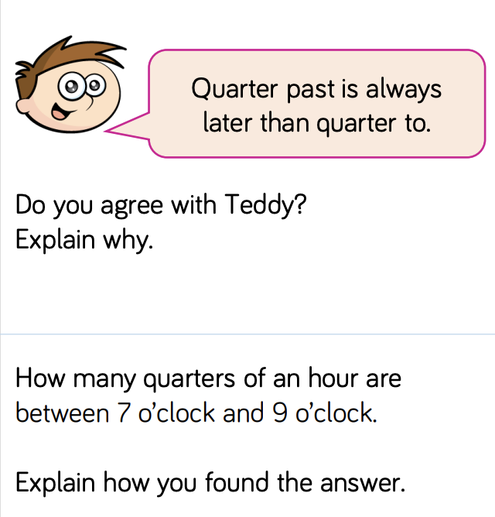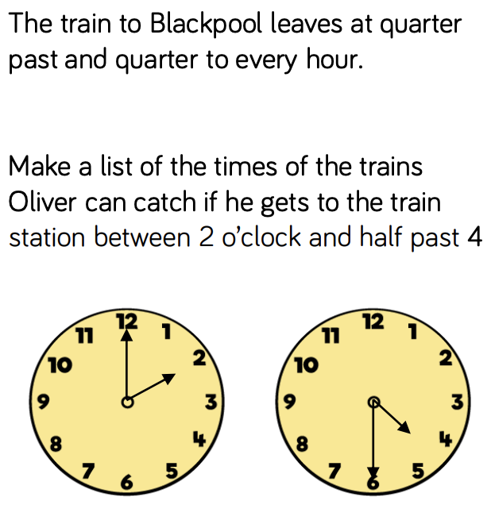  Y1 Access the White Rose Maths website for home learning (link below).  https://whiterosemaths.com/homelearning/year-1/  Complete Summer Term – Week 5 - Lesson 4 (watch the video before completing the activity).  Y2 Access the White Rose Maths website for home learning (link below).  https://whiterosemaths.com/homelearning/year-2/  Complete Summer Term – Week 5 – Lesson 4 (watch the video before completing the activity).  KS1 - If you do have access to a printer and want to print the White Rose sheets that go with each lesson, you can do. If you do this, you do not have to do the Power Maths pages as well.  If you do not have access to a printer, watch the White Rose video each day and then complete the Power Maths books.  Daily Project  Time for some engineering! Can you choose one of these activities to have a go at?  - Can you make a table football? You can use whatever you can find to make it. Don’t take pegs from the peg basket without checking with your grown ups first. Any cardboard box will do and you could use sticks or twigs and a scrunched up piece of paper for the ball. See how creative you can be.  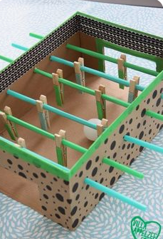  - Have a go at making a marble run. These are just some ideas, but you could use anything that you have available to you at home.  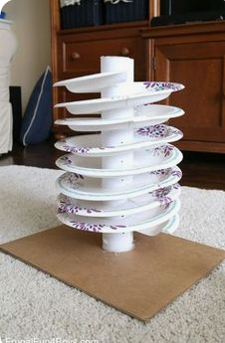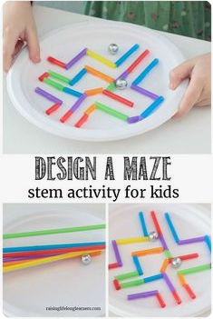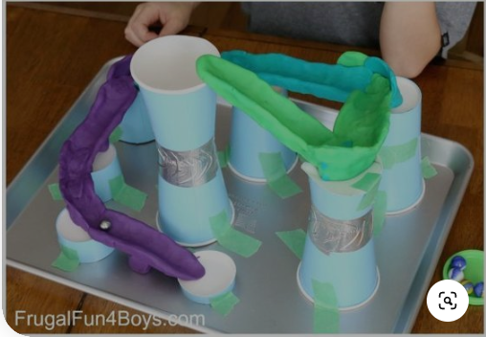  - Make your own golf course. It doesn’t matter if you don’t have a golf club - you could use anything (an umbrella, broom handle?) If you don’t have a golf ball, what else could you use? Be creative but make sure that you ask your grown up before you take anything!  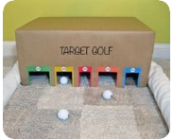
Friday | Phonics – ALL with support from parents/carers  Year 1 – Use this session as revision time for anything that you found tricky this week.  Year 2 – Revise any difficulties arising Monday - Thursday.  EYFS – We are learning to spell HFW and practise writing words with adjacent consonants: Repeat lesson from Thursday. Pick another sentence to dictate and write.  Maths  EYFS Maths Starter – Please practise your number bonds to 10  EYFS - Access the White Rose Maths website for home learning (link below).  https://whiterosemaths.com/homelearning/early-years/  Complete Summer Term Week 3 - Day 5 - (watch the video before completing the activity).  KS1 Maths Starter  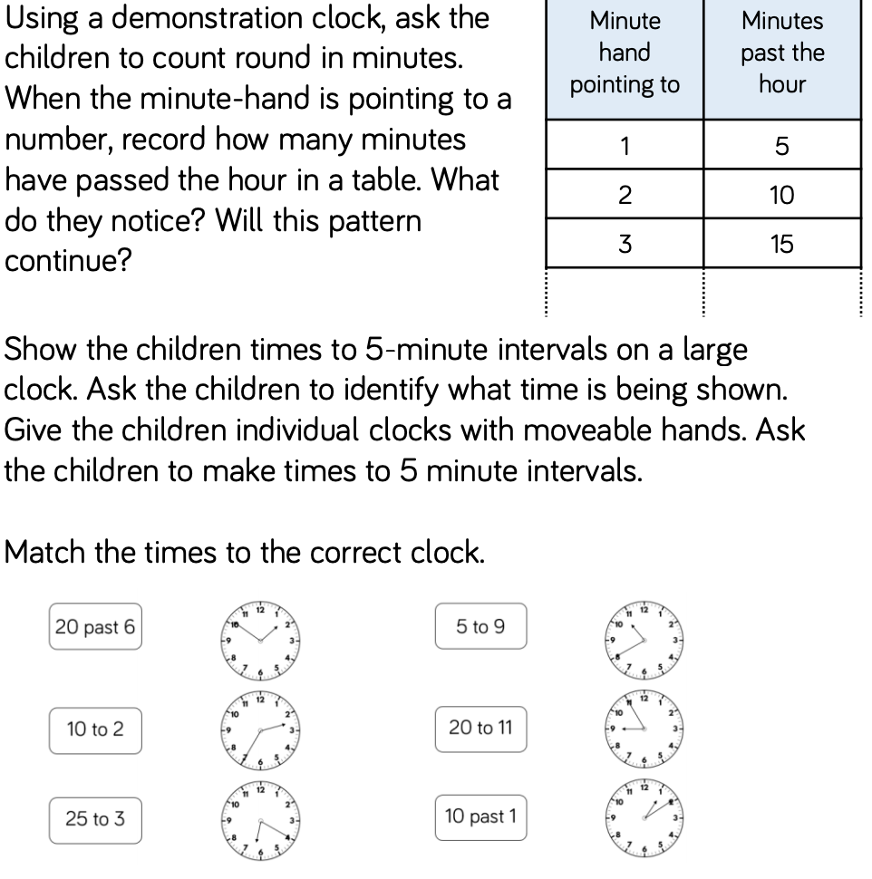  Y1 Access the White Rose Maths website for home learning (link below).  https://whiterosemaths.com/homelearning/year-1/  Complete Summer Term – Week 5 - Lesson 5 – Friday Maths Challenge (watch the video before completing the activity).  Y2 Access the White Rose Maths website for home learning (link below).  https://whiterosemaths.com/homelearning/year-2/  Complete Summer Term – Week 5 – Lesson 5 – Friday Maths Challenge (watch the video before completing the activity).  KS1 If you do have access to a printer and want to print the White Rose sheets that go with each lesson, you can do. If you do this, you do not have to do the Power Maths pages as well.  If you do not have access to a printer, watch the White Rose video each day and then complete the Power Maths books.  Daily Project - Extra-Curricular Time  Let’s get outside for your extra-curricular time this week! Find something that you enjoy doing in your garden. Maybe you could ask your grown-up to take a photograph of what you are up to. (If you don’t have a garden or the weather isn’t pleasant, then find something that you enjoy doing indoors. Be creative!)  Here are some ideas:  - Make a paintbrush out of natural resources and paint a picture.  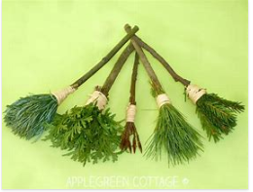  - Mandalas: A mandala is a circular structure with radial symmetry, meaning that the design radiates out symmetrically from the centre. It is one of nature’s more wonderful and perfect configurations. You can find mandalas in flowers, tree rings, the sun, eyes, snowflakes, spiderwebs, sea shells, seeds, fruits, succulents, and more. Keep an eye out for mandalas around you, both in the natural world (flowers, tree rings, eye balls, etc) and in the fabricated world (bike tires, wheels, fans, etc). How many can you find?  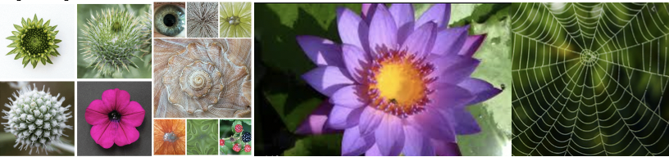  Create mandalas in nature with nature’s materials. Try it with seashells, sticks, pebbles, pinecones, leaves etc.  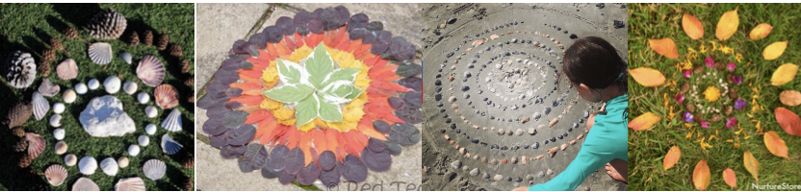  - Make a beautiful, magical fairy garden and tell some stories as you play: https://theimaginationtree.com/making-fairy-garden/  - Make a photograph frame out of sticks and string. Can you look carefully at how to lash the sticks together using a figure of eight movement? See if you can find a photograph to put into your frame.  