Learning
from Home

Class 2  Wk beg: 19th April ‘21 | Our Key Learning Behaviour this week is the Cat’s behaviour: questioning  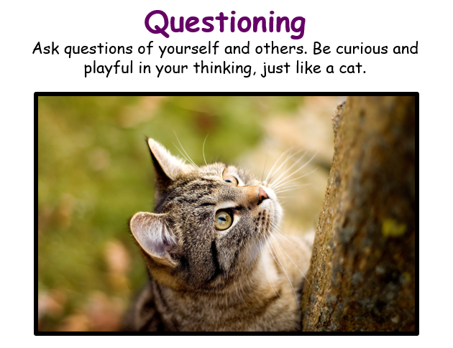  This week, as we start a new term and a new topic, we will be considering the questions we would like to find the answers to.  In Literacy, we will start a new sequence of work by writing about a question on which people might have different opinions, expressing our own views in a persuasive way.  In Geography, we will consider what we already know about the world’s rivers and pose questions to show what else we would like to learn.  In Art, we will ask questions about artists’ choices of contrasting colours and in RE will ask and answer questions about the impact of Pentecost.
 | Mental Health  (30 minutes) | Spelling (30 mins) | Reading (30 mins) | Writing (1 hour) | Maths (45 mins) | Afternoon Project  When finished each day
Monday  Collective Worship  In this week’s Collective Worship, we begin a new theme: justice.  What does the word justice mean to you?  In particular this week, we will consider justice for the poor. Who are the poor and what can we do to help them achieve justice?  We will research the work of the Christian charity, Christian Aid. What do they do to seek justice for the poor? | Mental Health focus: Do Something You Enjoy/ Talk About Your Feelings  In today’s Mental health focus, we will compare our holiday experiences and talk about how it feels to return to school. Take time to think about the importance of achieving a balance between work and play. What are your goals for the coming term? What are you hoping to achieve, learn or do? Write a few of these down and, if you feel able, share these with the rest of the class. | https://www.edshed.com/en-gb/login | https://www.activelearnprimary.co.uk/login?c=0  Please ensure you read regularly from Bug Club, answering the comprehension questions, as well as from any other books you are reading. | In today’s Literacy lesson, we will plan and begin to write the first piece of independent writing to introduce the new Literacy sequence. This will be used for assessment and to help plan the rest of the work in this sequence, so it is important that Miss Moss has access to it as soon as possible.  For this writing, you should consider a a question that is relevant to school life and of interest to you (e.g. Does having split playtimes help the younger pupils? Should children in Class 1 be given weekly homework?). Decide whether you agree or disagree and consider the reasons why. Then, write a report answering this question. You may prefer to write about a question of your own. The important thing is that you can give several reasons to support your point of view and explain each of these reasons in detail.  Plan carefully and then begin your writing, introducing the situation and your point of view.  THIS WRITING SHOULD BE HANDWRITTEN. | Warm up with  This week, the Maths lessons are from White Rose. These have accompanying worksheets that will be posted on the Google Classroom if required.  Year 3  https://whiterosemaths.com/homelearning/year-3/spring-week-2-number-multiplication-division/  Divide 100 into 2, 4, 5 and 10 equal parts  Year 4  https://whiterosemaths.com/homelearning/year-4/spring-week-3-number-multiplication-and-division/  Divide 2-digits by 1-digit (3)  Year 5 https://whiterosemaths.com/homelearning/year-5/spring-week-3-number-multiplication-and-division/  Divide 3-digits by 1-digit  Year 6 https://whiterosemaths.com/homelearning/year-6/spring-week-6-number-algebra/  Forming Equations  (Follow-up worksheet on Google Classroom if required.) | PE  Have a look at one of the PE grids on the Google Classroom from a previous week or have another go at one of the lessons.  Art  In our artwork this term, we are going to be exploring the use of contrasting colours using a range of media.  Start by exploring what is meant by the term at https://www.bbc.co.uk/bitesize/guides/z3bqycw/revision/7  Then, using whatever materials you have at home, have a go at drawing a water-themed picture like the ones below, using complementary colours.  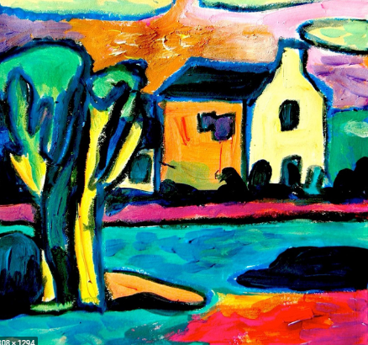  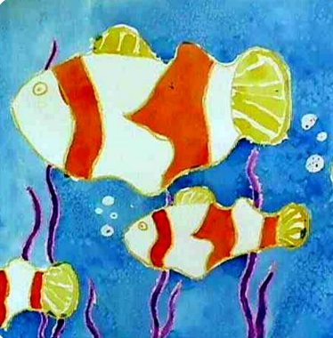
Tuesday | Mental Health focus:  Be Proud of Your Very Being/ Ask for Help  We will take the opportunity at school to reflect about what we learned last term, how we made progress towards our targets and to celebrate our successes. We will also consider our personal targets for the coming term’s learning and what help we might need to achieve those targets.  Have a think about the areas in which you feel confident and those areas where you might need a little more support or help…  Who could you ask for help? Let us know! | https://www.edshed.com/en-gb/login  Practise the spellings set for you in ‘Assignments’. Then practise the statutory words for your age group.  Your spelling Assignment change weekly on a Tuesday. I will be checking today and I will award 50 extra honey pots and 5TP to anyone who has achieved Royal Bee status in the past week’s assignments. | https://www.activelearnprimary.co.uk/login?c=0 | In this lesson, you should complete the independent writing you began yesterday. Start by reading through what you wrote yesterday. Does it make sense? Could you add any more detail or examples to make your writing more effective and support your argument.  Once it is finished, read your writing through again with care, checking that the writing makes sense and that the punctuation, spelling and vocabulary choices are accurate. Can you add any more detail to any of your sections? Can you redraft and improve any of your sentences to increase the impact of your writing? | Warm up with  Year 3  https://whiterosemaths.com/homelearning/year-3/spring-week-3-number-multiplication-division/  Divide with remainders activity  Year 4  https://whiterosemaths.com/homelearning/year-4/spring-week-3-number-multiplication-and-division/  Divide 2-digits by 1-digit (2)  Year 5  https://whiterosemaths.com/homelearning/year-5/spring-week-3-number-multiplication-and-division/  Divide 4-digits by 1-digit  Year 6 https://whiterosemaths.com/homelearning/year-6/spring-week-6-number-algebra/  Solve simple one-step equations  (Follow-up worksheet on Google Classroom) | Geography  To begin our new topic, ‘Flow’ we will start by exploring some of the world’s rivers.  Before you start, think about what you already know about the rivers of the world and consider what else you would like to know. Write down your questions.  https://classroom.thenational.academy/lessons/where-are-the-worlds-rivers-6dh32d  For those who would like an additional challenge, have a look at the lesson at the link below:  Access this lesson using pin code: RM7162  at Twinkl Go  Alternatively, you could complete some independent research to find out more about the answers to some of the questions you wrote down at the start of the lesson.
Wednesday  Collective Worship  Read the story of the rich man and Lazarus from Luke 16: 19-31 (you can look it up online if you don’t have a Bible handy). What do you think Jesus was trying to teach people when he told this story? How does it link to our them of ‘Justice for the Poor’? What can we learn from this story and how could we apply this learning?  Listen to the song, ‘God of Justice’ at https://www.youtube.com/watch?v=AyIQ2c3Ep_A | Mental Health focus:  10 a day:  Review the 10-a-day for Mental Health. Which do you need to focus on this week? Choose one or two that you sometimes find to be more of a challenge and consider how you can make an effort to build in some activities this week to help you achieve these. | https://www.edshed.com/en-gb/login  Practise the spellings set for you in ‘Assignments’. Then practise the statutory words for your age group. | https://www.activelearnprimary.co.uk/login?c=0 | For the remainder of this week, the focus of our Literacy lessons will be some of the grammar objectives for our year groups.  These lessons, with accompanying worksheets, will be posted on the Google Classroom as required.  Year 3: What are vowels and what are consonants?  Access this lesson using pin code: RM3820  at Twinkl Go  https://www.youtube.com/watch?v=rwxWKP4Ld8s  Year 4: Verb tenses  https://classroom.thenational.academy/lessons/to-practise-using-simple-past-present-and-future-tense-c5hp2c  Year 5: Verb tenses  https://classroom.thenational.academy/lessons/to-explore-using-the-simple-past-present-and-future-tense-c5h32d  Year 6: Present perfect and past perfect  https://www.youtube.com/watch?v=7GAjEdOiNaI  https://www.youtube.com/watch?v=ppFv1hlMHjI  Access this lesson using pin code: RM5680  at Twinkl Go | Warm up with  Year 3  https://whiterosemaths.com/homelearning/year-3/spring-week-3-number-multiplication-division/  Divide 2-digits by 1-digit (3)  Year 4 https://whiterosemaths.com/homelearning/year-4/spring-week-3-number-multiplication-and-division/  Divide 3-digits by 1-digit  Year 5 https://whiterosemaths.com/homelearning/year-5/spring-week-3-number-multiplication-and-division/  Divide with remainders  Year 6 https://whiterosemaths.com/homelearning/year-6/spring-week-6-number-algebra/  Solve two-step equations  (Follow-up worksheet on Google Classroom) | Music  This term, we will be learning more about pitch and we will explore the concept of melodic shape, identifying melodies which move by step and those that leap. Start by exploring notes of high, medium and low pitch in the lesson at:  https://classroom.thenational.academy/lessons/what-is-pitch-6nh3ct  What is your favourite water scene? How do you think the pitch of sounds used to represent the ocean might be different for those representing a waterfall, a stream or a river? Why not use the Chrome piano extension and have a go at composing and recording some tunes to represent different types of water scene?  RE  This half term in RE we will be considering the key question, ‘When Jesus left, what was the impact of Pentecost?’  Start today by finding out more or reminding yourself about the story of Pentecost, which is related in the Bible in the book of Acts, chapter 2.  Access this lesson using pin code: RM3649  at Twinkl Go  What questions does this story raise in your mind? Write down a few of your questions to research further in following lessons.
Thursday | Mental Health focus:  Do something you enjoy/ Care for others  Today, we will think about some of the hobbies and interests we have and how we can use these to care for others and the world around us. What can you do today to care for those around you or your local environment. Take time to plan something to do today that you will do to show love and care for others. You could…  Go on a litter-picking walk.  Plant some seedlingss to give a surprise gift to someone you know who enjoys gardneing later this term.  Make a card for someone who needs encouragement or support.  Make a phone call to someone who may be feeling isolated or lonely.  Offer to do a job in your house – tidy up or clean something! | https://www.edshed.com/en-gb/login  Practise the spellings set for you in ‘Assignments’. Then practise the statutory words for your age group. | https://www.activelearnprimary.co.uk/login?c=0 | For the remainder of this week, the focus of our Literacy lessons will be some of the grammar objectives for our year groups.  These lessons, with accompanying worksheets, will be posted on the Google Classroom as required.  Year 3: A or An?  Access this lesson using pin code: RM6451  at Twinkl Go  Year 4: Standard English verb forms  Access this lesson using pin code: RM7150  at Twinkl Go  (Complete this work over today and tomorrow).  Year 5: Verb tenses: https://classroom.thenational.academy/lessons/to-explore-the-past-present-and-future-progressive-tense-6djk2c  Year 6: Identifying the Subjunctive mood  Access this lesson using pin code: RM5462  at Twinkl Go | Warm up with  Year 3  https://whiterosemaths.com/homelearning/year-3/spring-week-3-number-multiplication-division/  Scaling activity  Year 4  https://whiterosemaths.com/homelearning/year-4/spring-week-3-number-multiplication-and-division/  Correspondence problems  Year 5  https://whiterosemaths.com/homelearning/year-5/spring-week-2-number-multiplication-division/  Multiply 4-digits by 2-digits.  Year 6 https://whiterosemaths.com/homelearning/year-6/week-7-number-addition-subtraction-multiplication-division/  Find pairs of values (1)  (Follow-up worksheet on Google Classroom) | Science  This term we are starting new sequences of work. While Year 3 and 4 investigate rocks and soils, Year 5 and 6 will find out more about how plants and animals adapt to suit their environments and the traits that they inherit.  Today, Year 3 and 4 should begin with  BBC Bitesize What is a rock? Lesson  https://www.bbc.co.uk/bitesize/topics/z9bbkqt/articles/zsgkdmn  Then, choose one or two different types of rocks and investigate further. Make a poster about the type of rock you have chosen. Your poster should include images of the rock and information about its distinguishing properties and what it is commonly used for. You could investigate one or more of the following:  granite, chalk, marble, limestone, sandstone, slate  Can you find any of these types of rocks in your local environment?  Year 5 and 6 should begin with  BBC Bitesize What is adaptation/ What is inheritance?  https://www.bbc.co.uk/bitesize/topics/zvhhvcw  Write a brief explanation, in your own words, of each of the following words:  adaptation  inheritance  genes  You should use diagrams or illustrations to support your explanation.
Friday  Collective Worship  As we consider the theme of justice, we will explore the topic of racial injustice in today’s collective worship:  https://www.churchofengland.org/our-faith/faith-home/faith-home-videos/collective-worship-primary-schools-racial-injustice-s3e1 | Mental Health focus:  In our PSHE lesson today, we will be considering the theme that ‘life is all about balance’.  In what areas of your life do you sometimes find it hard to get the balance right? We will think about balancing our relationships, hobbies, work and play, sleeping and waking and spending time alone or with others. We will consider how our personality might affect our preferences.  What does the phrase ‘work-life balance’ mean? What would happen if the balance tips one way or the other? | https://www.edshed.com/en-gb/login  Practise the spellings set for you in ‘Assignments’. Then practise the statutory words for your age group. | https://www.activelearnprimary.co.uk/login?c=0 | Today, the focus of our Literacy lessons will be some of the grammar objectives for our year groups.  These lessons, with accompanying worksheets, will be posted on the Google Classroom as required.  Year 3: A or An?  Complete the work set for you on spag.com and any outstanding work from yesterday’s lesson.  Year 4: Standard English verb forms  Complete the work begun yesterday, then test yourself with the Standard English activity on spag.com  Year 5: Verb tenses: https://classroom.thenational.academy/lessons/to-revise-the-past-present-and-future-progressive-tense-6rukjd  Year 6: Perfect verb forms  Complete the work set on Bug Club Grammar and Spelling. | Warm up with  Year 3  https://whiterosemaths.com/homelearning/year-3/spring-week-3-number-multiplication-division/  How Many Ways?  Year 4  Spring Week 11 - Number - Decimals | White Rose Maths  Dividing one and two digit numbers by 100  Year 5  https://whiterosemaths.com/homelearning/year-5/spring-week-2-number-multiplication-division/  Multiply 3-digits by 2-digits.  Year 6 https://whiterosemaths.com/homelearning/year-6/week-7-number-addition-subtraction-multiplication-division/  Find pairs of values (2)  (Follow-up worksheet on Google Classroom) | PSHE  This half term we will be thinking about keeping healthy. Start by completing the following lesson:  https://classroom.thenational.academy/lessons/life-is-all-about-balance-crwk6r  French  In our French lessons this term, we will learn a range of words to talk about the sports and activities we enjoy, combining this with last term’s work on clothes and then learning more about describing the weather and describing the sports played in different types of weather. Later in the term, we will begin to extend our sentences using conjunctions...  In today’s lesson, start by learning some words for different sports: https://classroom.thenational.academy/lessons/saying-different-sports-6th68d
__________has behaved like a ‘Cat’ at home by…..

