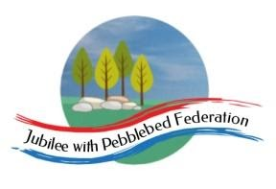
Learning
from Home
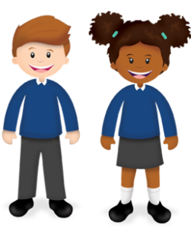
Unit 18

Class 1  Wk beg: 10th May 2021 | Lesson One | Lesson Two | Lesson Three | Lesson Four | Lesson Five
Learning Behaviour of the week | Our learning behaviour of the week is ‘Reasoning’. Encourage your child to think through their ideas and solve problems in a clear and orderly way. Squirrels are clever animals who can work out how to get to a food source when it is not an easy task. |  |  |  | 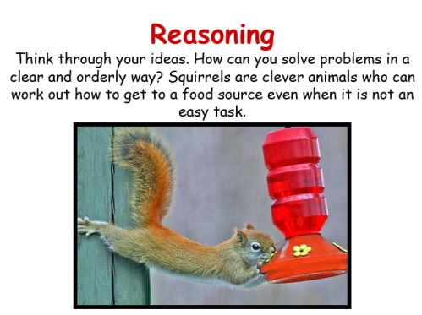
Monday | Phonics/  Spelling  https://www.activelearnprimary.co.uk/login?e=-610&c=0#bugclub_phonics  R: Unit 8 Phoneme /th/ Revision and Lesson (JF)  Y1: Unit 23 /c/ as 'c' Revision and lesson (MH)  2  Y2: IND (NNS block session 11) focus on ‘or’ written as ‘au/aw’. Look at when ‘au’ is used in a word. August, autumn, haunt, daunting, haul, Paul. Children complete Look, cover, write check sheet. See below | English  Complete your fairytale which you started last week.  Remember to follow your plan so you have a clear beginning, middle and ending.  Have you used a compound sentence and adjectives? Check your sentences make sense. | Maths  R: Watch session 1 and complete the activity.  https://whiterosemaths.com/homelearning/early-years/first-then-now-week-1/  Y1/2: https://classroom.thenational.academy/lessons/describing-the-position-of-an-object-68v36r | RE - Google Live lesson  Together we will recap the theme of forgiveness.  We will read the Gospel: Luke 6:37- 42, about forgiveness.  TASK: draw cartoons of people who need forgiving and write speech bubbles above with the words, ‘Sorry’., of people who need forgiving. Draw or write a rule about ‘forgiveness’, and we will add this to the class rules / guidance towards being a better person.  https://www.bbc.co.uk/bitesize/clips/zvhyr82  Watch this video clip first to introduce the 4 Gospel writers. | Music  Jack and the Beanstalk. 4: And he went higher!  https://www.bbc.co.uk/teach/school-radio/music-jack-and-the-beanstalk-song1/z7m67nb
Tuesday | Phonics/  Spelling  https://www.activelearnprimary.co.uk/login?e=-610&c=0#bugclub_phonics  R: Unit 8 Phoneme /ng/ Revision and Lesson (AB)  Y1: Unit 23 /c/ as 'k' Revision and Lesson (JF)  Y2: (IND) (NNS block 2 lesson 12) Complete the aw and au worksheet below. Can you add any more words containing au/aw?  spelling shed:  https://www.edshed.com/en-gb/login | Yoga/English  Follow the yoga activities found on Google Classroom.  Then illustrate your story for our class book. See if you can use paint, just like in traditional fairy tales. | Maths  R: Watch session 2 and complete the activity.  https://whiterosemaths.com/homelearning/early-years/first-then-now-week-1/  Y1/2: https://classroom.thenational.academy/lessons/giving-directions-from-point-a-to-point-b-cmt34r | Geography  Walk around the village to see what plants and flowers are growing there.  Make a list of the plants and flowers seen, recording your findings in a simple table .  https://www.woodlandtrust.org.uk/blog/2020/07/uk-poisonous-plants/  Beware of harmful plants - study these guidelines when looking at wild flowers. Never touch or digest any plants nad wash your hands if you do come into contact with unfamiliar plants.  Group the flowers into those that are poisonous and those that are not using the identification sheets to help you (see resources)  If you have a flower press you could choose some to press to be used later on. | Mental Health - google live lesson  We will play musical statues - freeze showing different emotions.  Then we will look at different  pictures of people who are scared and identify the ways in which people show they are frightened.  We will talk about situations that might scare us.  TASK: identify five different  people you could talk to if you were afraid. Draw around your hand and record each person in the fingers.
Wednesday | Phonics/  Spelling  https://www.activelearnprimary.co.uk/login?e=-610&c=0#bugclub_phonics  R: Complete your allocated Bug Club Games.  - Y1: Complete your allocated Bug Club games  - Y2: (JF) NNS block 2 lesson 13. See google classroom for list. Ask which spelling looks right. Model choosing the correct one and writing it in a sentence. Refer back to the most common spelling for that sound and making sensible choices. | English -  Today in school, we will be having a visit from the Creative Cabin. You can use this time to finish off illustrating your fairytale. | Maths  R: Watch session 3 and complete the activity.  https://whiterosemaths.com/homelearning/early-years/first-then-now-week-1/  Y1/2: https://classroom.thenational.academy/lessons/using-the-language-of-rotation-6wup6t | PE/Mental Wellbeing  Look at the timetable in the PE folder on google | RE - Google live lesson  We will recap Matthew and Luke. (Gospel writers)  We will read the story John 14:27, where Jesus promises his followers peace.  Use the four heart outlines provided. Draw, colour or stick on images that show a heart that is 1- afraid, 2- ill 3- worried, using three of the hearts.  Think about four kinds of peace: peace in my own life (in my heart?), peace with other people (no fights?), peace in the world (no wars?), peace with God for Christians (being forgiven).  Can you paint (or find) a picture to express one or two of these types of peace?  Paint this into a fourth heart shape: it could be your own idea, or you could think about what a Christian would draw to show peace, and why.
Thursday | Phonics/  Spelling  https://www.activelearnprimary.co.uk/login?e=-610&c=0#bugclub_phonics  R: Unit 9 Phoneme /ai/ Revision and Lesson  Y1: Unit 23 Phoneme /c/ written as 'ck'  Y2: (Ind) login to spelling shed and play the Year 2 CEW games. Try to move your status up!  Spelling shed:  https://www.edshed.com/en-gb/login | English - google live lesson.  Elicitation task: The writing should be completed independently.  Look closely at the photocopy of the first double page spread which has the text blanked out.  With an adult, discuss what might happen in this story.  TASK: Children write the story they think will happen based on the picture. | Maths  R: Watch session 4 and complete the activity.  https://whiterosemaths.com/homelearning/early-years/first-then-now-week-1/  Y1/2: https://classroom.thenational.academy/lessons/making-predictions-about-rotation-60wpac | PSHE  WALT: Understand that feelings can be shown without words - body language.  Join us for the live lesson. We will be looking at body language and facial expressions to express emotions. We will complete a worksheet set on google classroom about facial expressions. | Science  WALT: To name different parts of a plant and understand their job.  https://classroom.thenational.academy/lessons/what-are-the-parts-of-trees-and-plants-called-c9h6cr
Friday | Phonics/Spelling  https://www.activelearnprimary.co.uk/login?e=-610&c=0#bugclub_phonics  R - Unit 9 Phoneme /ee/ Revision and Lesson  Y1: Unit 23 Phoneme /c/ written as 'ch' revision and lesson  Y2: (JB) (NNS Block2 lesson 14 ) Play ‘Which one looks right?’ asking children to choose between different possible spellings of known words. Which ones are still tricky? Ask an adult to test you on spelling 5 of the words. See google classroom for list.  Spelling shed:  https://www.edshed.com/en-gb/login | English -  join us for a google live lesson where we will share with you some unusual discoveries found around the school. We will need your detective skills!  (Hook for our next English unit: ‘The Disgusting Sandwich’) | Maths  R: Watch session 5 and complete the activity.  https://whiterosemaths.com/homelearning/early-years/first-then-now-week-1/  Y1/2: https://classroom.thenational.academy/lessons/identifying-how-patterns-have-been-created-through-rotation-cdk3cd | Art: WALT: compare the work of famous artists and use their style to create a piece of art.  Look at the tate website about Georgia O’Keefe. https://www.tate.org.uk/kids/explore/who-is/who-georgia-okeeffe  How has she added texture to her paintings? Have a go to imitate her style. Be creative you could use flour or sawdust. | PE/Mental health and wellbeing  Look at the timetable in the PE folder on google classroom and choose some activities from here.  OR: You could go on a daily walk or bike ride with your family, try and explore a nearby footpath or try a different route.  Have fun! Upload some photos on google classroom.

Y2 Monday
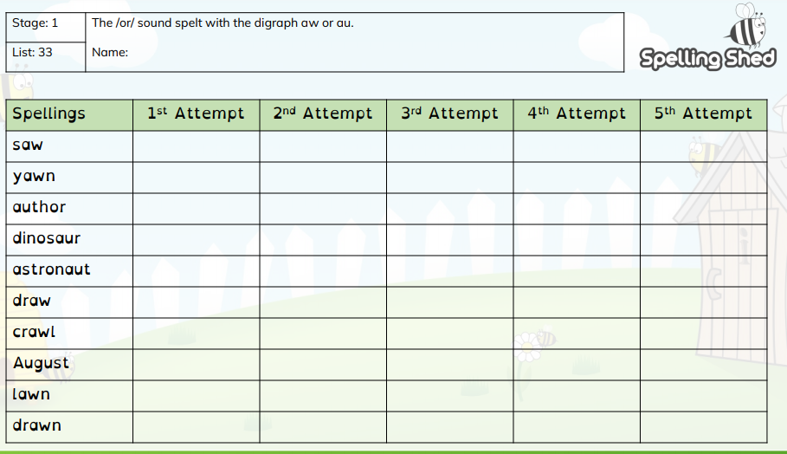

Y2 Tuesday
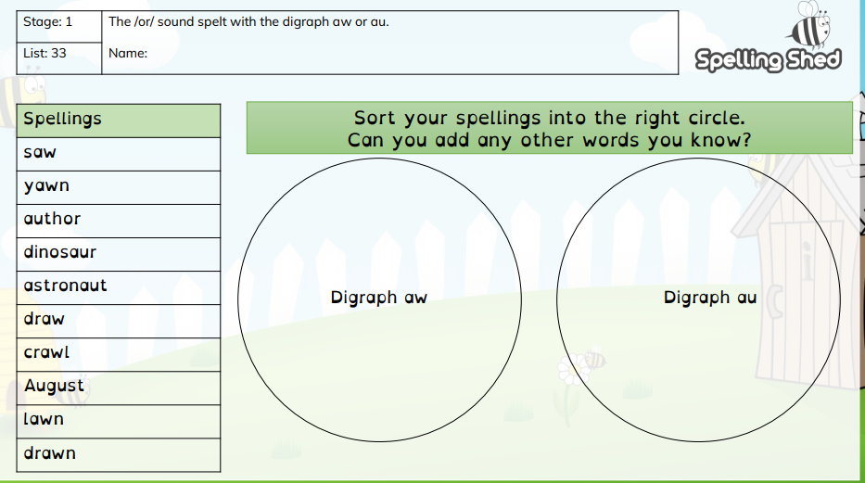

Y2 Wednesday
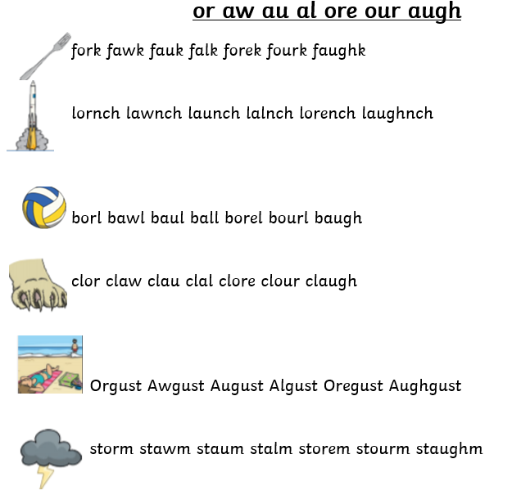
Y2 Friday
