Week beginning Monday 4th May 2020 – Home Learning for Class 1

Dear Parents and Children of Class 1,

Welcome to Week 4 of your Home Learning! We hope that you are all happy and well. As before, this very long piece of writing sets out your learning over the next week. We have continued to include them in a suggested daily activities list and accompanying daily timetable structure for those who would find it helpful, which includes the maths online videos as well as phonics lessons and your daily/weekly projects to complete. We hope that you are finding this accessible and clear.

New resources that we have found this week:
ELSA
What is ELSA? An ELSA in a school is an Emotional Literacy Support Assistant. Examples of things covered By ELSA are social skills, emotions, bereavement, social stories and therapeutic stories, anger management, self-esteem, counselling skills such as solution focus and friendship.
What is ELSA Support? ELSA Support is a website which provides downloadable resources that support the teaching of emotional literacy or emotional intelligence by ELSA’s. A lot of the resources on this website are perfectly suitable for all teaching professionals to use and there is also a parent section with resources suitable for parents to use. An example of an idea that we found particularly attractive:

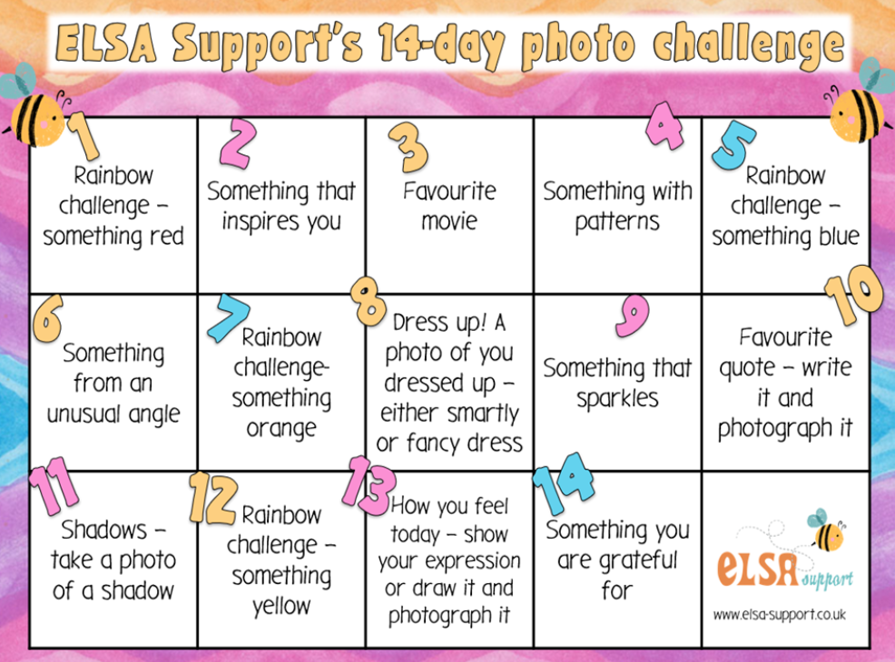

Also worth remembering and particularly useful for children 0 – 5 years is: https://hungrylittleminds.campaign.gov.uk/.

This week Mrs Bartlett and I will be attempting to mail a hug on the website using the following idea as inspiration. Why not have a go at mailing some hugs of your own?


We wanted to take this opportunity to remind all of you that the activities we have suggested are intended to be a bank of resources for you to select from. We do not expect anyone to complete all the activities. We hope that we have provided you with a mixture of activities that can be accessed online and those that involve more traditional or practical learning media, as well as appealing to a range of different interests and skills. We understand of you will have different access to computers, tablets, printers and other resources. Remember that there are printed packs left to pick up outside of school fortnightly, should you need them – please contact the school as per the guidelines on the website: If packs of work are needed (rather than you using the resources on the website) then these will be available for collection from the playground. Please just take a pack - you don't need to come to the school door - to reduce the number of people coming into contact with the pupils and staff. Please call school first and let us know you are coming so that we can print more packs if needed. The most important thing you can do to support your child’s learning whilst schools are closed is to ensure that they read every day and that they continue to practise their phonics and key mathematics skills such as number bonds to 10, 20 and 100 and 2, 3, 5 and 10 times tables.

As always, if you have any questions at all or you would like to email a picture of some lovely work you have been doing, please use the following email address - admin@branscombe.devon.sch.uk.

Take care and as always stay safe,
Miss Harvey-Jones and Mrs Bartlett

EVERY DAY
- 20 minutes phonics (Bug Club) (Reception and Y1). See table below for details of which lesson/resources to access. Y2 see below for separate phonics activities. A note to all: You could also use Phonics Play to practise reading sounds and words and also practise sounding and blending skills. They can also read sentences. It is FREE at this time: https://new.phonicsplay.co.uk/. App/tablet friendly.
- 20 minutes ‘Bug Club’ Reading (with comprehension ‘bug’ questions). Bug Club books continue to be updated to suit your level.
- 15 minutes ‘Spelling Shed’, ‘SPAG.com’ OR ‘Bug Club Grammar’ games (KS1 only). Please do contact us if you have any issues with passwords. If you would prefer to access paper-based work to limit screen time we can email SPAG documents for you to print off.
- 15 minutes ‘Times Table Rockstars’ (KS1 only) OR to limit screen time you may wish to spend this time learning 2, 3, 5 and 10 times tables to be able to recall them at speed.
- Choose 5 spellings from your Home Learning Books to learn.
- 20 - 30 minutes Maths: KS1 – see below for a 5 minute warm ups with your parents/game, then complete any tasks set. On days when work is not set you can work in your ‘Power Maths’ Practice Books (you should complete pages in your Autumn Term books including place value and number, addition and subtraction, 2D and 3D shapes (Y1), money (Y2), multiplication and division (Y2) to finish these books).
Reception/Pre-School – see activities detailed below.
- PE/Active Time - Joe Wicks (The Body Coach) has daily workout videos on YouTube (go online with your grown ups) but you do not need to feel restricted to this – get some fresh air when walking the dog, using skills developed in out of school clubs such as football/ballet or exercising in the garden instead, if you can safely do so.
- We would like children to continue their Summer Term diary and write one or two sentences a day (with support if necessary for younger pupils) and draw a picture. The sentence might be about something they have done, something they have seen or even what the weather is like. Some examples might be: ‘It is sunny.’ ‘It is a flower.’ ‘I went to the park’. Sentences do not need to be spelt correctly but the children should use their phonic skills to attempt to write words. KS1 children could also use the Time Capsule sheets attached on a separate link to help with ideas.
- Please keep reading/sharing a book you enjoy with your family. Try to keep a log together (one or two sentences) of what you have read that day. If you are reading a fiction book, what happened or what characters did you meet? If you are reading a non-fiction book perhaps you write down something that you have found out that you didn’t know before.

It is also worth remembering that the DFE have created a suite of resources to support parents called Oak Tree Academy, linked with the BBC. This includes daily online lessons to help pupils expand their learning and to aid parents to engage children of all ages with learning at home. You can access this here:
https://www.thenational.academy/?fbclid=IwAR1SltQXGn_uBUrQIWo6Y4APOFImRBk25_hFXjpoUxHnxrKj5ccKBfelV_U.

Monday | Phonics – ALL with support from parents/carers  Year 1 – Unit 27 Language session – After: tch, sh alternatives, ea, (w)a, o  Year 2 – Adding suffixes – ‘-ful’, ‘-less’ and ‘-ly’: Look at the sentences below (bold words are target words). Talk with your grown up about the meaning of ‘-ful’, ‘-less’ and ‘-ly’ and how sometimes these suffixes change a verb into an adjective (play to playful) or an adjective into an adverb (happy to happily). Look carefully at the spelling of each suffix, especially:  • single ‘l’ on ‘-ful’ (unlike the whole word ‘full’).  • double ‘s’ on ‘-ness’  • adding ‘i’ before’-ly’ and ‘-ness’ where words end in ‘y’ with a consonant before it, for example happily.  Together find some more words to show how, when you add ‘-ly’ to the ‘-ful’ suffix, it has a double ‘l’, for example, hopefully.  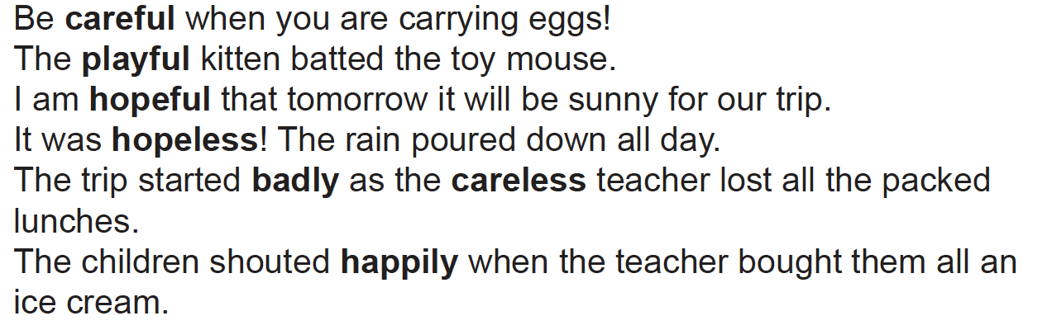  Now look at the word matrix below. Look at which words can take which suffixes. Write down each of the words that can be made. Check with your grown up that each one is a real word by discussing and trying to put the word in a sentence orally. Discuss any that you are unsure about and double check with a dictionary. Are there any tricky exceptions?  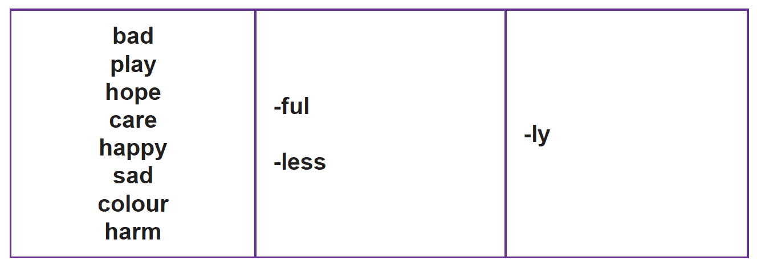  EYFS - Practise GPCs - Play Flashcards using the attached resources or Quickwrite Graphemes (say the sound on the flashcard ask your child to write it without them seeing it).  Teach reading CCVC words by writing pot. Soundtalk. Write s in front of pot to make spot. Point to the s and say sssss holding the sound then point to the next consonant and slide them together continue soundtalking the rest of the word. Repeat with step, stop, skip  trip, plan, from, frog, twin, swim.  Read the sentences, encourage your child to blend graphemes if they get stuck: Can I plan a trip to the moon? Help! Can you grab that green frog for me? Will a clown put on a green wig or stick with his brown hair?  Maths  EYFS Maths Starter – Access https://home.oxfordowl.co.uk/kids-activities/fun-maths-games-and-activities/ (Age 4-5 tab) to play Counting 0 – 20.  EYFS - Access the White Rose Maths website for home learning (link below).  https://whiterosemaths.com/homelearning/early-years/  Complete Summer Term Week 1 - Day 1 - Supertato (watch the video before completing the activity).  KS1 Maths Starter – Access https://home.oxfordowl.co.uk/kids-activities/fun-maths-games-and-activities/ (Age 5-6 tab) to play Number Words.  Y1 Access the White Rose Maths website for home learning (link below).  https://whiterosemaths.com/homelearning/year-1/  Complete Summer Term – Week 3 - Lesson 1 (watch the video before completing the activity).  Y2 Access the White Rose Maths website for home learning (link below).  https://whiterosemaths.com/homelearning/year-2/  Complete Summer Term – Week 3 – Lesson 1 (watch the video before completing the activity).  KS1 - If you do have access to a printer and want to print the White Rose sheets that go with each lesson, you can do. If you do this, you do not have to do the Power Maths pages as well.  If you do not have access to a printer, watch the White Rose video each day and then complete the Power Maths books.  Daily Project  Task 1 - EYFS and KS1 Theme – Can you draw pictures with captions to show your daily activities? You could use the storyboard format attached in the separate document or if you prefer you could create a digital document using software like PowerPoint or Publisher on your computer.  KS1 children should also add speech and thought bubbles to show me what you might say or think during these activities. Try to remember some of the things that that others might say during those different daily activities to include too. For example, every morning after breakfast, Mum might say ‘Brush your teeth and get dressed.’ At bedtime, Dad might say ‘Night night, sleep tight.’ Have a look at the examples attached on a separate document. Remember to rehearse your sentences orally before writing them inside speech or thought bubbles to avoid mistakes!  Task 2 – EYFS and KS1 – RE Ramadan work attached as a separate document.
Tuesday | Phonics – ALL with support from parents/carers  Year 1 - Unit 27 Assessment Games  Year 2 - Adding suffixes – ‘-ful’, ‘-less’ and ‘-ly’: Ask your child to use the words they created in the previous session to write some sentences. When complete, check these together - reinforce correct punctuation. Ask your child to check the spelling of the words with suffixes using their work from yesterday.  EYFS - Practise GPCs - Play Flashcards using the attached resources or Quickwrite Graphemes (say the sound on the flashcard ask your child to write it without them seeing it).  Teach reading tricky words have, like, some, come.  Play Buried Treasure (real words go in a treasure chest, nonsense words in a bin) with words: spot, step, trip, plan, frip, glan, spem, slin.  Read the sentences, encourage your child to blend graphemes if they get stuck: It smells like we might have some roast chicken tonight. Can we train a dragon to come and cook food for us? Will you come and have some roast bugs on toast for dinner?  Maths  EYFS Maths Starter – Access http://www.crickweb.co.uk/Early-Years.html to play Number Labelling.  EYFS - Access the White Rose Maths website for home learning (link below).  https://whiterosemaths.com/homelearning/early-years/  Complete Summer Term Week 1 - Day 2 - Supertato (watch the video before completing the activity).  KS1 Maths Starter – Access http://www.crickweb.co.uk/ks1numeracy.html to play Two Digit Number Labelling  Y1 Access the White Rose Maths website for home learning (link below).  https://whiterosemaths.com/homelearning/year-1/  Complete Summer Term – Week 3 - Lesson 2 (watch the video before completing the activity).  Y2 Access the White Rose Maths website for home learning (link below).  https://whiterosemaths.com/homelearning/year-2/  Complete Summer Term – Week 3 – Lesson 2 (watch the video before completing the activity).  KS1 - If you do have access to a printer and want to print the White Rose sheets that go with each lesson, you can do. If you do this, you do not have to do the Power Maths pages as well.  If you do not have access to a printer, watch the White Rose video each day and then complete the Power Maths books.  Daily Project  EYFS and KS1 Task 1 Theme - Today your daily project is linked to your new theme but it is also a reminder of, and perhaps chance to catch up with, work suggested in the ‘everyday’ section listed on page 1.  Think about and share some things you did on the two previous days of the week.  Describe something special or important from each of these and then write a sentence about it. Think carefully about the spelling of the days of the week and common exception words/HFW when writing (attached to the bottom of this sheet). You could use the special ‘diary’ sheets attached in a separate link to write these memories, add it to your time capsule or use the same format that you may have been using in previous weeks instead if you wish. You could make a collage style cover to personalise your diary. As you write your diaries day by day throughout the project, add photographs and illustrations where appropriate.  KS1 Task 2 – PSHE: Complete the quizzes attached to this document. Then discuss and answer this question: What could you do if you spot a potential danger or hazard at home, at school or in the community?
Wednesday | Phonics – ALL with support from parents/carers  Year 1 - Phase 6 - Suffix ending: '-ing' (a morpheme)  Year 2 – Contractions (can’t, didn’t, hasn’t, it’s, couldn’t, I’ll, they’re): Display some words with contractions from the cards provided or write these out:  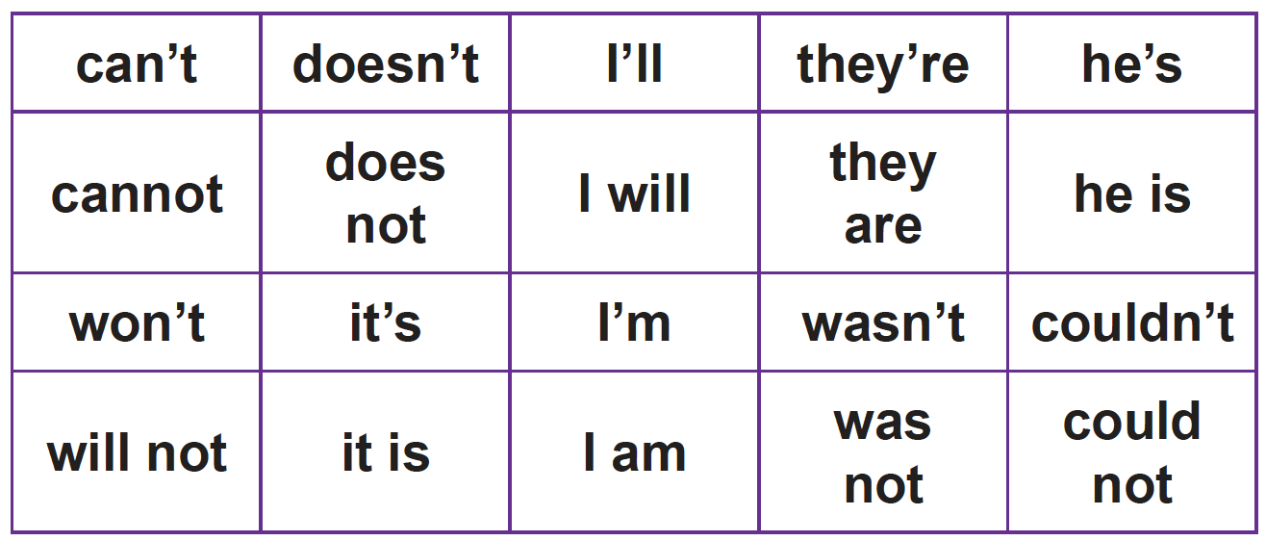  Ask your child what they can remember about what is special about the spelling of these words. Show the full versions and look at the changes in spelling. Remind pupils why we use contractions and practise saying the words contraction and apostrophe. Reinforce that the apostrophe goes in the place of the missing letter(s).  Play a game to reinforce the spelling of contractions, for example:  - Dominoes: Give your child a set of dominoes from the resource and show them how to play with them, placing them in a row, matching the corresponding words.  Go through each contraction and check that they have matched it correctly.  Now write the resulting chain of words  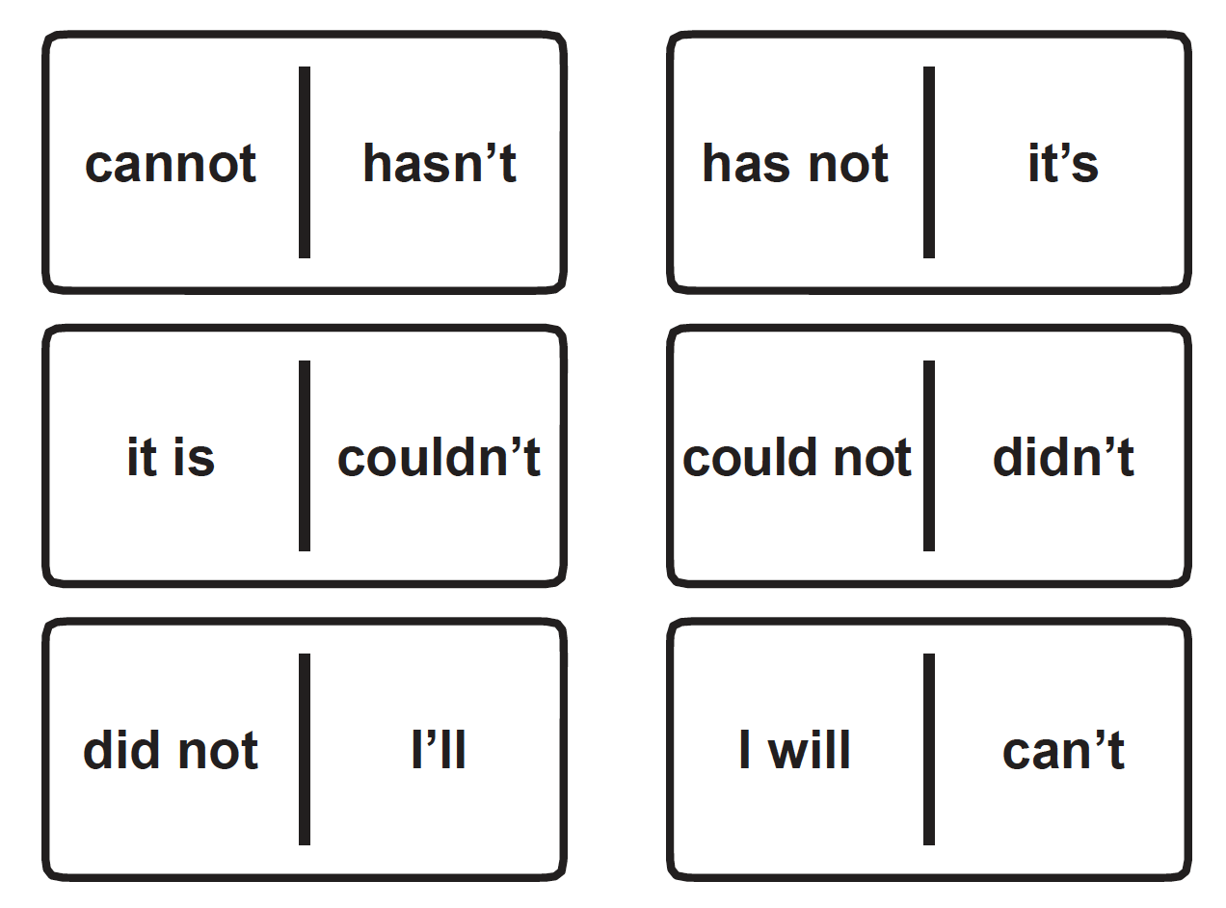  Now play Pairs. Use pairs of cards with contractions and full versions. Play with a partner (grownup or older sibling), putting all the cards face down on the table and taking turns to turn over two cards. If they have a matching pair, they can keep it. If not, they must turn the cards over again. The winner is the one with the most pairs.  EYFS – Practise GPCs - Play Flashcards using the attached resources or Quickwrite Graphemes (say the sound on the flashcard ask your child to write it without them seeing it).  Use a large four letter phoneme frame (a grid like below:)  Parent says the word stop. Soundtalk it slowly: s-t-o-p. Make the word in the phoneme frame with magnetic letters/write out individual letters on 4 pieces of paper and lay out in the frame (e.g. example below). Repeat with spin.  Play Phoneme Frame: Give you're the phoneme frame. Read out a word and ask them to create it in the phoneme frame with magnetic letters or grapheme cards or write them in. Words: spot, step, trip, from, skip, plan.  Read the sentences, encourage your child to blend graphemes if they get stuck: This frog is strong. His green skin has bumps. He likes to swim in his pond. Encourage them to soundtalk words. Pick one sentence to dictate and ask your child to write it. Show them the sentence and ask them to check each letter. Encourage them to correct any mistakes.  Maths  EYFS Maths Starter –  EYFS - Access the White Rose Maths website for home learning (link below).  https://whiterosemaths.com/homelearning/early-years/  Complete Summer Term Week 1 - Day 3 - Supertato (watch the video before completing the activity).  KS1 Maths Starter –  Y1 Access the White Rose Maths website for home learning (link below).  https://whiterosemaths.com/homelearning/year-1/  Complete Summer Term – Week 3 - Lesson 3 (watch the video before completing the activity).  Y2 Access the White Rose Maths website for home learning (link below).  https://whiterosemaths.com/homelearning/year-2/  Complete Summer Term – Week 3 – Lesson 3 (watch the video before completing the activity).  KS1 - If you do have access to a printer and want to print the White Rose sheets that go with each lesson, you can do. If you do this, you do not have to do the Power Maths pages as well.  If you do not have access to a printer, watch the White Rose video each day and then complete the Power Maths books.  Daily Project  EYFS and KS1 – Theme/Literacy:  - Listen to a familiar story such as Goldilocks and the Three Bears or Jack and the Beanstalk. You might find these links helpful.  http://learnenglishkids.britishcouncil.org/short-stories/goldilocks-and-the-three-bears  http://www.bbc.co.uk/wales/snapdragon/yesflash/story.htm  http://learnenglishkids.britishcouncil.org/short-stories/jack-and-the-beanstalk  https://www.bbc.co.uk/teach/school-radio/english-ks1-jack-and-the-beanstalk-index/zn9hxyc  For those without internet/computer access you will find a couple of basic versions of these traditional tales below and in separate attached documents.  - Now take a look at the example diary entries attached to the bottom of this sheet.  - Choose one story and imagine you are one of the characters. Talk about how they might be feeling/thinking at different points of the story.  - KS1 - Write a diary entry from this character’s point of view about the events of the day. Remember to think back to the story carefully to be able to sequence the events correctly. You will need to write in the past tense.
  s | t | o | p
Thursday | Phonics – ALL with support from parents/carers  Year 1 - Phase 6 - Suffix ending: '-ed' (a morpheme)  Year 2 – Revision session: Opportunity to revisit and secure adding suffixes – ‘-ful’, ‘-less’ and ‘-ly’ or repeat lesson from Wednesday.  EYFS - Practise GPCs - Play Flashcards using the attached resources or Quickwrite Graphemes (say the sound on the flashcard ask your child to write it without them seeing it).  Write the word was. Check that your child can read it. Say a sentence using the word. Soundtalk the word, raising a finger for each phoneme. Ask your child to do the same. Discuss the letters required for each phoneme, using letter names. Explain that it sounds like we need /o/ in the middle of this word but this word is special and we have to train our brains to remember to spell it with the letter a. Ask your child to trace the shapes of the letters with their fingers. Rub the word off and ask your child to write the word on their own. Repeat with you.  Play Buried Treasure (real words go in a treasure chest, nonsense words in a bin) with words: sniff, smell, brown, groan, floam, pliff, stell, vrown.  Read the sentences, encourage your child to blend graphemes if they get stuck: Sniff the sweet jar. Yum! Scoop the sweets into a bag. Chomp the sweets and crunch them up. Encourage them to soundtalk words. Pick one sentence to dictate and ask your child to write it. Show them the sentence and ask them to check each letter. Encourage them to correct any mistakes.  Maths  EYFS Maths Starter – Can you find a parent or sibling to play this game?  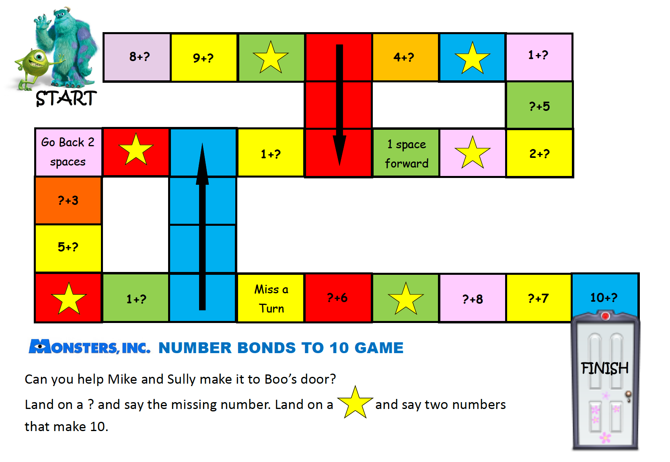  EYFS - Access the White Rose Maths website for home learning (link below).  https://whiterosemaths.com/homelearning/early-years/  Complete Summer Term Week 1 - Day 4 - Supertato (watch the video before completing the activity).  KS1 Maths Starter – Access https://www.themathsfactor.com/games/ to select a game from the ‘Explorer Key Stage 1’ section.  Y1 Access the White Rose Maths website for home learning (link below).  https://whiterosemaths.com/homelearning/year-1/  Complete Summer Term – Week 3 - Lesson 4 (watch the video before completing the activity).  Y2 Access the White Rose Maths website for home learning (link below).  https://whiterosemaths.com/homelearning/year-2/  Complete Summer Term – Week 3 – Lesson 4 (watch the video before completing the activity).  KS1 - If you do have access to a printer and want to print the White Rose sheets that go with each lesson, you can do. If you do this, you do not have to do the Power Maths pages as well.  If you do not have access to a printer, watch the White Rose video each day and then complete the Power Maths books.  Daily Project  EYFS and KS1 – Theme/Art: Family Memories/My Birthday Memories.  - Look at a range of birthday items, such as a party hat, candles, cards, cake and a wrapped present and guess the occasion with which these items are associated.  - Talk about why birthdays are celebrated and how they feel when it is their special day.  - Describe a memory from a previous birthday, recalling the presents that they received, whether they had a party and what made it special.  - Paint a picture or make drawings to show a family celebration that you remember. When you have finished explain what is happening in your work and say what you like or dislike about it.  - Useful links:  https://www.pumpitupparty.com/blog/how-did-the-tradition-of-birthdays-begin/  https://www.listplanit.com/list-of-birthday-traditions-from-around-the-world/  http://peacetreeinternational.org/teachers-resources/celebrations-around-the-world/  EYFS/KS1 Challenge  Can you organise a ‘home cinema’ night?  Some ideas:  - Make a poster for the sitting room door.  - Make some tickets.  - Take some money to spend and give change for snacks during the interval.  - Take it in turns to be usher to show family members to their seats using a torch.  Have fun!
Friday | Phonics – ALL with support from parents/carers  Year 1 – Phase 6 - Suffix ending: split digraph silent 'e' + '-ing', '-ed'  Year 2 – Words ending –tion: Use the following words: station, fiction, motion, nation, section, education, foundation, competition, lotion, direction, fraction. Ask your child to clap and count the syllables in station: ‘sta’ / ‘tion’. Ask them to spell the first part and highlight that this is a word where the /eɪ/ phoneme is spelt with single letter ‘a’. Explain that the ending ‘–tion’ is a tricky one that is not spelt as it sounds. Ask if they know how it is spelt and write it out. Tell them there are other spellings of ‘–tion’ but that this is the most common. Chant the letters in the word. Rub out a letter each time they chant but reinforce chanting every letter. Can they spell the word when all the letters are rubbed out? Choose another word and repeat the process. Ask your child to write a list of all of these words. What other words can you think of or find to add to this list?  EYFS – Repeat lesson from Thursday. Pick another sentence to dictate and write.  Maths  EYFS Maths Starter –Access https://www.bbc.co.uk/cbeebies/topics/numeracy to select a game to play.  EYFS - Access the White Rose Maths website for home learning (link below).  https://whiterosemaths.com/homelearning/early-years/  Complete Summer Term Week 1 - Day 5 - Supertato (watch the video before completing the activity).  KS1 Maths Starter – Access https://www.themathsfactor.com/games/ to select a game from the ‘Explorer Key Stage 1’ section.  Y1 Access the White Rose Maths website for home learning (link below).  https://whiterosemaths.com/homelearning/year-1/  Complete Summer Term – Week 3 - Lesson 5 – Friday Maths Challenge (watch the video before completing the activity).  Y2 Access the White Rose Maths website for home learning (link below).  https://whiterosemaths.com/homelearning/year-2/  Complete Summer Term – Week 3 – Lesson 5 – Friday Maths Challenge (watch the video before completing the activity).  KS1 If you do have access to a printer and want to print the White Rose sheets that go with each lesson, you can do. If you do this, you do not have to do the Power Maths pages as well.  If you do not have access to a printer, watch the White Rose video each day and then complete the Power Maths books.  Daily Project  EYFS and KS1 – RE Lesson 2: Last week we looked at how the Creation story in the Jewish Bible was the reason they celebrate Shabbat every week. This week we are going to learn about Allah and creation and look at how Muslims believe they should look after the world for God. Please click on the link to watch the video and complete the tasks. Perhaps you could work with an adult this week to plant some seeds or weed a patch in the garden or plant pot. https://www.natre.org.uk/uploads/Free%20Resources/Pupil%20resources%20amended/F1%205-7%20RE%20Today%20and%20NATRE%20home%20learning%20Charlie%20and%20Blue%20gardens%20Islam.pdf

