DAILY PROJECT - PSHE QUIZ – Tuesday
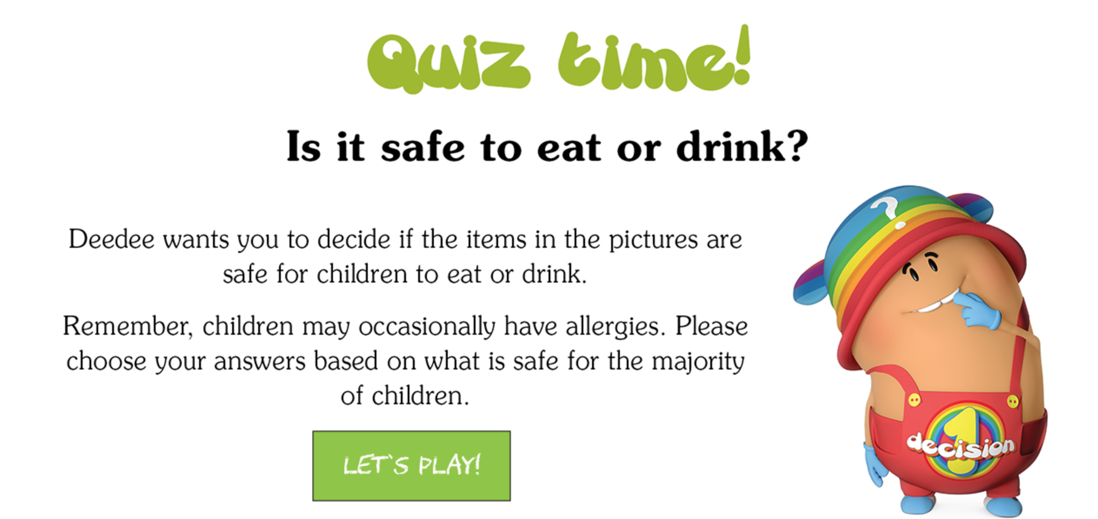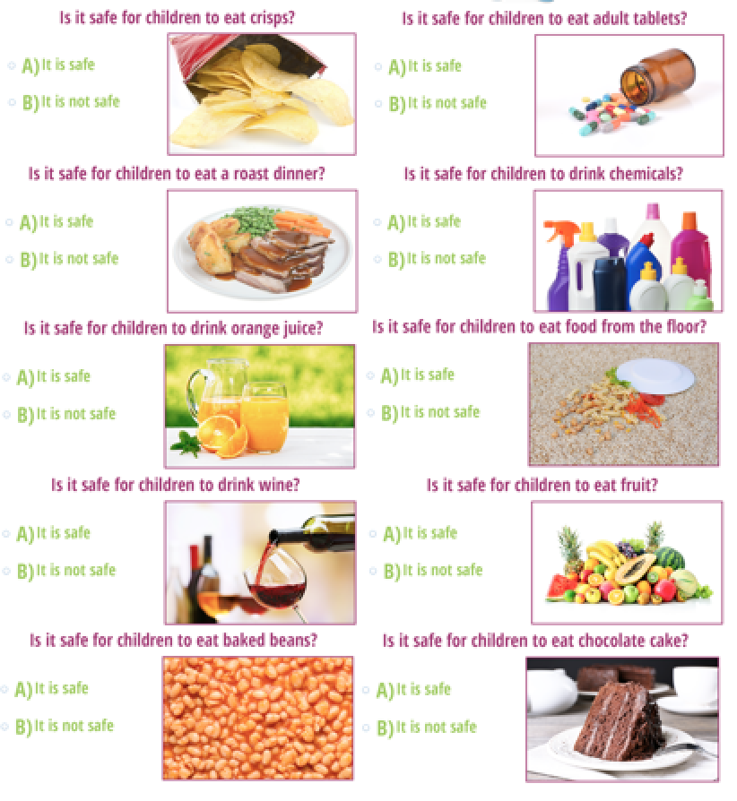

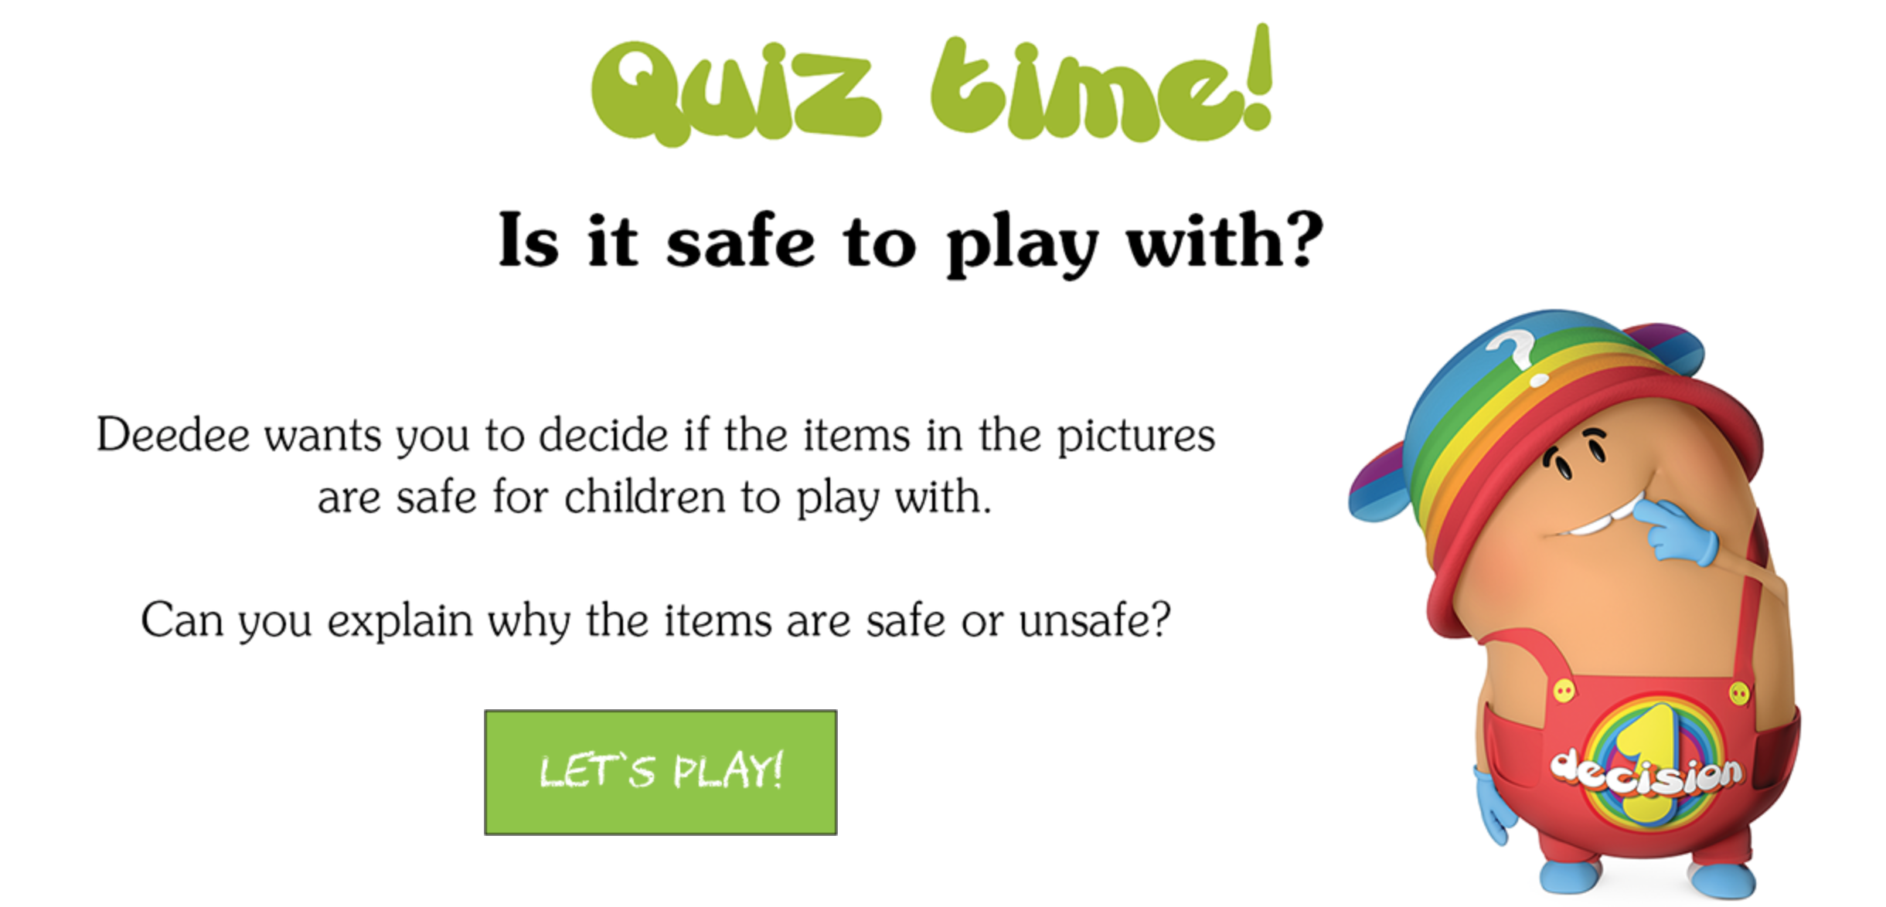
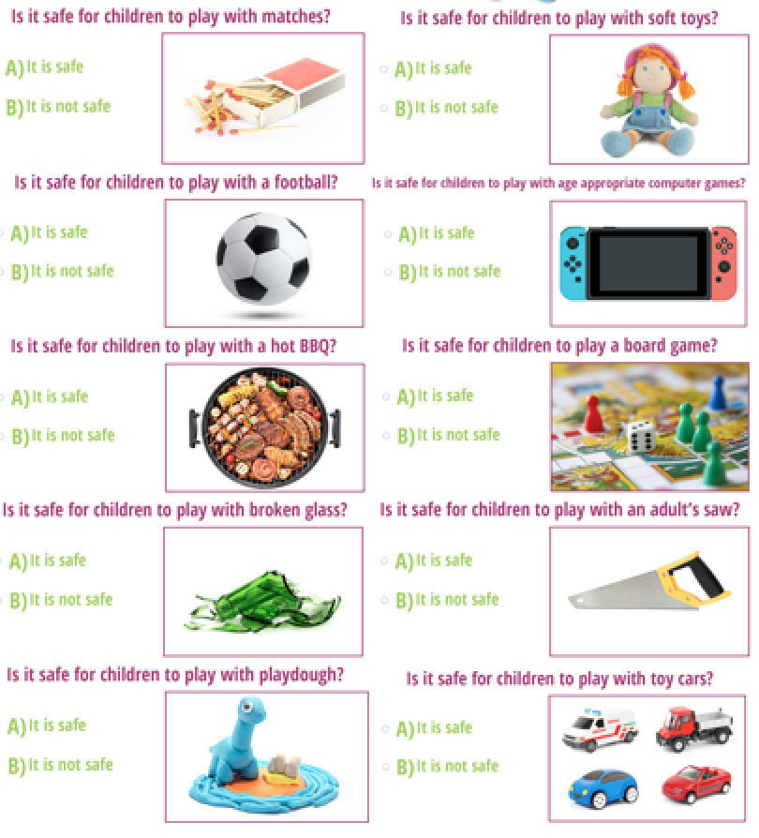

Diary Entry 1 for Daily Project – Wednesday
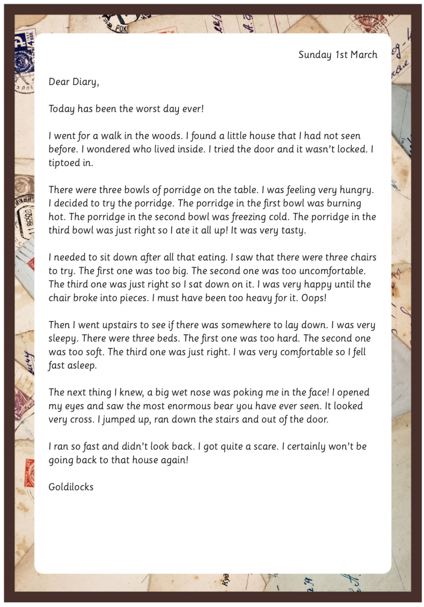

Diary Entry 2 for Daily Project – Wednesday
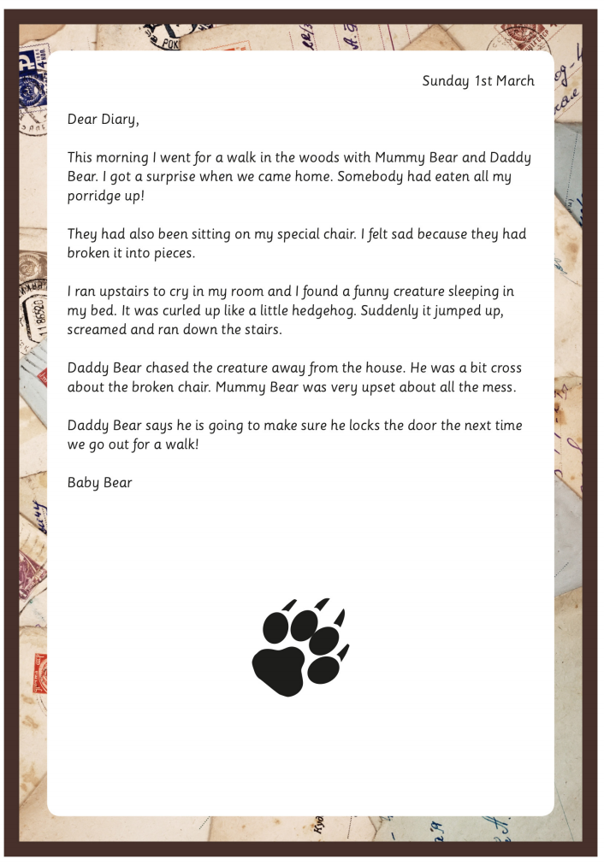

Diary Entry 3 for Daily Project – Wednesday
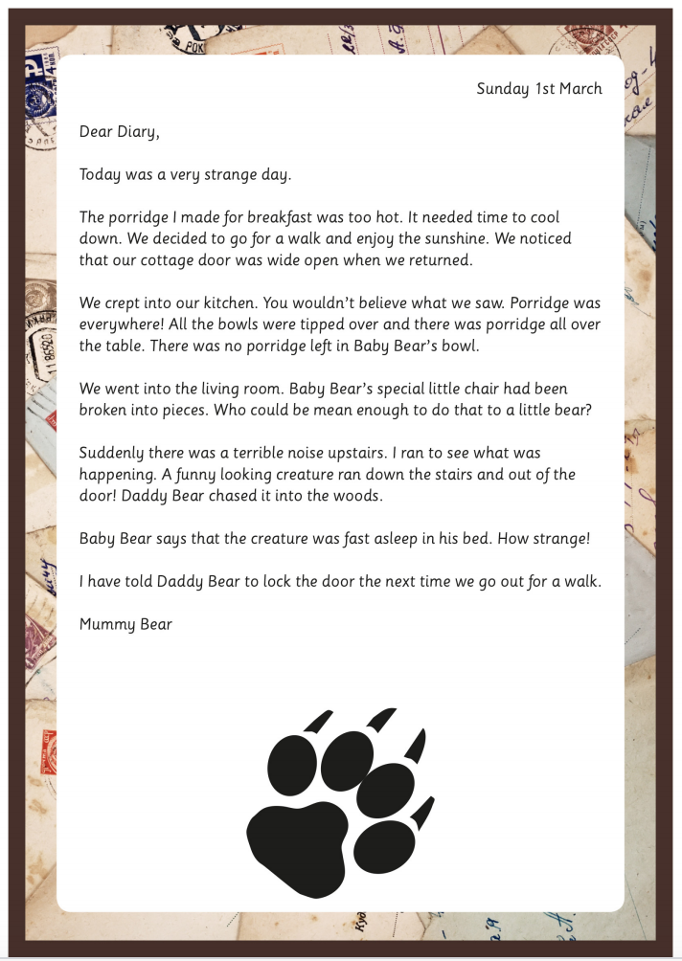

The Story of Goldilocks and the Three Bears - 1
Once upon a time, there was a little girl named Goldilocks. One day she went for a walk in the forest. Before long, she came upon a house. She knocked and, when no one answered, she walked in.
At the table in the kitchen, there were three bowls of porridge. Goldilocks was hungry. She tasted the porridge from the first bowl.
"This porridge is too hot!" she exclaimed.
So, she tasted the porridge from the second bowl.
"This porridge is too cold," she said
So, she tasted the last bowl of porridge.
"Ahhh, this porridge is just right," she said happily and she ate it all up.
After she'd eaten the three bears' breakfasts she decided she was feeling a little tired. So, she walked into the living room where she saw three chairs. Goldilocks sat in the first chair to rest her feet.
"This chair is too big!" she exclaimed.
So she sat in the second chair.
"This chair is too big, too!" she whined.
So she tried the last and smallest chair.
"Ahhh, this chair is just right," she sighed. But just as she settled down into the chair to rest, it broke into pieces!
Goldilocks was very tired by this time, so she went upstairs to the bedroom. She lay down in the first bed, but it was too hard. Then she lay in the second bed, but it was too soft. Then she lay down in the third bed and it was just right. Goldilocks fell asleep.
As she was sleeping, the three bears came home.
"Someone's been eating my porridge," growled the Papa bear.
"Someone's been eating my porridge," said the Mama bear.
"Someone's been eating my porridge and they ate it all up!" cried the Baby bear.
"Someone's been sitting in my chair," growled the Papa bear.
"Someone's been sitting in my chair," said the Mama bear.
"Someone's been sitting in my chair and they've broken it all to pieces," cried the Baby bear.
They decided to look around some more and when they got upstairs to the bedroom, Papa bear growled, "Someone's been sleeping in my bed,"
"Someone's been sleeping in my bed, too" said the Mama bear
"Someone's been sleeping in my bed and she's still there!" exclaimed Baby bear.
Just then, Goldilocks woke up and saw the three bears. She screamed, "Help!" And she jumped up and ran out of the room. Goldilocks ran down the stairs, opened the door, and ran away into the forest. And she never returned to the home of the three bears.
THE END

The Story of Goldilocks and the Three Bears – 2

Once upon a time there were three Bears, who lived together in a house of their own, in a wood. One of them was a Little Wee Bear, and one was a Middle-sized Bear, and the other was a Great Big Bear. They had each a bowl for their porridge; a little bowl for the Little Wee Bear; and a middle-sized bowl for the Middle-sized Bear; and a great bowl for the Great Big Bear. And they had each a chair to sit in; a little chair for the Little Wee Bear; and a middle-sized chair for the Middle-sized Bear; and a great chair for the Great Big Bear. And they had each a bed to sleep in; a little bed for the Little Wee Bear; and a middle-sized bed for the Middle-sized Bear; and a great bed for the Great Big Bear.

One day, after they had made the porridge for their breakfast, and poured it into their porridge-bowls, they walked out into the wood while the porridge was cooling, that they might not burn their mouths by beginning too soon, for they were polite, well-brought-up Bears. And while they were away a little girl called Goldilocks, who lived at the other side of the wood and had been sent on an errand by her mother, passed by the house, and looked in at the window. And then she peeped in at the keyhole, for she was not at all a well-brought-up little girl. Then seeing nobody in the house she lifted the latch. The door was not fastened, because the Bears were good Bears, who did nobody any harm, and never suspected that anybody would harm them. So Goldilocks opened the door and went in; and well pleased was she when she saw the porridge on the table. If she had been a well-brought-up little girl she would have waited till the Bears came home, and then, perhaps, they would have asked her to breakfast; for they were good Bears—a little rough or so, as the manner of Bears is, but for all that very good-natured and hospitable. But she was a rude little girl, and so she set about helping herself.

First she tasted the porridge of the Great Big Bear, and that was too hot for her. Next she tasted the porridge of the Middle-sized Bear, but that was too cold for her. And then she went to the porridge of the Little Wee Bear, and tasted it, and that was neither too hot nor too cold, but just right, and she liked it so well that she ate it all up, every bit!

Then Goldilocks, who was tired, for she had been catching butterflies instead of running on her errand, sat down in the chair of the Great Big Bear, but that was too hard for her. And then she sat down in the chair of the Middle-sized Bear, and that was too soft for her. But when she sat down in the chair of the Little Wee Bear, that was neither too hard nor too soft, but just right. So she seated herself in it, and there she sat till the bottom of the chair came out, and down she came, plump upon the ground; and that made her very cross, for she was a bad-tempered little girl.

Now, being determined to rest, Goldilocks went upstairs into the bedchamber in which the Three Bears slept. And first she lay down upon the bed of the Great Big Bear, but that was too high at the head for her. And next she lay down upon the bed of the Middle-sized Bear, and that was too high at the foot for her. And then she lay down upon the bed of the Little Wee Bear, and that was neither too high at the head nor at the foot, but just right. So she covered herself up comfortably, and lay there till she fell fast asleep.

By this time the Three Bears thought their porridge would be cool enough for them to eat it properly; so they came home to breakfast. Now careless Goldilocks had left the spoon of the Great Big Bear standing in his porridge.
"SOMEBODY HAS BEEN AT MY PORRIDGE!"
said the Great Big Bear in his great, rough, gruff voice.
Then the Middle-sized Bear looked at his porridge and saw the spoon was standing in it too.
"SOMEBODY HAS BEEN AT MY PORRIDGE!"
said the Middle-sized Bear in his middle-sized voice.
Then the Little Wee Bear looked at his, and there was the spoon in the porridge-bowl, but the porridge was all gone!
"SOMEBODY HAS BEEN AT MY PORRIDGE, AND HAS EATEN IT ALL UP!"
said the Little Wee Bear in his little wee voice.
Upon this the Three Bears, seeing that some one had entered their house, and eaten up the Little Wee Bear's breakfast, began to look about them. Now the careless Goldilocks had not put the hard cushion straight when she rose from the chair of the Great Big Bear.
"SOMEBODY HAS BEEN SITTING IN MY CHAIR!"
said the Great Big Bear in his great, rough, gruff voice.
And the careless Goldilocks had squatted down the soft cushion of the Middle-sized Bear.
"SOMEBODY HAS BEEN SITTING IN MY CHAIR!"
said the Middle-sized Bear in his middle-sized voice.
"SOMEBODY HAS BEEN SITTING IN MY CHAIR, AND HAS SATE THE BOTTOM THROUGH!"
said the Little Wee Bear in his little wee voice.
Then the Three Bears thought they had better make further search in case it was a burglar, so they went upstairs into their bedchamber. Now Goldilocks had pulled the pillow of the Great Big Bear out of its place.
"SOMEBODY HAS BEEN LYING IN MY BED!"
said the Great Big Bear in his great, rough, gruff voice.
And Goldilocks had pulled the bolster of the Middle-sized Bear out of its place.
"SOMEBODY HAS BEEN LYING IN MY BED!"
said the Middle-sized Bear in his middle-sized voice.
But when the Little Wee Bear came to look at his bed, there was the bolster in its place!
And the pillow was in its place upon the bolster!
And upon the pillow——?
There was Goldilocks's yellow head—which was not in its place, for she had no business there.
"SOMEBODY HAS BEEN LYING IN MY BED, AND HERE SHE IS STILL!"
said the Little Wee Bear in his little wee voice.

Now Goldilocks had heard in her sleep the great, rough, gruff voice of the Great Big Bear; but she was so fast asleep that it was no more to her than the roaring of wind, or the rumbling of thunder. And she had heard the middle-sized voice of the Middle-sized Bear, but it was only as if she had heard some one speaking in a dream. But when she heard the little wee voice of the Little Wee Bear, it was so sharp, and so shrill, that it awakened her at once. Up she started, and when she saw the Three Bears on one side of the bed, she tumbled herself out at the other, and ran to the window. Now the window was open, because the Bears, like good, tidy Bears, as they were, always opened their bedchamber window when they got up in the morning. So naughty, frightened little Goldilocks jumped up and ran into the woods. The Three Bears never saw anything more of her.

The End

Jack and the Beanstalk

Once upon a time, there lived a widow woman and her son, Jack, on their small farm in the country. Every day, Jack would help his mother with the chores - chopping the wood, weeding the garden and milking the cow. But despite all their hard work, Jack and his mother were very poor with barely enough money to keep themselves fed. "What shall we do, what shall we do?" said the widow, one spring day. "We don't have enough money to buy seed for the farm this year! We must sell our cow, Old Bess, and with the money buy enough seed to plant a good crop."
"All right, mother," said Jack, "It's market-day today. I'll go into town and sell Bessy."

So Jack took the cow's halter in his hand, walked through the garden gate and headed off toward town. He hadn't gone far when he met a funny-looking, old man who said to him, "Good morning, Jack."
"Good morning to you," said Jack, wondering how the little, old man knew his name.
"Where are you off to this fine morning?" asked the man.
"I'm going to market to sell our cow, Bessy."
"Well what a helpful son you are!" exclaimed the man, "I have a special deal for such a good boy like you."
The little, old man looked around to make sure no one was watching and then opened his hand to show Jack what he held.
"Beans?" asked Jack, looking a little confused.
"Three magical bean seeds to be exact, young man. One, two, three! So magical are they, that if you plant them over-night, by morning they grow right up to the sky," promised the funny little man.
"And because you're such a good boy, they're all yours in trade for that old milking cow."
"Really?" said Jack, "and you're quite sure they're magical?"
"I am indeed! And if it doesn't turn out to be true you can have your cow back."
"Well that sounds fair," said Jack, as he handed over Bessy's halter, pocketed the beans and headed back home to show his mother.
"Back already, Jack?" asked his mother; "I see you haven't got Old Bess -- you've sold her so quickly. How much did you get for her?"
Jack smiled and reached into his pocket, "Just look at these beans, mother; they're magical, plant them over-night and…"
"What!" cried Jack's mother. "Oh, silly boy! How could you give away our milking cow for three measly beans."
And with that she did the worst thing Jack had ever seen her do - she burst into tears.

Jack ran upstairs to his little room in the attic, so sorry he was, and threw the beans angrily out the window thinking, "How could I have been so foolish - I've broken my mother's heart." After much tossing and turning, at last Jack dropped off to sleep.

When Jack woke up the next morning, his room looked strange. The sun was shining into part of it like it normally did, and yet all the rest was quite dark and shady. So Jack jumped up and dressed himself and went to the window. And what do you think he saw? Why, the beans he had thrown out of the window into the garden had sprung up into a big beanstalk which went up and up and up until it reached the sky.

Using the leaves and twisty vines like the rungs of a ladder, Jack climbed and climbed until at last, he reached the sky. And when he got there he found a long, broad road winding its way through the clouds to a tall, square castle off in the distance.

Jack ran up the road toward the castle and just as he reached it, the door swung open to reveal a horrible lady giant, with one great eye in the middle of her forehead. As soon as Jack saw her he turned to run away, but she caught him, and dragged him into the castle. "Don't be in such a hurry, I'm sure a growing boy like you would like a nice, big breakfast," said the great, big, tall woman, "It's been so long since I got to make breakfast for a boy."

Well, the lady giant wasn't such a bad sort, after all, even if she was a bit odd. She took Jack into the kitchen, and gave him a chunk of cheese and a glass of milk. But Jack had only taken a few bites when thump, thump, thump! The whole house began to tremble with the noise of someone coming. "Goodness gracious me! It's my husband," said the giant woman, wringing her hands, "What on earth shall I do? There's nothing he likes better than boys broiled on toast and I haven't any bread left. Oh dear, I never should have let you stay for breakfast. Here, come quick and jump in here." And she hurried Jack into a large copper pot sitting beside the stove just as her husband, the giant, came in.
He ducked inside the kitchen and said,
"I'm ready for my breakfast -- I'm so hungry I could eat three cows. Ah, what's this I smell?
“Fee-fi-fo-fum, I smell the blood of an Englishman. Be he alive, or be he dead
I'll have his bones to grind my bread.”
"Nonsense, dear," said his wife, "We haven't had a boy for breakfast in years. Now you go and wash up and by the time you come back your breakfast will be ready for you."
So the giant went off to tidy up. Jack was about to make a run for it when the woman stopped him. "Wait until he's asleep," she said, "He always has a little snooze after breakfast." Jack peeked out of the copper pot just as the giant returned to the kitchen carrying a basket filled with golden eggs and a sickly-looking, white hen. The giant poked the hen and growled, "Lay" and the hen laid an egg made of gold which the giant added to the basket.

After his breakfast, the giant went to the closet and pulled out a golden harp with the face of a sad, young girl. The giant poked the harp and growled, "Play" and the harp began to play a gentle tune while her lovely face sang a lullaby. Then the giant began to nod his head and to snore until the house shook.

When he was quite sure the giant was asleep, Jack crept out of the copper pot and began to tiptoe out of the kitchen. Just as he was about to leave, he heard the sound of the harp-girl weeping. Jack bit his lip, sighed and returned to the kitchen. He grabbed the sickly hen and the singing harp, and began to tiptoe back out. But this time the hen gave a cackle which woke the giant, and just as Jack got out of the house he heard him calling, "Wife, wife, what have you done with my white hen and my golden harp?"

Jack ran as fast as he could and the giant, realising he had been tricked, came rushing after - away from the castle and down the broad, winding road. When he got to the beanstalk the giant was only twenty yards away when suddenly he saw Jack disappear - confused, the giant peered through the clouds and saw Jack underneath climbing down for dear life. The giant stomped his foot and roared angrily.
“Fee-fi-fo-fum, I smell the blood of an Englishman. Be he alive, or be he dead
I'll have his bones to grind my bread.”

The giant swung himself down onto the beanstalk, which shook with his weight. Jack slipped, slid and climbed down the beanstalk as quickly as he could, and after him climbed the giant. As he neared the bottom, Jack called out, "Mother! Please! Hurry, bring me an axe, bring me an axe." His mother came rushing out with Jack's wood chopping axe in her hand, but when she came to the enormous beanstalk she stood stock still with fright.

Jack jumped down, got hold of the axe and began to chop away at the beanstalk. Luckily, because of all the chores he'd done over the years, he'd become quite good at chopping and it didn't take long for him to chop through enough of the beanstalk that it began to teeter. The giant felt the beanstalk shake and quiver so he stopped to see what was the matter. Then Jack gave one last big chop with the axe, and the beanstalk began to topple over. Then the giant fell down and broke his crown, and the beanstalk came toppling after.

The singing harp thanked Jack for rescuing her from the giant - she had hated being locked up in the closet all day and night and wanted nothing more than to sit in the farmhouse window and sing to the birds and the butterflies in the sunshine.

With a bit of patience and his mother's help, it didn't take long for Jack to get the sickly hen back in good health and the grateful hen continued to lay a fresh golden egg every day.

Jack used the money from selling the golden eggs to buy back Old Bess, purchase seed for the spring crop and to fix up his mother's farm. He even had enough left over to invite every one of his neighbours over for a nice meal, complete with music from the singing harp.

And so Jack, his mother, Old Bess, the golden harp and the white hen lived happy ever after.

